11.Write the Python Program for Tic Tac Toe Game
Aim
To implement a simple Tic Tac Toe game in Python.
Algorithm
- Create a 3×3 board.
- Display the board.
- Alternate turns between X and O.
- Accept row and column input.
- Update the board.
- Check for winner or draw.
- Repeat until game ends.
Python Program
board = [[" "]*3 for _ in range(3)]

def display():
for row in board:
print("|".join(row))
print("-"*5)

player = "X"

for turn in range(9):
display()
r = int(input("Row (0-2): "))
c = int(input("Column (0-2): "))

if board[r][c] == " ":
board[r][c] = player

for i in range(3):
if all(board[i][j] == player for j in range(3)) or \
all(board[j][i] == player for j in range(3)):
display()
print(player, "Wins!")
exit()

if (board[0][0] == board[1][1] == board[2][2] == player) or \
(board[0][2] == board[1][1] == board[2][0] == player):
display()
print(player, "Wins!")
exit()

player = "O" if player == "X" else "X"

display()
print("Match Draw")
Sample Input
Row: 0
Column: 0
Row: 1
Column: 1
...
Sample Output
X| |
-----
|O|
-----
| |

X Wins!
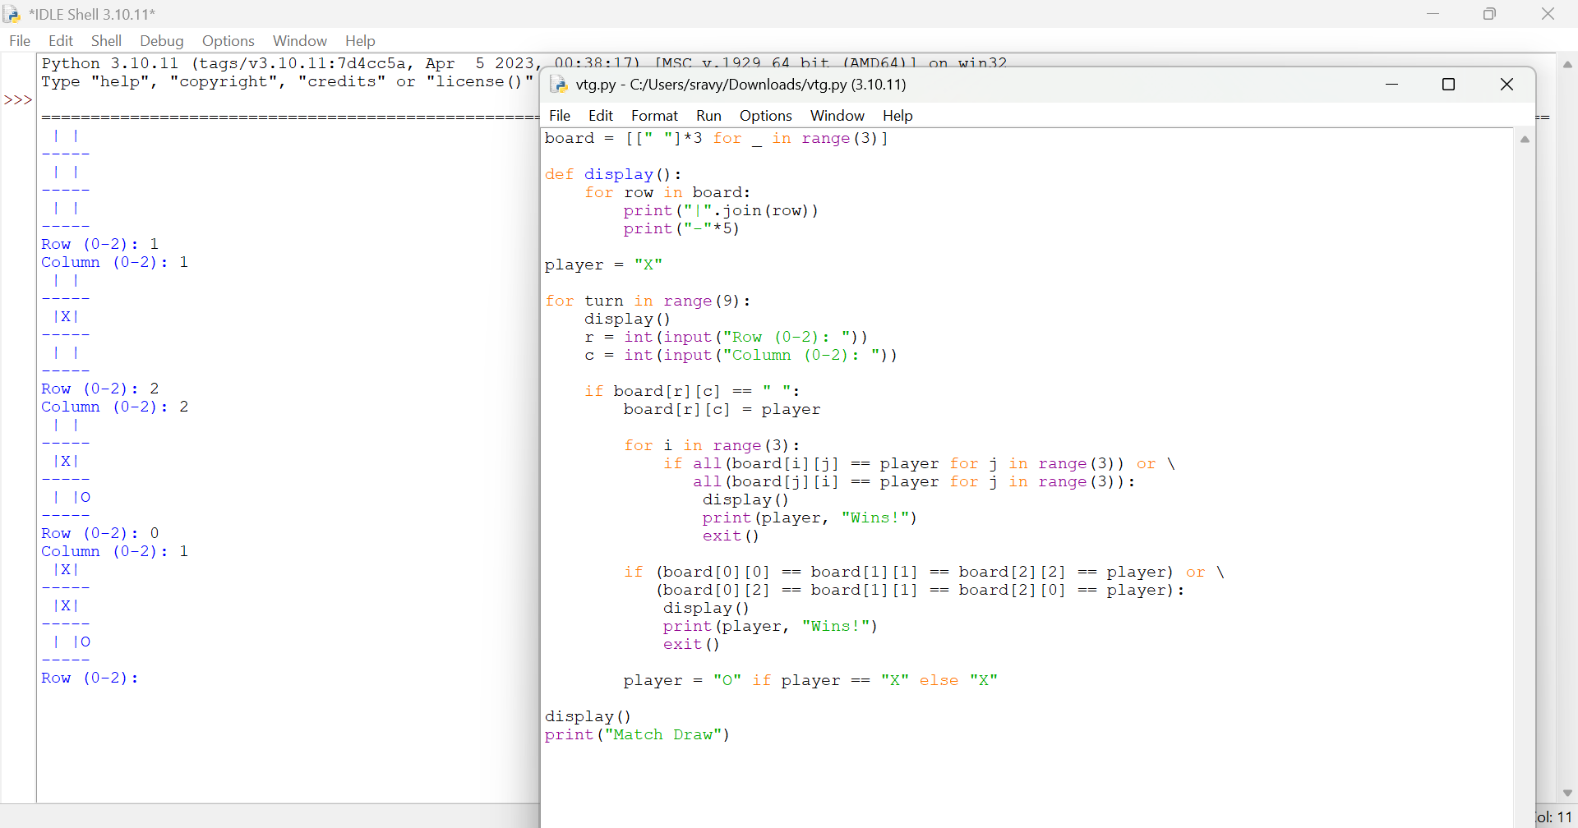

Result
Thus, the Tic Tac Toe game was implemented successfully.

