12.Write the Python Program for Minimax Algorithm for Gaming
Aim
To implement the Minimax Algorithm for game decision-making.
Algorithm
- Define terminal values.
- If depth is zero, return evaluation value.
- If maximizing player's turn, choose maximum value.
- If minimizing player's turn, choose minimum value.
- Return the optimal value.
Python Program
import math
scores = [3, 5, 2, 9, 12, 5, 23, 23]
def minimax(depth, node, isMax, height):
if depth == height:
return scores[node]
if isMax:
return max(
minimax(depth + 1, node * 2, False, height),
minimax(depth + 1, node * 2 + 1, False, height)
)
else:
return min(
minimax(depth + 1, node * 2, True, height),
minimax(depth + 1, node * 2 + 1, True, height)
)
height = math.log2(len(scores))
print("Optimal Value:", minimax(0, 0, True, int(height)))
Sample Input
No input required.

Sample Output
Optimal Value: 12
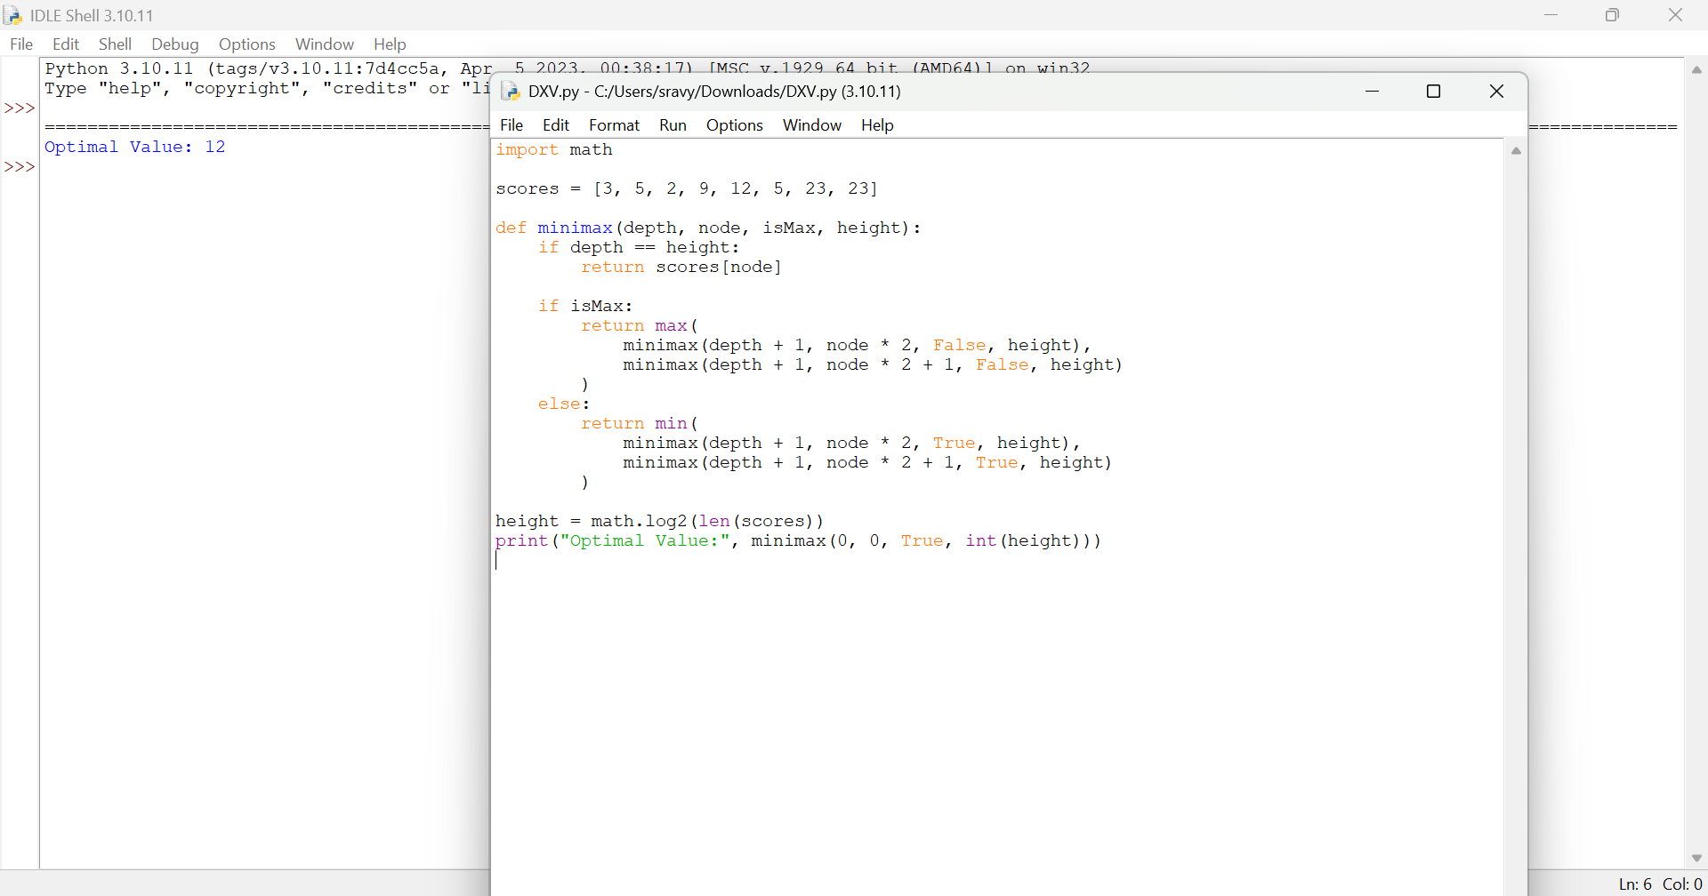

Result
Thus, the Minimax Algorithm was implemented successfully.

