13.Write the Python Program for Alpha-Beta Pruning Algorithm
Aim
To implement the Alpha-Beta Pruning Algorithm for optimizing the Minimax search.
Algorithm
- Initialize alpha = −∞ and beta = +∞.
- Traverse the game tree recursively.
- Update alpha for maximizing player.
- Update beta for minimizing player.
- Prune branches whenever alpha ≥ beta.
- Return the optimal value.
Python Program
import math

scores = [3, 5, 6, 9, 1, 2, 0, -1]

def alphabeta(depth, node, isMax, scores, alpha, beta, height):
if depth == height:
return scores[node]

if isMax:
best = -math.inf
for i in range(2):
val = alphabeta(depth + 1, node * 2 + i, False,
scores, alpha, beta, height)
best = max(best, val)
alpha = max(alpha, best)
if beta <= alpha:
break
return best
else:
best = math.inf
for i in range(2):
val = alphabeta(depth + 1, node * 2 + i, True,
scores, alpha, beta, height)
best = min(best, val)
beta = min(beta, best)
if beta <= alpha:
break
return best

height = int(math.log2(len(scores)))

print("Optimal Value:",
alphabeta(0, 0, True, scores, -math.inf, math.inf, height))
Sample Input
No input required.
Sample Output
Optimal Value: 5
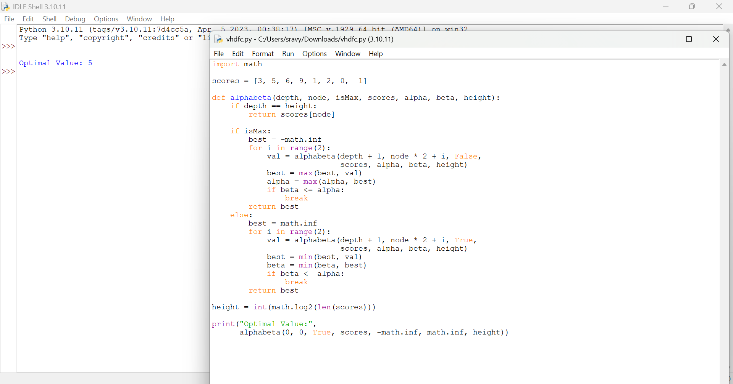

Result
Thus, the Alpha-Beta Pruning Algorithm was implemented successfully, reducing unnecessary node evaluations while producing the optimal result.

