14.Write the Python Program to Implement Decision Tree
Aim
To implement a Decision Tree Classifier in Python for classification.
Algorithm
- Import the required libraries.
- Load a sample dataset.
- Split the dataset into training and testing sets.
- Create a Decision Tree classifier.
- Train the model using the training data.
- Predict the output for the test data.
- Calculate and display the accuracy.
Python Program
from sklearn.datasets import load_iris
from sklearn.model_selection import train_test_split
from sklearn.tree import DecisionTreeClassifier
from sklearn.metrics import accuracy_score
# Load dataset
data = load_iris()
X = data.data
y = data.target
# Split data
X_train, X_test, y_train, y_test = train_test_split(
X, y, test_size=0.3, random_state=42
)
# Create model
model = DecisionTreeClassifier()
# Train model
model.fit(X_train, y_train)
# Predict
y_pred = model.predict(X_test)

# Accuracy
print("Accuracy:", accuracy_score(y_test, y_pred))
Sample Input
No input required.
Sample Output
Accuracy: 1.0
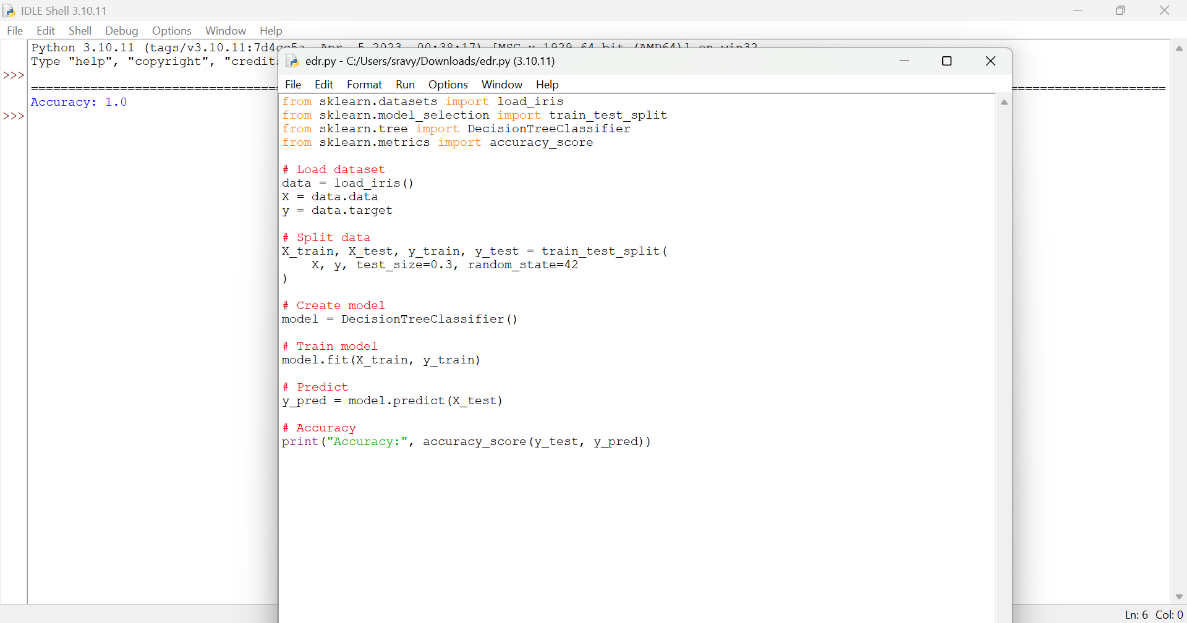

Result
Thus, the Decision Tree classifier was implemented successfully.

