2.Write a Python Program for Crypt Arithmetic Problem
Aim
To solve the Crypt Arithmetic Problem using permutations.
Algorithm
- Identify all unique letters.
- Assign digits using permutations.
- Ensure leading letters are not zero.
- Convert words into numbers.
- Check if the arithmetic equation is satisfied.
- Print the solution.
Program
from itertools import permutations
letters = ('S', 'E', 'N', 'D', 'M', 'O', 'R', 'Y')
digits = (0, 1, 2, 3, 4, 5, 6, 7, 8, 9)
for perm in permutations(digits, len(letters)):
d = dict(zip(letters, perm))
# Leading letters cannot be zero
if d['S'] == 0 or d['M'] == 0:
continue
SEND = 1000*d['S'] + 100*d['E'] + 10*d['N'] + d['D']
MORE = 1000*d['M'] + 100*d['O'] + 10*d['R'] + d['E']
MONEY = 10000*d['M'] + 1000*d['O'] + 100*d['N'] + 10*d['E'] + d['Y']
if SEND + MORE == MONEY:
print("Solution Found:")
print("SEND =", SEND)
print("MORE =", MORE)
print("MONEY =", MONEY)
print("\nLetter Assignments:")
for key in sorted(d):
print(key, "=", d[key])
break
Sample Input
SEND + MORE = MONEY
Sample Output
SEND = 9567
MORE = 1085
MONEY = 10652
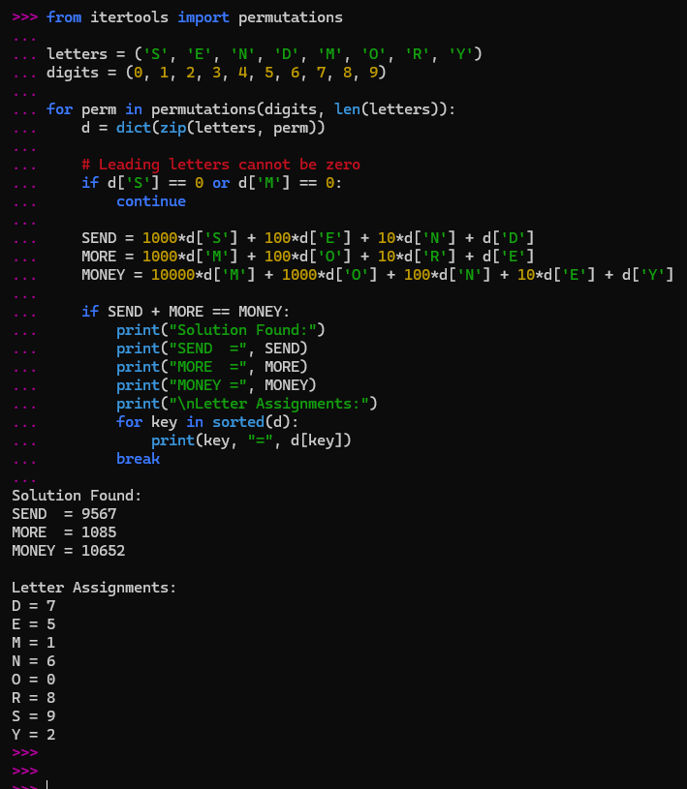
Result
Thus, the Crypt Arithmetic Problem was solved successfully.

