3.Write a Python Program for Machinaries cannibal problem
Aim
To solve the Missionaries and Cannibals Problem using BFS.
Algorithm
- Represent the initial and goal states.
- Generate all valid boat moves.
- Check safety constraints.
- Avoid revisiting states.
- Display the solution path.
Program
from collections import deque
def is_valid(m_left, c_left):
m_right = 3 - m_left
c_right = 3 - c_left
if (m_left > 0 and c_left > m_left):
return False
if (m_right > 0 and c_right > m_right):
return False
return True
def missionaries_cannibals():
start = (3, 3, 1) # (Missionaries Left, Cannibals Left, Boat Left=1)
goal = (0, 0, 0)
queue = deque([(start, [])])
visited = set()
moves = [
(1, 0), # 1 Missionary
(2, 0), # 2 Missionaries
(0, 1), # 1 Cannibal
(0, 2), # 2 Cannibals
(1, 1) # 1 Missionary and 1 Cannibal
]
while queue:
(m_left, c_left, boat), path = queue.popleft()
if (m_left, c_left, boat) in visited:
continue
visited.add((m_left, c_left, boat))
path = path + [(m_left, c_left, boat)]
if (m_left, c_left, boat) == goal:
print("Solution Found:")
for step in path:
print(step)
return
for m, c in moves:
if boat == 1: # Boat on left side
new_state = (m_left - m, c_left - c, 0)
else: # Boat on right side
new_state = (m_left + m, c_left + c, 1)
nm, nc, nb = new_state
if (0 <= nm <= 3 and 0 <= nc <= 3 and
is_valid(nm, nc) and
new_state not in visited):
queue.append((new_state, path))
print("No solution exists.")
missionaries_cannibals()

Sample Input
Initial State:
3 Missionaries
3 Cannibals

Sample Output
Solution Found:
(3,3,1)
...
(0,0,0)
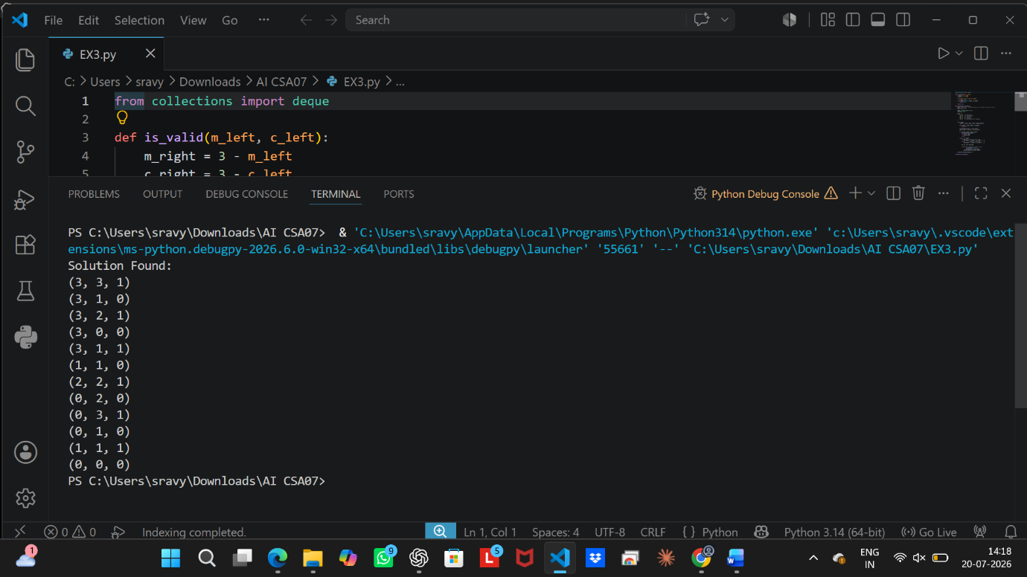

Result
Thus, the Missionaries and Cannibals Problem was solved successfully.

