4.Write a Python Program for Vaccum cleaner problem
Aim
To simulate the Vacuum Cleaner Agent.
Algorithm
- Read the room status.
- Start from the selected room.
- If dirty, clean it.
- Move to the next room.
- Display the final room status.
Program
# Vacuum Cleaner Problem
# Input room status
rooms = {
"A": input("Enter status of Room A (Dirty/Clean): "),
"B": input("Enter status of Room B (Dirty/Clean): ")
}
current_room = input("Enter starting room (A/B): ").upper()
print("\nVacuum Cleaner Actions:")
for _ in range(2):
if rooms[current_room].lower() == "dirty":
print("Room", current_room, "is Dirty -> Cleaning...")
rooms[current_room] = "Clean"
else:
print("Room", current_room, "is already Clean.")
# Move to the other room
if current_room == "A":
current_room = "B"
else:
current_room = "A"

print("\nFinal Room Status:")
for room in rooms:
print("Room", room, ":", rooms[room])
Sample Input
Room A = Dirty
Room B = Clean
Starting Room = A
Sample Output
Room A is Dirty -> Cleaning...
Room B is already Clean.

Final Status
Room A : Clean
Room B : Clean
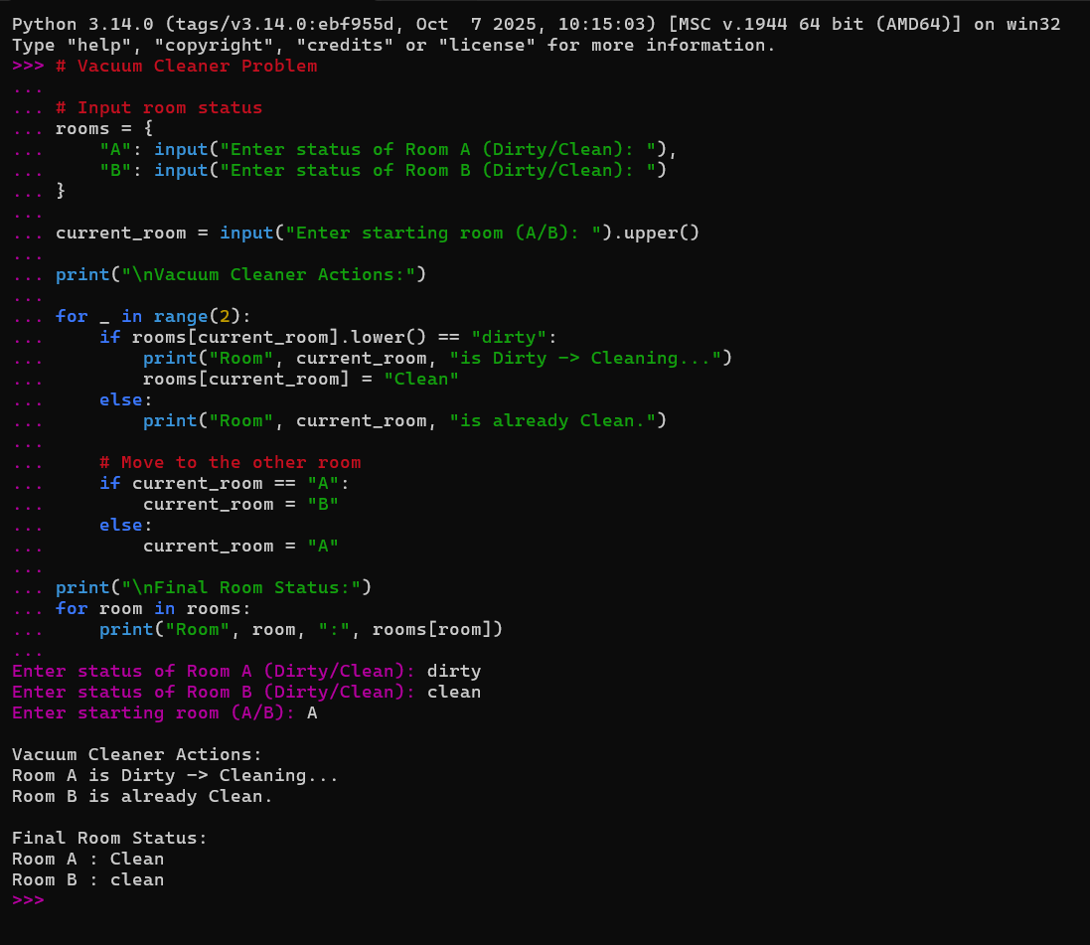

Result
Thus, the Vacuum Cleaner Agent cleaned all dirty rooms successfully.

