5.Write a Python Program for implement BFS(breadth first search)
Aim
To implement Breadth First Search traversal of a graph.
Algorithm
- Create the graph.
- Insert the starting node into the queue.
- Remove one node at a time.
- Visit all adjacent nodes.
- Continue until the queue becomes empty.
Program
from collections import deque
# BFS Function
def bfs(graph, start):
visited = set()
queue = deque([start])
print("BFS Traversal:")
while queue:
node = queue.popleft()
if node not in visited:
print(node, end=" ")
visited.add(node)
for neighbor in graph[node]:
if neighbor not in visited:
queue.append(neighbor)

# Graph Representation
graph = {
'A': ['B', 'C'],
'B': ['D', 'E'],
'C': ['F'],
'D': [],
'E': ['F'],
'F': []
}
# Starting Node
start = input("Enter the starting node: ").upper()
bfs(graph, start)
Sample Input
Starting Node = A
Sample Output
BFS Traversal:
A B C D E F
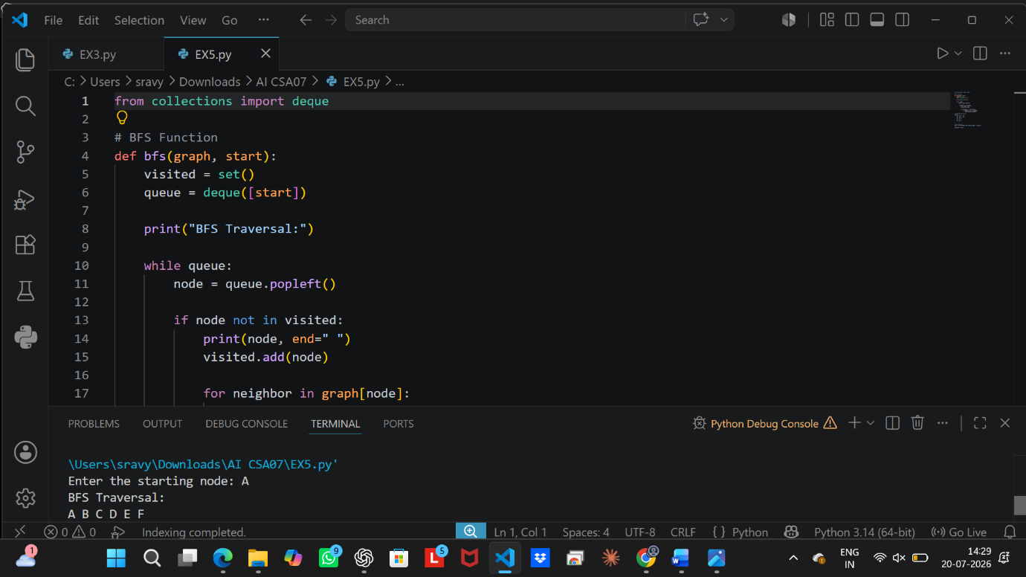
Result
Thus, the BFS traversal was performed successfully.

