6.Write a Python Program for Implement DFS(Dept first search)
Aim
To implement Depth First Search traversal of a graph.
Algorithm
- Create the graph.
- Visit the starting node.
- Mark it as visited.
- Recursively visit adjacent nodes.
- Continue until all nodes are visited.
Program
# DFS Function
def dfs(graph, node, visited):
if node not in visited:
print(node, end=" ")
visited.add(node)
for neighbor in graph[node]:
dfs(graph, neighbor, visited)
# Graph Representation
graph = {
'A': ['B', 'C'],
'B': ['D', 'E'],
'C': ['F'],
'D': [],
'E': ['F'],
'F': []
}
visited = set()
# Starting Node
start = input("Enter the starting node: ").upper()

print("DFS Traversal:")
dfs(graph, start, visited)
Sample Input
Starting Node = A
Sample Output
DFS Traversal:
A B D E F C
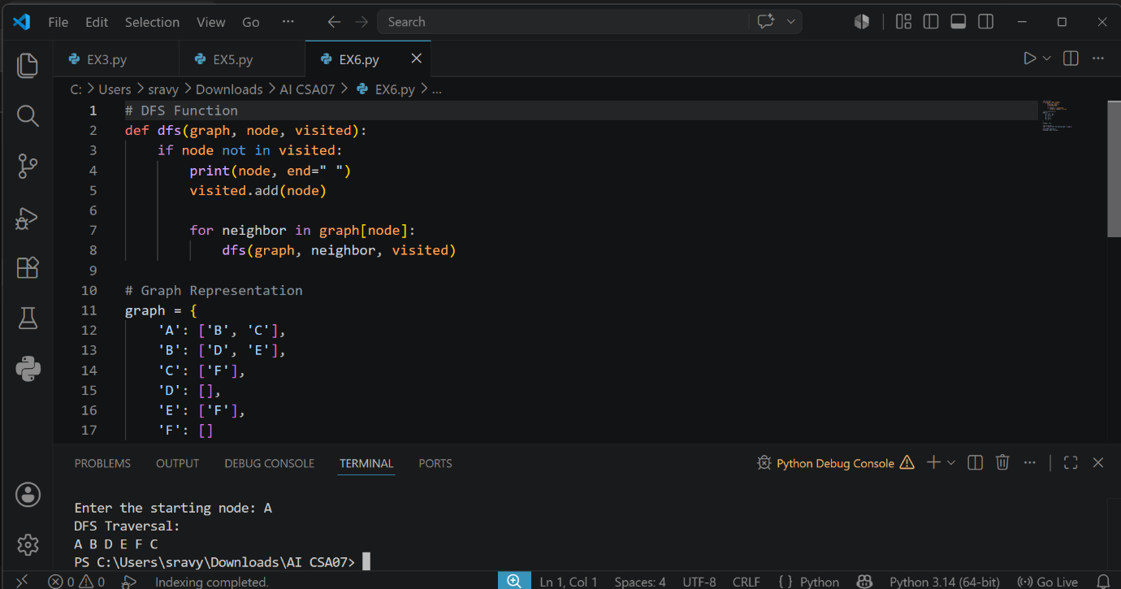

Result
Thus, the DFS traversal was performed successfully.

