7.write a python program for TRAVELLING salesman problem
Aim
To find the minimum-cost route using the Travelling Salesman Problem.
Algorithm
- Represent cities using a cost matrix.
- Select the starting city.
- Generate all possible routes.
- Compute the cost of each route.
- Select the route with minimum cost.
- Display the best path and minimum cost.
Program
from itertools import permutations
def travelling_salesman(graph, start):
n = len(graph)
cities = list(range(n))
cities.remove(start)
min_cost = float('inf')
best_path = []
# Generate all possible routes
for path in permutations(cities):
cost = 0
current = start
# Calculate path cost
for city in path:
cost += graph[current][city]
current = city

# Return to starting city
cost += graph[current][start]
# Update minimum cost
if cost < min_cost:
min_cost = cost
best_path = [start] + list(path) + [start]
print("Minimum Cost:", min_cost)
print("Best Path:", best_path)
# Cost Matrix
graph = [
[0, 10, 15, 20],
[10, 0, 35, 25],
[15, 35, 0, 30],
[20, 25, 30, 0]
]
start = int(input("Enter starting city (0-3): "))
travelling_salesman(graph, start)
Sample Input
Starting City = 0
Sample Output
Minimum Cost = 80
Best Path = [0,1,3,2,0]
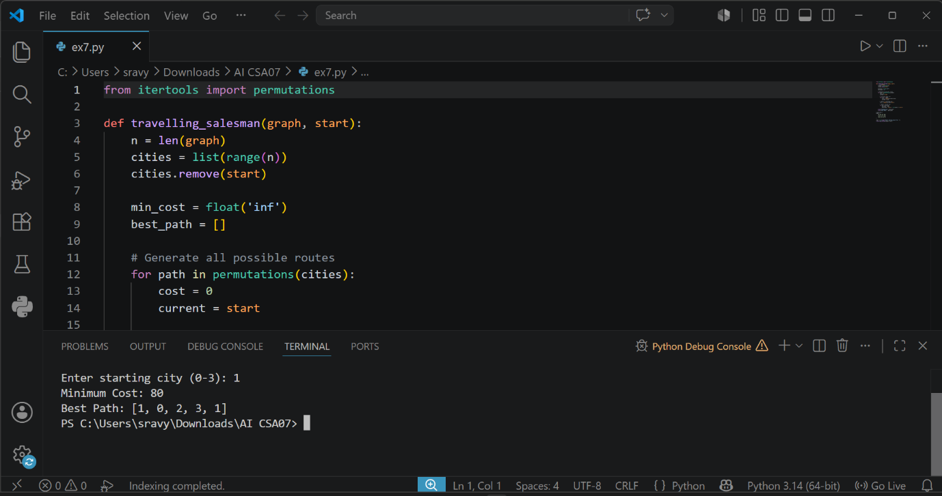
Result
Thus, the Travelling Salesman Problem was solved successfully using the Brute Force method.

