8.Write a Python Program to Implement A* algorithm
Aim
To implement the A* (A-Star) Search Algorithm in Python to find the shortest path between a start node and a goal node using heuristic values.
Algorithm
- Initialize the open list with the start node.
- Initialize the closed list as empty.
- Select the node with the lowest f(n) = g(n) + h(n) from the open list.
- If the selected node is the goal node, print the path and stop.
- Otherwise, move the node to the closed list.
- Generate all neighboring nodes.
- Calculate the cost for each neighbor:
  - g(n) = Cost from the start node.
  - h(n) = Heuristic value.
  - f(n) = g(n) + h(n).
- Add the neighbors to the open list if they are not already explored or update their cost if a shorter path is found.
- Repeat until the goal node is reached or the open list becomes empty.
Python Program
from queue import PriorityQueue
graph = {
'A': {'B': 1, 'C': 3},
'B': {'D': 3, 'E': 1},
'C': {'F': 5},
'D': {'G': 2},
'E': {'G': 4},
'F': {'G': 2},
'G': {}
}

heuristic = {
'A': 7,
'B': 6,
'C': 4,
'D': 2,
'E': 3,
'F': 1,
'G': 0
}

def astar(start, goal):
open_list = PriorityQueue()
open_list.put((0, start))

g_cost = {start: 0}
parent = {start: None}
visited = set()

while not open_list.empty():
current = open_list.get()[1]

if current == goal:
path = []
while current is not None:
path.append(current)
current = parent[current]
path.reverse()
print("Shortest Path:", " -> ".join(path))
print("Total Cost:", g_cost[goal])
return

visited.add(current)

for neighbor, cost in graph[current].items():
new_cost = g_cost[current] + cost

if neighbor not in g_cost or new_cost < g_cost[neighbor]:
g_cost[neighbor] = new_cost
f_cost = new_cost + heuristic[neighbor]
open_list.put((f_cost, neighbor))
parent[neighbor] = current

print("No path found.")

start = input("Enter Start Node: ").upper()
goal = input("Enter Goal Node: ").upper()

astar(start, goal)
Sample Input
Enter Start Node: A
Enter Goal Node: G
Sample Output
Shortest Path: A -> B -> D -> G
Total Cost: 6
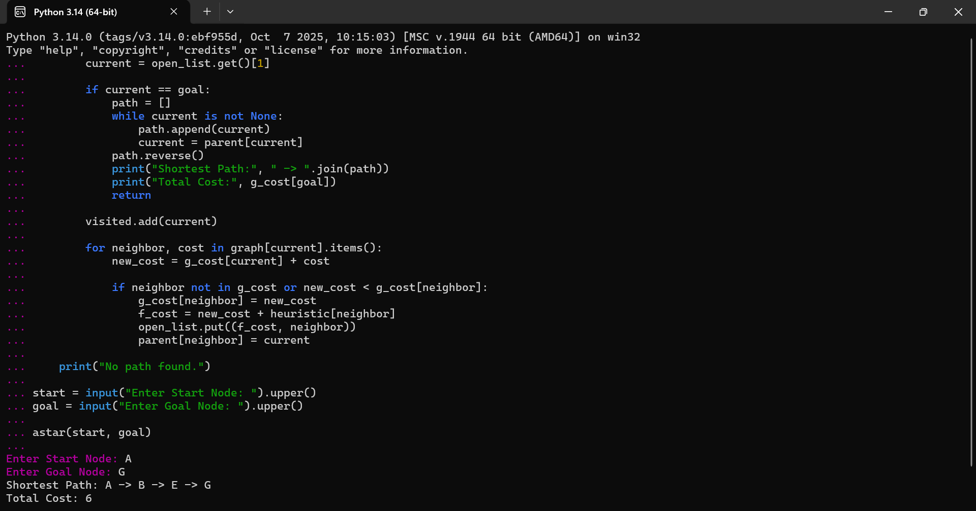
Result
Thus, the A* (A-Star) search algorithm was implemented successfully in Python, and the shortest path between the start node and the goal node was found using heuristic values.

