9.Write Python Program for Map Coloring Problem (Constraint Satisfaction Problem - CSP)
Aim
To implement the Map Coloring Problem using Constraint Satisfaction Problem (CSP) in Python such that no two adjacent regions have the same color.
Algorithm
- Define the map as a graph where nodes represent regions and edges represent adjacency.
- Define a set of colors.
- Assign colors to regions one by one.
- Check whether the assigned color satisfies the constraints.
- If valid, move to the next region.
- Otherwise, backtrack and try another color.
- Display the valid color assignment.
Python Program
# Map Coloring using Backtracking (CSP)

graph = {
'A': ['B', 'C'],
'B': ['A', 'C', 'D'],
'C': ['A', 'B', 'D'],
'D': ['B', 'C']
}

colors = ["Red", "Green", "Blue"]
result = {}

def is_safe(node, color):
for neighbor in graph[node]:
if neighbor in result and result[neighbor] == color:
return False
return True

def solve(nodes, index):
if index == len(nodes):
return True

node = nodes[index]

for color in colors:
if is_safe(node, color):
result[node] = color
if solve(nodes, index + 1):
return True
result.pop(node)

return False

nodes = list(graph.keys())

if solve(nodes, 0):
print("Color Assignment:")
for node in result:
print(node, ":", result[node])
else:
print("No Solution")
Sample Input
No input required.

Sample Output
Color Assignment:
A : Red
B : Green
C : Blue
D : Red
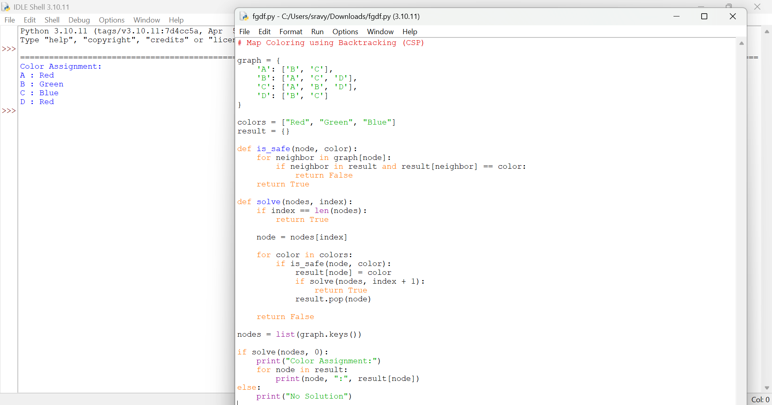

Result
Thus, the Map Coloring Problem was solved successfully using CSP.

