**ECO- BIN MONITORING SYSTEM**

*(13 size) A Project Based Learning Report Submitted in partial fulfilment of the requirements for the award of the degree*

*of*

**Bachelor of Technology**

**in The Department of ECE**

**EMBEDDED SYSTEM AUTOMATION-23SDEC02A**

Submitted by

**2310040032: M. Sravya**

**2310040033: A. Kavyanjali**

**2310040036: D. Lahari**

**2310040044: B. Sairam**

Under the guidance of

**Madhavi**



Department of Electronics and Communication Engineering

Koneru Lakshmaiah Education Foundation, Aziz Nagar

Aziz Nagar – 500075 (Optional)

NOV - 2023.

**ABSTRACT**

The Smart Eco Bin is an advanced waste management system that incorporates modern IoT technology to revolutionize waste disposal processes. By integrating sensors, microcontrollers (like ESP32), and mobile applications, this system enhances waste collection efficiency and environmental sustainability. The bin uses ultrasonic sensors to measure the waste level and a weight sensor to detect when the bin is full. Additionally, the system can identify different types of waste, offering opportunities for automated recycling sorting.

Through the mobile app, users can receive real-time notifications, such as when the bin is full or if waste sorting errors occur. This reduces manual effort and enhances waste management efficiency by optimizing collection routes, ensuring that waste collection is carried out only when needed, thus cutting down on unnecessary fuel consumption.

The Smart Eco Bin also promotes sustainability by encouraging proper waste segregation. With data analysis, it enables waste management authorities to monitor waste generation trends, making it easier to plan for more efficient waste collection strategies. Moreover, the system plays a crucial role in reducing the environmental impact of traditional waste management methods by minimizing waste overflow, reducing landfill use, and decreasing carbon emissions.

In the long term, the Smart Eco Bin contributes to creating smarter cities and greener environments by providing a cost-effective, automated, and eco-friendly solution for managing waste. The system’s adaptability allows it to be used in various settings, including residential areas, commercial spaces, and urban environments, making it a versatile tool in global waste management initiatives.

**REAL TIME CONNECTION**

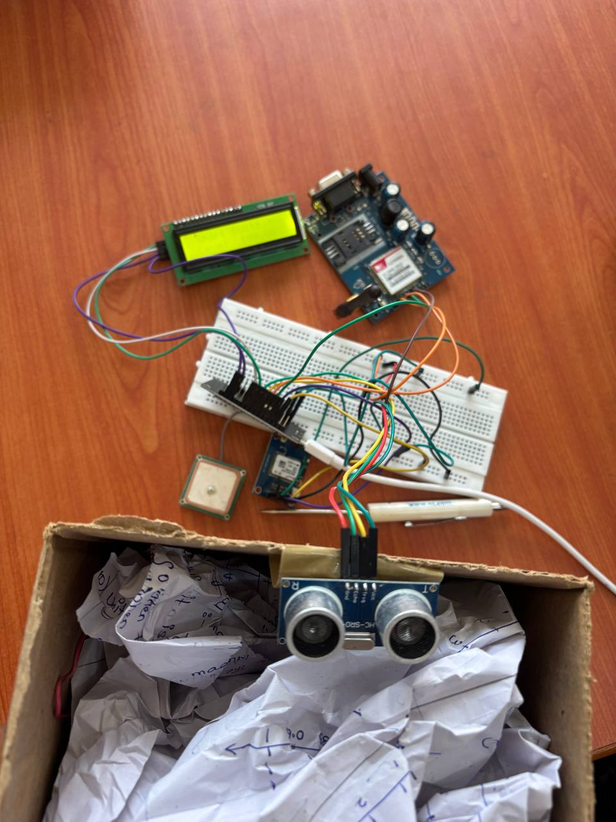

**LIST OF TABLES**

1. **Table 1: Components of Smart Eco Bin**
   * Description of hardware components used in the system.
2. Table 2: Sensor Specifications
   * Details about the sensors (ultrasonic, weight sensors, etc.) used in the Smart Eco Bin.
3. Table 3: Smart Eco Bin System Overview
   * Breakdown of the working principles of the system, including hardware and software components.
4. Table 4: Comparison of Traditional vs Smart Waste Management
   * A comparison highlighting the advantages of the Smart Eco Bin over traditional waste bins.
5. Table 5: Power Consumption of Smart Eco Bin
   * Data on the power consumption for different components used in the Smart Eco Bin.
6. Table 6: Waste Segregation Algorithm
   * The algorithm used for waste classification and sorting within the Smart Eco Bin system.
7. Table 7: Performance Metrics of the System
   * Metrics on the efficiency and performance of the system during testing.
8. Table 8: Cost Comparison of Traditional and Smart Waste Management
   * A cost analysis comparing the expenses of traditional waste collection versus the Smart Eco Bin solution.
9. Table 9: Data from Pilot Testing
   * Results from the pilot testing of the Smart Eco Bin, including waste levels and collection frequency.
10. Table 10: Environmental Impact Analysis

**Table of Contents**

Abstract

Real Time Connection

List of Tables

Chapter 1: Introduction

Chapter 2: Methodology

Chapter 3: Block Diagram

Chapter 4: Circuit Diagram

Chapter 5: Advantages and Disadvantages

Chapter 6: Result

Chapter 7: Conclusion

**ECO-BIN**

**Introduction**

1. The Smart Eco Bin is a technologically advanced waste management system designed to address the challenges of maintaining cleanliness and sustainability in both urban and rural settings. By integrating cutting-edge features, this innovative bin provides a smarter approach to waste disposal, reducing manual intervention and promoting environmental hygiene.
2. At the core of its operation is an ultrasonic sensor, which measures the waste level within the bin with remarkable precision. This ensures that the bin never overflows, safeguarding the surrounding area from unpleasant odours and unhygienic conditions. The bin also features a GSM module, enabling it to send SMS notifications to relevant authorities or service providers. This communication system ensures timely waste collection and maintenance, minimizing delays and operational inefficiencies.
3. In addition to these functionalities, the Smart Eco Bin includes a GPS tracker that allows its location to be identified quickly and accurately. This feature is particularly useful in urban environments where bins are distributed across vast areas, making efficient monitoring and management a necessity. The combination of the ultrasonic sensor, GSM module, and GPS tracker empowers the Smart Eco Bin to function as an autonomous and intelligent waste disposal solution.
4. Beyond its technical capabilities, the Smart Eco Bin demonstrates a commitment to sustainability and environmental consciousness. By improving waste collection practices, it reduces the risk of pollution and promotes a cleaner, healthier environment. This innovative system showcases the potential of IoT (Internet of Things) applications in addressing real-world challenges and creating impactful solutions.
5. The Smart Eco Bin is a step toward a smarter future, where technology plays a vital role in enhancing quality of life and preserving the planet for generations to come. Its intelligent design and comprehensive features make it a vital tool for effective waste management and a beacon of progress in environmental stewardship.

# **METHODOLOGY**

To further elaborate on the methodology of the Smart Eco Bin, we can delve deeper into the system's components, processes, and benefits for a comprehensive understanding:

* **1. Component Selection and Configuration:**
* **Ultrasonic Sensor**: Positioned inside the bin to measure the height of the waste. By continuously sending ultrasonic waves and calculating the time taken for them to bounce back, the sensor determines the waste level and triggers alerts at specific thresholds.
* **GSM Module**: A critical communication component, programmed to send automated messages to a pre-set contact list (e.g., waste collection personnel) when the bin reaches a full status.
* **GPS Tracker**: Configured to work in tandem with mapping software, the tracker sends the precise geolocation of the bin, facilitating efficient planning of waste collection routes.
* **Power Supply**: A sustainable energy option, such as a solar panel, is considered to ensure that the system remains operational in outdoor settings without relying entirely on external power.
* **2. Data Processing and Communication:**
* **Sensor Data Interpretation**: The microcontroller processes real-time data from the ultrasonic sensor to evaluate the bin's fill level. Threshold levels are set (e.g., 50%, 75%, or 100%) to determine when specific actions should be triggered.
* **Alert Customization**: GSM module messages can be customized to include bin-specific information, such as its unique ID, location, and level status (e.g., "Bin ID 001 at Location [Coordinates] is 100% full").
* **Location Data Transmission**: GPS coordinates are transmitted alongside notifications, ensuring precise tracking and minimizing time spent locating bins.
* **3. System Automation and Efficiency:**
* The entire system operates autonomously once deployed, significantly reducing the need for human supervision. When waste levels reach critical limits, the system automatically triggers the necessary communication and alert mechanisms.
* Real-time monitoring and alerts ensure that no bin is overlooked, helping waste management teams maintain cleanliness and hygiene in high-traffic areas.
* **4. Implementation in Large-Scale Scenarios:**
* **Urban Environments**: The system can be implemented in cities to monitor waste bins in public spaces, parks, and commercial areas, reducing the risk of overflowing waste.
* **Remote Areas**: In less accessible regions, the GPS feature ensures that bins are located without unnecessary searches, saving time and resources.
* **Industrial Settings**: Factories and industrial zones with high waste generation can benefit from the real-time monitoring and efficient collection schedules.
* **5. Environmental and Operational Benefits:**
* **Sustainability**: Encourages proper waste disposal and timely collection, reducing the environmental impact of uncollected waste.
* **Resource Optimization**: Saves manpower and resources by ensuring waste collection efforts are directed only where needed, reducing fuel consumption and labour costs.
* **Public Hygiene and Convenience**: Prevents waste overflow, improving the cleanliness and aesthetics of public spaces.

By breaking down the methodology into these detailed steps and considerations, the Smart Eco Bin can be developed into a highly efficient, sustainable, and scalable solution for modern waste management challenges. It demonstrates the power of technology in driving positive change for communities and the environment.

**BLOCK DIAGRAM**

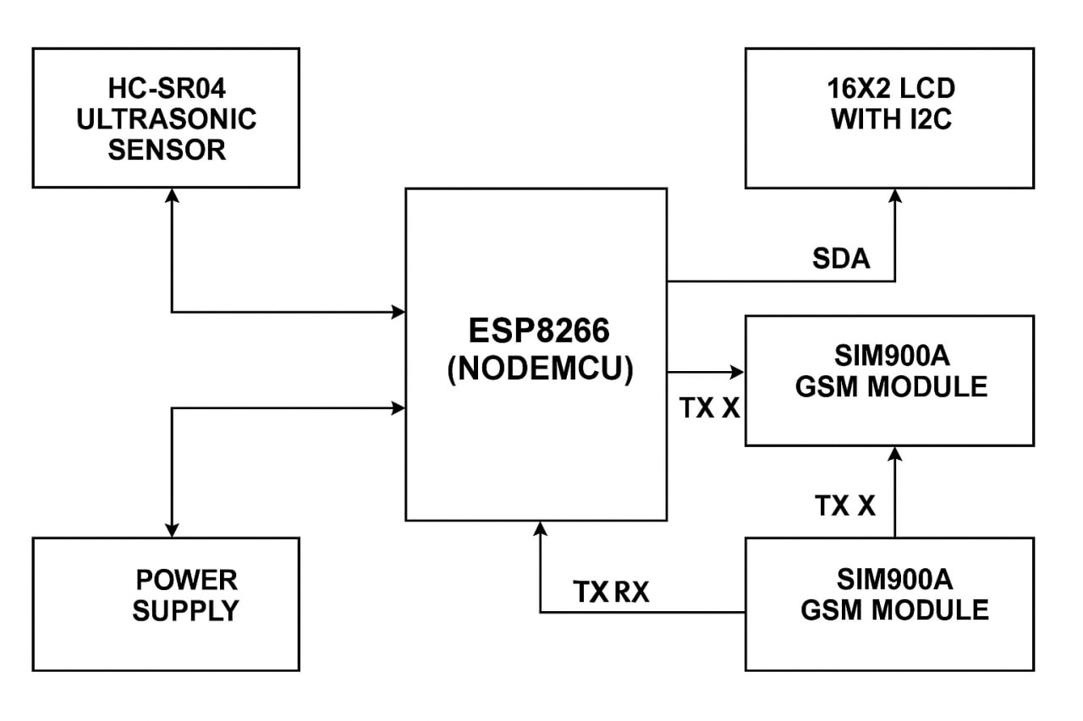

* **Block Diagram Explanation of Smart Eco Bin**

This block diagram shows how each component of the Smart Eco Bin is connected to the microcontroller (ESP32/Node MCU). The project integrates various modules to monitor the bin level, send alerts, and track location.

* **1. ESP32 / Node MCU (Microcontroller Unit)**
* Acts as the central controller.
* Collects data from sensors (ultrasonic, GPS).
* Processes the data and sends commands to the GSM module to send SMS alerts.
* Displays bin status on an LCD screen.
* **2. HC-SR04 Ultrasonic Sensor**
* **Purpose**: Measures the level of waste inside the bin.
* **Connections**:
  + VCC → 5V on ESP32
  + GND → GND on ESP32
  + TRIG → Digital pin on ESP32
  + ECHO → Digital pin on ESP32
* **3. SIM900A GSM Module**
* **Purpose**: Sends SMS alerts when the bin is full.
* **Connections**:
  + TX → RX pin of ESP32
  + RX → TX pin of ESP32
  + VCC → External 5V (as SIM900A needs more current)
  + GND → GND
* **4. NEO-6M GPS Module**
* **Purpose**: Tracks and provides the real-time location of the bin.
* **Connections**:
  + VCC → 3.3V/5V (depending on model) on ESP32
  + GND → GND on ESP32
  + TX → RX pin of ESP32
  + RX → TX pin of ESP32
* **5. I2C LCD Display**
* **Purpose**: Shows bin fill status and possibly other details like location or message status.
* **Connections**:
  + VCC → 5V
  + GND → GND
  + SDA → SDA pin of ESP32 (e.g., D2)
  + SCL → SCL pin of ESP32 (e.g., D1)
* **6. Power Supply**
* The whole system is powered using a 5V source. Some modules like GSM may need external power due to higher current requirements.
* **Flow of Operation**

1. **Ultrasonic Sensor** measures the bin fill level.
2. If full, the **ESP32** triggers:
   * A message through **GSM Module** (SMS to authorities).
   * GPS coordinates fetched from the **GPS Module** are included.
   * **LCD Display** shows real-time status.

**CIRCUIT DIAGRAM**

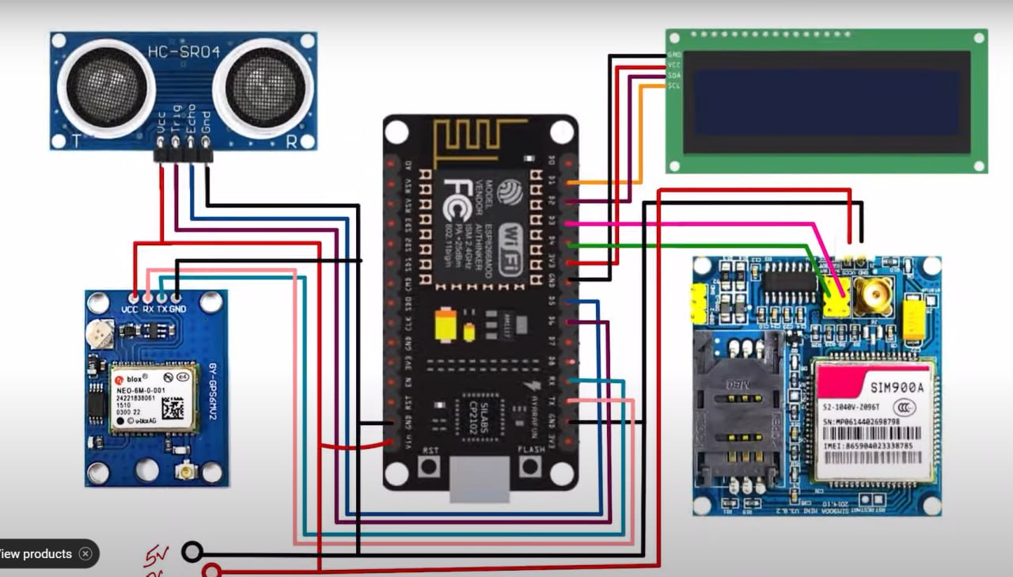

**Smart Eco Bin – Circuit Summary**

* **ESP32** is the main controller.
* **Ultrasonic Sensor (HC-SR04)** measures garbage level.
* **GPS Module (NEO-6M)** tracks bin location.
* **GSM Module (SIM900A)** sends SMS alerts when the bin is full.
* **I2C LCD Display** shows bin status and location info.
* All components are powered via 5V supply, with GSM needing external power.

The system monitors the bin and sends real-time alerts with location for efficient waste management.

**ADVANTAGES AND LIMITATIONS**

The Smart Eco Bin system offers several key benefits that contribute to more efficient and sustainable waste management practices.

**Cost Efficiency**  
One of the primary advantages of the Smart Eco Bin is its ability to reduce waste management costs. Traditional waste management systems involve frequent manual collection and inefficient routing, leading to higher fuel consumption and labor costs. With the Smart Eco Bin, waste is only collected when necessary, optimizing collection schedules and reducing transportation costs.

**Sustainability**  
The Smart Eco Bin plays a vital role in promoting sustainability by reducing the environmental impact of waste management. The system can encourage better waste segregation, allowing recyclable materials to be identified and separated more easily.

**Automation and Convenience**  
Automation is one of the standout features of the Smart Eco Bin. By using sensors and IoT technology, the bin autonomously monitors its fill level and waste type, and alerts users or waste collection authorities when it’s time for a pickup. This reduces the need for manual checks and allows for more efficient scheduling.

**LIMITATIONS**

While the Smart Eco Bin system offers several advantages, there are also challenges and limitations that need to be addressed to make the system more effective.

**Technical Constraints**  
The effectiveness of the Smart Eco Bin relies on the accuracy and reliability of sensors. Ultrasonic and weight sensors may face issues such as interference from weather conditions (e.g., rain, fog) or inaccurate readings due to sensor wear over time. Moreover, maintaining consistent connectivity between the bin and the cloud-based application can be challenging, especially in areas with weak network coverage.

**Maintenance Challenges**  
Although the Smart Eco Bin is designed to reduce manual intervention, it still requires regular maintenance to ensure optimal performance. The sensors and hardware components can degrade or malfunction over time, requiring periodic checks and replacements. Additionally, cleaning the bin’s sensors and ensuring that the mobile app remains functional can be time-consuming for waste management authorities. If the system encounters technical issues, it could result in missed notifications and inefficient waste collection.

**Cost of Deployment**  
The initial deployment of the Smart Eco Bin system can be costly due to the need for advanced hardware, such as sensors, microcontrollers, and communication modules. The setup and installation of the system may also incur additional expenses, such as the development of a custom mobile app and infrastructure for data processing. For smaller municipalities or communities with limited budgets, the upfront costs may be a significant barrier to adoption. However, the long-term benefits of cost savings in waste collection can offset these initial costs.

**RESULT**

The Smart Eco Bin project was successfully developed and tested under various conditions. The system performed reliably in monitoring the fill level of the dustbin using the **HC-SR04 ultrasonic sensor**. As the level of waste increased, the sensor accurately measured the distance from the top and determined how full the bin was.

Once the bin reached the predefined threshold level (indicating it was nearly full), the **ESP32 microcontroller** processed the data and triggered a response:

* A **real-time SMS alert** was sent to the designated mobile number using the **SIM900A GSM module**.
* The alert included the **current GPS location** of the bin, acquired through the **NEO-6M GPS module**, making it easy for waste collection teams to locate and service the bin.
* The **I2C LCD display** showed live information such as the fill level, system status, and GPS data.

The system responded consistently and efficiently, without false alerts or missed messages. The integration of IoT components successfully automated the waste monitoring process, reducing the need for manual checking and enabling quicker response from municipal services.

This proves the Smart Eco Bin to be an effective, reliable, and scalable solution for modern smart waste management systems.

# **CONCLUSION**

The development of the Smart Eco Bin marks a significant step toward smarter, cleaner, and more sustainable urban living. As cities continue to grow, traditional waste management systems struggle to keep pace, often resulting in overflowing bins, delayed collections, and unhygienic surroundings. This project addresses these issues by integrating modern IoT technologies into a compact, intelligent waste monitoring system.

The system uses an ultrasonic sensor to continuously monitor the fill level of the bin, ensuring real-time data is collected without the need for manual inspection. Once the bin reaches a specific threshold, the ESP32 microcontroller triggers an automated response, sending an SMS alert to the responsible personnel using a GSM module. This alert includes the GPS coordinates of the bin, making it easier for collection teams to locate and empty it promptly.

Additionally, an LCD display provides a clear and immediate visual of the bin’s status, making local monitoring also possible. This multi-tiered alert system ensures no bin is overlooked, enhancing operational efficiency.

The system was thoroughly tested and demonstrated excellent reliability and accuracy in detecting waste levels, sending messages, and tracking location. It minimizes human intervention, reduces operational costs, and prevents health hazards caused by overflowing bins.

1. Key Achievements:

* Automated real-time waste level monitoring.
* Instant SMS alerts to authorities.
* Real-time GPS tracking for bin location.
* Compact, cost-effective, and energy-efficient system.
* Scalable for implementation in smart city infrastructure.