Internship and Placement Trends Analysis

# Abstract

Internships and placements have become integral to higher education and career development. With industries demanding practical exposure and institutions striving to enhance employability, internship and placement trends play a crucial role in shaping student careers. This report analyzes the evolving patterns, significance, benefits, challenges, and future directions of internships and placements. It highlights how industries are adapting to digital transformations, how institutions are aligning with corporate expectations, and how students are preparing for dynamic career opportunities.

# Introduction

Education without practical exposure is often incomplete. Today, employers seek graduates who are not only knowledgeable in theory but also skilled in applying knowledge to real-world problems. This has made internships and placements central to a student’s academic journey.  
  
-> Internships provide students with short-term industry exposure, allowing them to apply their learning in real-life projects.  
- >Placements are long-term employment opportunities offered to students through institutional support.  
  
The analysis of internship and placement trends helps understand how opportunities are evolving across industries, how students are preparing themselves, and how organizations are revising recruitment strategies.

# Objectives of the Study

1. To study the importance of internships and placements in higher education.  
2. To analyze recent trends in internship and placement processes.  
3. To identify the challenges faced by students, institutions, and employers.  
4. To evaluate the role of placement cells in bridging the industry-academia gap.  
5. To highlight future directions for improving internship and placement outcomes.

# Methodology

The analysis in this report is based on:  
-> Review of institutional placement records from recent years.  
- >Secondary data from industry reports and online surveys.  
- >Observations of student internship experiences.  
- >Discussions with placement coordinators and HR professionals.  
  
This descriptive approach provides a holistic view of internship and placement trends across different sectors.

# Analysis of Internship Trends

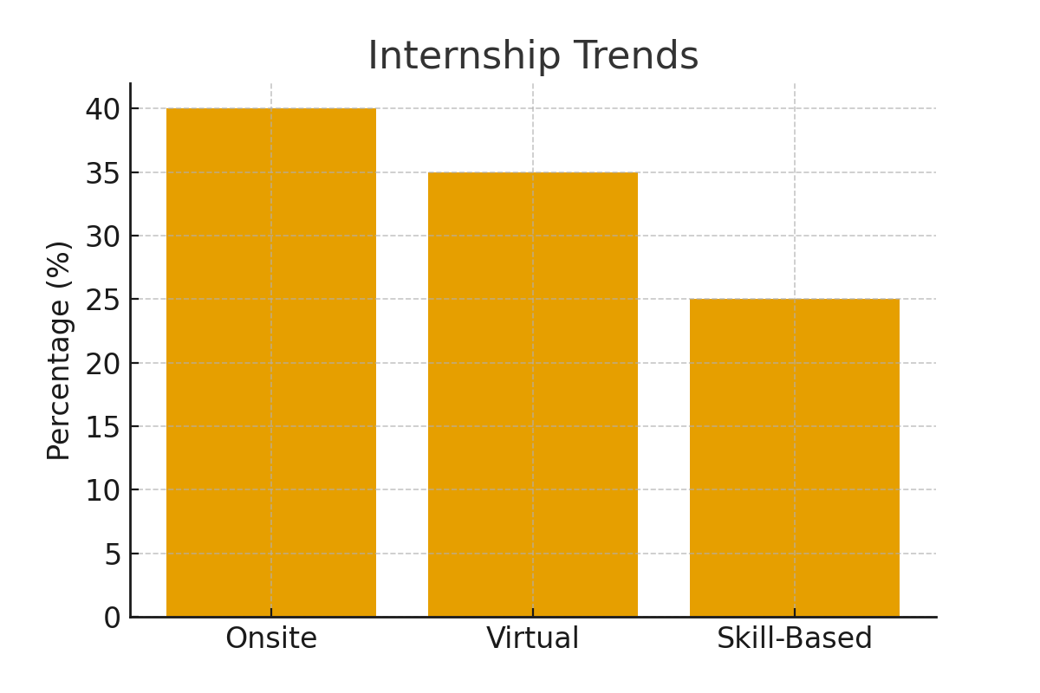

Figure 1: Internship distribution showing growth of virtual and skill-based internships.

Internships are no longer just an optional activity but a mandatory requirement in most academic programs. The following patterns are observed:  
  
1. Rising Demand for Internships – Students now prefer multiple internships across their study years to gain diverse exposure. Summer internships remain the most popular, but winter and virtual internships are also growing.  
  
2. Shift Towards Virtual Internships – Post-pandemic, online internships have become mainstream. They offer flexibility, cost savings, and global exposure, though sometimes lack real workplace interaction.  
  
3. Skill-Based Internships – Companies focus on digital skills such as data analytics, programming, artificial intelligence, and digital marketing. Soft skills like communication, leadership, and teamwork remain equally important.  
  
4. Pre-Placement Offers (PPOs) – High-performing interns are offered PPOs, reducing the uncertainty of final placements. PPOs benefit both students and companies by ensuring early hiring.

# Analysis of Placement Trends

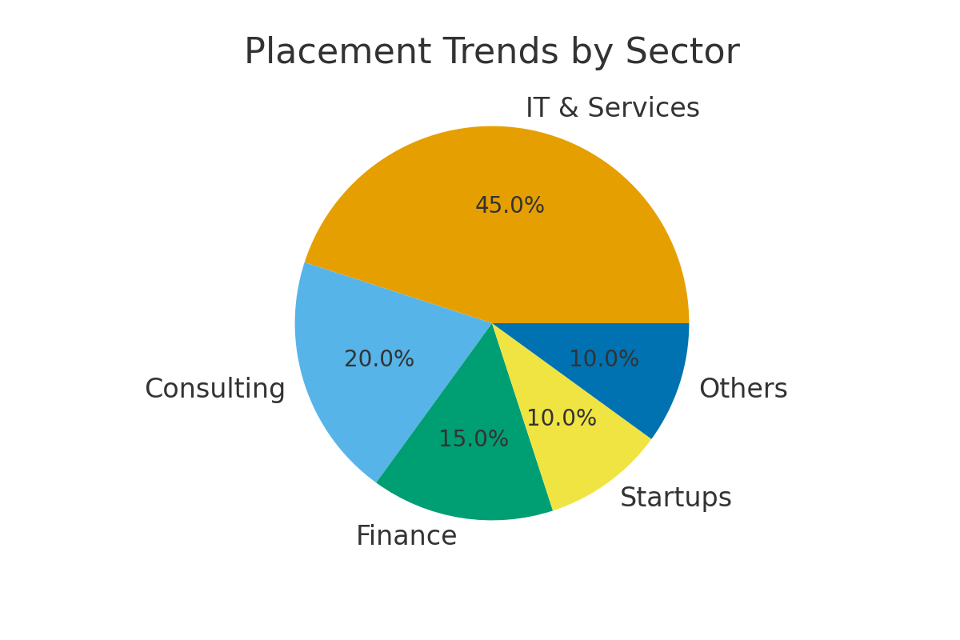

Figure 2: Sector-wise placement opportunities highlighting dominance of IT & Services.

Campus placements mark the culmination of a student’s academic journey. The following trends are notable:  
  
1. Increased Campus Hiring by IT and Service Sectors Information technology, consulting, and finance companies dominate campus recruitment. Startups are also emerging as major recruiters offering innovative roles.  
  
2. Skill-Based Hiring over Grades Employers now prioritize problem-solving ability, technical skills, and practical knowledge rather than just academic scores. Hackathons, coding competitions, and case-study evaluations are common recruitment methods.  
  
3. Global Placement Opportunities Many multinational companies provide overseas job offers, giving students international exposure.  
  
4. Rise of Tier-2 and Tier-3 College Placements With digital hiring platforms, companies are reaching beyond premier institutions to tap into diverse talent pools.

# Findings

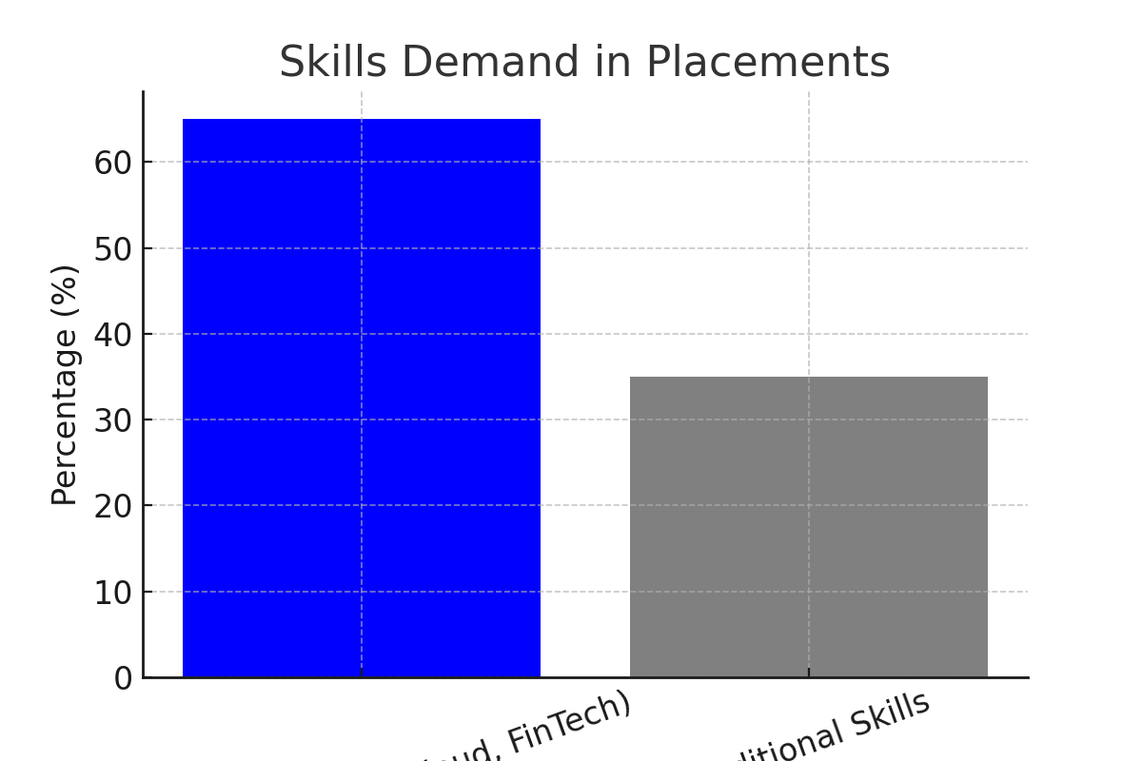

Figure 3: Comparison of digital vs traditional skill demand in placements.

The analysis indicates the following key findings:  
  
1. Internships enhance employability: Students with internship experience are more confident and secure better placements.  
2. Placements are shifting towards digital skills: Roles in AI, machine learning, cloud computing, and fintech are in high demand.  
3. Soft skills are equally important: Students with strong communication, adaptability, and teamwork skills perform better in interviews.  
4. Hybrid models are here to stay: Virtual internships and online interview processes will continue alongside traditional models.  
5. Institutional support is critical: A strong placement cell with industry ties significantly improves student outcomes.

# Challenges

Despite the positive trends, several challenges remain:  
  
- Skill Gap: Many students lack the technical and soft skills required by industries.  
- Unpaid Internships: Some organizations offer unpaid internships, limiting opportunities for students from weaker financial backgrounds.  
- High Competition: Limited opportunities in top companies create intense competition.  
- Geographic Barriers: Students from smaller towns or rural areas face fewer opportunities compared to urban students.  
- Economic Uncertainty: Global recessions or industry slowdowns impact hiring numbers.

# Role of Placement Cells

Placement cells in colleges act as mediators between students and organizations. Their responsibilities include:  
  
- >Organizing workshops on resume building, aptitude training, and mock interviews.  
- >Establishing strong industry linkages to bring reputed companies for recruitment.  
- >Guiding students on career choices, industry trends, and emerging opportunities.  
- >Coordinating placement drives, internship fairs, and pre-placement talks.  
- >Collecting feedback from recruiters and students for continuous improvement.

# Future Trends in Internships and Placements

Looking ahead, several future directions can be identified:  
  
1. Integration of AI in Recruitment – Companies will use AI-driven tools for resume screening, video interviews, and skill assessments.  
2. Focus on Lifelong Learning – Students will need continuous upskilling through certifications, MOOCs, and online platforms.  
3. Expansion of Startups and Entrepreneurial Roles – Internships with startups will grow, offering hands-on innovation-driven experiences.  
4. Sustainability and Green Jobs – Careers in renewable energy, environment management, and sustainable technologies will become popular.  
5. Global Internships – More students will pursue international internships, supported by remote collaboration technologies.

# Conclusion

Internships and placements are no longer supplementary but essential components of higher education. They help students transition smoothly into the workforce, build confidence, and develop practical skills. Institutions, students, and companies together shape the ecosystem of career development.  
  
This analysis reveals that internships significantly improve employability and that placement patterns are shifting towards digital skills, soft skills, and global opportunities. Challenges such as skill gaps and economic uncertainties remain, but proactive strategies by institutions and students can overcome them.  
  
With the rise of virtual platforms, international opportunities, and startup-driven roles, internships and placements will continue to evolve. For students, the key to success lies in continuous learning, adaptability, and seizing every opportunity to apply knowledge in real-world contexts.

# References & Further Reading

1. Andrews, J., & Higson, H. (2008). Graduate Employability, 'Soft Skills' Versus 'Hard' Business Knowledge: A European Study. Higher Education in Europe.

2. Yorke, M. (2006). Employability in Higher Education: What It Is – What It Is Not. Higher Education Academy.

3. NASSCOM Reports on Future Skills (https://nasscom.in/knowledge-center/publications)

4. Deloitte Insights: Future of Work (https://www2.deloitte.com/insights)

5. Allen, J., & van der Velden, R. (2011). The Flexible Professional in the Knowledge Society. Springer.

2310030415-Bairi Sravya Goud

2310030222-Allu Sahithi Reddy

2310030327-Gundla Aashritha

2310030284-Rangu Sowmya

2310039457-Jakkula Hasini