# HOME WORK #6

# 7357-ANALYTICS FOR DECISION SUPPORT

**Answer a(i)**   
We have 59 Facebook users in our dataset.

**Answer a(ii)**

Now, for each group of users, we have 2 friends on single edge, thus total friends would be

146*2 = 292

Average number of friends per user would be given by = (total friends/total users)

* 292/59
* 4.95

**Answer a(iii)**   
After selecting valid entries dataset as 'Users.School'.   
We get,

A B

0 19

Thus, the most common locale out of the students who listed a school is 'Locale B'.

**Answer(iv)**

|  |  |  |  |
| --- | --- | --- | --- |
|  |  | A | AB |
|  | 1 | 1 | 0 |
| A | 11 | 3 | 1 |
| B | 28 | 13 | 1 |

No, neither of school A nor B is all-boys or all-girls school.

As we see (from last column named as AB), both genders have attended both the schools (A & B).

**Answer b(i)**

From the generated graph, we can see that we have 4 connected components each having at least 2 nodes.

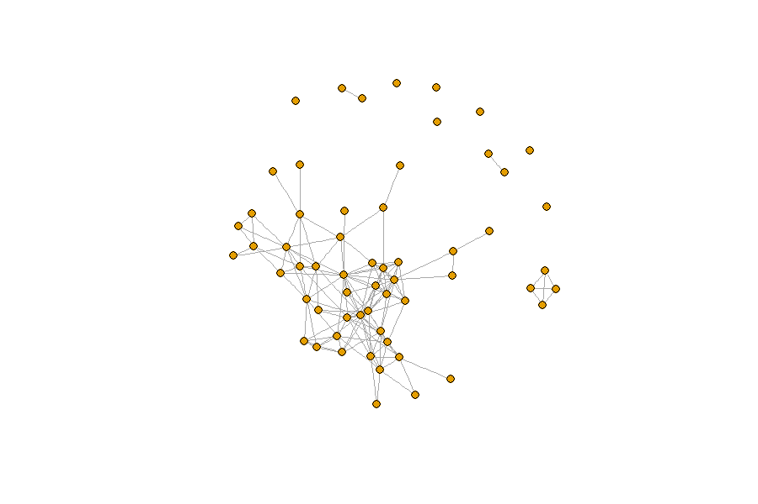

First connected component is the largest with multiple nodes (44 nodes), two of them have 2 nodes each, and the last one is having 4 nodes.

**Answer b(ii)**

From the graph generated in the previous part, we can see that 7 nodes are not connected any other nodes. Hence, 7 users in the netwrok have no friends.

**Answer b(iii)**

table(degree(g)) 🡪 Gives number of nodes (users, 2nd row) having numberof friends (degree, in 1st row).

Degree: 0 1 2 3 4 5 6 7 8 9 10 11 13 17 18

Nodes: 7 10 4 9 1 4 4 3 6 2 4 1 2 1 1

table(degree(g) >= 10)

Output

FALSE TRUE

50 9

#Thus, 9 users are friends with 10 or more other users in the network.

**Answer c(i)**

After generating the new graph, we can see that majority of users in the network are of gender 'B'.

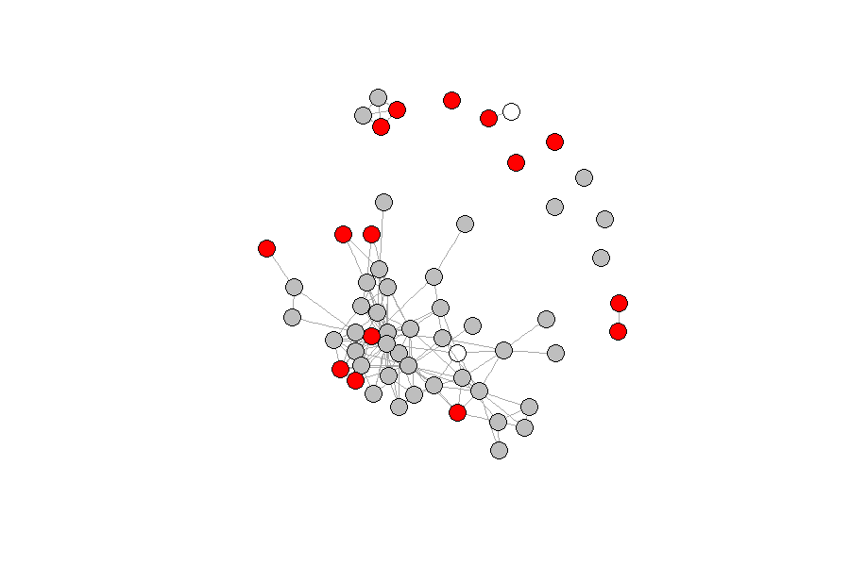

Additionally, 2 people didn't define their gender. Also, we don't see any connection between users to be friends with each other based on gender. We can see connection of same color nodes (same gender) as well as connections between different color nodes (different genders).

**Answer c(ii)**

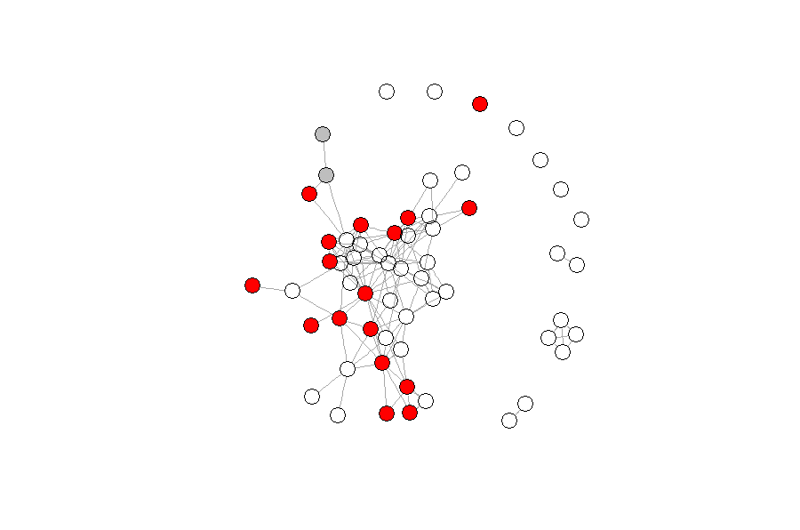  
We can see from the generated graph that there are only 2 students who attended both the schools A & B, (grey color nodes) are Facebook friends with each other.

**Answer c(iii)**

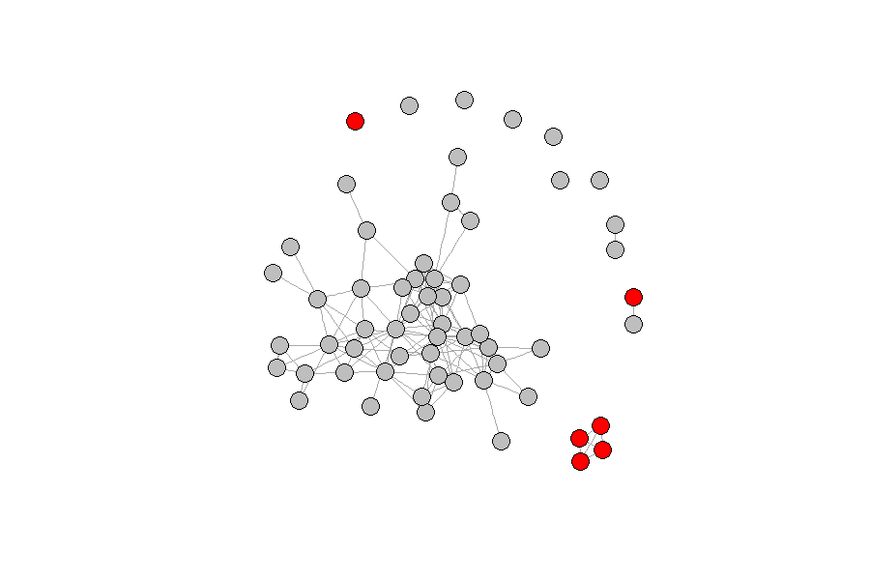

We can see from the generated graph that there exist a connection between the users (nodes) being Facebook friends based on Location. In general, same color nodes are connected. Out of 4 connected components, we see that the largely connected component has users from Locale 'B' and 4 node connected component has all users from Locale 'A'.