**SCRUM WORKFLOW**

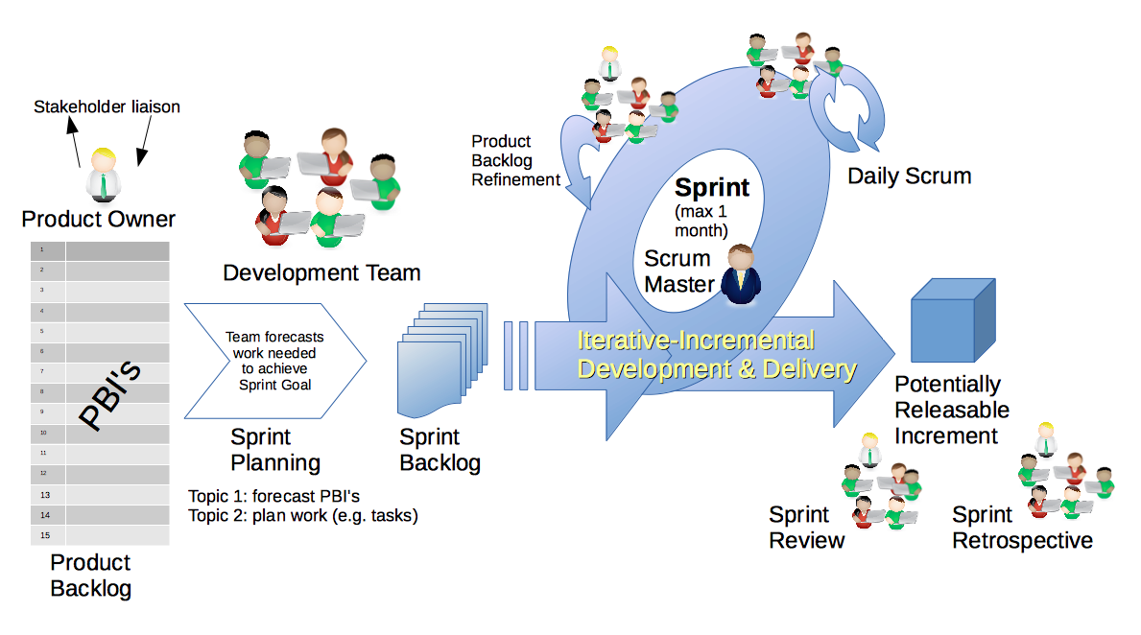

**1. User Stories:**

- User stories are essential in Scrum, representing specific features or functionality from the user’s perspective.

- A user story typically follows the format: “As a [user], I want [feature] so that [benefit].”

- These stories guide development efforts and prioritize work based on customer value .

**2. Product Backlog:**

- The product backlog is an ordered list of features, enhancements, and bug fixes needed to improve the product.

- It serves as the single source of truth for work undertaken by the Scrum Team.

- Product backlog items that can be completed within one sprint are ready for selection during sprint planning .

**3. Sprint Planning:**

- Sprint planning initiates the sprint by defining the work to be performed.

- The Scrum Team collaboratively selects items from the product backlog for the current sprint.

- They estimate effort, break down tasks, and create a sprint backlog.

**4. Sprint Backlog:**

- The sprint backlog consists of:

- The sprint goal (why).

- The set of product backlog items selected for the sprint (what).

- An actionable plan for delivering them (how).

- It’s a real-time picture of the work the Developers plan to accomplish during the sprint .

**5. Daily Standup (Daily Scrum):**

- The daily standup (or daily scrum) is a 15-minute event held each day during the sprint.

- Developers synchronize their work, discuss progress, and plan the day.

- It focuses on progress toward the sprint goal and produces an actionable plan for the next day .

**6. Product Development:**

- The team works on the selected user stories and tasks.

- They collaborate, code, test, and integrate changes to create the anticipated increment.

- The sprint review ensures that the increment meets the Definition of Done .

**7. Sprint Review:**

- At the end of the sprint, the team demonstrates the completed work to stakeholders.

- Feedback is gathered, and adjustments may be made based on stakeholder input.

- The sprint review supports empiricism and ensures value delivery .

**8. Retrospective:**

- The retrospective is a meeting where the team reflects on the sprint.

- They discuss what went well, what could be improved, and actionable steps for the next sprint.

- It’s a key inspect-and-adapt meeting to enhance team performance .

**SCRUMS ROLES**

**1. Product Owner:**

* The Product Owner is a crucial role in Scrum, primarily accountable for maximizing the value of the product resulting from the Scrum Team’s work.
* **Responsibilities include:**
  + Defining and communicating the Product Goal.
  + Creating and prioritizing Product Backlog Items.
  + Ensuring transparency and understanding of the Product Backlog.
  + Making decisions about the product based on stakeholder needs and feedback.

**2. Scrum Master:**

* The Scrum Master is responsible for establishing Scrum practices within the team and organization.
* **Their multifaceted role includes:**
  + Coaching the team in self-management and cross-functionality.
  + Facilitating Scrum events (such as Sprint Planning, Daily Standup, and Retrospective).
  + Removing impediments to the team’s progress.
  + Ensuring Scrum events are positive and productive.
  + Leading, training, and coaching the organization in Scrum adoption.

**3. Development Team:**

* The Development Team consists of professionals who create the product.
* **Key points about the Development Team:**
  + It is self-organized and cross-functional.
  + Members collaborate to deliver a potentially releasable Increment of the product every Sprint.
  + Skills can vary widely, including computer engineers, designers, writers, and data analysts.

**4. Q/A Testing Team:**

* While not explicitly part of the core Scrum roles, quality assurance (Q/A) testing is essential.
* **Q/A testers ensure:**
  + The product meets quality standards.
  + Adheres to requirements.
  + Functions as expected.
* They collaborate closely with the Development Team and Product Owner to validate the Increment.

