INR–USD Exchange Rate Trend Analysis
and India–United States Economic Comparison
COMP-670 | Python-Based Trend Analysis and Prediction
Historical period: August 1947–August 2024 | Forecast: September 2026–August 2050
Student: Sravya Jasti

Abstract
This project examines the historical movement of the Indian rupee against the US dollar, reviews major events associated with rupee devaluation and depreciation, develops a statistical forecast for September 2026–August 2050, and compares selected economic indicators for India and the United States. Python, pandas, NumPy, Matplotlib and statsmodels were used for data preparation, visualization and time-series modelling. The monthly exchange-rate dataset contains 620 observations from January 1973 to August 2024, supplemented by separately compiled historical observations for the earlier period. The selected seasonal ARIMA model achieved the lowest reported holdout errors among the tested methods (MAE 2.188, RMSE 2.823, MAPE 2.94%). Its point forecast rises from about ₹87.07 per USD in September 2026 to ₹122.14 per USD in August 2050. This is a statistical baseline, not a guaranteed prediction.

1. Introduction and Objectives
The exchange rate is expressed as INR per USD: an increase means that more rupees are required to buy one US dollar, indicating rupee depreciation. The project objectives are to study the historical trend, connect major movements with economic events, forecast the requested future period, and compare India and the United States across monetary stability, billionaire counts and happiness.

2. Data and Methodology
The project uses two historical segments rather than presenting them as one homogeneous monthly series: separately compiled historical observations for 1947–1971 and monthly FRED observations from January 1973 through August 2024. The transition around 1971–1972 is treated separately because the source periods differ in frequency and construction. The monthly dataset contains 620 observations.
Annual depreciation is calculated from calendar-year average exchange rates: (current annual average / previous annual average − 1) × 100. This measures the change between annual averages, not a one-day official devaluation. Other comparison datasets include World Bank CPI inflation (2000–2024), RBI repo-rate effective-date observations, FRED monthly Federal Funds Rate, Forbes billionaire counts, and World Happiness Report rankings.

3. Historical INR/USD Trend and Major Events
The long-run series shows an increase in INR per USD over time. This reflects interacting factors including inflation differentials, external balances, capital flows, productivity, policy regimes and global shocks. No single event explains every annual movement.
Period | Event and relevance
1949 | Rupee devaluation recorded in the RBI historical account.
1966 | The Government of India records a 36.5% devaluation; the quoted dollar rate moved from ₹4.75 to ₹7.50. Reserve pressures, droughts and wars formed part of the difficult economic setting.
1975 | India moved away from the earlier sterling link toward a basket-of-currencies arrangement.
1991 | A balance-of-payments crisis led to a two-step downward exchange-rate adjustment of roughly 18–19% in July.
1992–1993 | LERMS introduced a dual exchange-rate system in March 1992; a unified market-determined exchange rate took effect on 1 March 1993.
2008–2009 | The global financial crisis and associated capital-flow changes affected emerging-market currencies, including the rupee.
2013 | US Federal Reserve tapering concerns contributed to global portfolio-flow pressure and rupee weakness.
The largest annual-average depreciation in the project's 1973–2024 dataset occurred in 1991 (29.81%), followed by 1992 (23.83%), 1989 (16.57%), 2012 (14.47%) and 1998 (13.65%). Other top-ten years were 1984 (12.36%), 2009 (11.31%), 1993 (11.10%), 1981 (10.07%) and 2013 (9.68%). These figures are annual-average changes, not exact one-time devaluation rates.
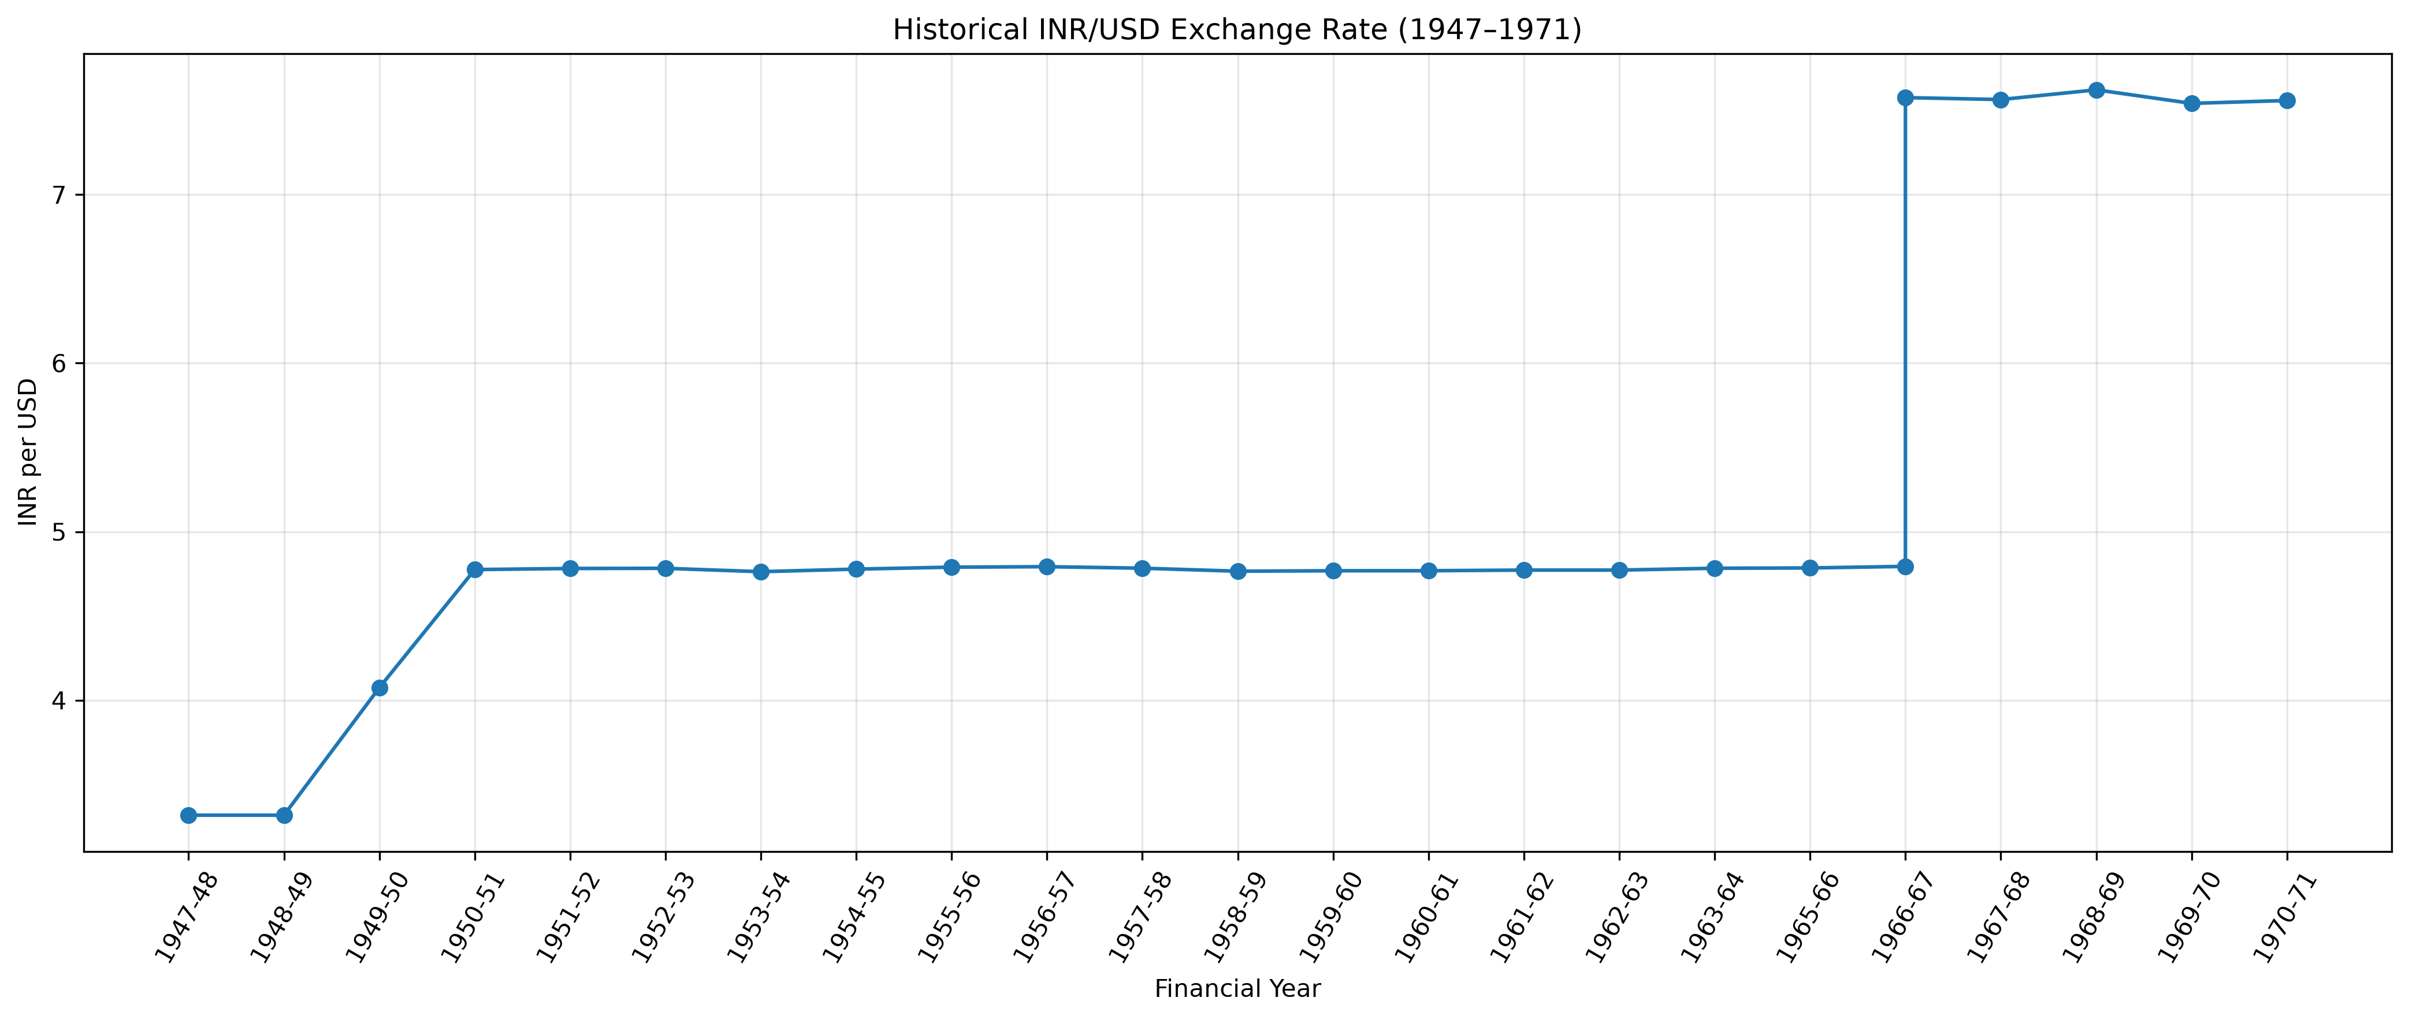
Figure 1. Historical INR/USD exchange-rate observations, 1947–1971.
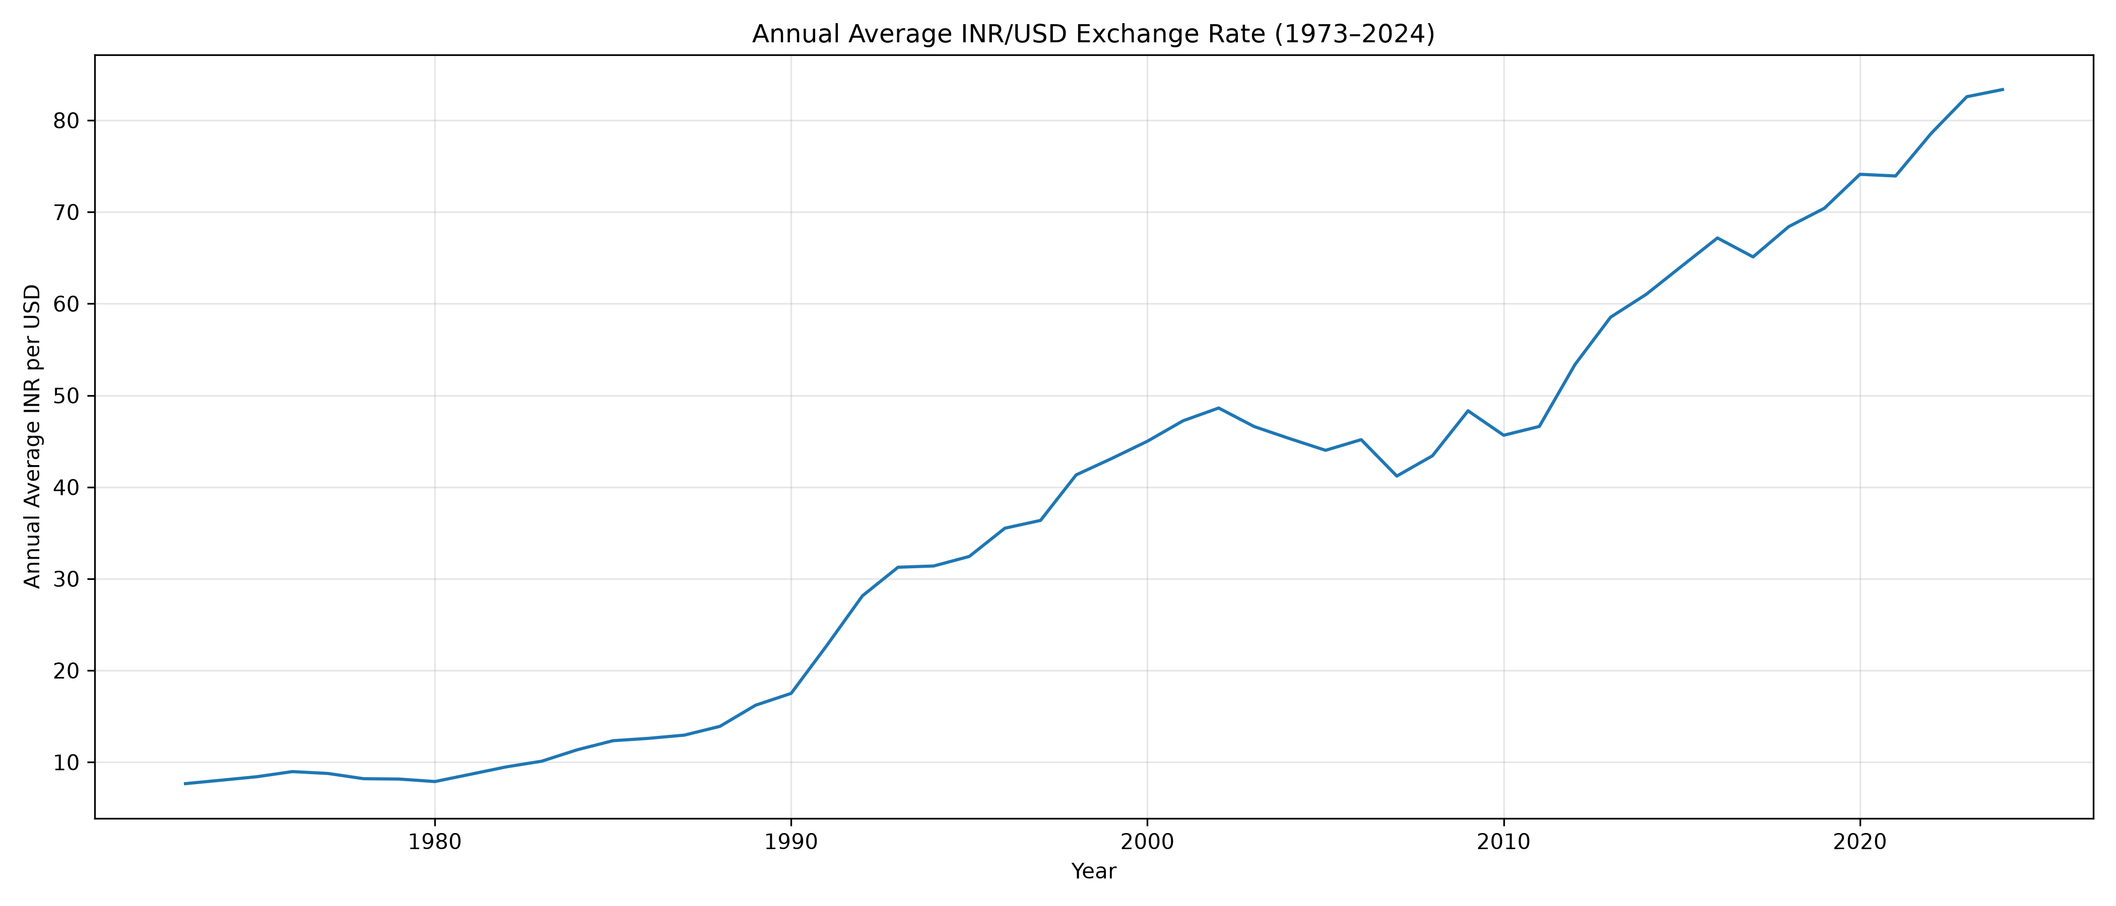
Figure 2. Annual average INR/USD exchange rate.
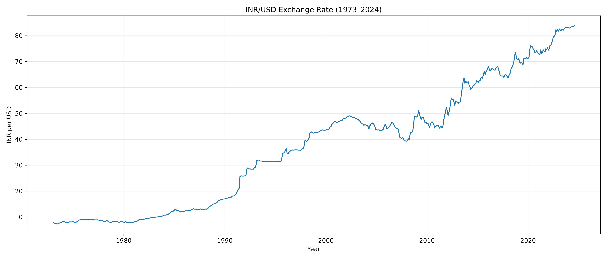
Figure 3. Monthly INR/USD exchange-rate movement, 1973–2024.
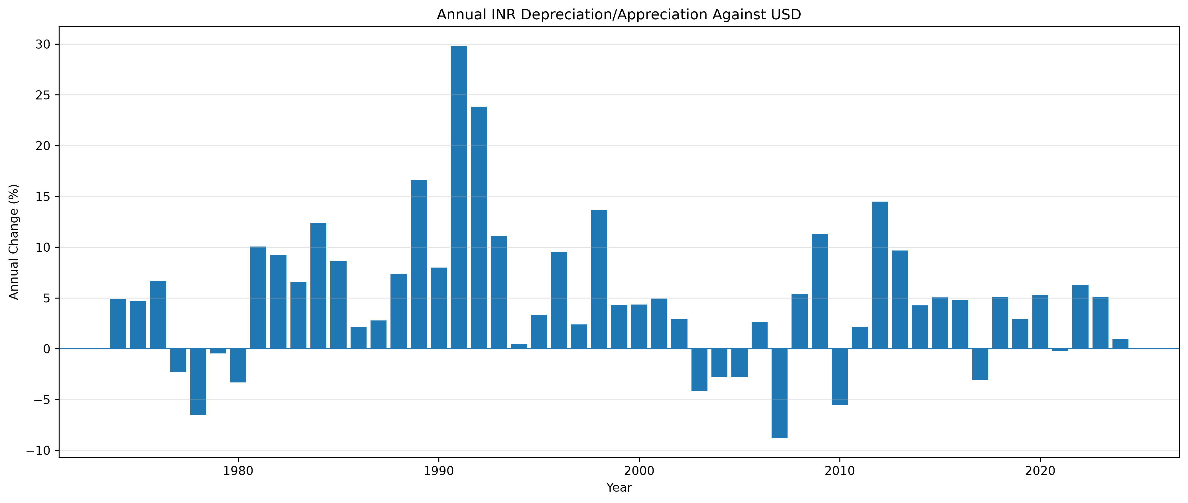
Figure 4. Annual percentage change in INR/USD.
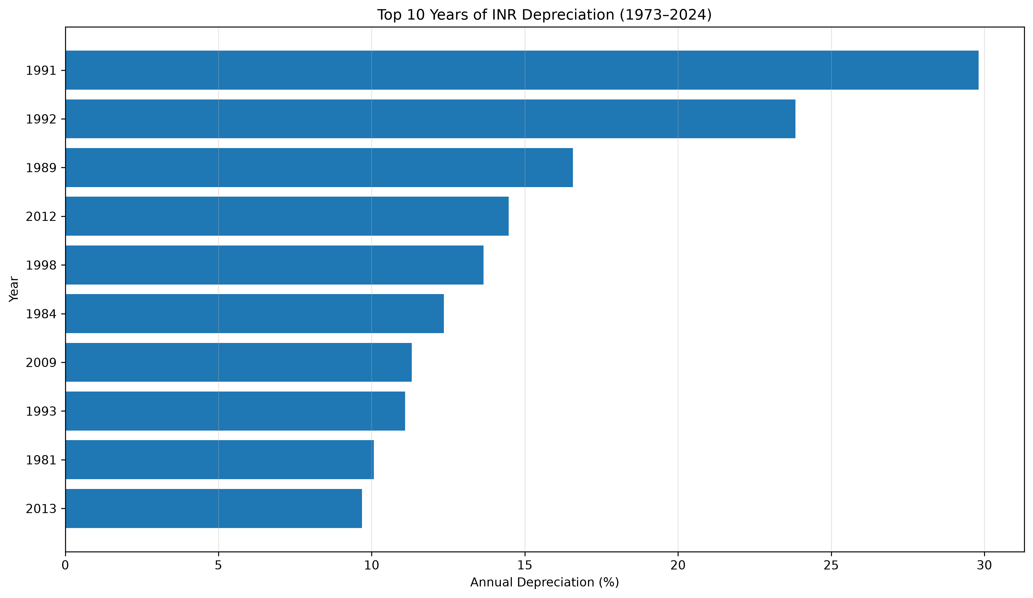
Figure 5. Ten years with the largest annual-average INR depreciation.

4. Forecasting Methodology and Model Evaluation
The monthly dataset was split chronologically: 496 training observations (January 1973–April 2014) and 124 test observations (May 2014–August 2024). Reported model results are:
Model | MAE | RMSE | MAPE
ARIMA(1,1,1) | 11.389 | 13.342 | 15.11%
Holt damped additive | 12.508 | 14.348 | 16.67%
Log-linear regression | 31.298 | 33.266 | 42.71%
ARIMA(2,1,2) | 11.684 | 13.609 | 15.52%
SARIMA(1,1,1)(1,1,1,12) | 2.188 | 2.823 | 2.94%
SARIMA had the lowest reported holdout errors. A separate validation result reported MAE 2.112, RMSE 2.152 and MAPE 2.55%; however, its validation window overlaps the original test period, so it is not independent validation.
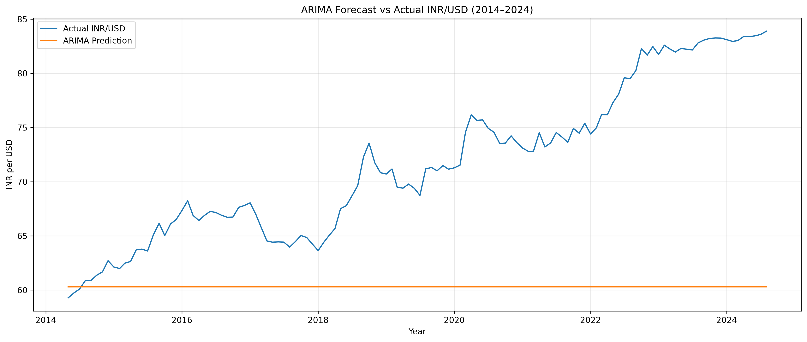
Figure 6. ARIMA actual versus predicted values.
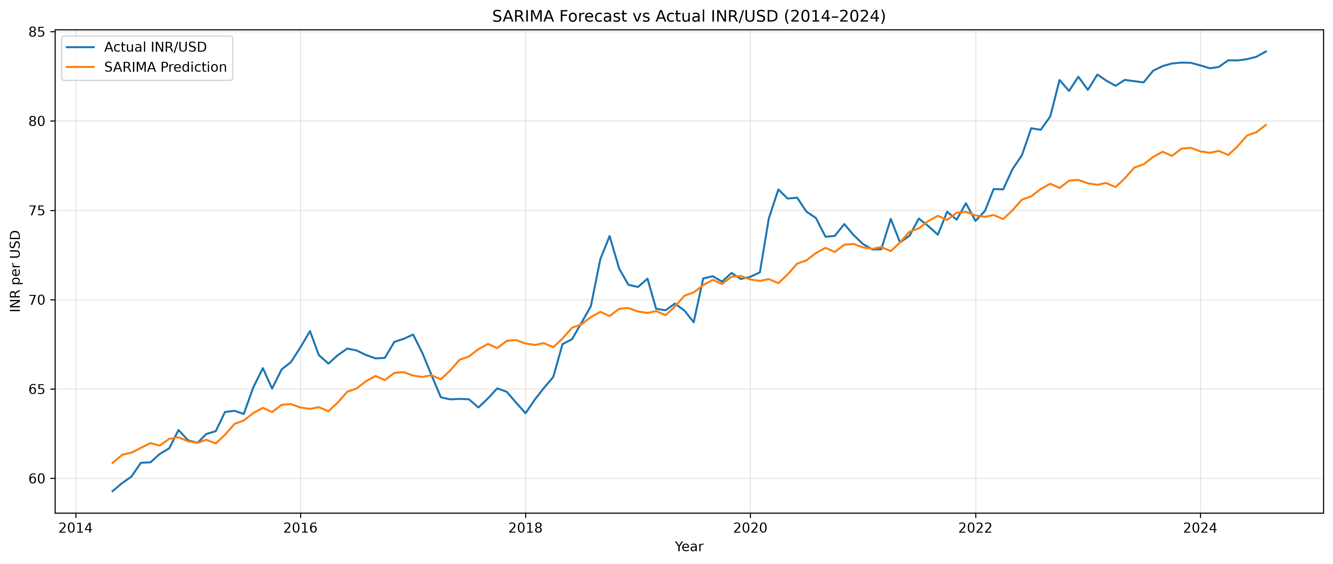
Figure 7. SARIMA actual versus predicted values.

5. Forecast: September 2026–August 2050
The selected SARIMA model was fitted through August 2024 and forecast 312 months through August 2050. The requested 288-month interval begins at approximately ₹87.07 per USD in September 2026 and reaches ₹122.14 per USD in August 2050. The reported 95% interval widens from ₹79.21–₹94.93 in September 2026 to ₹88.60–₹155.67 in August 2050.
The forecast indicates a gradual long-term increase in INR per USD, but uncertainty expands substantially over 24 years. The univariate model does not explicitly incorporate future inflation differentials, policy decisions, productivity, trade balances, oil prices, geopolitical events or capital flows. It should be interpreted as a baseline statistical scenario.
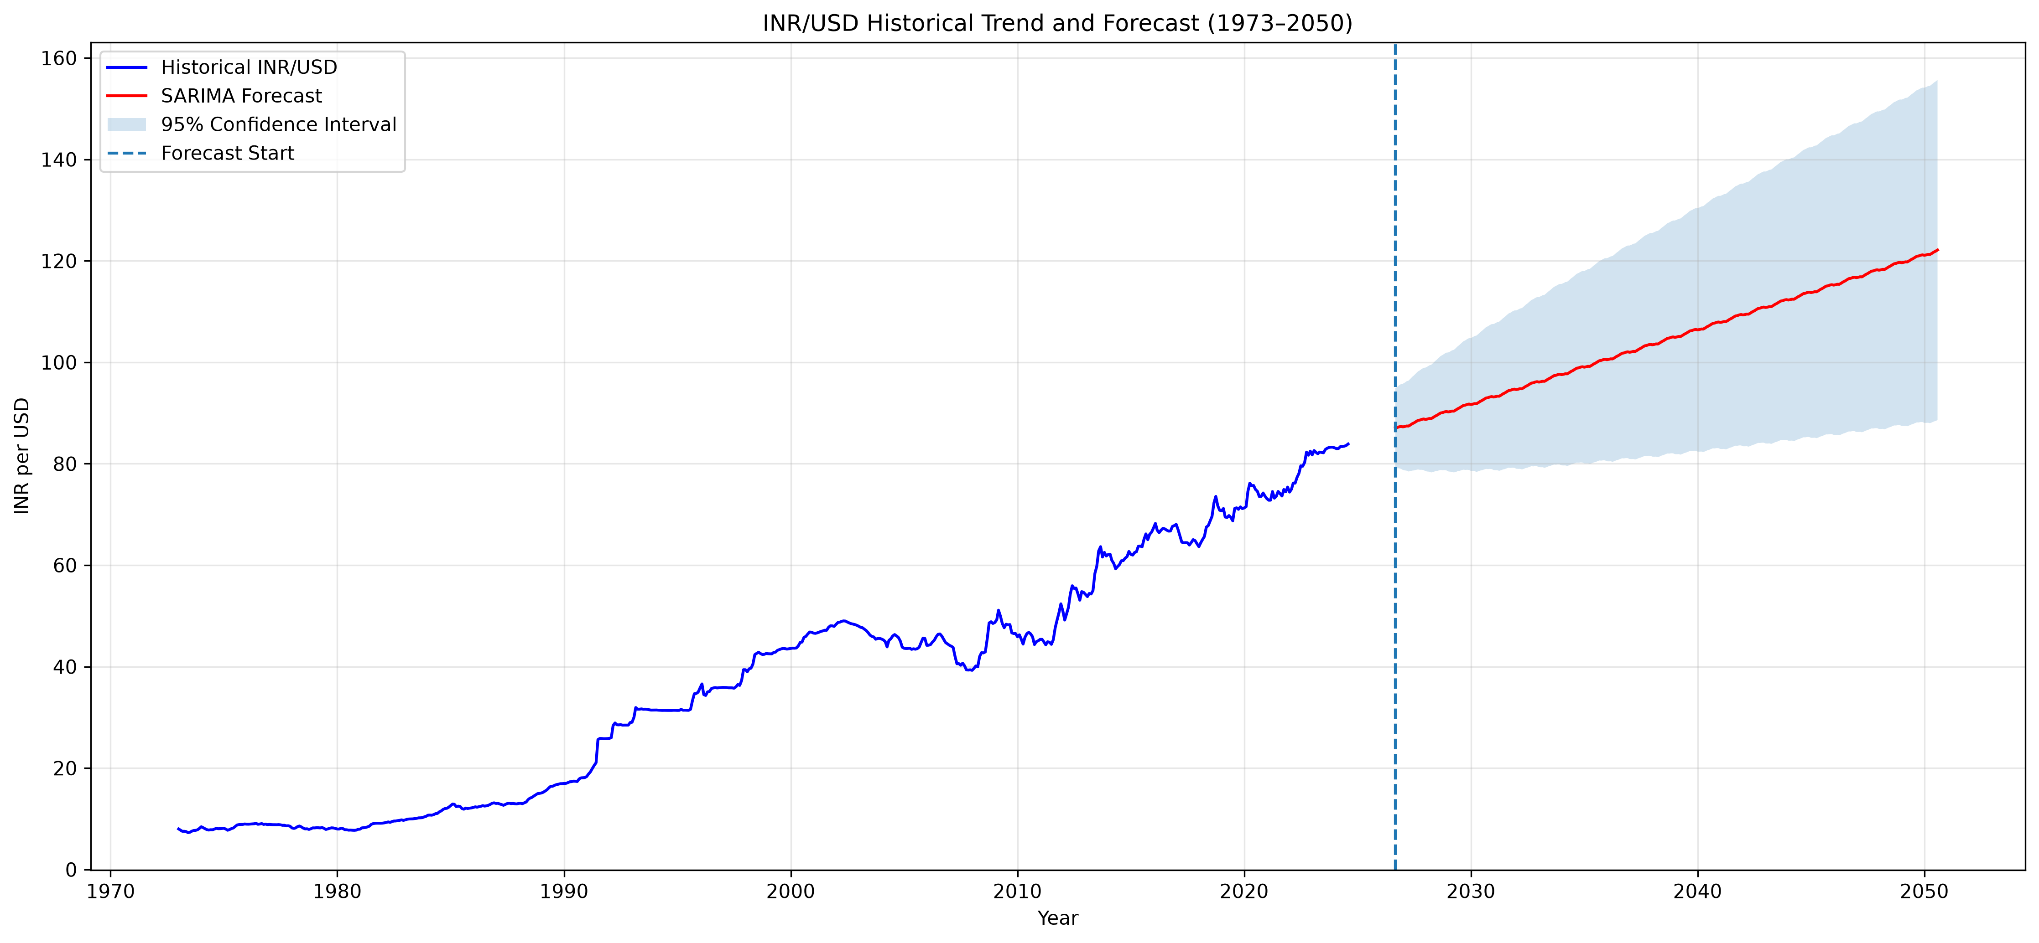
Figure 8. SARIMA-based INR/USD forecast for September 2026–August 2050.

6. India–United States Comparison
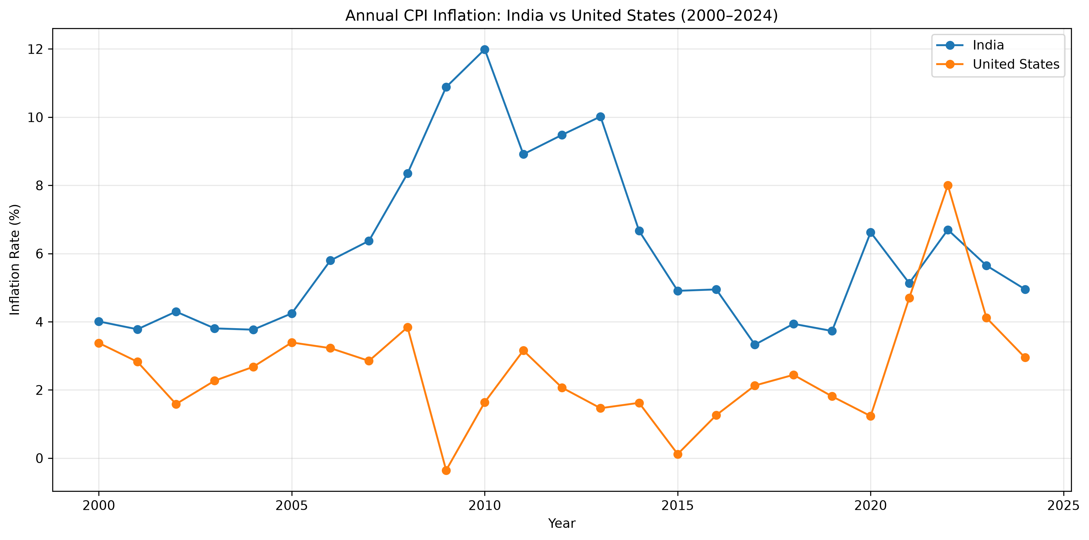
Figure 9. India–US annual CPI inflation comparison, 2000–2024.
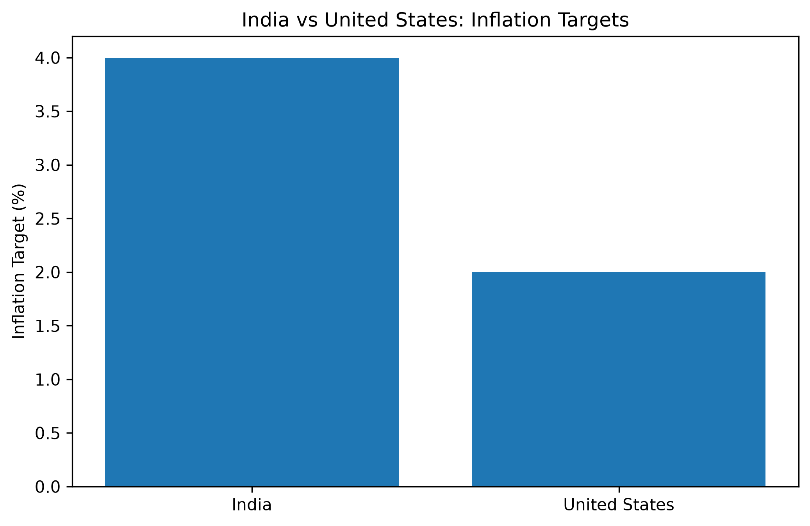
Figure 10. Comparison of the India and US inflation targets (different inflation measures).
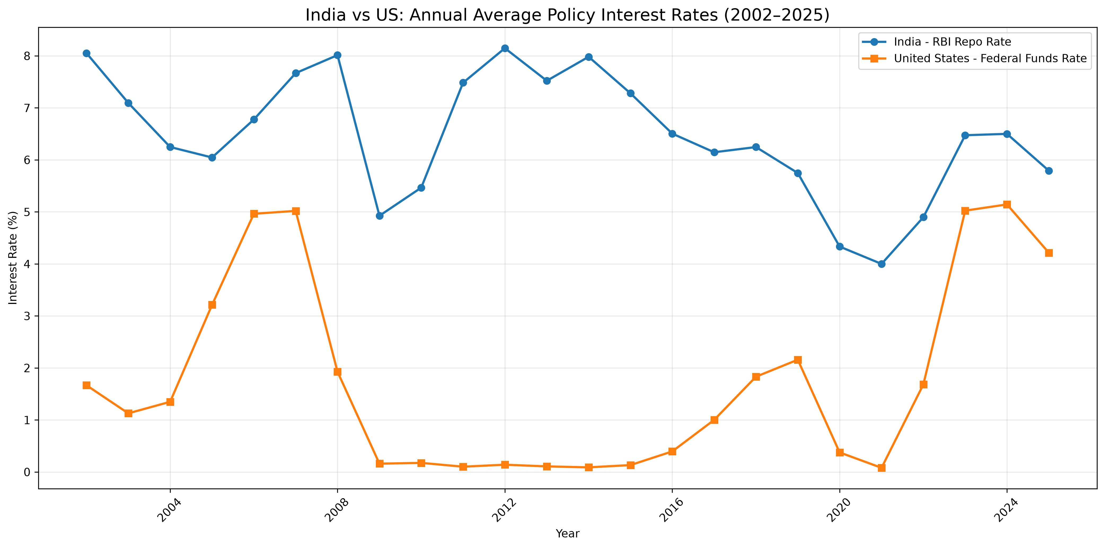
Figure 11. Annual average RBI repo rate and US Federal Funds Rate, 2002–2025.
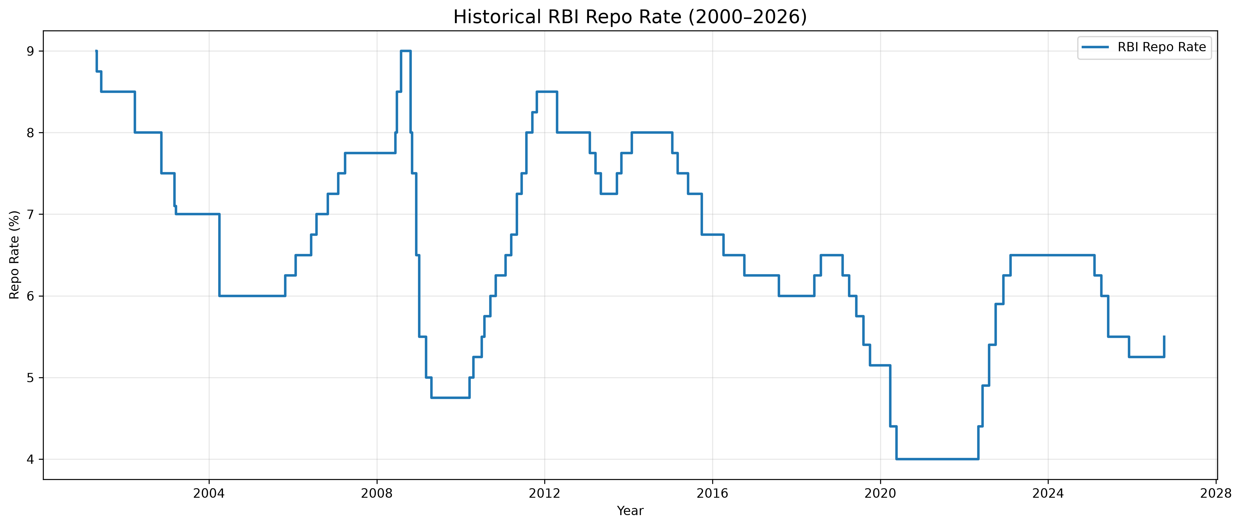
Figure 12. Historical RBI repo rate.
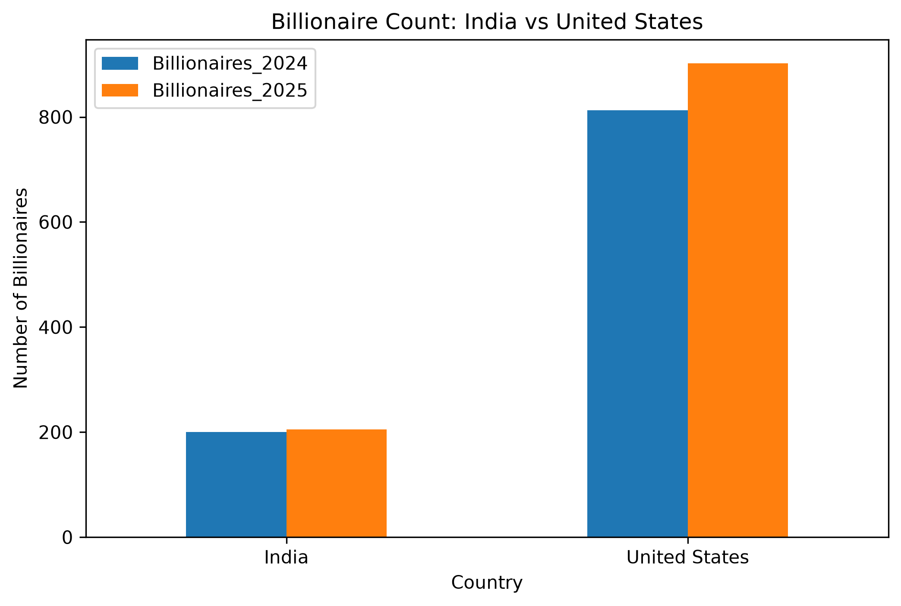
Figure 13. Billionaire counts in India and the United States.
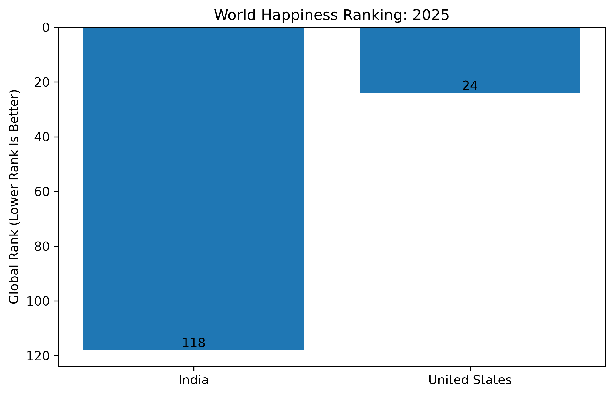
Figure 14. World Happiness Report 2025 rankings.

6.1 Inflation and monetary stability
For 2000–2024, the project's World Bank CPI dataset reports average annual inflation of 6.09% for India and 2.58% for the United States. Median inflation was 5.13% and 2.44%, respectively. The observed ranges were 3.33%–11.99% for India and −0.36%–8.00% for the United States. This suggests higher and more variable CPI inflation in India over this sample; inflation is only one dimension of monetary stability.
India's monetary policy framework uses a 4% CPI inflation target with a 2%–6% tolerance band. The Federal Reserve's longer-run inflation goal is 2%, measured using the PCE price index. CPI and PCE are different measures, so the targets are not perfectly comparable.

6.2 Policy interest rates
The annual comparison covers 2002–2025. India's annual average RBI repo rate was above the US Federal Funds Rate in every year in the project dataset. For example, 2021 averages were 4.00% for India and 0.08% for the US; 2023 averages were 6.47% and 5.02%; and 2025 averages were 5.79% and 4.21%. RBI rates were reconstructed from effective-date changes using daily forward-filling and monthly averaging, while FRED provides a monthly average Federal Funds Rate. These are different policy instruments.

6.3 Billionaire counts
The project's Forbes-based counts show India increasing from 200 billionaires in 2024 to 205 in 2025 (+2.5%). The US increased from 813 to 902 (approximately +10.95%). Counts above a wealth threshold do not measure income distribution, median wealth, poverty reduction or broad-based prosperity.

6.4 Happiness rankings
The World Happiness Report 2025 places India at rank 118 with a life-evaluation score of 4.389. The project's comparison records the United States at rank 24. Happiness rankings reflect survey-based life evaluations and associated explanatory factors; they are not direct measures of GDP or monetary stability.

7. Key Findings
- The INR/USD series shows long-run rupee depreciation, with sharper adjustments during periods of economic stress.
- 1991 is the largest depreciation year in the project's annual-average calculations.
- SARIMA outperformed the other tested models on the reported holdout metrics, but the 2050 forecast is highly uncertain.
- Average CPI inflation was higher in India than in the US over 2000–2024.
- India's average policy rate was higher than the US rate in the 2002–2025 comparison; rate levels alone do not establish which economy is more stable.
- The US had a larger billionaire count and a higher happiness ranking in the cited comparisons; neither indicator alone measures overall welfare.

8. Limitations
- The 1947–1971 and 1973–2024 data segments differ in frequency and construction; the transition period is not a continuous monthly series.
- The forecasting model is univariate and does not include macroeconomic explanatory variables or structural breaks.
- The long-horizon confidence interval is wide.
- The validation period overlaps the original test period and is not independent.
- The policy-rate measures are different instruments with different data conventions.
- Billionaire counts and happiness rankings capture narrow, distinct dimensions of society.

9. Conclusion
The project demonstrates how Python-based analysis can examine historical exchange-rate patterns, connect major events to currency adjustments, compare forecasting methods and evaluate selected cross-country indicators. The SARIMA baseline continues the historical direction of rising INR per USD through 2050, but its uncertainty is substantial. The India–US comparison reveals differences in inflation, policy rates, billionaire counts and happiness rankings. These measures should be interpreted together and with attention to their definitions.

References
- Reserve Bank of India. Foreign Exchange Market in India: Overview. https://rbi.org.in/scripts/FS_Overview.aspx?fn=5
- Reserve Bank of India. Historical account of foreign exchange management. https://rbi.org.in/scripts/PublicationsView.aspx?Id=18086
- Press Information Bureau, Government of India (2017). Indian Economy: Critical Milestones during 70 years. https://www.pib.gov.in/newsite/printrelease.aspx?lang=2&reg=48&relid=169769
- Federal Reserve. Statement on Longer-Run Goals and Monetary Policy Strategy. https://www.federalreserve.gov/monetarypolicy/files/FOMC_LongerRunGoals.pdf
- World Bank. World Development Indicators: Inflation, consumer prices (annual %), FP.CPI.TOTL.ZG. https://data.worldbank.org/indicator/FP.CPI.TOTL.ZG
- Federal Reserve Bank of St. Louis, FRED. Indian Rupees to U.S. Dollar (EXINUS). https://fred.stlouisfed.org/series/EXINUS
- Federal Reserve Bank of St. Louis, FRED. Federal Funds Effective Rate (FEDFUNDS). https://fred.stlouisfed.org/series/FEDFUNDS
- Forbes (2025). The Countries With The Most Billionaires 2025. https://www.forbes.com/sites/sylvanlebrun/2025/04/01/the-countries-with-the-most-billionaires-2025/
- World Happiness Report (2025). https://files.worldhappiness.report/WHR25.pdf

