AquaWatch: Real-Time Water Quality Monitoring Using an ESP32 and a Live Web Dashboard
A Project Based Learning Report Submitted in partial fulfilment of the requirements for the award of the degree

of

Bachelor of Technology
in The Department of ECE
Full Stack Web Development (FSWD) – 25SC2008E

Submitted by
2510040070: Sania Khan
2510040083: P Srija
2510040109: K Sravya
2510040120: B Gowri

Under the guidance of
Mr. Chiranjeevi



Department of Electronics and Communication Engineering
Koneru Lakshmaiah Education Foundation, Aziz Nagar
Aziz Nagar – 500075
OCTOBER - 2026.
Abstract
Water quality is usually checked by manual sampling, which is slow and gives no early warning when water becomes unsafe. This project presents AquaWatch, a real-time water quality monitoring system built around an ESP32 microcontroller and a live web dashboard. The complete design, covering pH, turbidity and total dissolved solids (TDS), is demonstrated in simulation, while the hardware prototype implements the pH channel only, because of cost. A pH probe and a PH-4502C signal-conditioning module feed the ESP32 through a resistive voltage divider. The firmware averages 30 ADC samples, converts the module voltage to a provisional pH value, and drives a green LED, a red LED and a buzzer according to a safe range of pH 6.5 to 8.5. Every second the ESP32 publishes a JSON message over MQTT, and a browser dashboard subscribes over WebSockets to show the live value, a colour scale, a history chart, statistics and an alert log. In tests, the module output was about 1.9 V in tap water and about 3.35 V in diluted lemon juice, and the LEDs, buzzer and dashboard alert responded correctly. The pH values are provisional because calibration with buffer solutions was not possible; two-point calibration, additional sensors and a private broker are identified as future work.

List of Figures
Fig. 1: System architecture of AquaWatch 7
Fig. 2: Circuit connections of the hardware prototype 8
Fig. 3: Live dashboard 10
Fig. 4: Module output voltage for the tested conditions 11

List of Tables
Table I: Components used in the hardware prototype 7
Table II: Pin connections between the modules and the ESP32 8
Table III: Measured results for the tested conditions 11

Table of Contents
1. Introduction 6
2. Methodology 7
a. System Overview 7
b. Hardware Design 7
c. Signal Conditioning and ADC Reading 8
d. Firmware and Alert Logic 8
e. Web Dashboard 9
f. Simulation of the Full System 10
3. Experiments 10
a. Test Procedure 10
b. Limits of the Test 11
4. Results 11
a. Measured Voltages and Alert Behaviour 11
b. Discussion and Limitations 11
5. Conclusion and Future Work 12
References 12

AquaWatch: Real-Time Water Quality Monitoring Using an ESP32 and a Live Web Dashboard

Introduction
Safe drinking water is essential for public health, and its quality depends on several physical and chemical parameters. Three of the most commonly monitored parameters are pH, turbidity and total dissolved solids (TDS). The pH value shows how acidic or basic the water is and affects taste, corrosion of pipes and the effectiveness of disinfection. Turbidity shows how cloudy the water is because of suspended particles, and TDS gives an indication of the amount of dissolved minerals and salts. In India, the drinking water specification IS 10500 gives an acceptable pH range of 6.5 to 8.5 [1], and the World Health Organization also discusses pH as an operational parameter in its drinking-water guidelines [2].
In most places, water quality is still checked by collecting a sample and testing it manually or in a laboratory. This approach is slow, depends on people being available, and only shows the condition of the water at the moment the sample was taken. If a tank or a pipeline becomes contaminated between two tests, nobody is warned until the next test. Continuous electronic monitoring removes this gap: low-cost sensors measure the water all the time, a microcontroller processes the readings, and an alert is raised as soon as a value leaves its safe range.
A pH probe is a glass electrode that produces a small voltage that changes with the acidity of the liquid, roughly 59 mV per pH unit at 25 °C [3]. This voltage is far too small and has too high an impedance to be read directly by a microcontroller, so a signal-conditioning module is used to amplify it and shift it into a readable voltage range. In this project the PH-4502C module performs this task. The ESP32 microcontroller was chosen to read the module because it has a 12-bit analog-to-digital converter (ADC) and built-in WiFi, so one low-cost board can measure, decide and communicate [4]. For communication, MQTT was chosen because it is a lightweight publish/subscribe protocol designed for small devices on unreliable networks [5].
This project, AquaWatch, was developed as part of the Full Stack Web Development course. The aim was to build a complete chain from sensor to web page: a sensor reading on the device, a local alert on the device, and a live dashboard that anyone with the link can open from a phone or laptop. The complete system, with pH, turbidity and TDS, was built and demonstrated as a simulation. Because of cost, only the pH channel was built in hardware, so the prototype is a working proof of concept for the whole sensing, alerting and web-display chain. Turbidity and TDS are shown on the hardware dashboard as not connected, so that no simulated number can be mistaken for a real measurement.
The main objectives of the project are:
- to read pH from a real probe using an ESP32 and convert the reading to a pH value;
- to give an immediate local alert, using LEDs and a buzzer, when the pH leaves the safe range of 6.5 to 8.5;
- to publish the readings over MQTT and show them on a responsive live web dashboard with history, statistics and an alert log; and
- to test the prototype with real liquids and to state clearly which results are validated and which are only provisional.
The rest of this report is organised as follows. Section 2 describes the methodology: the hardware, the signal conditioning, the firmware and the dashboard. Section 3 describes the experiments. Section 4 presents and discusses the results and limitations, and Section 5 gives the conclusion and future work.

METHODOLOGY

System Overview
Fig. 1 shows the architecture of AquaWatch. The pH probe is connected to the PH-4502C module, whose analog output is reduced by a voltage divider and read by the ADC of the ESP32. The firmware converts the reading to a pH value, decides whether the water is safe, and switches the LEDs and the buzzer. In parallel, the ESP32 connects to WiFi and publishes the reading as a JSON message to a public MQTT broker. The web dashboard, which is a single static HTML page, subscribes to the same topic through the broker and updates its display each time a message arrives. The page can be hosted on a free static-hosting service, so it can be opened from any device with internet access.
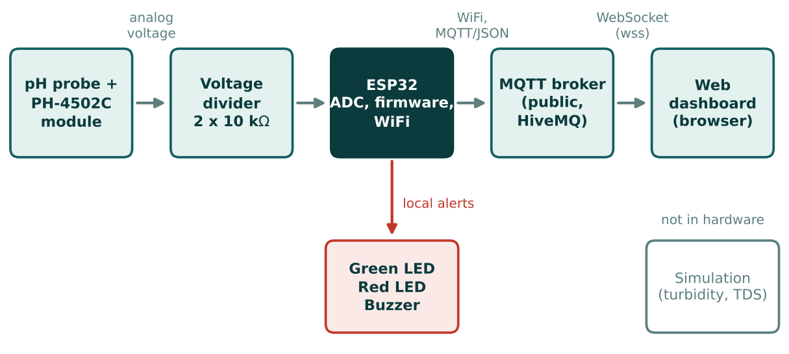
- System architecture of AquaWatch

Hardware Design
Table I lists the components used. The ESP32 Dev Module is powered over USB. The PH-4502C module is powered from the 5 V (VIN) pin of the ESP32 and shares its ground. The module output is passed through a voltage divider before it reaches the ADC pin, as described in the subsection on signal conditioning. The green LED, red LED and active buzzer are connected to three digital output pins, with a 220 Ω resistor in series with each LED. Table II gives the pin connections, and Fig. 2 shows the circuit. All parts were assembled on a full-size breadboard without soldering.
- Components used in the hardware prototype
Component | Quantity | Purpose
ESP32 Dev Module | 1 | Microcontroller with ADC and WiFi
pH probe with BNC connector | 1 | Senses the acidity of the liquid
PH-4502C pH module | 1 | Amplifies and shifts the probe signal
10 kΩ resistor | 2 | Voltage divider for the ADC input
220 Ω resistor | 2 | Current limiting for the LEDs
Green LED and red LED | 1 each | Safe and alert indication
Active buzzer | 1 | Audible alert
Breadboard and jumper wires | 1 set | Connections without soldering

- Pin connections between the modules and the ESP32
From | To (ESP32) | Note
PH-4502C V+ | VIN (5 V) | Module power
PH-4502C G | GND | Common ground
PH-4502C Po | GPIO 34 through the divider | Analog output, input-only ADC pin
Green LED + 220 Ω | GPIO 25 | Lit when the water is safe
Red LED + 220 Ω | GPIO 26 | Lit when the pH is outside the range
Active buzzer | GPIO 27 | Sounds when the pH is outside the range

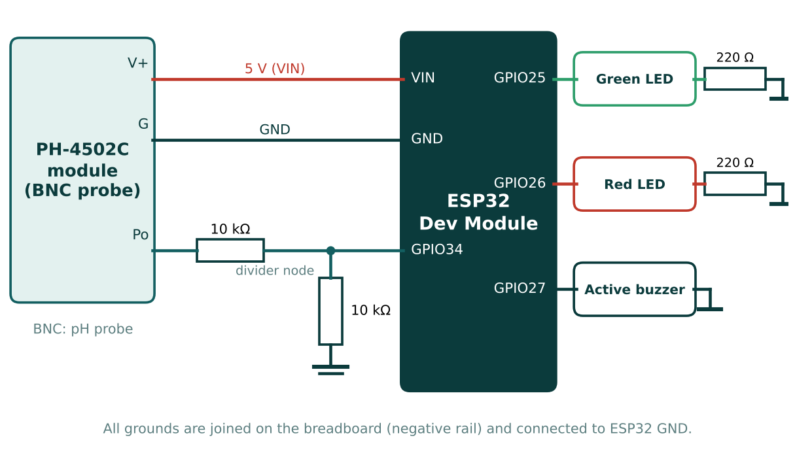
- Circuit connections of the hardware prototype

Signal Conditioning and ADC Reading
When powered from 5 V, the PH-4502C module can output a voltage of up to about 5 V, but the ESP32 ADC pins accept a maximum of 3.3 V. The Po output was therefore connected to GPIO 34 through a divider of two equal 10 kΩ resistors, which halves the voltage. The ADC was set to 12-bit resolution (0 to 4095) with 11 dB attenuation, which gives an input range of roughly 0 to 3.3 V. The module voltage is recovered from the raw ADC value as:
V_mod = 2 × (raw × 3.3 / 4095) (1)
The ADC of the ESP32 is not perfectly linear, especially near the ends of its range, and this is one source of error in the measurements. To reduce noise, the firmware reads 30 samples, 10 ms apart, and uses their average for each reading.

Firmware and Alert Logic
The firmware was written in the Arduino IDE (version 2.3.10) using the ESP32 board package [9]. Each second it reads the averaged module voltage and converts it to a provisional pH value using a one-point linear model:
pH = 7.0 + (V_N − V_mod) / S (2)
where V_N is the module voltage treated as pH 7 and S is the slope in volts per pH unit. On this module the voltage rises as the liquid becomes more acidic. The values used were V_N = 1.90 V, taken from the settled reading in tap water, and S = 0.30 V per pH unit. The slope was first set to a typical value of 0.18 V per pH unit, but this gave impossible negative pH values for diluted lemon juice, so it was revised to about 0.3 V per pH unit by assuming that diluted lemon juice has a pH of about 2.5. The computed pH is limited to the range 0 to 14. Because no buffer solutions were available, these constants are estimates and the resulting pH is provisional, not calibrated.
The water is declared safe when the pH is between 6.5 and 8.5, which corresponds to a module voltage of roughly 1.45 V to 2.05 V with these constants. When the water is safe, the green LED is on. Otherwise, the red LED and the buzzer are switched on. After connecting to the home WiFi, the ESP32 synchronises its clock using NTP and publishes a JSON message once per second through the PubSubClient library [6]. The message contains the module voltage, the pH value, the safe flag and a timestamp in milliseconds, for example {"voltage":1.806,"ph":7.31,"safe":true,"ts":1791470000000}.

Web Dashboard
The dashboard is a single HTML page that uses the MQTT.js library [7] to connect to the public HiveMQ broker [8] over secure WebSockets and subscribes to a unique topic. It shows the following:
- the current pH as a large number, with a Safe or Alert badge and a colour scale from pH 0 to 14 with the safe band outlined;
- a history chart with 1-minute, 10-minute, 1-hour and all-saved views, saved in the browser so that it survives a page refresh, with the lowest, average and highest pH for the selected range;
- an alert log that records when each alert started, the pH at that time and how long it lasted, together with an optional sound and browser notification;
- the delay between the ESP32 and the screen, calculated from the timestamp in each message, and a Device offline label if no message arrives for 10 seconds;
- an unstable-signal warning when the voltage changes by more than 0.2 V within 10 seconds while the status is Safe, which can happen when the probe is lifted out of the liquid; and
- a Download CSV button, a dark and light theme button, and cards for turbidity and TDS that are marked as not connected.
Because the public broker does not store messages, the history shown on a device is recorded only while the page is open on that device. Fig. 3 shows the dashboard.
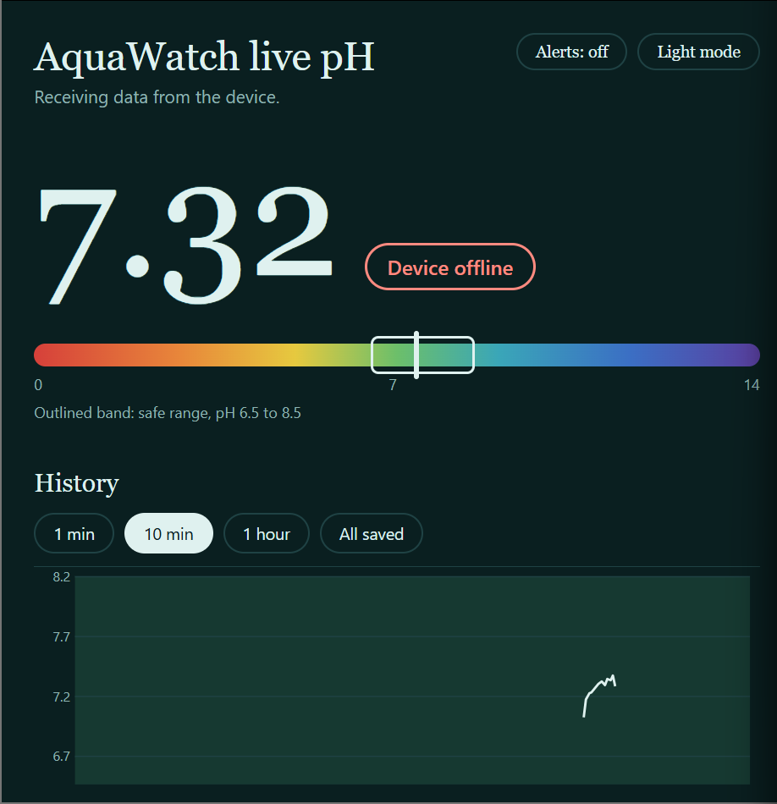
- Live dashboard

Simulation of the Full System
The complete AquaWatch design, including the turbidity and TDS channels, was developed and demonstrated as a simulation, because the corresponding sensors were not purchased. The hardware prototype validates the sensing, alerting and web-display chain on the pH channel, and the same approach can be extended to the other two parameters by adding sensors and extra fields to the message.

EXPERIMENTS

Test Procedure
The prototype was tested with real liquids using the setup in Fig. 2. Before each test the probe was rinsed gently with clean water, without rubbing the glass bulb, and the reading was allowed to settle for 30 to 60 seconds. The following conditions were tested in order:
- Probe connected but dry (in air): the module output was recorded to check that the wiring, the divider and the ADC were working;
- Tap water: the settled module voltage was recorded and used as the pH 7 reference V_N;
- Diluted lemon juice: the probe was dipped for 10 to 20 seconds to check that the voltage rises with acidity and that the alert starts; and
- Recovery: the probe was rinsed, returned to clean water, and the voltage was observed as it moved back towards the water value.
In each case, the module voltage and the provisional pH were read from the Serial Monitor at 115200 baud, and the state of the LEDs, the buzzer and the dashboard was observed. The delay between the ESP32 and the dashboard was read from the dashboard, which compares the browser clock with the timestamp sent by the ESP32. The probe was kept wet with its storage cap between sessions.

Limits of the Test
No pH 4 or pH 7 buffer solutions were available, and household liquids vary too much in pH to act as references. The experiments therefore check the direction of the response, the stability of the readings and the behaviour of the alert logic, but they do not establish the numerical accuracy of the pH values.

RESULTS

Measured Voltages and Alert Behaviour
Table III and Fig. 4 summarise the measurements. With the probe connected but dry, the module output was steady at about 2.74 V (the raw ADC value varied by only a few counts), which shows that the divider and the ADC work correctly. In tap water the output fell to about 1.93 V, and it drifted slowly downwards, to about 1.80 V, while the probe settled. In diluted lemon juice the output rose to between 3.34 V and 3.36 V, so the voltage increases with acidity as assumed in the firmware. After rinsing and returning the probe to water, the voltage fell back to about 1.8 V within a few minutes, and the green LED returned.
- Measured results for the tested conditions
Condition | Module voltage (V) | Provisional pH | Alert state
Probe in air (dry) | 2.74 | not valid | Alert (not a real pH)
Tap water | 1.80 to 1.93 | 6.9 to 7.4 | Safe
Diluted lemon juice | 3.34 to 3.36 | about 2.2 | Alert (red LED, buzzer)
Rinsed, back in water | 1.79 to 1.81 | 7.3 to 7.4 | Safe
Delay, ESP32 to dashboard | [add measured average] ms | - | -

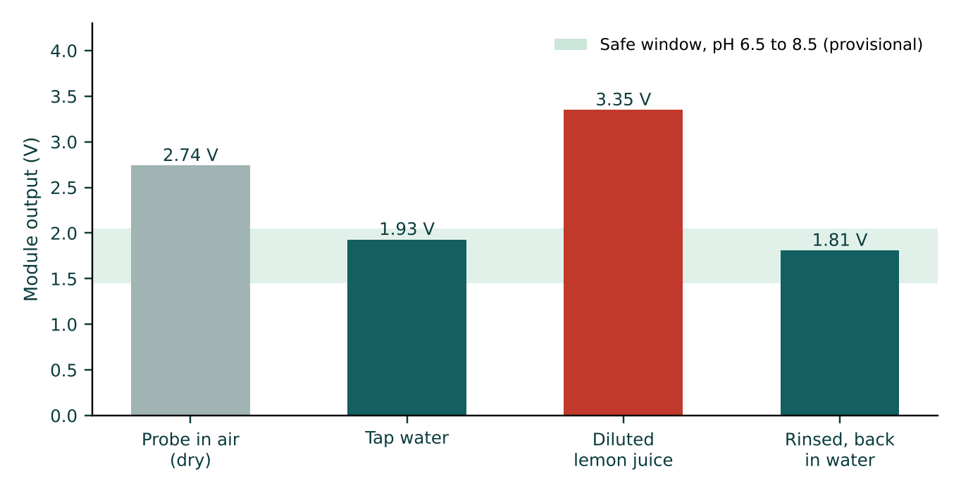
- Module output voltage for the tested conditions
In every test the alert behaved as designed: the green LED was on while the pH was inside 6.5 to 8.5, and the red LED and buzzer switched on when it was outside this range, including when the probe was disconnected or dry. The dashboard displayed the same Safe or Alert state as the LEDs, and its alert log is designed to record each event.

Discussion and Limitations
The results show that the complete chain works on real liquids, from the probe to the ESP32, the local alert, MQTT and the web dashboard. The numerical pH values, however, must be treated as approximate, for the following reasons:
- the pH 7 reference (1.90 V) was taken from tap water, whose pH may be anywhere between 7 and 8, and the slope was estimated from one assumed value for diluted lemon juice, so the pH scale is not calibrated;
- the ESP32 ADC is nonlinear and the glass probe drifts, especially in the first minutes after being placed in a liquid or after acid;
- a lifted or dry probe gives meaningless values, and the unstable-signal warning can only suggest this, not detect it reliably;
- turbidity and TDS are not measured in hardware, and the free public MQTT broker has no login or encryption of the stored data, so anyone who knows the topic can read it; and
- the dashboard history is stored per browser, so a new device shows only the data it has received since it opened the page.

CONCLUSION and FUTURE WORK
AquaWatch demonstrates a complete low-cost chain for real-time water quality monitoring. A pH probe and the PH-4502C module were interfaced safely to an ESP32 through a voltage divider, the firmware gave an immediate local alert with LEDs and a buzzer, and the readings were published over MQTT to a live dashboard that can be opened from any device. Tests with tap water and diluted lemon juice confirmed that the module voltage rises with acidity, that the alert fires outside the safe range, and that the system recovers after the probe is rinsed. The full three-parameter system was shown in simulation, and the report clearly separates what was validated in hardware from what was simulated.
In the future, the following improvements are planned:
- two-point calibration with pH 4 and pH 7 buffer solutions, using the offset trimmer and measured slope, followed by validation against known buffers to state a real accuracy;
- real turbidity and TDS sensors, with extra fields in the same JSON message;
- a cloud database so that every visitor sees continuous 24/7 history, and a private MQTT broker with login and TLS encryption;
- a proper detection of a dry or disconnected probe, and regular recalibration to handle probe drift; and
- a waterproof enclosure with a battery or power bank, and push alerts to a phone by SMS or an app.

References
- Bureau of Indian Standards, IS 10500:2012, Drinking Water - Specification (Second Revision), New Delhi, India, 2012.
- World Health Organization, Guidelines for Drinking-water Quality: Fourth Edition Incorporating the First and Second Addenda, Geneva, Switzerland, 2022.
- R. G. Bates, Determination of pH: Theory and Practice, 2nd ed., New York, NY, USA: Wiley, 1973.
- Espressif Systems, ESP32 Series Datasheet, Shanghai, China.
- A. Banks and R. Gupta (Eds.), MQTT Version 3.1.1, OASIS Standard, Oct. 2014.
- N. O'Leary, PubSubClient: A client library for MQTT messaging on Arduino, GitHub repository (knolleary/pubsubclient).
- MQTT.js: the MQTT client library for Node.js and the browser, GitHub repository (mqttjs/MQTT.js).
- HiveMQ, Public MQTT Broker (broker.hivemq.com), https://www.hivemq.com.
- Espressif Systems, Arduino core for the ESP32, GitHub repository (espressif/arduino-esp32).

