**44-599: Introduction to Data Visualization**

**Worksheet**

**Worksheet for Arc Diagrams using Micro Strategy**

**Objective:** The main objective of this worksheet is to generate **Arc Diagrams using MicroStrategy**

In this worksheet, we have a dataset.

1. The impaired driving death rate in the United States by age and gender during the year 2012 and 2014.

**Worksheet for Treemap using Qlik Sense:**

**Goal 1**: To find the number of deaths in European countries from years 2001-2010

Implementing goal 1 with the help of Arc Diagram with MicroStrategy.

Steps to be followed:

1. Download and install Microstrategy.
2. Go to the following link <https://www.microstrategy.com/us/get-started> and register to download MicroStrategy Desktop.
3. Run the file to install the MicroStrategy on your desktop. After the installation is finished you will see an icon on your desktop.
4. Download the below excel sheet containing the modified data of number of deaths in European countries during 2001-2010.

<http://appsso.eurostat.ec.europa.eu/nui/show.do?dataset=hlth_cd_anr&lang=en>

1. Now we should add data. Go to file -> add data.

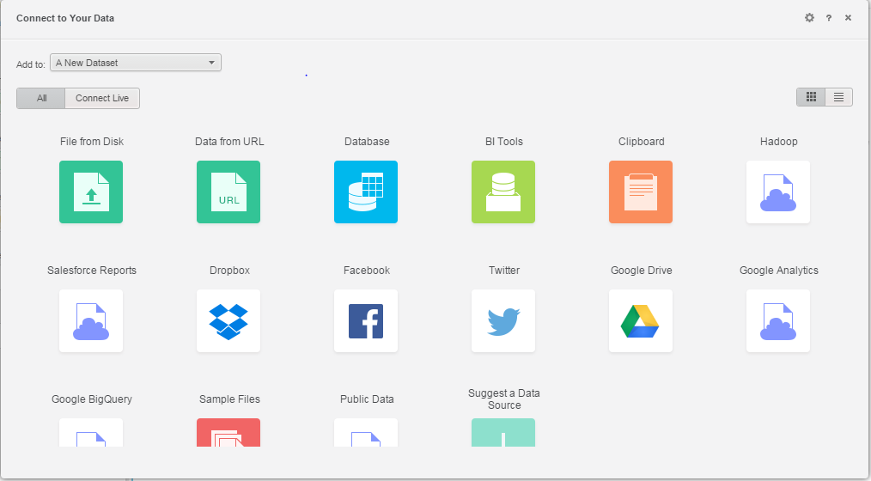

1. Now we have editor were we have drag and drop the columns. Now add GEO/TIME in to from item section .

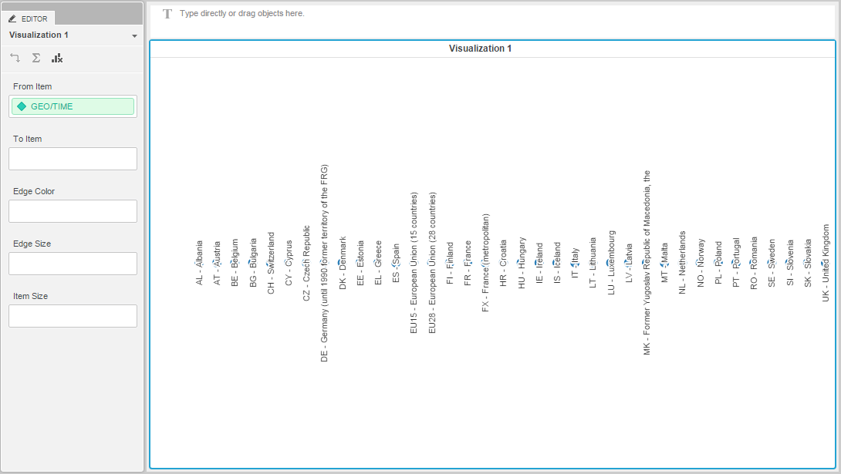

1. Next we drag columns in to item section.

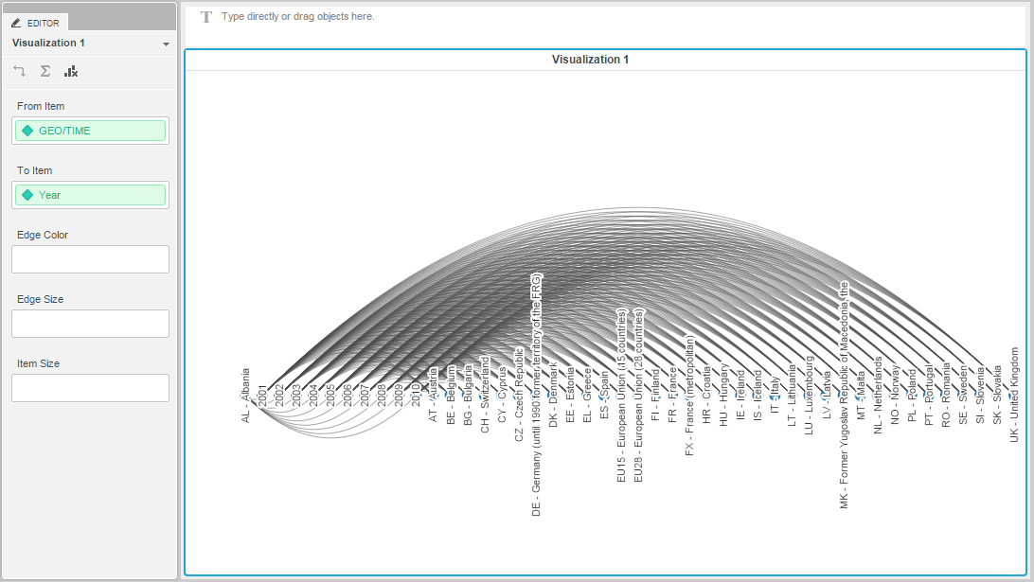

1. Now drag metric to edge color. Percentage of metric shows the number of deaths .

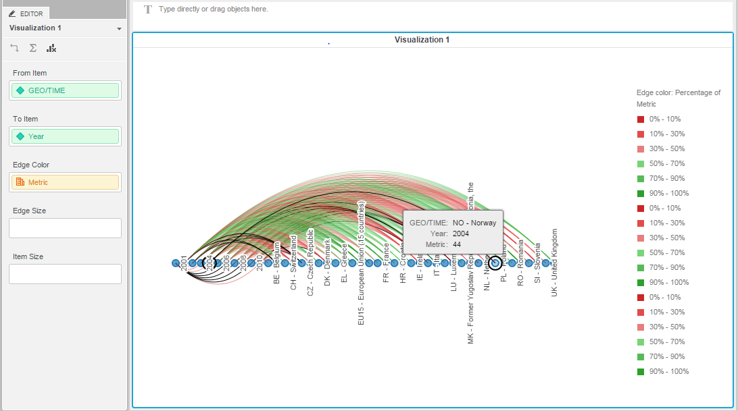

Data source:

Dataset:

<http://appsso.eurostat.ec.europa.eu/nui/show.do?dataset=hlth_cd_anr&lang=en>

Github Link: