**Goal 6:**To visualize the average monthly income  based on education fields of the employees and current number of employees in that education field. This chart drawn using Microsoft Power BI and it is drawn with line and stacked column chart .

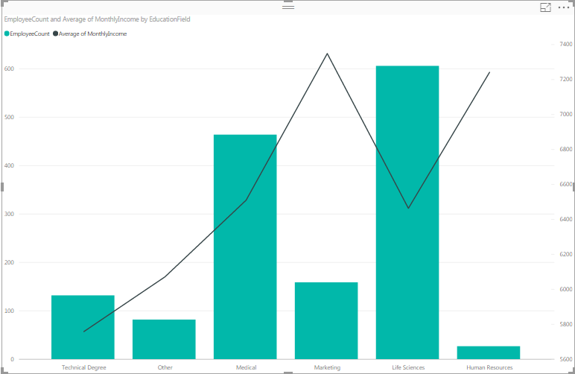

The chart above shows different departments and number of people working in that fields compared with average salary of employees. As we see in life sciences number of people working are very high but the average salary is low. when we take human resources the number of people working is low but the average salary is very high. Even comparing other fields as the count of employees increases the average salary decreases. I want to conclude that people should not only go for life sciences , medical or technical degree. They also should try something different which would make them unique in all the possible ways.

This is the link to the Github repository:

<https://github.com/sravyakandepu/Milestone-2>