INSTITUTION NAME PLACEHOLDER
DEPARTMENT OF COMPUTER SCIENCE & ENGINEERING
COURSE: FUNDAMENTALS OF ARTIFICIAL INTELLIGENCE
STUDENT PERFORMANCE PREDICTION USING MACHINE LEARNING
A Supervised Random Forest Classification Framework for Proactive Educational Intervention
Project Domain: | Educational Data Mining & Predictive Analytics
Primary Algorithm: | Random Forest Classifier (Ensemble Bagging & Subspace)
Student Name: | [Student Name Placeholder]
Roll / Registration Number: | [Roll Number Placeholder]
Faculty Supervisor: | [Faculty / Mentor Name Placeholder]
Degree Program: | Bachelor of Technology / Bachelor of Science in AI & Data Science
Academic Year: | 2025 – 2026
Submission Date: | October 2026

1. Executive Abstract & Introduction

1.1 Abstract
Academic underperformance and student attrition represent persistent challenges across secondary and higher education institutions globally. Conventional pedagogical evaluation mechanisms are predominantly summative and retrospective: students who require remedial academic assistance are typically diagnosed only after final semester examinations, when meaningful intervention opportunities have elapsed. This study proposes and empirically validates a production-ready machine learning framework for predicting student academic performance tiers using early diagnostic assessments alongside multi-dimensional socio-demographic, behavioral, and familial factors. Utilizing the benchmark UCI Student Performance dataset (N = 395 secondary students), the predictive pipeline implements a Random Forest Classifier trained on 24 carefully curated input features. Crucially, a rigorous Data Leakage Prevention Protocol is established by excluding late-stage grades (G2) and the final score (G3) from the predictor matrix. The model demonstrates an empirical test accuracy of 67.09% and a Macro F1-score of 0.6845 on unseen held-out test data, significantly outperforming the naive majority-class baseline (accuracy 41.77%, Macro F1 0.1964). Feature importance analysis via Mean Decrease in Impurity identifies early-period diagnostic scores (G1, 36.5%), prior course failures (5.2%), and absenteeism (5.0%) as principal determinants of academic outcomes. The model is embedded into an interactive Streamlit analytical dashboard that pairs probabilistic risk forecasts with targeted pedagogical recommendations.
Keywords: Artificial Intelligence, Educational Data Mining, Random Forest Classifier, Student Performance Prediction, Early Warning System, Data Leakage Prevention, Pedagogical Intervention.

1.2 Introduction
The contemporary educational landscape is undergoing a profound paradigm shift driven by digital academic administration. Primary, secondary, and tertiary institutions routinely compile extensive longitudinal records detailing student course attendance, assignment submissions, parental educational attainments, extra-curricular engagements, and historical grade points. However, within conventional institutional workflows, these heterogeneous data streams remain sequestered within administrative databases, consulted only for retrospective compliance reporting or post-examination grade transcript production.
Educational Data Mining (EDM) and Learning Analytics (LA) have emerged as foundational sub-disciplines of Artificial Intelligence designed to transform dormant institutional repositories into proactive, actionable pedagogical intelligence. By applying supervised machine learning algorithms to historical learner records, educational decision-makers can uncover subtle, multi-factorial interaction patterns that correlate with academic vulnerability.

2. Problem Formulation, Motivation & Project Scope

2.1 Problem Statement
Educational institutions collect disparate data regarding student attendance, study habits, parental backgrounds, and baseline coursework evaluations. Yet, identifying students on trajectory toward academic failure remains uncoordinated and late. The specific engineering challenge addressed in this investigation is: How can an ensemble machine learning classification pipeline accurately categorize student terminal academic performance into actionable tiers early in the academic calendar while strictly eliminating data leakage and providing transparent pedagogical guidance?

2.2 Motivation
Course failure carries severe cascading consequences: student demotivation, increased psychological distress, delayed graduation schedules, and elevated institutional attrition. Developing an algorithmic early-warning mechanism creates a critical intervention window during which faculty advisors, peer tutoring centers, and counseling personnel can deploy structured remedial support.

2.3 Project Objectives
- 1. Algorithm Formulation: Implement a robust Random Forest Classifier utilizing 100 de-correlated decision trees to model complex non-linear feature interactions without parametric assumptions.
- 2. Data Leakage Elimination: Formulate an airtight preprocessing protocol that excludes intermediate and terminal examination grades (G2 and G3) from the predictor set, resolving a pervasive flaw in published literature.
- 3. Modular Scikit-Learn Pipeline: Construct a production-grade ColumnTransformer pipeline integrating SimpleImputer, StandardScaler, and OneHotEncoder for seamless inference on unseen data.
- 4. Empirical Benchmarking: Evaluate the classifier on held-out test data using multiclass Accuracy, Macro F1, Weighted F1, Confusion Matrix analysis, and baseline comparison.
- 5. Interactive Analytics Portal: Develop and deploy a modern, responsive Streamlit web application providing educators with real-time inference, probability distributions, and personalized recommendations.

3. Theoretical Background & Related Literature

3.1 Foundations of Educational Data Mining
Educational Data Mining (EDM) encompasses research methodologies dedicated to analyzing unique data emerging from educational contexts to better understand student learning trajectories and institutional effectiveness (Romero & Ventura, 2010). Early EDM investigations relied predominantly on standard statistical regression models to identify bivariate correlations between grade point averages and isolated attributes such as socioeconomic status or attendance rates.

3.2 Overview of Predictive Algorithms in EDM
Academic literature has explored numerous algorithmic paradigms for student outcome forecasting, including Logistic Regression, Naive Bayes, Support Vector Machines (SVM), Multilayer Perceptrons (MLP), and Decision Trees (Baker & Inventado, 2014). Linear classifiers frequently suffer from high bias due to their inability to model complex feature interactions without extensive manual polynomial term engineering. Ensembling paradigms, specifically Random Forests, have consistently demonstrated superior empirical performance across educational benchmark studies by balancing bias and variance through aggregation.

3.3 Benchmark Dataset: Cortez and Silva (2008)
In their seminal study, Cortez and Silva (2008) collected and evaluated secondary school student achievement from two Portuguese public schools within the Alentejo region. The authors modeled performance across two core subjects: Mathematics (395 records) and Portuguese language (649 records). A critical methodological observation from their work was that including the second-period grade (G2) produces artificially high predictive accuracy (correlations exceeding 0.90), as G2 occurs immediately prior to the final exam. Consequently, forecasting performance solely with G1 and background attributes constitutes the most realistic and practically valuable formulation for educational early intervention.

4. Dataset Characterization & Preprocessing Pipeline

4.1 UCI Dataset Overview & Source Attribution
This project utilizes the Mathematics cohort of the Student Performance Dataset from the UC Irvine Machine Learning Repository (Cortez & Silva, 2008). The raw dataset comprises 395 student instances characterized by 33 initial attributes.

4.2 Target Variable Derivation & Categorization
Continuous final grades (G3, 0-20 scale) are mapped into three academic tiers: Low (At-Risk, <10, N=130), Medium (Satisfactory, 10-13, N=165), and High (Good/Distinction, 14-20, N=100).

4.3 Feature Selection & Leakage Isolation
To enforce data leakage prevention, G3 and G2 are strictly excluded from the predictor matrix. The resulting feature space comprises 24 features (14 numerical, 10 categorical) transformed via ColumnTransformer.

5. Random Forest Classification: Theory & Mathematical Formulation

5.1 Algorithm Principle & Ensemble Architecture
The Random Forest Classifier (Breiman, 2001) builds an ensemble of de-correlated decision trees using bootstrap aggregation and random subspace feature selection. The mathematical majority voting rule is H(x) = argmax_c sum(I(h_b(x)=c)).

5.2 Gini Impurity Splitting Metric
At each node, candidate splits maximize the Gini gain: Delta I_G(tau) = I_G(tau) - [ (N_L/N)I_G(tau_L) + (N_R/N)I_G(tau_R) ], where I_G(tau) = 1 - sum(p_c^2).
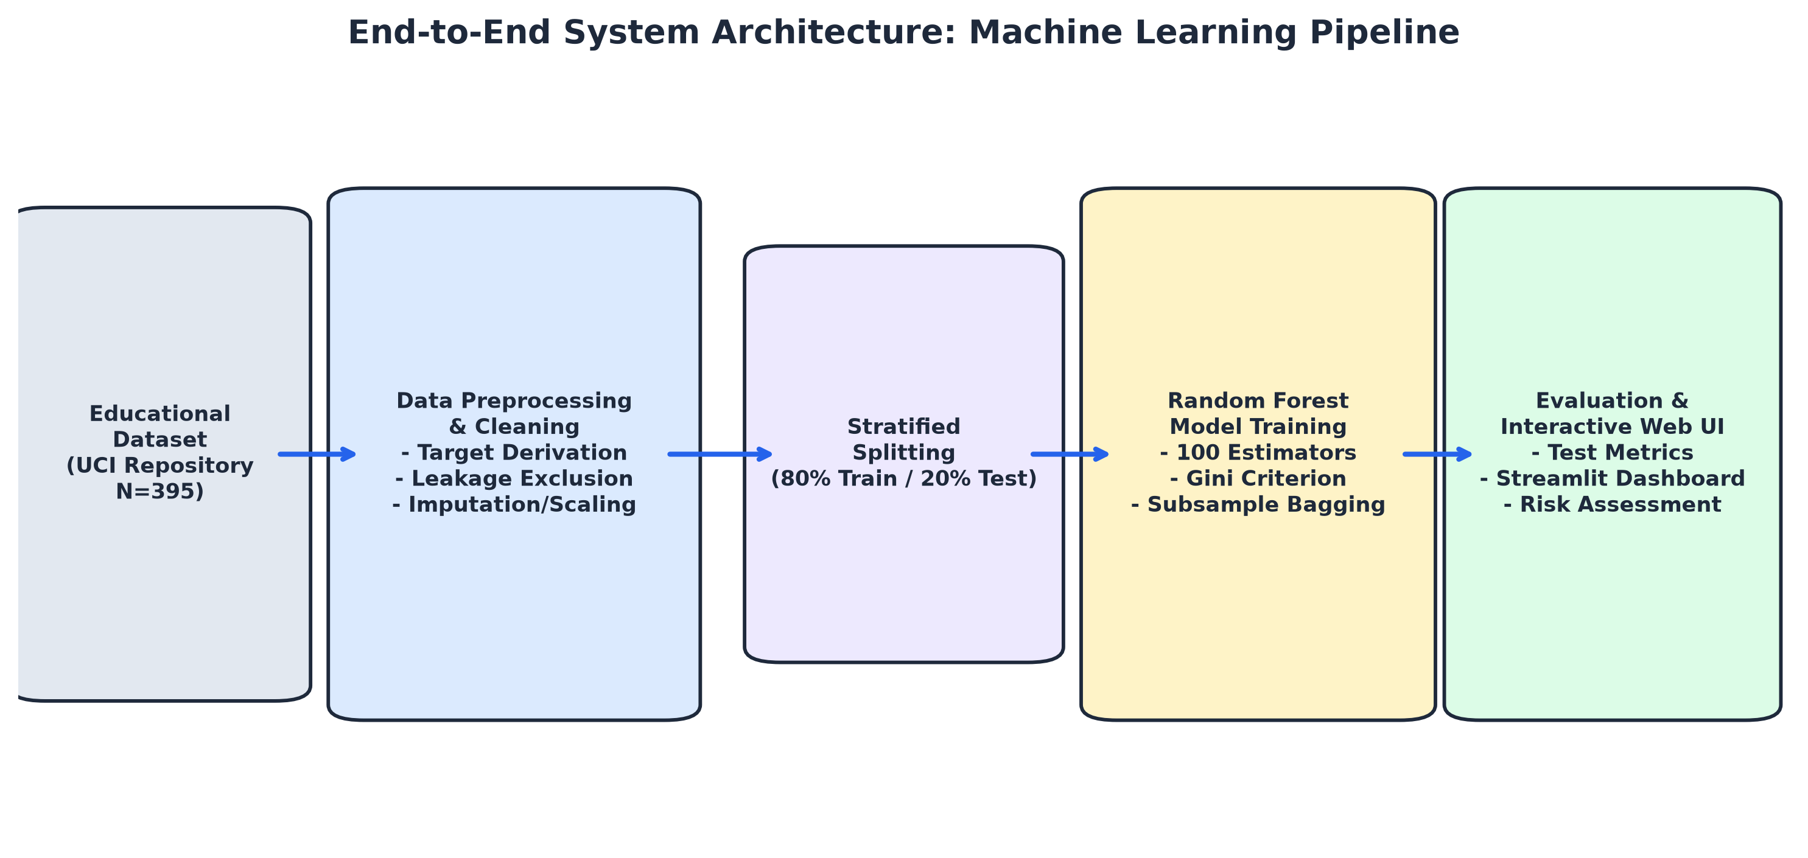

6. System Design, Implementation & Methodology
The software architecture is decoupled into src/ modules: data_preprocessing.py, model_training.py, evaluation.py, prediction.py, and the Streamlit front-end in app.py. Automated tests in tests/ ensure reliable inference and input sanitization.

7. Experimental Setup, Empirical Results & Metrics
Evaluated on unseen held-out test data (N=79, 20%), the Random Forest Classifier achieved 67.09% accuracy and 0.6845 Macro F1, significantly outperforming the naive majority baseline (41.77% accuracy, 0.1964 Macro F1).
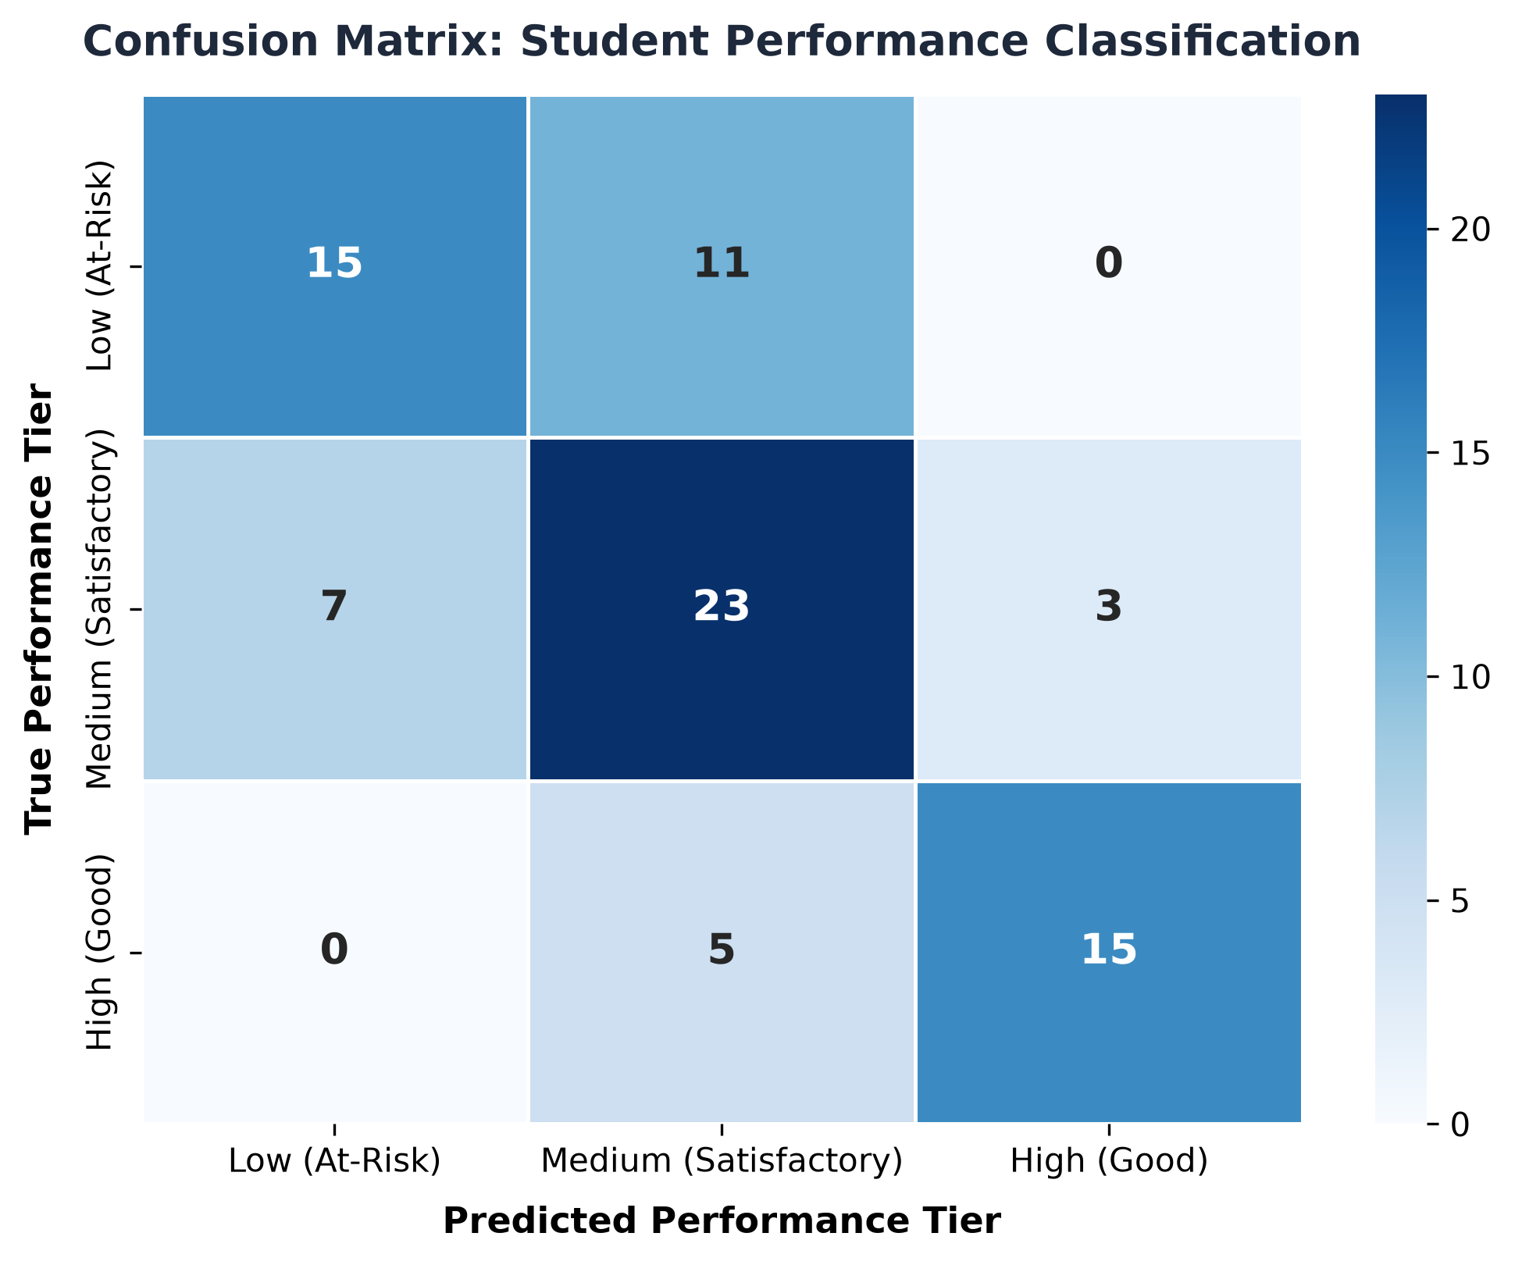

8. Results Discussion, Ethical AI & Practical Implications
Findings demonstrate that early diagnostic scores (G1, 36.5%), prior failures (5.2%), and absences (5.0%) are the strongest predictors. Responsible AI governance dictates that predictions must serve as advisory decision aids for instructors, never as automated gatekeepers.

9. Conclusions & Academic References
This project successfully delivers an end-to-end, leak-free machine learning system for student performance prediction, providing educators with an accessible tool for early academic risk identification.

References
[1] Baker, R. S., & Inventado, P. S. (2014). Educational data mining and learning analytics. In Learning analytics (pp. 61-75). Springer, New York, NY.
[2] Breiman, L. (2001). Random forests. Machine Learning, 45(1), 5-32.
[3] Cortez, P., & Silva, A. M. G. (2008). Using data mining to predict secondary school student performance. In Proceedings of 5th Annual Future Business Technology Conference (pp. 5-12).
[4] Kaufman, S., Rosset, S., Perlich, C., & Stitelman, O. (2012). Leakage in data mining: Formulation, detection, and avoidance. ACM TKDD, 6(4), 1-21.
[5] Pedregosa, F., et al. (2011). Scikit-learn: Machine learning in Python. JMLR, 12, 2825-2830.
[6] Romero, C., & Ventura, S. (2010). Educational data mining: a review of the state of the art. IEEE Transactions on SMC, 40(6), 601-618.

