Task 6: Decode and Interpret Security Logs
Findings report
Name: Dadana Sravya Reddy Date: 28/10/2026

1. What I did
For this task I worked with an authentication log. A real company log would be private, so I made a fictional one with a small Python script. It covers one week (19 to 25 October 2026), has 741 events, 25 accounts and 56 source IP addresses. Every user is invented, and every IP address comes from the ranges reserved for documentation (RFC 5737), so none of it points to a real network.
Most of the log is ordinary office activity. I also planted a few attacks and two harmless oddities in it. That way I know what the right answers are and can check whether my analysis finds them without raising false alarms on the normal and harmless events.
The work has three steps. First I describe what normal looks like. Then I look for events that break that pattern. Finally I explain which of those events need a person to look at them, and which are probably nothing.

2. How to read the log
Each line is one event, and it has seven fields.
Field | What it means | Example
timestamp | When it happened (IST) | 2026-10-21 03:26:00
user | The account used or targeted | admin, svc_backup
src_ip | The address the request came from | 198.51.100.23
country | The country that address belongs to | RU
event | What happened (see below) | LOGIN_FAILURE
user_agent | The software that made the request. A browser means a person, a script name means automation | python-requests/2.31
reason | Extra detail, such as wrong_password, unknown_user or helpdesk_reset | unknown_user
The event types are LOGIN_SUCCESS, LOGIN_FAILURE, MFA_DENIED (the user rejected a push approval on their phone), ACCOUNT_LOCKED, PASSWORD_CHANGE and PRIV_GRANT (someone was given a higher-level role).
As an example, “03:12, admin, 198.51.100.23, RU, LOGIN_FAILURE, python-requests, wrong_password” means a script from a Russian address tried a wrong password for admin at 3 in the morning. One line like that means very little. A hundred and forty of them in fourteen minutes is the brute force attack I describe in F1.

3. What normal looks like
Before looking for anything strange I needed a picture of normal behaviour, so I measured a few things.
What I measured | Result | Why it helps
Home country | India. All office addresses are in 203.0.113.10 to 203.0.113.39, and each user also has a home address | Logins from other countries stand out
Working hours | 99.8% of weekday logins by people are between 09:00 and 18:59. There are only 7 weekend logins in the whole week | Gives me a way to spot off-hours activity
Normal failure rate | 4.2% of in-country attempts fail (23 failures, never more than 6 for one user in a day) | Normal failures are just typos, usually one retry and then a success
Browsers | Chrome, Edge and Firefox. The backup service account uses its own agent, backup-agent/2.1 | Each account has an expected client
Service account | svc_backup logs in once a night around 01:00 from 203.0.113.5 | It should never behave like a person
Per-user habits | Each user sticks to one or two addresses (office and home) and one browser | A new address or client is worth noticing
The overall failure rate for the week is 27.3%, which looks alarming. But 175 of the 198 failures came from just two addresses, so the figure says more about the attackers than about the users. It is a good reminder that a single average can hide what is going on, and that it is better to look at failures per address and per user.
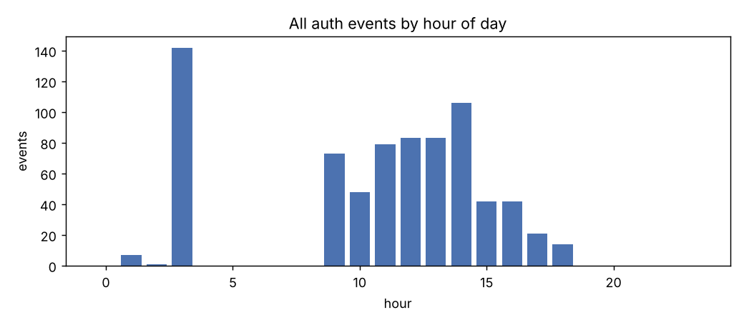
Activity follows working hours. The small bar at 01:00 is the nightly backup job, and the tall bar at 03:00 is the brute force attack (F1).
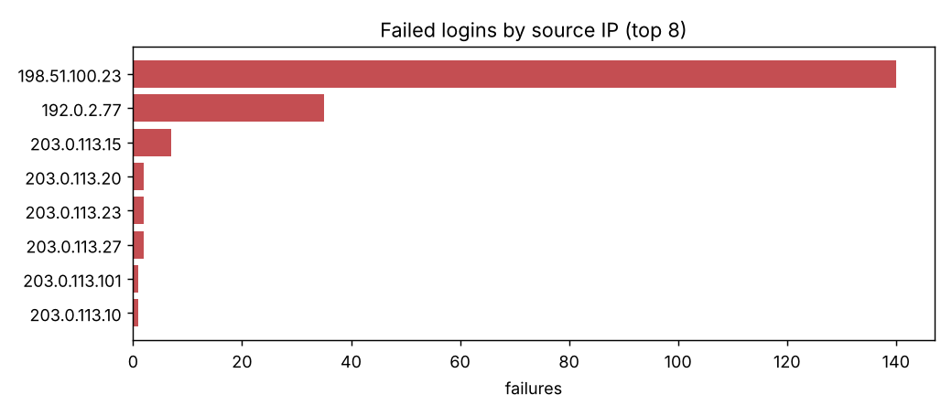
Two outside addresses cause nearly all the failures. Normal users have one or two.
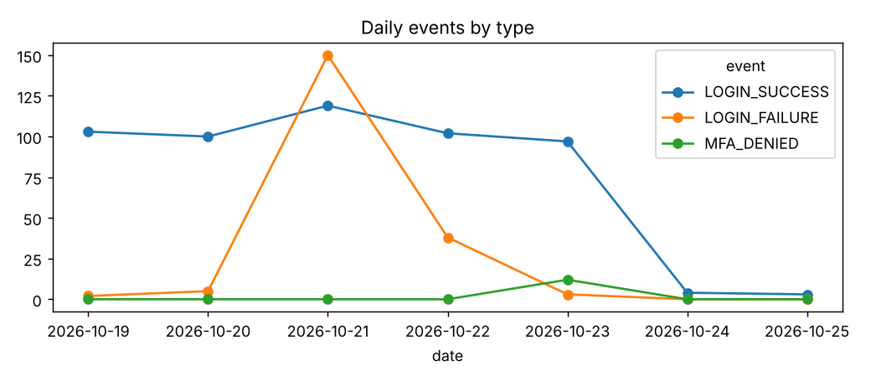
Failures jump on Wednesday 21 Oct (F1) and Thursday 22 Oct (F2).
One more thing I noticed: python-requests/2.31 shows up 143 times, which makes it look like a common client. In fact 142 of those come from a single attacking address. If I had only counted how often each client appears, I would have thought it was normal.

4. What stood out
I have given each finding a rough severity, based on how likely it is to be a real attack and how much damage it could do.

Things that need looking at straight away
F1: Brute force on the admin account (critical). On Wednesday 21 October, from 03:10 to 03:23, the address 198.51.100.23 (Russia) failed to log in as admin 140 times. That is roughly ten tries a minute, all from a script (python-requests/2.31). At 03:26 the same address logged in successfully. The failures stop exactly when a success appears, which strongly suggests the password was guessed. The time of night, the country and the tool all fit an attack. I considered whether it could be an internal script with a wrong password, but this address is outside the company and no legitimate user ever used it. What to do: treat admin as compromised, reset the password, end its sessions, block the address and review everything done after 03:26.
F9: A new admin account created right after (critical). At 03:31, five minutes after that login, the same session gave the domain_admin role to a new account called svc_tmp01. Attackers often do this so they can keep access even if the original password is changed. This is what makes F1 look like a real incident and not just an attempt. What to do: disable svc_tmp01, check whether it has been used, and audit what admin did.
F2: Password spraying (critical). On Thursday 22 October between 14:00 and 14:27, the address 192.0.2.77 (Brazil) tried 24 different accounts, only once or twice each, 35 attempts in total. Four of the names did not exist (testuser, hr, finance, backup), which looks like guessing common names. At 14:33 it got into the account dpatel. This is the opposite of F1: instead of hammering one account, it tries a few passwords on many accounts, which stays under the lockout limit. What to do: treat dpatel as compromised and look for other activity from the same address.
F3 for dpatel: impossible travel (high). dpatel logged in from India at 14:31:33 and from Brazil at 14:33:00, a minute and a half apart. That backs up F2, because it looks like the real user and the attacker were both active at the same moment.
F4: MFA fatigue on tnair (high). On Friday 23 October, from around 11:40, the address 192.0.2.150 (China) triggered 12 phone approval requests in 8 minutes and the user denied every one. A login from the same address succeeded at 11:50. Whoever was doing this already knew the password, and kept sending approval requests hoping the user would eventually accept one. The success ten minutes later suggests that is what happened. The log also shows two impossible-travel alerts for tnair (India to China, then China back to India). The second is probably the real user logging in again, so I treat all three alerts as one incident. What to do: contact the user, reset the password, end sessions, and move to number-matching approvals.
F3 for asharma: impossible travel (high). On Tuesday 20 October, asharma logged in from India at 10:05 and from Germany (198.51.100.140) at 10:22, just 17 minutes apart. The browser was the same as usual, so the client tells us nothing. It could be a VPN that exits in Germany, and the log cannot rule that out, so the next step is simply to ask the user and see whether the second session did anything unusual.
F5: Service account used like a person (high). svc_backup normally logs in once a night at about 01:00 from 203.0.113.5 using backup-agent/2.1, and did so seven times that week. On Saturday 24 October at 16:14 it logged in from 198.51.100.88 (Netherlands) using an ordinary web browser. A service account should never do that. What to do: ask the owner, rotate its secret and reduce its permissions.

Things worth a quick check
F6: A script used on a normal account (medium). On Thursday 22 October at 09:30, lfernandes logged in using python-requests/2.31. The other 29 logins for this user are from Chrome on a Mac. It might be a script they run themselves, or a stolen password used through a tool. The address is a normal office address and it only happened once, so the risk is lower. A quick question to the user should settle it.
F7: Late night login for mkhan (low). On Saturday 24 October at 02:47, mkhan logged in. They had never logged in at that hour before, but the login came from their usual home address, in India, with their usual browser. That looks like someone on call. I would only escalate it if they could not explain it.

Probably harmless
F8: Account lock for jroy (info). On Wednesday 21 October, jroy failed five times in a row from one office address, about 20 seconds apart, and the account was locked. Fourteen minutes later the helpdesk reset the password and jroy logged in normally. This is what a forgotten password looks like. One known address, a small number of tries, and a helpdesk reset. The only thing to confirm is that a helpdesk ticket exists.

5. Facts and guesses
I tried to keep what the log proves separate from what I am assuming. Here it is for the admin incident.
The log shows | My guess (needs other evidence) | The log cannot tell us
140 failures from one Russian address in about 14 minutes, then one success at 03:26 | The attacker guessed the password | What the attacker did once inside
svc_tmp01 was given domain_admin at 03:31 from the same address | It is a backdoor for later | Whether svc_tmp01 has been used since
The client was python-requests/2.31 | A brute force tool or a custom script | Which tool it was, or who is behind the address

6. Summary of findings
No. | Severity | Type | Account | Source | What to do
F1 | Critical | Brute force, then success | admin | 198.51.100.23 (RU) | Investigate now
F9 | Critical | New admin account | admin, svc_tmp01 | 198.51.100.23 (RU) | Investigate now
F2 | Critical | Password spraying, then success | dpatel and 23 others | 192.0.2.77 (BR) | Investigate now
F4 | High | MFA fatigue, then success | tnair | 192.0.2.150 (CN) | Investigate now
F3 | High | Impossible travel | asharma | India to Germany | Ask the user (VPN?)
F5 | High | Service account misuse | svc_backup | 198.51.100.88 (NL) | Investigate
F6 | Medium | Unusual client | lfernandes | office address | Quick check
F7 | Low | Off-hours login | mkhan | own home address | Probably fine
F8 | Info | Account lock | jroy | office address | Fine, confirm ticket
The findings.csv file has 12 rows and this table has 9, because the impossible travel rule fires once for dpatel and twice for tnair. I grouped those with their main incident here.

7. Limits of this analysis
- The data is made up and the attacks were planted by me, so finding them shows the method works. It does not show it would be this clean on a real log, where VPNs, mobile networks and shared addresses cause many more false alarms.
- The country check is very rough. Impossible travel is judged by a change of country within two hours, not by real distance.
- The thresholds were my own choices (20 failures in 30 minutes for brute force, 10 or more accounts with 3 or fewer tries for spraying, 5 or more denied approvals in 15 minutes). On a real system they would need tuning.
- A login log shows who got in, not what they did afterwards. For that I would need application and endpoint logs.
- The log cannot prove intent. Words like “likely compromised” are my conclusion from a pattern, and would need confirming with the users and other data.

8. What I would recommend
- Contain: reset admin, dpatel, tnair and svc_backup, disable svc_tmp01, and block 198.51.100.23, 192.0.2.77 and 192.0.2.150.
- Detect: alert on bursts of failures per address and on many accounts tried from one address, on a success after a burst of failures, on logins from a new country, on bursts of denied approvals, and on any interactive login by a service account.
- Prevent: use number-matching approvals for MFA, restrict admin logins by location, tie service accounts to fixed addresses, and rate-limit or lock out by source address as well as by account.

9. Evidence
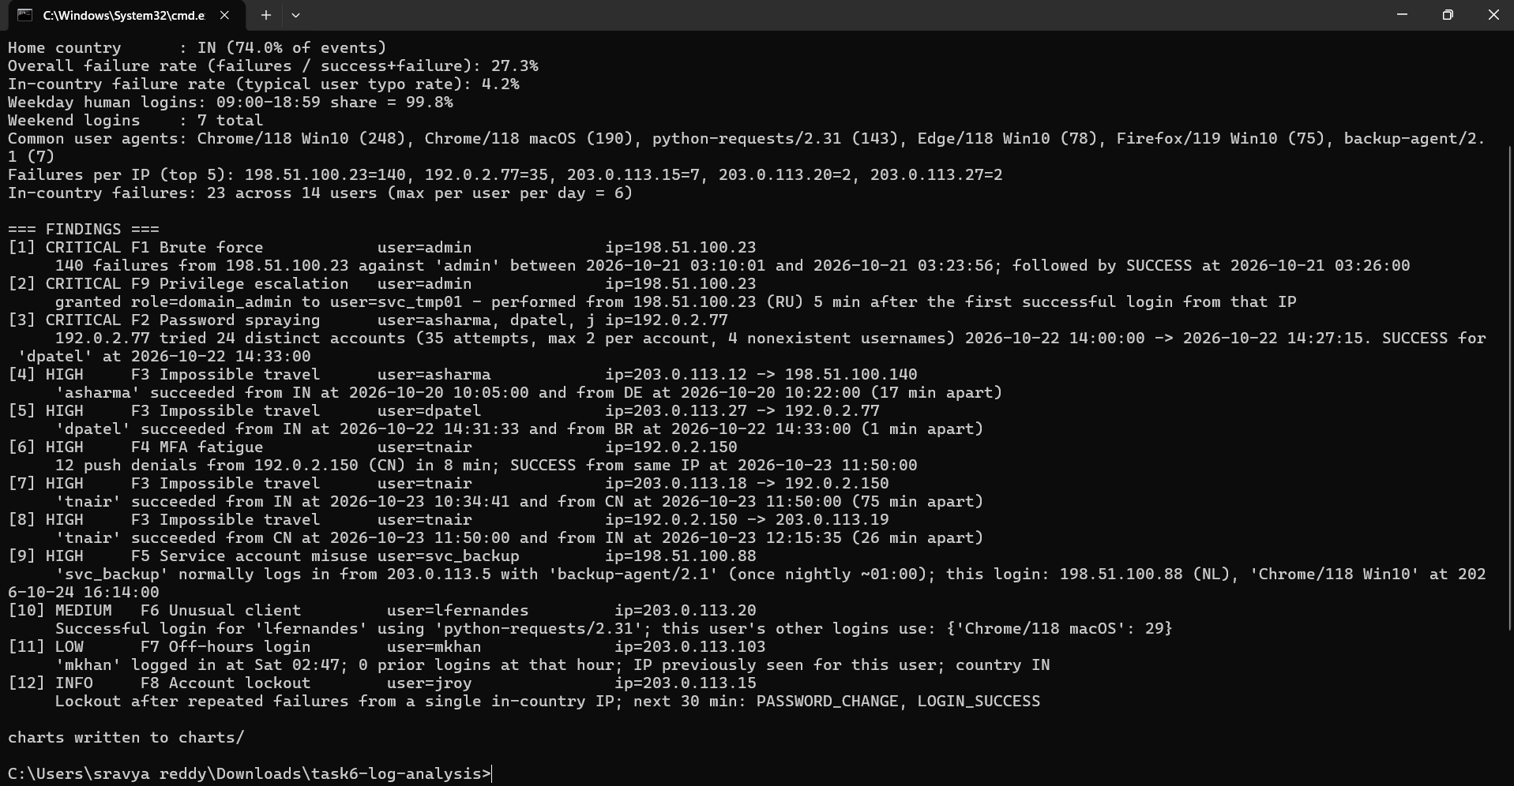
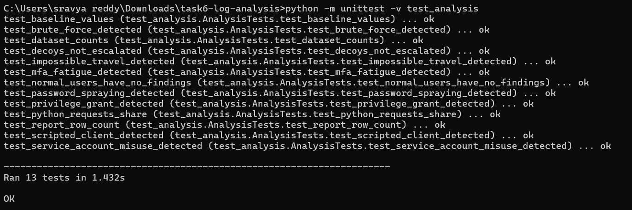

10. References
- NIST SP 800-92, Guide to Computer Security Log Management. https://csrc.nist.gov/pubs/sp/800/92/final
- MITRE ATT&CK T1110, Brute Force (includes password spraying). https://attack.mitre.org/techniques/T1110/
- MITRE ATT&CK T1621, Multi-Factor Authentication Request Generation. https://attack.mitre.org/techniques/T1621/
- MITRE ATT&CK T1078, Valid Accounts. https://attack.mitre.org/techniques/T1078/
- RFC 5737, IPv4 Address Blocks Reserved for Documentation. https://www.rfc-editor.org/rfc/rfc5737
- Cybersecurity Assessment Task Catalogue, Task 6.

