**Class timing- Tuesday , Thursday**

**Assignment submission form:**[**https://forms.gle/EbKTzLd7DyBccip49**](https://forms.gle/EbKTzLd7DyBccip49)

**Deadline: before next class(Tuesday)**

**13/12/2022**

* WAP to accept two numbers from the user and display their sum
* WAP to accept radius of a Circle from the user and calculate area and circumference
* WAP to accept roll number , grade and percentage as input from the user and display it back
* Write a program that asks the user to enter his/her name and age. Print out a message , displaying the user’s name along with the year in which they will turn 100 years old.
* Write a program that asks the user to input 2 integers and adds them . Accept both the numbers in a single line only
* Write a Python program which accepts the user's first and last name and print them in reverse order with a space between them.

**—-----------------------------------------------------------------**

**15/12/2022**

* **WAP to accept an integer from the user and check whether it is an even or odd**
* **WAP to accept a character from the user and check whether it is a capital letter or small letter. Assume user will input only alphabets**
* **WAP to accept a character from the user and check whether it is a capital letter or small letter or a digit or some special symbol**
* **WAP to accept 3 integers from the user and without using any logical operator and cascading of relational operators , find out the greatest number amongst them**

**—--------------------------------------------------------------**

* **WAP to accept a year from the user and check whether it is a leap year or not.**

**An year is a leap year if:**

**It is exactly divisible by 4 and at the same time not**

**divisible by 100**

**OR**

**It is divisible by 400**

**For example:**

**2017 is not a leap year**

**2012 is a leap year**

**1900 is a not leap year**

**2000 is a leap year**

* **You have to develop a number guessing game. Following are the steps needed:**
* **At first , the program will generate a random integer secretly.**
* **Now it will ask the user to guess that number .**
* **If the user guessed it correctly then the program prints “Congratulations! You guessed it right” .**
* **But if the number guessed by the user is larger than the secret number then program should print “Number too large” and , if the number guessed by the user is smaller than the secret number then the program should print “Number too small”**
* **This should continue until the user guesses the number correctly or quits .**
* **If the user wants to quit in between he will have to type 0 or negative number**

**—-----------------------------------------------------------------**

* Write a program to accept a string from the user and display it vertically but don’t display the vowels in it.
* Write a program to continuously accept integers from the user until the user types 0 and as soon as 0 is entered display sum of all the nos entered before 0

**Note:Modify the previous code so that if the user inputs a negative integer , your program should ignore it .**

* Write a program using a for loop to accept a string from the user and display it vertically but don’t display the vowels in it.
* Write a program to accept an integer from the user and display the sum of all the numbers from 1 to that number.
* Write a program to accept an integer from the user and calculate its factorial
* Write a program to print the following pattern

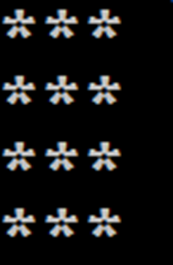

* Write a program to print the following pattern

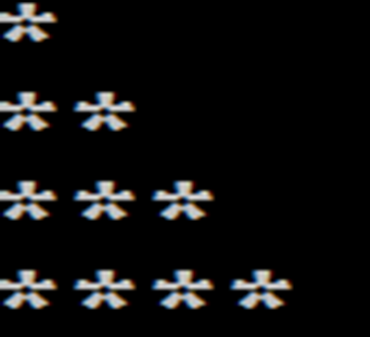

* Write a program to print the following pattern

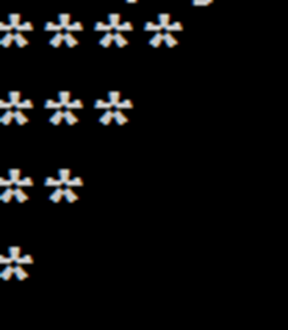

* Write a program to accept an integer from the user and display all the numbers from 1 to that number. Repeat the process until the user enters 0.