Project Members

S. No Name Roll No Branch
1. M. Prathik Reddy 23P81A6946 CSO
2. Anumula Samarth 23P81A6906 CSO
3. Surya Kiran 23P81A6952 CSO
4. Ch. Sathvik Kumar 23P81A6912 CSO
5. DL. Sravya 23P81A6718 CSD

PROBLEM STATEMENT:
How can we leverage IoT technology to create an efficient, automated water level control and monitoring system that optimizes water usage, prevents wastage, and provides real-time insights for better water management?
- OBJECTIVE: Efficiently managing a borewell to ensure consistent water availability, preventing over-extraction, and minimizing the maintenance by converting into a smart device.
- REQUIREMENTS/FEATURES OFFERED:
- Monitoring water levels
- Automate the pump based on water levels.
- Ensure safety mechanisms to prevent dry runs or overflows.
- Provide data logging for usage analytics.
- Integrate alerts for low/high water levels or pump malfunctions.

Date | Updated information
16th August 2024 | Research about hardware and software to be used
17th August 2024 | Collection of Hardware Components
23rd August 2024 | Detailed research and Installation of Software’s (C++) to be used
4th September 2024 | Detailed research of functionalities and attributes of ESP8266 (Wi-fi Module)
6th September 2024 | Setup of BLYNK console was done
9th September 2024 | Installation of Arduino IDE and required Header files
12th September 2024 | Designing of the Circuit and connections are implemented on the Bread Board.
13th September 2024 | Virtual pins and data streams for the circuit has been setup for the BLYNK console
14th September 2024 | Testing the model through references
15th September 2024 – 27th September 2024 | Working on the failures of the model and re-modifying it using various references and sources
7th October 2024 – 13th  October 2024 | Working model has been tested alternately using mini relay.
15th October 2024 | Recorded a demo video of the working model
16th October 2024 | Took mentors opinion regarding the working-model
18th October 2024– 21st October 2024 | Demonstration of the project to the College Management.
22nd October 2024 | Implemented the working model by replacing the mini relay with single phase relay parallelly connected with 3 phase relays.
24th October 2024 | Implemented the working model using the three-phase relay.

25th October 2024 | Got instructions from the college to implement the working-model on the college motor and worked on the wiring regarding this.
4th November 2024 | Reviewing of the code which was dumped in ESP
5th November 2024 | Started to work on implementing the working-model on the college motor
6th November 2024 | While implementing, we came to know that the pipeline system of our college is in-compatible with our project.
7th November 2024 | Informed this problem to the management and they instructed us to implement it by taking our mentors advice and proper research on the pipeline system of the college.
8th November 2024 | Due to some misleading, there was a new functionality added to the code and we started working on it.
9th November 2024 | We completed working on the functionality and came to know it was not mandatory.

HARDWARE AND SOFTWARE REQUIREMENTS:
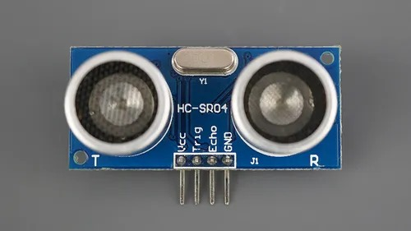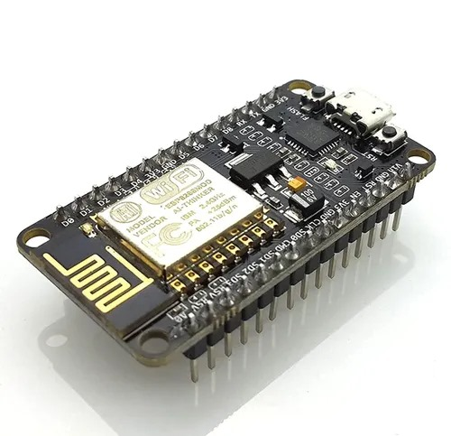
Ultra sonic sensor Wifi-module(ESP)

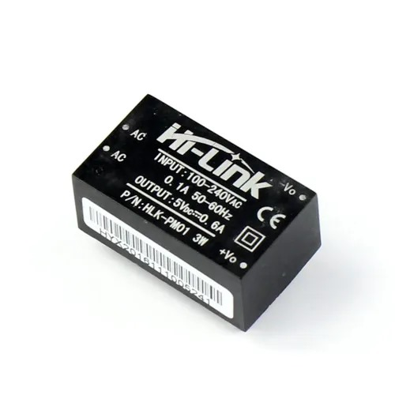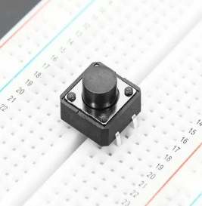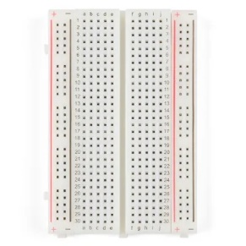
Hi-Link Button Bread Board

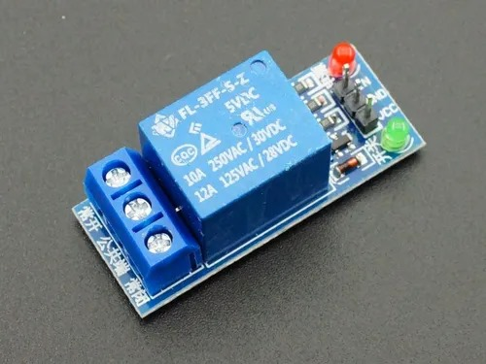
Relay Jumper-wires
Software Requirements:
Installation Process of ARDUINO IDE:
Step-1: Make sure that your device is connected to a stable internet.
Step-2: Consider the following link to download ARDUINO IDE.
https://support.arduino.cc/hc/en-us/articles/360019833020-Download-and-install-Arduino-IDE
Step-3: Select the Software Option. Download the application according to your device’s software and wait for it to get installed.
Step-4: Review the license agreement, then click "I Agree".
Step-5: Select the components to install, then click “I Agree”.
Step-6: Select your destination location to store your VS code, then click “Install”.
Step-7: To install the software on your device, then click “Install” 3 times.
Step-7: The installation process is completed, then click “Close”.

Dealing with the code to be dumped in the Hardware:
- After installing the ARDUINO IDE, to run the app double click on the app icon.
- To connect your ARDUINO IDE with your hardware, we use packages, plug-ins and extensions in the application.
- We have Boards Manager to connect our ESP8266 (Wi-fi Module) to our ARDUINO IDE using ARDUINO AVR Boards.
- We dumped the source code to the ESP.
Designing of the circuit:
- We designed the required circuit for the working of the prototype.
- Took 1 day to design the circuit, the next day we started running the prototype but there occurred a failure due to high voltage.
- Again, took an ESP, dumped the code but the prototype wasn’t working. This time the resistor was damaged due to voltage fluctuation.
- For a month we encountered many issues like the hardware was damaged and sometimes the components of the circuit were not responding.
- We re-designed the circuit and re-modified the code from the beginning.
- By September month-end, one of the functionalities started responding to the code.
- After a period of time, the functionalities of the prototype started responding successfully.
- The prototype was completed successfully.
Setting up a platform to test the prototype:
Blynk.Console:
Step-1: Make sure your device is connected to a stable network.
Step-2: To use the Blynk.console, visit the following link
https://blynk.io/
Step-3: Enter your log-in credentials or sign up to log-in.
Step-4: We initially have to connect our ESP to the BLYNK.console with the “Add device” option.
Step-5: After connecting the device, we will be provided few credentials which are “Template_ID”, “Template_Name”, “Authentication_Token”.
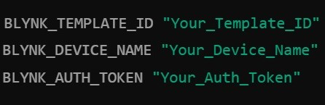
Step-6: We have to store these credentials as they are confidential.
Step-7: We have to update these credentials and also our wi-fi credentials in our ESP.
Step-8: We have modified our dashboard with various data-streams and virtual pins.

WHAT IS AUTOMATED - BOREWELL SYSTEM?

Definition:
The Automated Borewell System efficiently manages both water extraction and distribution, focusing on maintaining control over operations and promoting sustainability. The system has sensors and automation technology, which monitor the water levels in real time and only turns on the borewell motor whenever it is necessary. This way, it optimizes water usage. It is linked with automated switching based on predefined water levels, remote monitoring capabilities and safety measures for dry running and motor overheating. The focus of this project is going to be the efficient use of water in agriculture, household uses, and industries, it aims to minimize wastage of water, save energy and offer a safe and reliable approach for water management.
Advantages:
Water Conservation: The system promotes water conservation by automatically adjusting how much water is drawn based on real-time water levels.
Energy Efficiency: It prevents the motor from running unnecessarily, thereby saving energy and lower electricity consumption bills.
Preventing Dry Runs: When water levels drop too low, sensors in the system quickly shut off the motor to prevent it from running without water, this is called dry-running which ultimately shortens the motors life span. By stopping the motor in these situations, the system protects it from damage.
Reduced Maintenance Costs: Automation prevents the mechanical wear from overuse, thereby reducing maintenance needs and costs over time.
Remote Monitoring: The system includes connectivity features that allow users to monitor and control it remotely, which is especially helpful for those using borewells in agriculture and industrial settings.
Improved Reliability: Automated systems make the water supply more consistent by maintaining steady water levels, which helps in preventing unexpected breakdowns and ensures smooth, efficient operation.
Environmental Sustainability: As the system supports efficient use of water and lesser energy wastes, it goes in agreement with sustainable practices. It is well-suited for community and environmentally friendly.

PURPOSES OF THE AUTOMATED BOREWELL SYSTEM:
- Automate Borewell Operation:
The main goal of the system is to automate how the borewell works by using sensors and smart control features. This ensures the pump runs only when necessary, based on the actual water levels, making the whole process more efficient.
- Reduce Human Intervention:
By using the Automation process, the system reduces the need for constant human monitoring, making it easier for users/clients to manage borewells, especially in areas which are hard to access.
- Ensure Consistent Water Supply:
The system ensures a consistent water supply by monitoring water levels and maintaining pump operation. This avoids conflicts in water availability, which is critical for agricultural or industrial use.
- Provides Protection Mechanisms:
The purpose is also to safeguard the motor and the borewell system from damage by using automated protection features like dry-run prevention, motor overload and overheat protection, and real-time fault detection.
- Enhance Data-Driven Decision Making:
The system provides real-time data and insights, allowing users to make informed decisions about water usage, maintenance, and system optimization. This can lead to more efficient resource planning.
- Promote Sustainability and Resource Efficiency:
By carefully managing water extraction and reducing energy consumption, the system supports sustainable water practices. It helps conserve water and energy, benefiting both the environment and the users in the long run.
1. Technical Feasibility
- The system is built using readily available technology like sensors, controllers, and motors, making it easy to implement and integrate with existing borewell setups. Automation ensures smooth operation and reliable performance, with minimal maintenance needs.
- Designed to enhance, the system’s automation reduces human errors and operational failures. With proper maintenance, the system can run for long periods with minimal intervention, ensuring dependable performance.
- The system is designed to be user-friendly, and in case of any issues, we can either seek guidance from our mentor or refer to a detailed manual guide to troubleshoot and resolve the problem efficiently.
2. Financial Feasibility
- The working model was ideal to our estimated costs. The entire equipment was purchased by us very carefully.
- Our management supported us to maintain a quotation for each equipment. Through that quotation, our management approval will let us purchase it.
- Such working-models in the market are sold in the range of 10,000-20,000 INR but the entire model costed us less than 3000 to get it working.
- By this we can say the working-model is not only affordable but also very optimized.
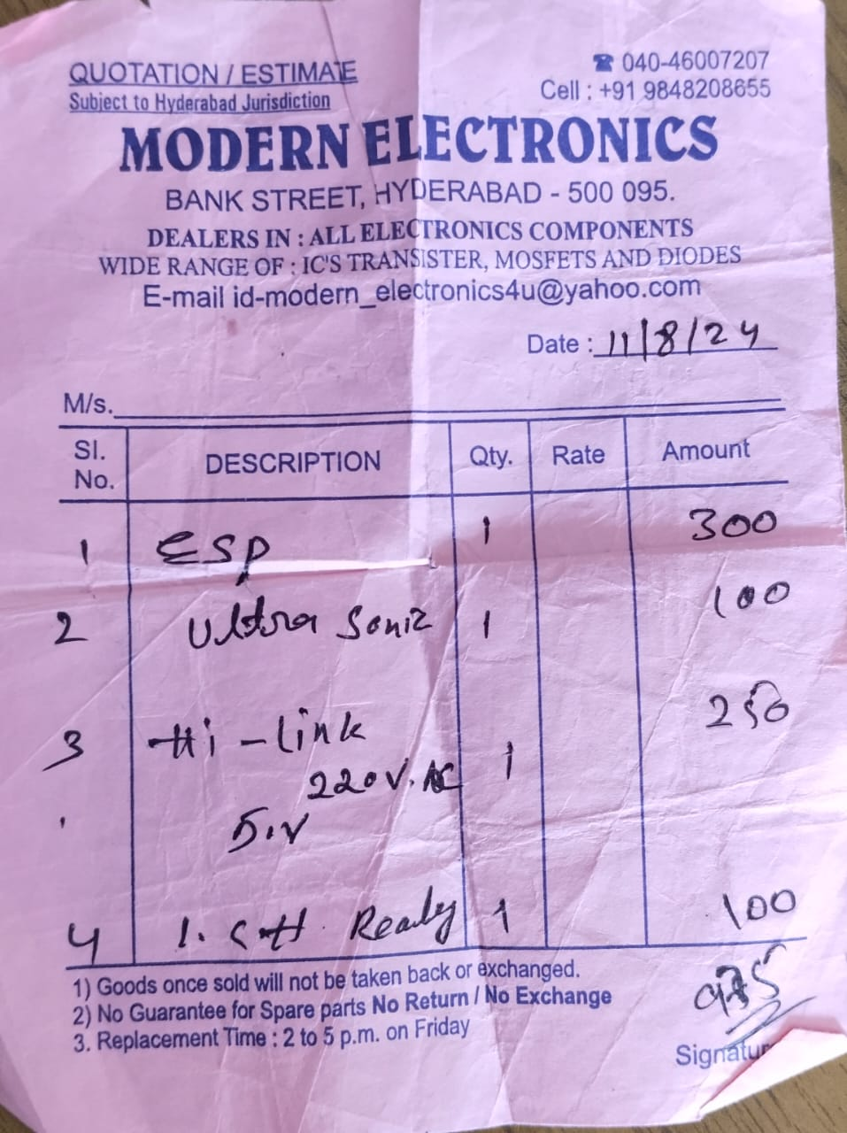
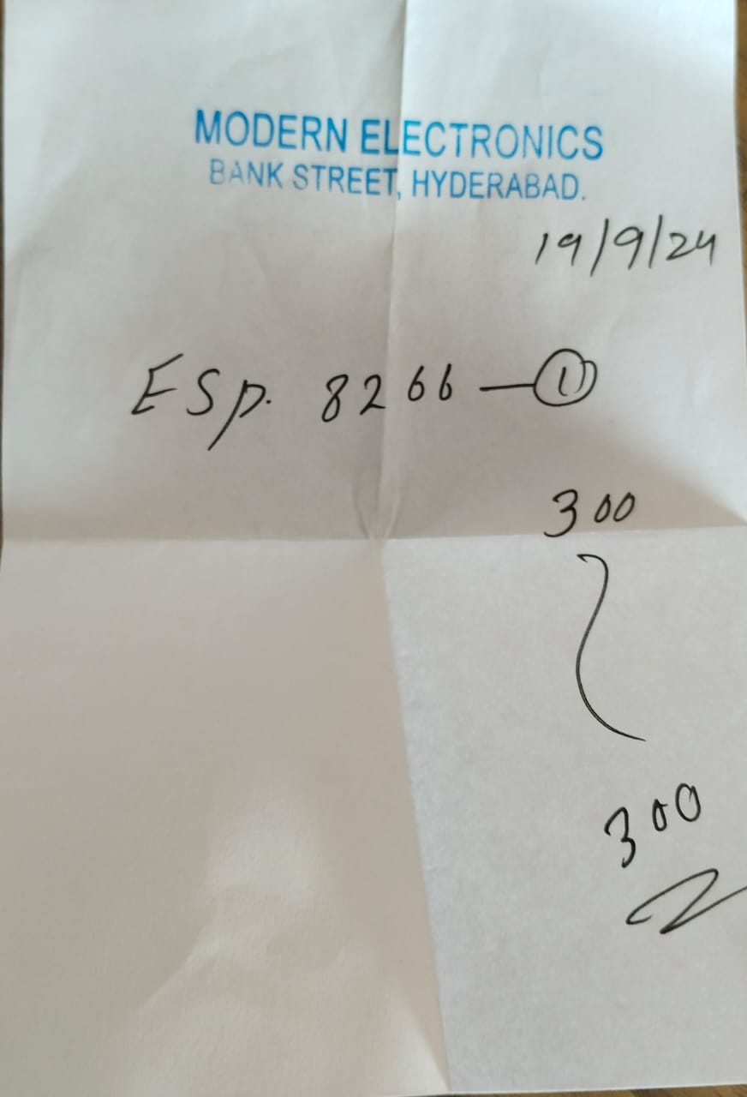
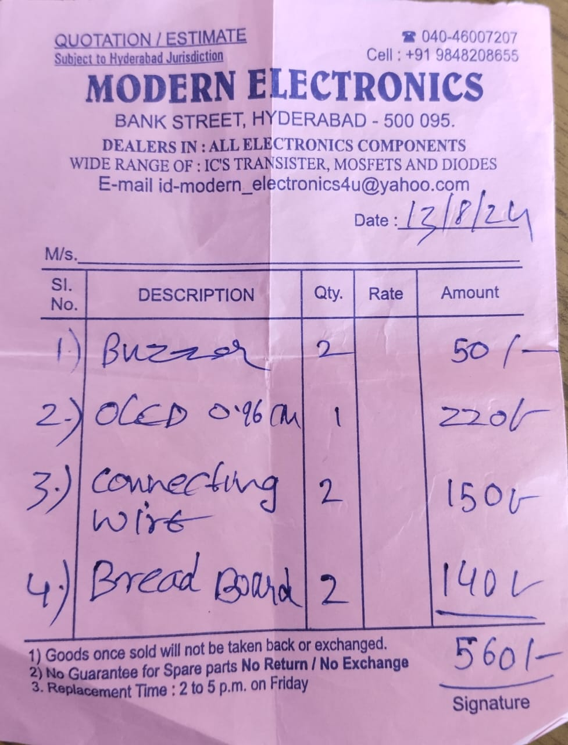

3. Operational Feasibility
- The system is easy to use and operates automatically, reducing the need for constant manual monitoring. It’s scalable, so it can be adapted for both small and large-scale applications, making it versatile for various user needs.
- The system is user-friendly, especially for non-experts. After installation, it requires little ongoing attention, and remote monitoring makes it easy to track performance from anywhere.
- The system is specifically designed to reduce the maintenance so it requires regular checks for the sensors and the connections.
- The protection features help to prevent the breakdowns of the system.
4. Environmental Feasibility
- This helps to conserve water, which is especially crucial in areas with limited resources.
- One of the primary environmental benefits is the reduction in energy consumption. The automated system ensures that the pump only operates when required, meaning it avoids unnecessary running.
5. Social and Market Feasibility
- Water management is a major challenge in agriculture, with many farmers still using inefficient irrigation methods. The Automated Borewell System offers a smart solution to optimize water usage, addressing water scarcity.
This way the system gains a higher market demand.
- Industries such as manufacturing, mining, and textiles depend heavily on water for their operations. The Automated Borewell System helps these industries use water more efficiently, cutting down on waste. With growing pressure to become more sustainable, this system provides a cost-effective way to reduce expenses.
- In areas with limited or unreliable water supply, the Automated Borewell System offers a dependable and efficient way to extract water.
- The system helps make water more accessible, truly benefiting those who need it most, especially in communities facing water scarcity.

CHALLENGES:
Regarding Software:
- Initially we started working on the code using C++ which is dumped in the hardware equipment (wi-fi module) on different platforms such as VS code, BLYNK web and Arduino IDE while facing quiet many challenges on creating and managing the header files.
- After having an overview throughout the code in the BLYNK web, we encountered an error. As we completed the debugging we dumped the code in the hardware equipment.

