def readFile(filepath):

with open(filepath, 'r') as f:

filedata = f.read() # Reads the entire file data into a string

return filedata

filepath = 'DataFiles/data.txt'

print(readFile(filepath))



# Function to read a file into a list of lines

# Each element in the list is one line in the file - Line Processing

def readFileIntoList(filepath):

with open('DataFiles/data.txt', 'r') as f:

filedata = f.read()

lines = filedata.split('\n')

#lines = []

#for line in f:

#lines.append(line)

return lines

#filepath ='DataFiles/data.txt'

readFileIntoList(filepath)



# Function to count number of lines in a file

def countLinesFile(filepath):

count = len(readFileIntoList(filepath))

return count

countLinesFile(filepath)

O/p 4

def charCountFile(filepath):

count = len(readFile(filepath))

return count

charCountFile(filepath)

O/p 235

# Function to count the number of words in a file

import re

def wordCountFile(filepath):

pattern = '[ \n]'

filedata = readFile(filepath)

count = len(re.split(pattern, filedata))

return count

def wordsFromFile(filepath):

pattern = '[ \n./]'

filedata = readFile(filepath)

allWordsList = re.split(pattern, filedata)

return allWordsList

wordsFromFile(filepath)

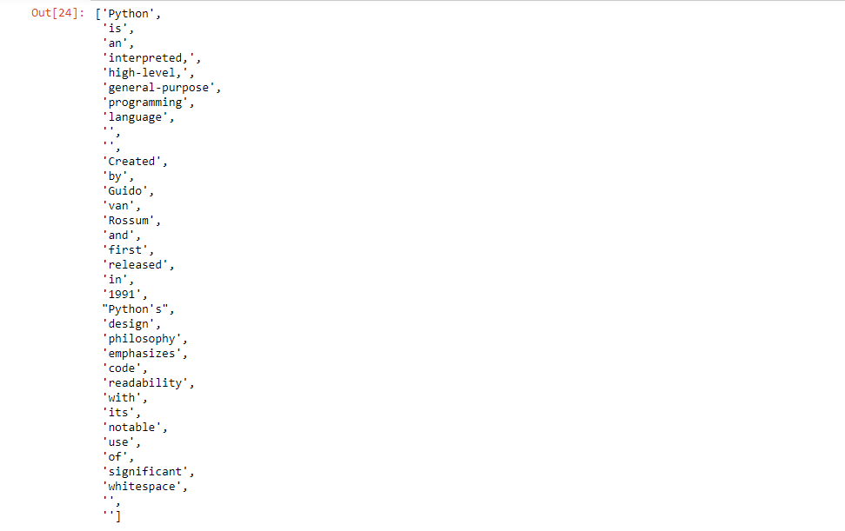

fh = open(filepath, "w")

lines_of_text = ["a line of text", "another line of text", "a third line"]

fh.writelines(lines_of_text)

fh.close()

filepath='DataFiles/tex.txt'

o/p a line of text another line of text a third line

#To append to file, use:

fh = open(filepath, "a")

fh.write(" \n Hello World again")

fh.close()

filepath='DataFiles/tex.txt'

O/p Hello World again