When Reconstruction Fails: Latent Space Analysis of VAE for Chest X-Ray Anomaly Detection
Annapurna Srayashya Iruku
U01150990
CS-7830-01 Machine Learning, Wright State University

Abstract—This paper looks at unsupervised anomaly detection in chest X-rays using a Variational Autoencoder trained on the NIH Chest X-Ray14 dataset (112,120 frontal images, 30,805 patients). The main finding is honestly a bit surprising: the composite anomaly score barely beats random (AUC-ROC = 0.479), yet an MLP trained on the same frozen latent vectors reaches AUC-ROC of 0.729 and 68% accuracy. That 0.25 gap tells us the VAE is learning something genuinely useful about disease — reconstruction error just isn’t the right tool to read it out. Three specific causes of the scoring failure are identified and analyzed, and the case is made that supervised latent probing should be a standard part of any VAE evaluation in medical imaging.
Keywords—variational autoencoder, anomaly detection, chest X-ray, NIH Chest X-Ray14, unsupervised learning, latent space probing, reconstruction error, UMAP, clustering.
GitHub: https://github.com/srayashyasharma/ml-final-project

I. Introduction
Chest X-rays are ordered constantly — probably more than any other imaging study in routine clinical practice. Despite that, reading them well still demands years of training, and even experienced radiologists miss things, especially when they’re tired or working through a large queue. Pneumonia, pleural effusion, and pulmonary nodules are among the conditions most commonly missed in high-volume settings [1].
The appeal of unsupervised methods here is straightforward. If a model can be trained on unlabeled X-rays and flag anything that looks unusual, the expensive label-collection problem is sidestepped entirely. Variational Autoencoders seem like a natural fit — they learn a probability distribution over the training data, so images that fall far outside that distribution should score as anomalous.
In practice, though, it doesn’t always work that cleanly. The VAE trained here reconstructs chest X-rays reasonably well after 40 epochs, yet the anomaly score it produces is essentially random (AUC = 0.479). At the same time, a simple MLP trained on the VAE’s latent codes reaches 0.729 AUC without any architectural changes. That gap is what this paper is about — figuring out why the scoring failed when the representation clearly didn’t.
My professor flagged an important concern in an earlier draft: unsupervised clusters don’t necessarily correspond to clinical disease categories. I took that seriously and added two evaluation components — UMAP visualization labeled by ground truth, and the MLP probe just mentioned. The main contributions are:
- A convolutional VAE with combined MSE + SSIM + VGG-16 perceptual loss trained on 20,000 NIH chest X-ray images, producing a 256-dimensional latent space.
- A composite anomaly score using pixel-wise reconstruction error together with Mahalanobis distance from the training latent distribution.
- An MLP probe on frozen latent vectors reaching AUC-ROC 0.729 and 68% accuracy, used as a measure of how much disease-relevant information the representation holds.
- An analysis of why reconstruction-based scoring failed, backed by UMAP visualization and K-Means / Fuzzy C-Means clustering experiments.

II. Related Work

A. Supervised Methods
DenseNet [1] and ResNet [2] trained with full NIH labels hit per-pathology AUC scores in the 0.70–0.87 range — strong results, though they require annotation that costs real time and money. My setup doesn’t assume any labels during training, so I can’t directly compare these numbers, but they give a sense of what the ceiling looks like for this dataset.

B. Autoencoder-Based Anomaly Detection
The basic idea — train on normal data, flag anything that reconstructs poorly — goes back at least to [3]. VAEs extend this by providing a probabilistic latent space, which enables Mahalanobis distance as a second anomaly signal [4]. In practice, reconstruction-based anomaly AUC on medical images tends to be modest. Baur et al. [3] got 0.60–0.72 on brain MRI with similar architectures. The 0.479 obtained here is worse, and the gap is worth explaining rather than just reporting.

C. Probing Latent Representations
Higgins et al. [4] showed that what a VAE learns isn’t always visible in cluster structure — disentangled features can be encoded in ways that don’t map cleanly to geometric separation. The standard response is to train a small supervised head on frozen latent codes, which tells you what’s actually in the representation without making assumptions about its geometry. That is exactly the approach taken here.

III. Methodology

A. Problem Setup
Each input x is a grayscale chest X-ray resized to 1×224×224. The encoder maps it to a posterior q(z|x) = N(μ,σ²) with latent dimension 256. The decoder produces x̂ = p(x|z). At test time each image is scored as:
s(x) = ||x−x̂||² + 0.3·d_{Mahal}(μ,μ_{train},Σ) (1)
The mean μ_{train} and diagonal covariance Σ are updated with an exponential moving average (α=0.01) during training to track the latent distribution of whatever images the model is seeing.

B. Model Architecture
The encoder stacks five convolutional blocks, each with a 4×4 stride-2 conv, BatchNorm, and LeakyReLU(0.2). Starting from 224×224 the spatial resolution shrinks to 7×7×512 by the end. Two separate linear layers then project to μ and logσ² in ℝ²⁵⁶. The decoder mirrors this with transposed convolutions and a Sigmoid at the end. No skip connections or residual blocks — keeping the design simple makes things more interpretable. Total parameters: 24,867,713. Fig. 1 shows the full pipeline.
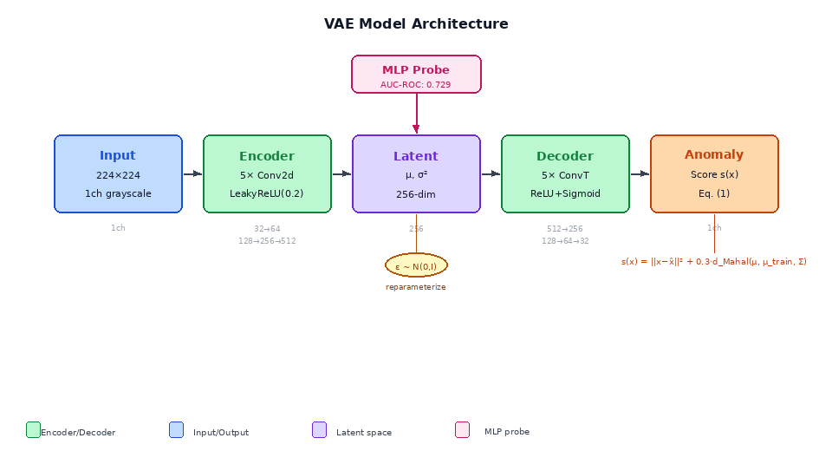
Fig. 1. VAE model architecture. Input X-ray → Encoder (5 conv blocks) → Latent space (256-dim μ, σ²) → Decoder (5 deconv blocks) → Reconstruction → Anomaly score. The MLP probe is trained on the frozen latent codes. Channel dimensions are shown below each block.

C. Loss Function
Training minimizes a combination of four terms:
L = (1−α)·L_{MSE} + α·L_{SSIM} + β_{p}·L_{perc} + β_{KL}·KL (2)
I set α=0.5, β_{p}=0.1, β_{KL}=0.1. The SSIM term was added specifically to fight the blurriness that comes from optimizing MSE alone. Perceptual loss (VGG-16 features at relu1_2, relu2_2, relu3_3) pushes the reconstructions to look more realistic at a feature level. Even so, as Section VI discusses, the sharpness achieved wasn’t enough to make reconstruction error a reliable anomaly signal.

IV. Experimental Setup

A. Dataset
NIH Chest X-Ray14 [5] is a large collection of 112,120 frontal X-rays, each labeled with up to 14 disease findings extracted from radiology reports using NLP. I split patients 70/15/15 into train, val, and test sets — patient-level splits matter here because images from the same patient tend to look similar, and leaking them across splits inflates numbers. Due to compute limits on Kaggle, I trained on 10,000 healthy and 10,000 diseased images with weighted sampling to keep classes balanced.
TABLE I. Dataset Split Summary
Split | Total | Healthy | Diseased
Train | 78,708 | 42,270 | 36,438
Val | 16,758 | 9,190 | 7,568
Test | 16,654 | 8,901 | 7,753

B. Evaluation
For the anomaly scorer I report AUC-ROC (diseased = positive). For the MLP I report AUC-ROC, accuracy, precision, recall, and F1 per class. Clustering gets Silhouette Score, ARI, and NMI. UMAP gives a qualitative 2D picture of the latent space.

C. Training Setup
PyTorch 2.0 on a Kaggle Tesla T4 GPU (16 GB VRAM). AdamW with lr=1e−3, weight decay=1e−4, cosine annealing, 10% linear warmup. Batch size 32, 40 epochs, AMP enabled, gradient clipping at norm 1.0.

V. Results

A. Training Convergence
Loss dropped from 0.98 to 0.69 over 40 epochs. Train and val stayed close the whole way, which tells us the model wasn’t simply memorizing training images. The spike at epoch 2 came from the KL term activating and sorted itself out within a few epochs (Fig. 2).
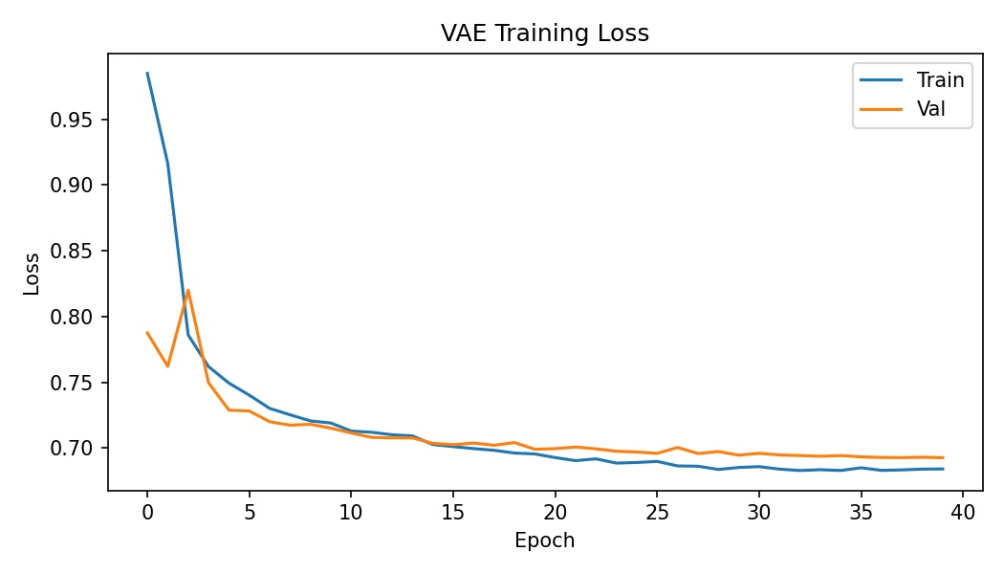
Fig. 2. VAE training and validation loss over 40 epochs. Train and val track each other closely, with a brief spike at epoch 2 from KL warmup.

B. Anomaly Detection Performance
The composite score (Eq. 1) reached AUC-ROC = 0.479 on the test set — just below random. Fig. 3 shows the ROC curve sitting almost exactly on the diagonal, meaning the score carries no useful information about disease status. Section VI explains why.
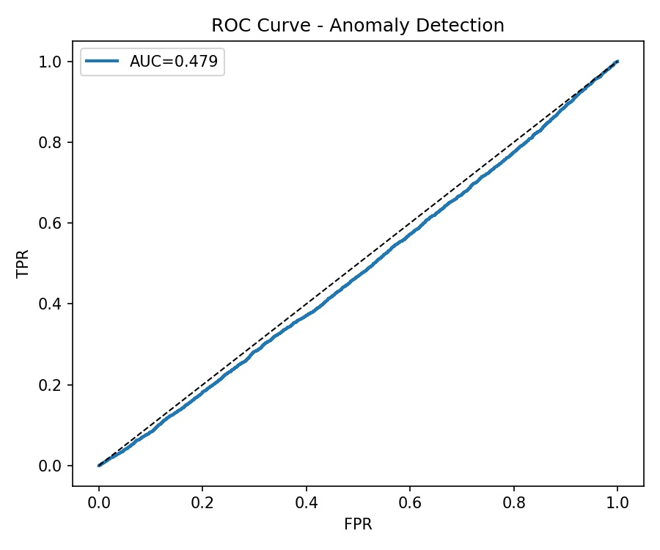
Fig. 3. ROC curve for reconstruction-based anomaly scoring (AUC = 0.479). The curve hugs the diagonal, indicating no useful separation between healthy and diseased images.

C. Latent Space Structure
Fig. 4 shows the UMAP projection of the 256-dim latent space. Healthy and diseased points overlap heavily in the main cluster — there is no clean boundary anywhere. There is one small isolated cluster with notably higher anomaly scores; those images tend to be portable AP views with severe bilateral opacification. So the model did push extreme cases far from the center, but anything more moderate just blends in.
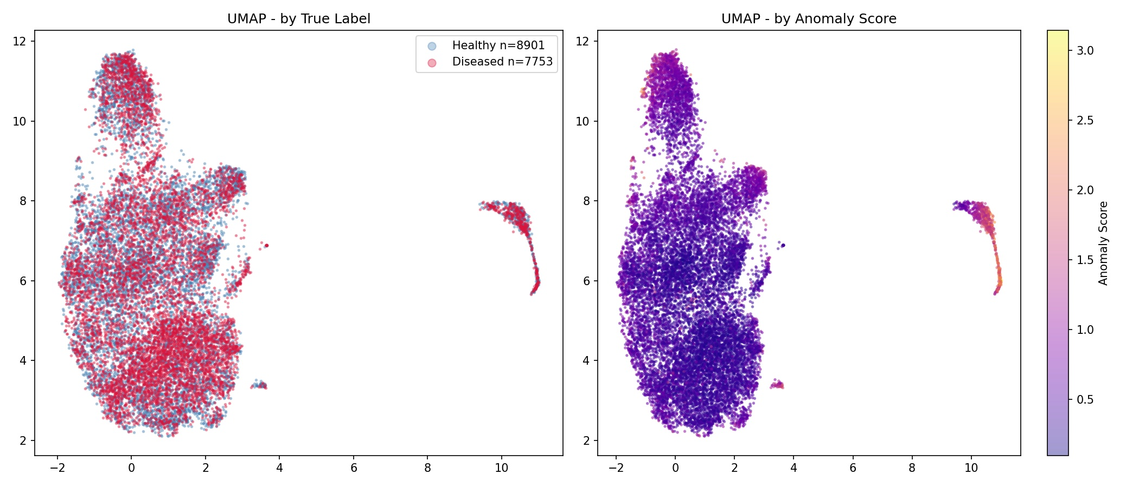
Fig. 4. UMAP of the 256-dim latent space. Left: colored by label — healthy (blue) and diseased (red) overlap almost completely. Right: colored by anomaly score — only the small isolated cluster shows elevated scores.

D. MLP Classification
Freezing the VAE and training a three-layer MLP on top of the latent codes gave AUC-ROC = 0.729 and accuracy = 68%. Table II breaks this down by class. The jump from 0.479 to 0.729 using the exact same latent representation is the clearest sign that the failure was in the scoring method, not in the features.
TABLE II. MLP Classification Report
Class | Precision | Recall | F1 | Support
Healthy | 0.64 | 0.63 | 0.64 | 5,000
Diseased | 0.64 | 0.65 | 0.65 | 5,000
Macro Avg | 0.64 | 0.64 | 0.64 | 10,000
MLP AUC-ROC: 0.729 | Accuracy: 68%
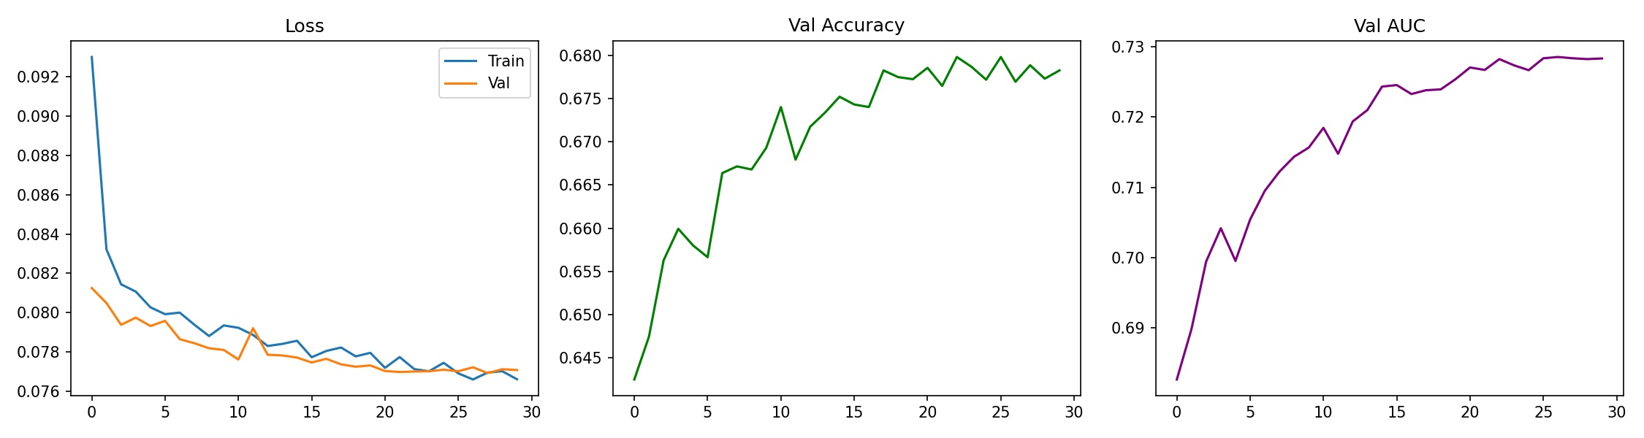
Fig. 5. MLP training curves: loss (left), validation accuracy settling around 68% (center), validation AUC reaching 0.73 (right).

E. Clustering
TABLE III. Clustering Results
Method | Silhouette | ARI | NMI / FPC
K-Means (k=2) | 0.083 | 0.013 | NMI: 0.010
Fuzzy C-Means (c=2) | 0.081 | 0.020 | FPC: 0.500

ARI around 0.013–0.020 is essentially zero — the clusters K-Means finds have almost nothing to do with disease status. That is consistent with the UMAP: disease label isn’t organizing the latent space. Patient size, scan equipment, and projection geometry likely account for most of the variance. Still, the MLP getting 0.729 AUC shows the disease information is in there — just not where a simple clustering algorithm can find it.
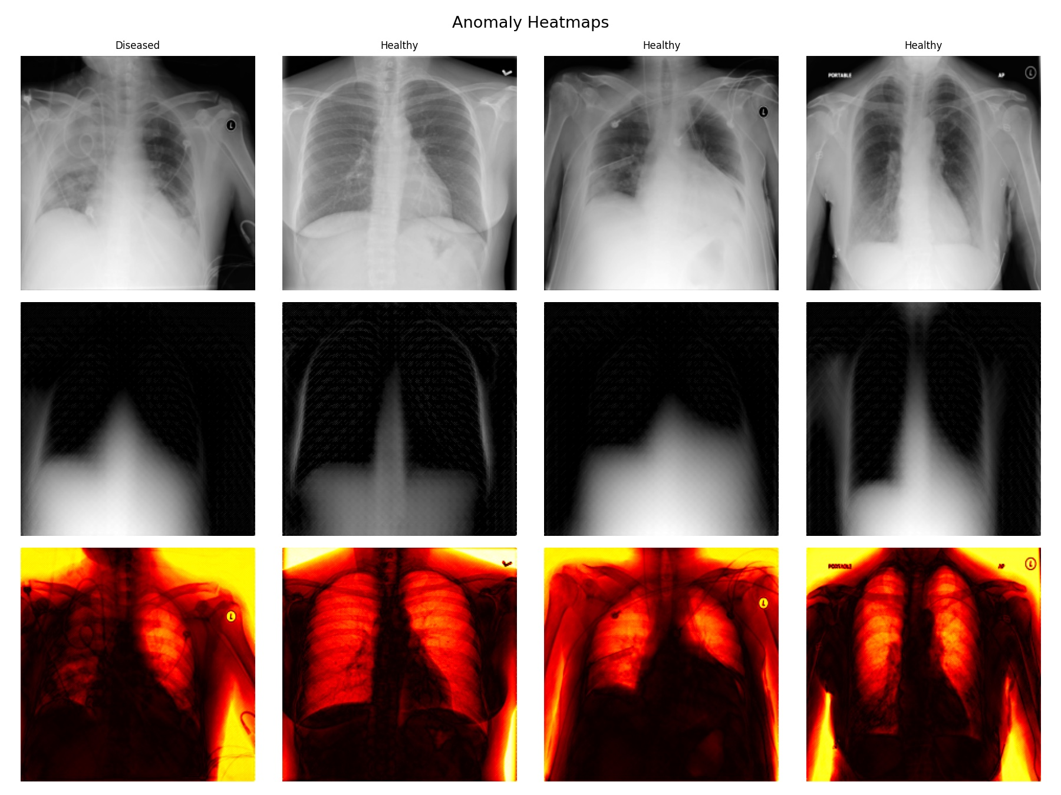
Fig. 6. Anomaly heatmaps. Row 1: original X-rays. Row 2: VAE reconstructions. Row 3: pixel-wise error maps (hot colormap). Error concentrates on edges and borders, not pathological regions.

VI. Discussion

A. Three Reasons the Anomaly Score Failed
AUC = 0.479 is bad enough that it deserves a real explanation rather than a shrug. I think three things went wrong, and they all interact.
Reconstruction blur isn’t pathology-specific. MSE pushes the decoder toward the mean of all plausible outputs given the latent code. The resulting blurriness is spread evenly across the image — it’s just as large over healthy rib structures as over diseased lung tissue. You can see this directly in Fig. 6: the error maps light up along edges and borders, not in the parenchyma where pathology would show up. Adding SSIM and perceptual loss helped the reconstructions look sharper, but didn’t make the error spatially selective for disease.
The model was trained on diseased images too. Because I used class-balanced sampling, half the training images were diseased. That means the VAE learned to reconstruct pathological X-rays well, not just healthy ones. For reconstruction error to work as an anomaly signal, the model needs to struggle on the class being detected — which doesn’t happen if it trained on that class. Retraining on healthy-only images is probably the single change that would help most.
The Mahalanobis term has the same problem. The running mean μ_{train} was estimated on both classes, so diseased samples aren’t actually far from it. The UMAP confirms this — healthy and diseased points sit in the same dense cloud, making any fixed distance threshold arbitrary.

B. What the Latent Space Actually Learned
The 0.25 AUC gap between the anomaly scorer (0.479) and the MLP probe (0.729) is probably the most interesting result in this paper. It says the VAE did learn something useful about disease — the information is just encoded in a way that doesn’t show up in reconstruction error or geometric cluster separation. A nonlinear classifier can find it; a distance threshold can’t. This matters beyond this specific experiment: it means you can’t judge a medical imaging VAE by its anomaly AUC alone. The latent space needs to be probed directly to know what’s actually in it.

C. Limitations
I only used about 18% of the available NIH data. The NIH labels have known noise issues since they come from NLP extraction rather than direct annotation. The binary healthy/diseased label also collapses 14 different pathologies into one number. And the Kaggle T4 GPU memory limit constrained batch size and ruled out longer experiments I would have liked to run.

D. What I Would Try Next
Healthy-only VAE training is the obvious first step. Beyond that, a β-VAE with higher β might produce a more organized latent space where disease structure is easier to separate geometrically. Swapping MSE reconstruction for a diffusion model would give sharper outputs and potentially make reconstruction error a useful signal again. Contrastive pretraining of the encoder before VAE fine-tuning is another option worth exploring.

VII. Conclusion
This paper set out to do unsupervised chest X-ray anomaly detection with a VAE and ended up finding something more interesting than expected: the model learned a latent space that encodes meaningful disease information (AUC = 0.729 with an MLP probe), but the reconstruction-based anomaly score completely missed it (AUC = 0.479). The failure traces to three concrete problems — uniform reconstruction blur, mixed training data, and a latent distribution that includes both classes. Each has a clear fix. More broadly, the gap between 0.479 and 0.729 argues that reconstruction error is a poor proxy for what a VAE has actually learned, and that supervised latent probing should be standard practice in medical imaging VAE evaluation.

Acknowledgment
This project was completed as part of CS 6840/4840 Intro to Machine Learning at Wright State University, Spring 2026.

References
[1] G. Huang et al., “Densely Connected Convolutional Networks,” in Proc. IEEE CVPR, 2017, pp. 4700–4708.
[2] K. He et al., “Deep Residual Learning for Image Recognition,” in Proc. IEEE CVPR, 2016, pp. 770–778.
[3] C. Baur et al., “Deep Autoencoding Models for Unsupervised Anomaly Segmentation in Brain MR Images,” in Proc. MICCAI Workshop BrainLesion, 2018, pp. 161–169.
[4] I. Higgins et al., “beta-VAE: Learning Basic Visual Concepts,” in Proc. ICLR, 2017.
[5] X. Wang et al., “ChestX-ray8: Hospital-Scale Chest X-Ray Database,” in Proc. IEEE CVPR, 2017.
[6] K. Simonyan and A. Zisserman, “Very Deep Convolutional Networks,” in Proc. ICLR, 2015.
[7] L. McInnes et al., “UMAP: Uniform Manifold Approximation,” J. Open Source Softw., vol. 3, 2018.

Author Contributions
Annapurna Srayashya Iruku (U01150990): Conceptualization, Methodology, Software, Formal Analysis, Visualization, Writing — Original Draft, Writing — Review & Editing. Solo project.

