Glove design

<http://www.robotmesh.com/conductive-thread-60g-stainless-steel?gclid=CjgKEAjwzcWcBRCat43fy9e5i3ASJADXOBwuqaZ2PbIZhgLK0cgroqL-GCefJj5iMc6o_X4JAjieX_D_BwE>

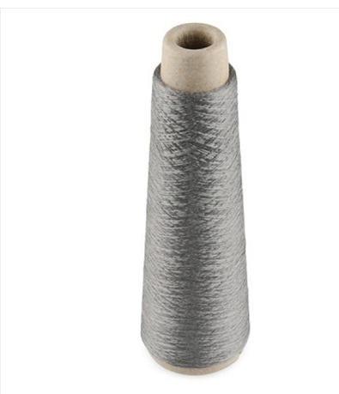

Use any glove and sew this on. Then run the 40 or so threads to some contact.

Connect to a pcf8675 [www.ti.com/lit/ds/symlink/pcf8574.pdf](http://www.ti.com/lit/ds/symlink/pcf8574.pdf) or other IO extender depending on your device’s I/O pin capability.

Use blue tooth in a module like this [https://www.sparkfun.com/products/10253 or the HC-06](https://www.sparkfun.com/products/10253%20or%20the%20HC-06) <http://mcuoneclipse.com/2013/06/19/using-the-hc-06-bluetooth-module/>

Or use a zigbee or take apart an old wireless keyboard.

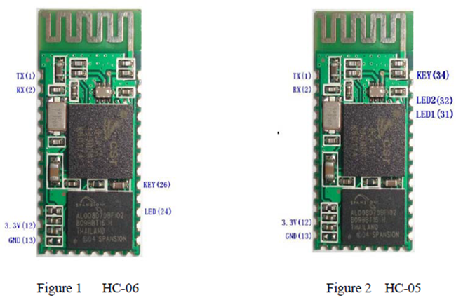

Use an IMU unit such as <http://www.ebay.com/itm/10DOF-IMU-MS5611-HMC5883L-MPU6050-Sensor-module-/271031471551>

This one has these MPU6050 + HMC5883L + MS5611 which are all i2c and have pretty straightforward.

Connect them, filter the data (The beaglebone probably has libraries for this).

Send that filtered data for mouse movements.

Also consider a flex cable <http://www.adafruit.com/products/182> to detect a closed fist.

The biggest issue with this might be interfacing with the Bluetooth usb stack to act as an HID device. The beaglebone likely has built-in stuff to do this though. I think this can be done on an msp430 though and connect with Bluetooth to one of these: <https://www.pjrc.com/store/teensypp.html>

The teensy can be programmed using the Arduino IDE and has built in USB HID stuff. It can act as a keyboard and mouse natively so you will only to get the Bluetooth working on this and then forward the commands to the computer.

This overall shouldn’t be much more than $200