This is an end-to-end LLM-based application built using OpenAI and LangChain that enables natural language interaction with a MySQL database. The system allows users to ask questions in plain English, which are automatically translated into SQL queries, executed on the database, and returned as human-readable answers. To optimize LLM response accuracy I implemented few-shot prompting, enabling reliable natural-language-to-SQL generation.

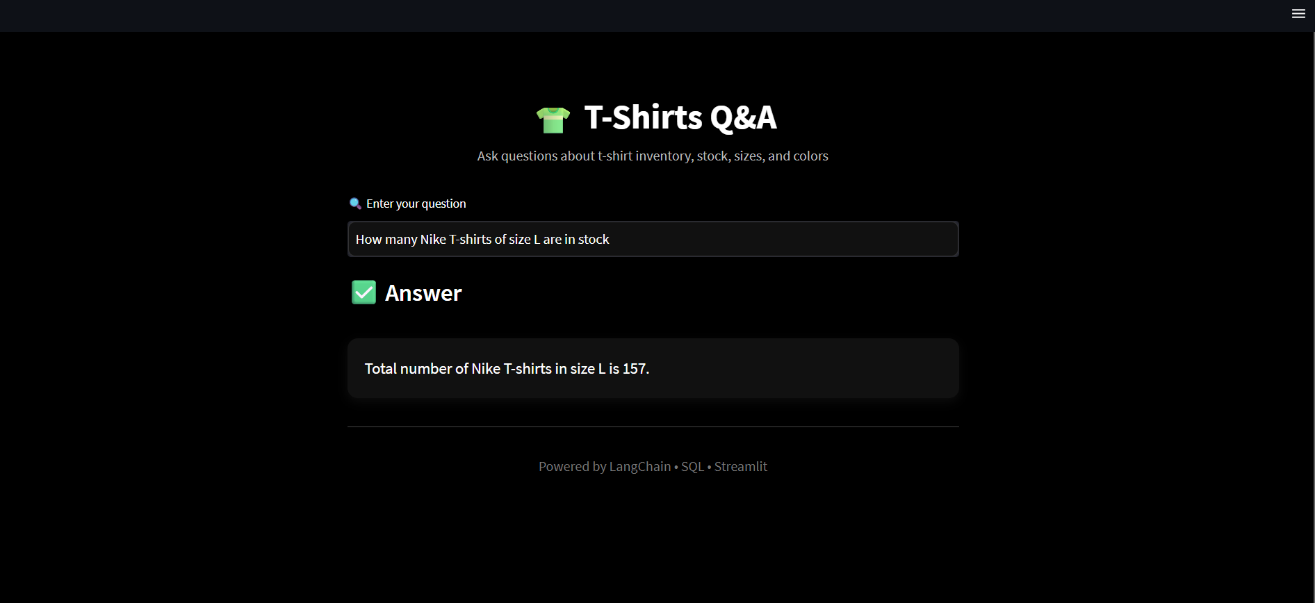

Key Highlights
- Inventory, sales and discounts data is stored in a MySQL database
- OpenAI
- OpenAI face embeddings
- Streamlit for UI
- Langchain framework
- Chromadb as a vector store
- Few shot learning
- Semantic Search
In the UI, store manager will ask questions in a natural language and it will produce the answers

