______________________________

Memorial University of Newfoundland Social Network(MUNSN)

Prepared By: Group D

Tyler Vey

Saahil Budhrani

Mark Hewitt

Allan Collins

MUNSN Architectural

Document

February 26, 2017

**Overview** **3**

**Hardware Modules** **3**

**Software Modules** **4**

Software Modules List 5

Server Side Modules 5

Client-Side Javascript Sub-Modules 5

**Service Calls** **7**

**MongoDB Logical Model** **37**

MongoDB Collections 39

**Responsibilities** **40**

Document Responsibilities 40

Module Responsibilities 40

**Scheduling** **41**

Week 1(5-1-17 to 13-1-17): 41

Week 2(14-1-17 to 21-1-17): 41

Week 3(22-1-17 to 28-1-17): 41

Week 4(29-1-17 to 5-2-17): 41

Week 5(6-1-17 to 12-2-17): 42

Week 6(13-1-17 to 19-2-17): 42

Week 7(13-1-17 to 19-2-17): 42

Week 8(20-1-17 to 26-2-17): 42

Week 9(27-1-17 to 5-3-17): 42

Week 10(6-17 to 12-3-17): 42

Week 11(13-17 to 19-3-17): 42

Week 12(20-3-17 to 25-3-17): 42

Week 13(26-17 to 2-4-17): 42

# 

# Overview

This document lays out the architecture of the MUN Social Network (MUNSN) application. We are using a 3 tier architecture; having a presentation tier (web server), service tier (web service), and a data tier (mongoDB database). The users browser only connects to the presentation tier. The users browser never connects to the web service or the database directly. This improves security and scalability as discussed in the SRS document. Having mongoDB calls in a single place (web service) improves maintainability and enforces re-usability.

We first describe the hardware components - the three tiers mentioned above - and how they break down into modules and sub-modules. Next we look at how the software is broken down into modules and sub-moduels.

Then we discuss the service calls that the system requires. We list the required inputs and the expected output. This enables the back-end to be developed independently from the front-end. We also see the access patterns and the data flows - from this we call build the mongoDB schema. The mongoDB schema is presented.

Finally we look at how we are dividing the work amongst the team members and how it will be scheduled as well as what the responsibilities were for this current document.

# Hardware Modules

1. NodeJS-Express Web Server
   1. Multiple publisher-subscriber modules
      1. Timeline
      2. Polls
      3. Chat
2. NodeJS-Express-Mongoose RESTful web service
3. MongoDB database

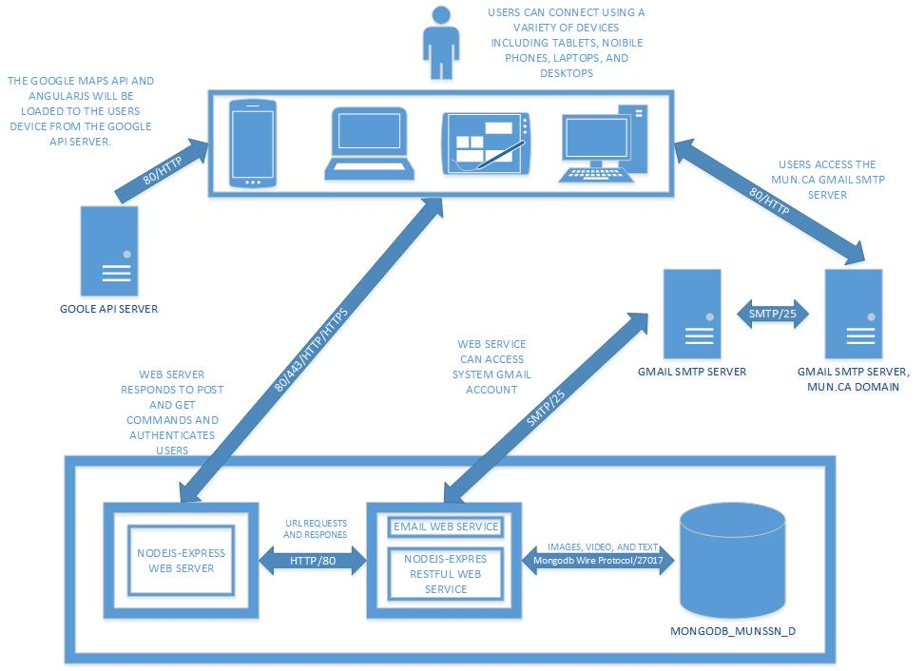

# Software Modules

This is a single-page application. Each module is highly cohesive and loosely coupled. A single business transaction only touches a single module. This allows us to let each module have its own client-side MVC model. When we have a case we require information from another module instead of coupling the the two and introducing a dependency we simply have the new module re-use the service call.

For example the Lost and Found Module needs to know if the person who lost an item is their friend so their cell number can be displayed. We could introduce a dependency and couple the Lost and Found Module to the Friends Module but it is much preferable to re-use the service call that returns a user’s list of friends. This ensures modules loosely-coupled.

When a new module is loaded the old MVC model is no longer needed - loosely coupled. The controller makes the calls to the web service and changes the model and then the view is updated. Module ideally should be independant or possibly loosely coupled.

We are using good design patterns to keep the modules loosely coupled. For Example by using the publisher-subscriber pattern neither ‘Polls’, nor ‘Study Groups’, nor ‘Friends’ or any other module need to be coupled to the Timeline module - they simply update the publisher-subscriber on the web server and a new publication is sent to all subscribers.

In keeping with good usability principles every service call results in a change in the user interface so that the user can know that the action has been performed or has failed.

## Software Modules List

1. Timeline Module
2. Resume Module
3. Private Messaging
4. Lost and Found
5. Polls
6. Friends
7. Study Groups
8. Account Module
9. Schedule
10. Web Communications module

## Server Side Modules

1. RESTful Web Service
   1. Authentication Sub-Module
   2. MongoDB Queries Sub-Module
2. Web Server
   1. Publisher-Subscriber Sub-Module
3. Database

## Client-Side Javascript Sub-Modules

Each software module will have its own client side mvc model and they will all use the communications module to access the connection to the web server and receive and send data. There will be;

* Nine model submodules named ‘model*<SoftwareModuleName.js>*’
* Nine view submodules named ‘view*<SoftwareModuleName.js>*’
* Nine controller classes named ‘controller*<SoftwareModuleName.js>’* all call the WebCommunications module which is a helper function that creates the connection to the web server and handles GET and POST requests. It controls all the flow of data to and from the individual module controllers.
* A main model, view, and controller sub-modules named
  + modelMain
  + viewMain
  + controllerMain - aka ‘WebCommunications’. All controllers will use this class to access the connection to the web server and send and receive data.

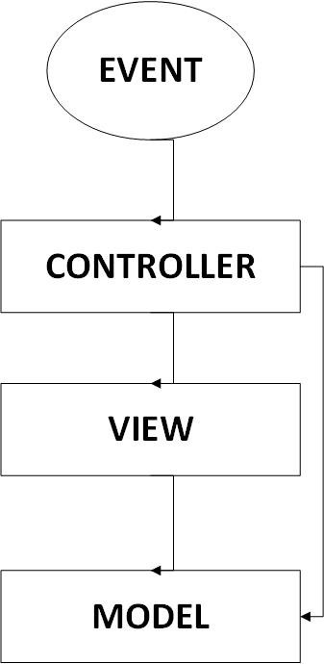

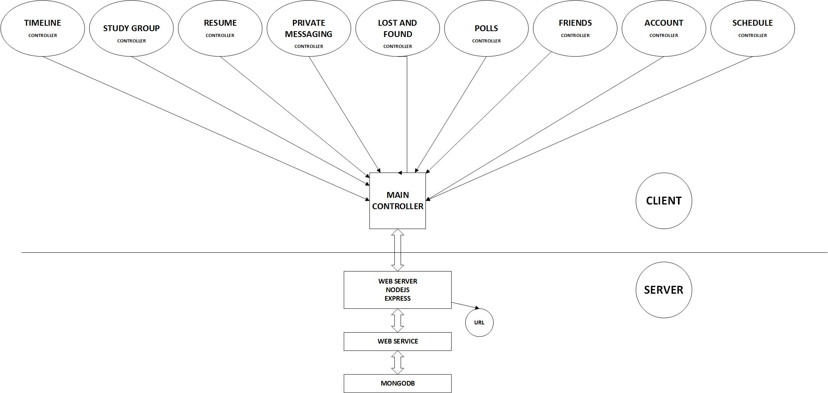

Figure 1 - CLASS DIAGRAMS

# Service Calls

Below is the list of service calls that the application will require. This is essential so that backend and front-end developers can work independently and know what the inputs/outputs are. Note that,

GET Requests - URL contains parameters

DELETE Requests - URL contains parameters

POST requests - URL does not contain parameters.

Knowing the list of service calls enables us structure our mongoDB database according to the access pattern for efficiency.

|  |  |
| --- | --- |
|  | **Module 1: Timeline** |
| **SC-TL-01** | **View a Timeline** |
| Input | Parameters: timeline_id, viewer’s user_id |
| Sample URL | http://cs.mun.ca/s77ajc/MUNSN/timeline/view?timeline_id=1234567&user_id=7654321 |
| Output | Content including text, images, video and comments grouped by post.  Posting Rights of the Viewer for each post. |
| Sample JSON | {  “Posts”:  [  {  “post_id”:”<post id>”,  “user_id”:”<user of timeline owner>  “poster”:”<poster id>”,  “post_time”:”<date timestamp>”,  “post_text”:”<post text>”,  “media_url”:”<media url>”,  “Posting_right”:”1”,  “Comments”:  [  {  “user_id”:”<user id of commenter>”,  “comment_text”:”<comment text>”,  “date_time”:”<date time stamp>”  },  {  “user_id”:”<user id of commenter>”,  “comment_text”:”<comment text>”,  “date_time”:”<date time stamp>”  }  ]  },  {  “post_id”:”<poster id of second poster”,  …….  }  ]  } |
| Explanation | Determine if the viewer is the owner of the timeline and if not whether this viewer has visibility or posting rights. Visibility is determined by the web service and only posts which the user is allowed to see will be returned. If it is not the viewers timeline then the timeline options are not available. The timeline may not be visible to the viewer or the viewer may not be able to post. The User is subscribed to the publisher-subscriber model for this timeline. |
| Web-Server Request Type | GET |

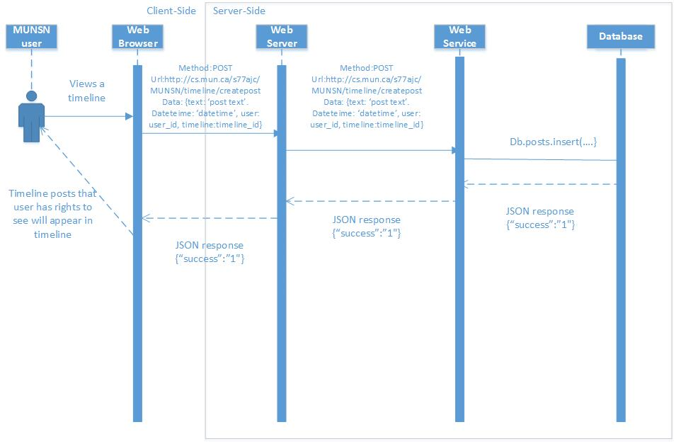

Figure SC-TL-01

|  |  |
| --- | --- |
|  | **Module 1: Timeline** |
| **SC-TL-02** | **Create a Post** |
| Input | Parameters: poster_userid, timeline_id  Data: Post text, optionally media. |
| Sample URL | http://cs.mun.ca/s77ajc/MUNSN/timeline/createpost |
| Output | 1 or 0. Verification that data has been loaded into db. So client side MVC model can be updated. |
| Sample JSON | {“success”:”<1 or 0>”} |
| Explanation | Can determine who is posting and where they are posting and if they have rights to post. Verify that they have rights to post. POST request contains text and optionally media. Publisher-Subscriber model for this timeline is updated and a new publication is pushed out to all subscribers. The new post will show without the page being refreshed. |
| Web-Server Request Type | POST |

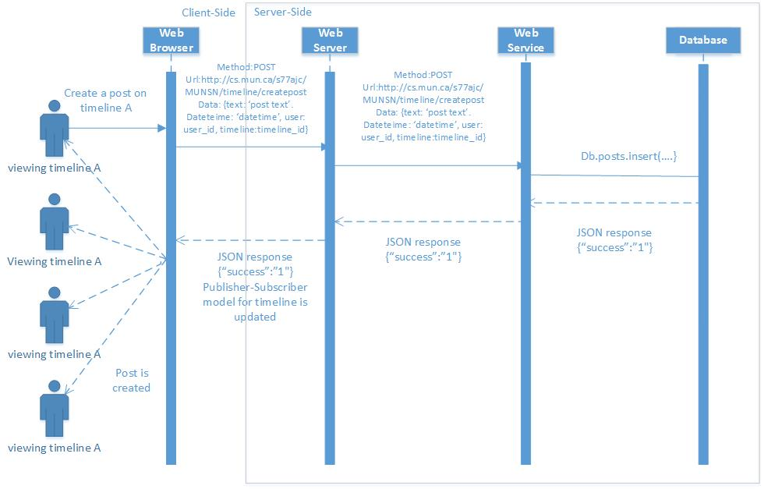

Figure SC-TL-02

|  |  |
| --- | --- |
|  | **Module 1: Timeline** |
| **SC-TL-03** | **Comment on a Post** |
| Input | Parameters: user_id of commenter, timeline_id  Data: comment text |
| Sample URL | http://cs.mun.ca/s77ajc/MUNSN/timeline/comment |
| Output | Text Comment. Verification that text has been uploaded. |
| Sample JSON | {“success”:”<1 or 0>”} |
| Explanation | Can determine if the user has rights to post comments on this timeline. Have comment show up under post when verified it has been loaded in database. The publisher-subscriber model for this timeline is updated and a new publication is pushed out to all subscribers. The new comment will show without the page being refreshed to all viewers of this timeline. |
| Web-Server Request Type | POST |

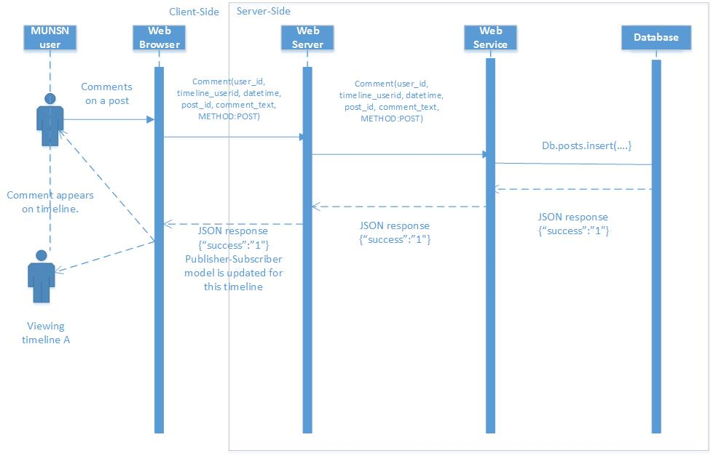

Figure SC-TL-03

|  |  |
| --- | --- |
|  | **Module 1: Timeline** |
| **SC-TL-04** | **Edit a Comment** |
| Input | Parameters: user_id of editor, post_id, comment_id, datetime  Data: comment text |
| Sample URL | http://cs.mun.ca/s77ajc/MUNSN/timeline/editcomment |
| Output | Confirmation that the comment has been edited. |
| Sample JSON | {“success”:”<1 or 0>”} |
| Explanation | Determine what timeline(post_id), what comment(comment_id), when(datetime), are they allowed(user_id of editor), and what(comment text) |
| Web-Server Request Type | POST |

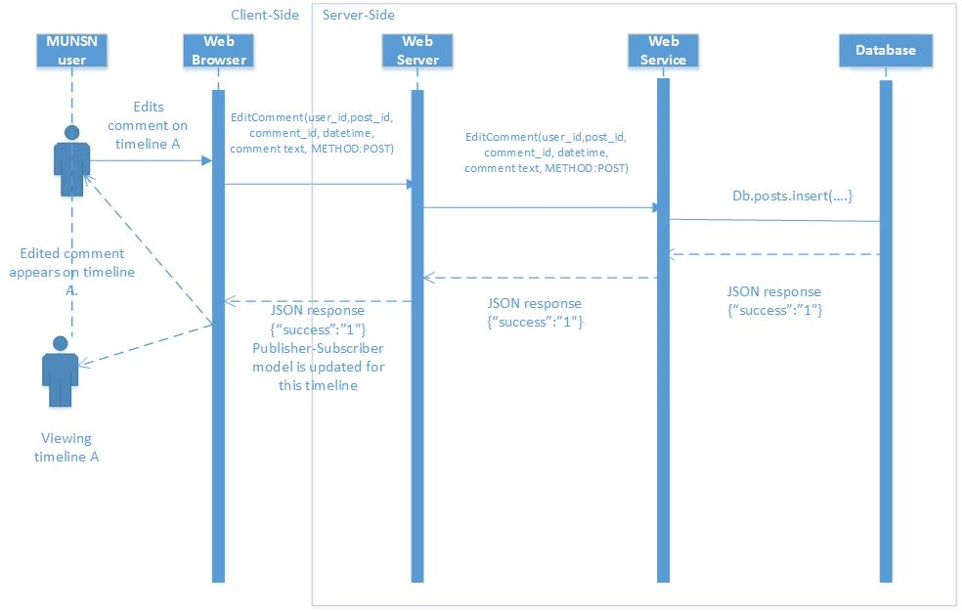

FIgure SC-TL-04

|  |  |
| --- | --- |
|  | **Module 1: Timeline** |
| **SC-TL-05** | **View Comment Edit History** |
| Input | Parameters: post_id, comment_id, user_id of viewer |
| Sample URL | http://cs.mun.ca/s77ajc/MUNSN/timeline/commentedithistory?post_id=1234&comment_id=4321&user_id=5555 |
| Output | Confirmation that comment has been edited. |
| Sample JSON | {“success”:”<1 or 0>” |
| Explanation | Post_id identifies the post, comment_id identifies the comment, and user_id determines if the user if allowed to edit. |
| Web-Server Request Type | GET |

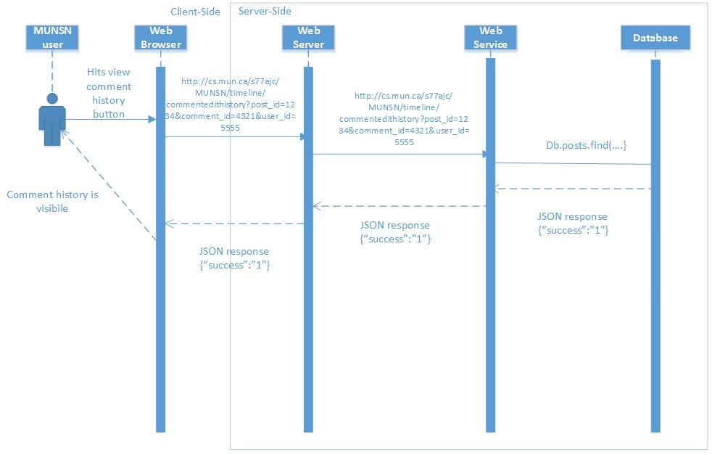

Figure SC-TL-05

|  |  |
| --- | --- |
|  | **Module 1: Timeline** |
| **SC-TL-06** | **Reply to a Comment** |
| Input | Parameters: post_id, comment_id, user_id  Data: Comment reply text |
| Sample URL | http://cs.mun.ca/s77ajc/MUNSN/timeline/replycomment |
| Output | 1 or 0 to determine if the comment reply was successfully posted to the database. |
| Sample JSON | {“success”:”<1 or 0>” |
| Explanation | Post_id determines which post, comment_id determines which comment and user_id determines if the user is allowed to reply to comments on this timeline. Reply text is sent with the POST request. |
| Web Server Request Type | POST |

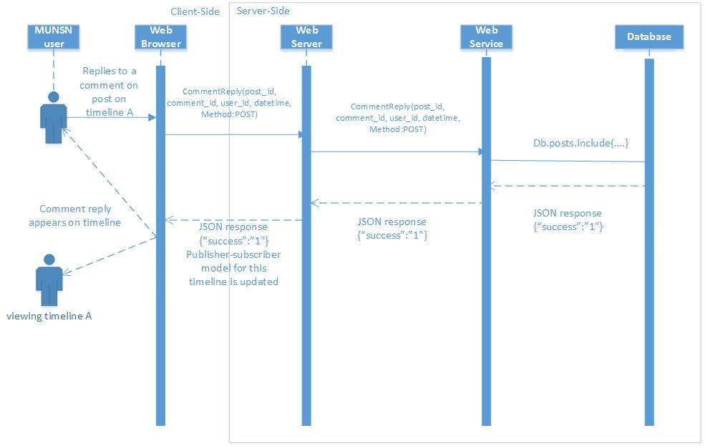

Figure SC-TL-06

|  |  |
| --- | --- |
|  | **Module 1: Timeline** |
| **SC-TL-07** | **Change Timeline Posting Rights** |
| Input | Parameters: userid  Data: posting_right*, optionally a list of friends if ‘List’ is chosen  *One of ‘Everyone’, ‘User’, ‘Friends’, ‘List’. |
| Sample URL | http://cs.mun.ca/s77ajc/MUNSN/timeline/changeTimelinePostingRights |
| Output | Verification that change has been applied to mongoDB database |
| Sample JSON | {“success”:”1”} |
| Explanation | Have user interface let user know that the change to posting rights has been applied. If ‘List’ is chosen then the database would determine the list of friends from the parameter userid. POST request contains the type of change. Update the publisher-subscriber model for this timeline and push out a new publication to all subscribers. Posting rights will change for all affected viewers without a page refresh. |
| Web-Server Request Type | POST |

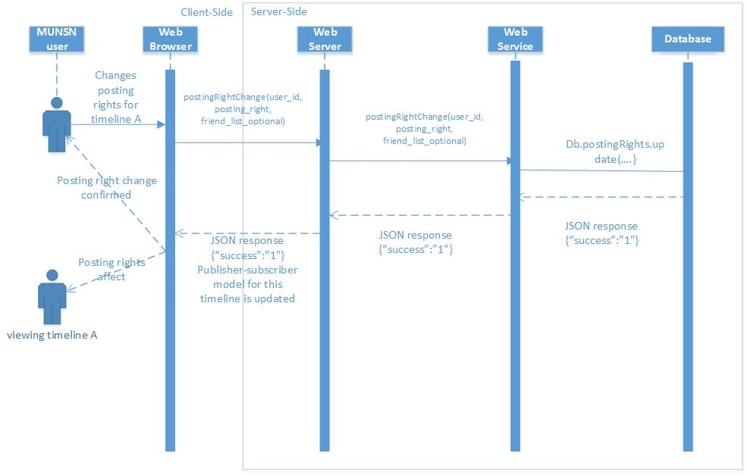

Figure SC-TL-07 - Timeline posting right change

|  |  |
| --- | --- |
|  | **Module 1: Timeline** |
| **SC-TL-08** | **Change Timeline Visibility** |
| Input | Parameters: Userid  Data: Visibility*  Visibility options include one of Private, Friends, Public. |
| Sample URL | http://cs.mun.ca/s77ajc/MUNSN/timeline/changeTimelineVisibility |
| Output | A private, friends only or public timeline. |
| Sample JSON | {“success”:”<1 or 0>”} |
| Explanation | Depending on the Timeline visibility the output can be either a private, friends only or public timeline. User is notified that the change has been applied when the positive reply from the web server is received. The publisher-subscriber model is updated and a new publication is pushed out to all subscribers. Posts disappear or appear for all affected viewers without a page refresh. |
| Web-Server Request Type | POST |

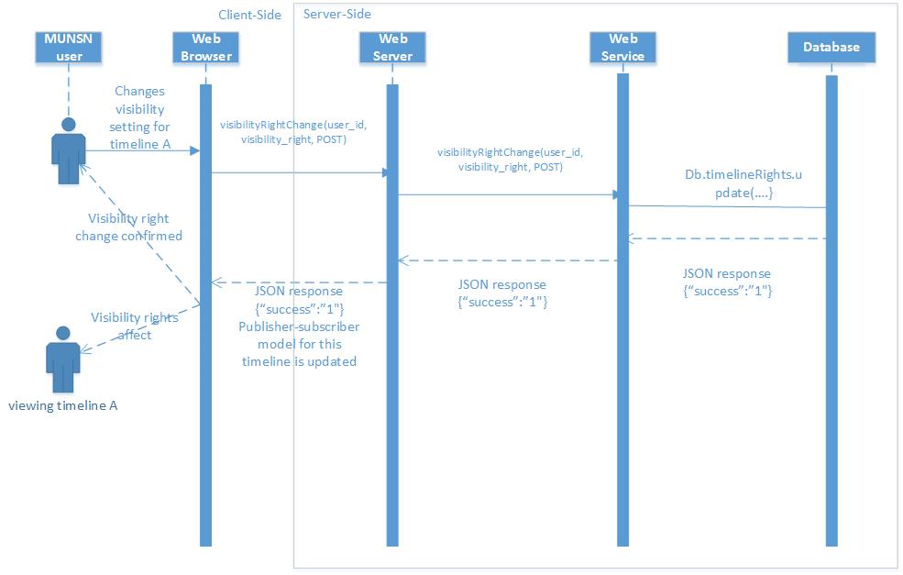

SC-TL-08 - Timeline visibility change

|  |  |
| --- | --- |
|  | **Module 1: Timeline** |
| **SC-TL-09** | **Change Timeline Individual Visibility** |
| Input | Parameters: timeline_id, post_id  Data: Visibility Selection |
| Sample URL | http://cs.mun.ca/s77ajc/MUNSN/timeline/changeIndividualVisibility |
| Output | A Post that is visible to one of Private, Friends, Public depending on the user’s choice. The publisher-subscriber model is updated for this timeline and a new publication is pushed out to all subscribers. Change is applied to all viewers of this timeline without a page refresh. |
| Sample JSON | {“success”:”<1 or 0>” |
| Explanation | Can determine which post and timeline to apply the visibility change. |
| Web-Server Request Type | POST |

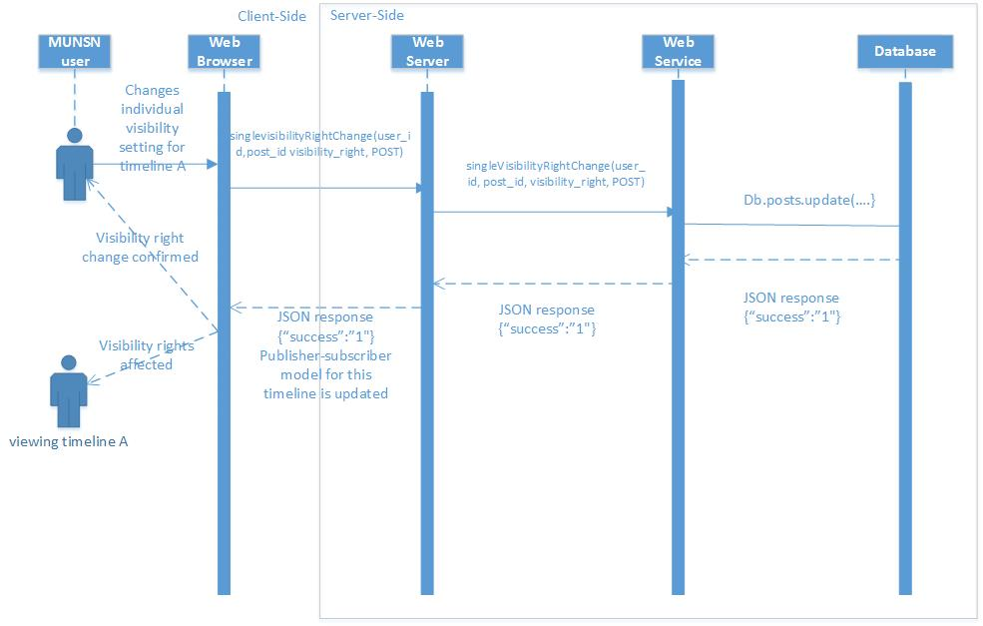

Figure SC-TL-09 - Change Individual Visibility for a timeline post.

|  |  |
| --- | --- |
|  | **Module 2: Study Group** |
| **SC-SG-01** | **CREATE A STUDY GROUP** |
| Input | UserID of Group creator |
| Sample URL | http://cs.mun.ca/s77ajc/MUNSN/userID/studygroup01/ |
| Output | A group in which members can be added or invited by the admin or selected members. |
| Sample JSON | POST http://{hostname}:{port}  /groups/?{parameters} Accept: application/json Content-Type: application/json  {  "id": "97447ea3-a95f-4d29-ba6e-d65fc2e84e85",  "name": "Example Group",  "enabled": true,  "users": [  {  "id": "00000000-0000-0000-0000-000000000003",  "name": "releaser",  "displayName": "releaser"  },  {  "id": "00000000-0000-0000-0000-000000000002",  "name": "admin",  "displayName": "admin"  } |
| Explanation | The user creates a study group and sets the privacy of it to ‘private’ or ‘public’ |
| Web-Server Request Type | POST |

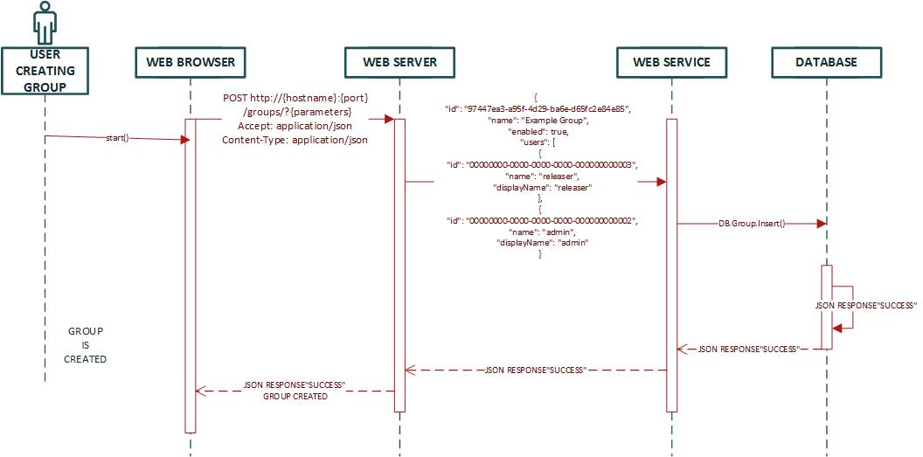

Figure SC-SG-01 - CREATE STUDY GROUP

|  |  |
| --- | --- |
| **SC-SG-02** | **INVITE TO STUDY GROUP** |
| Input | UserID of Admin and invited members |
| Sample URL | http://cs.mun.ca/s77ajc/MUNSN/userID/studygroup01/inviterequest |
| Output | Members will be added into a group. |
| Sample JSON | {  "kind": "directory#member",  "id": "group member's unique ID",  "email": "liz@mun.ca",  "role": "MEMBER",  "type": "GROUP"  } |
| Explanation | Members will be added into a group automatically if it is a public group or members will have to accept a group invitation to be added into the group if it is a private group. |
| Web-Server Request Type | POST |

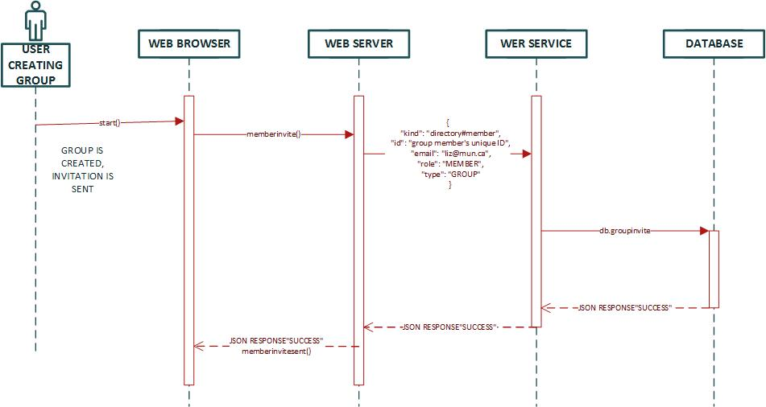

Figure SC-SG-02- INVITE TO STUDY GROUP

|  |  |
| --- | --- |
| **SC-SG-03** | **ACCEPT STUDY GROUP INVITATION** |
| Input | UserID of Admin and invited members |
| Sample URL | http://cs.mun.ca/s77ajc/MUNSN/userID/studygroup01/acceptrequest |
| Output | Members will be accept invitation into a group. |
| Sample JSON | {  "kind": "directory#member",  "id": "group member's unique ID",  "email": "liz@mun.ca",  "role": "MEMBER",  "type": "GROUP"  } |
| Explanation | Members will be added into a group automatically if it is a public group or members will have to accept a group invitation to be added into the group if it is a private group. |
| Web-Server Request Type | POST |

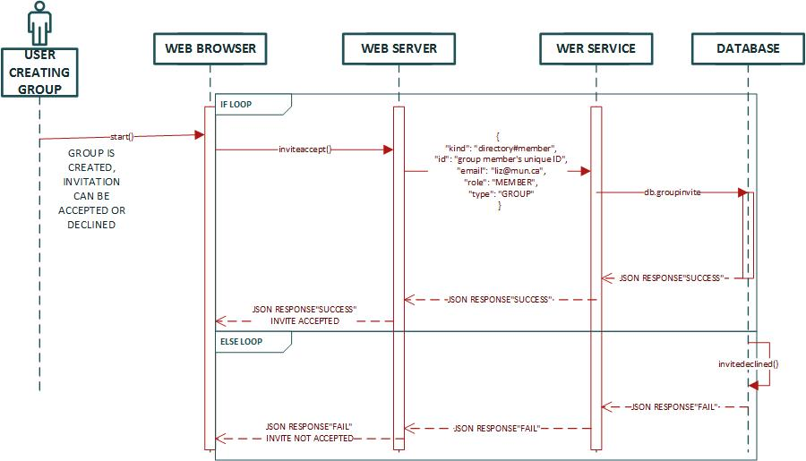

Figure SC-SG-03 - ACCEPTING STUDY GROUP INVITATION

|  |  |
| --- | --- |
| **SC-SG-04** | **VIEW GROUPS** |
| Input | UserID of User |
| Sample URL | http://cs.mun.ca/s77ajc/MUNSN/userID/groups |
| Output | User will be able to view all the groups he’s enrolled in |
| Sample JSON | {“groups” Group1,  “groups” Group2} |
| Explanation | All groups will be shown in clickable links to open their group pages |
| Web-Server Request Type | GET |

|  |  |
| --- | --- |
| **SC-SG-04** | **VIEW A GROUP PAGE** |
| Input | UserID of User |
| Sample URL | http://cs.mun.ca/s77ajc/MUNSN/userID/groups/group01 |
| Output | User will be able to view the group page he selects. |
| Sample JSON | {“groups” Group1} |
| Explanation | Any group a user is a part of can be clicked to be viewed to see activity thats going on in the group. |
| Web-Server Request Type | GET |

|  |  |
| --- | --- |
|  | **MODULE 3: RESUME** |
| **SC-RS-01** | **Upload Resume** |
| Input | idUser, pdf file |
| Sample URL | http://cs.mun.ca/s77ajc/MUNSN/resume/userid |
| Output | Verification that upload was successful and a view of uploaded resume. |
| Sample JSON | {“success”:”<1 or 0>” |
| Explanation | The user is uploads a resume as a pdf which can then be viewed by others. |
| Web-Server Request Type | POST |
| **SC-RS-02** | **Delete Resume** |
| Input | userID |
| Sample URL | http://cs.mun.ca/s77ajc/MUNSN/resume/userid |
| Output | Verification that the existing resume has been deleted. Resume page no longer displays a resume. |
| Sample JSON | {“success”:”<1 or 0>”} |
| Explanation | User removes an existing resume |
| Web-Server Request Type | DELETE |
| **SC-RS-03** | **View Resume** |
| Input | userID |
| Sample URL | http://cs.mun.ca/s77ajc/MUNSN/resume/userid |
| Output | Webpage displaying user’s resume |
| Sample JSON | {“Resume”:  [  {  “resumeOwner”: “userID”  “resume_url”:”<resume url>”  }  ]  } |
| Explanation | When user navigates to resume page, if they have an existing resume it will be displayed |
| Web-Server Request Type | GET |

Figure SC-RS - UPLOAD/DELETE/VIEW RESUME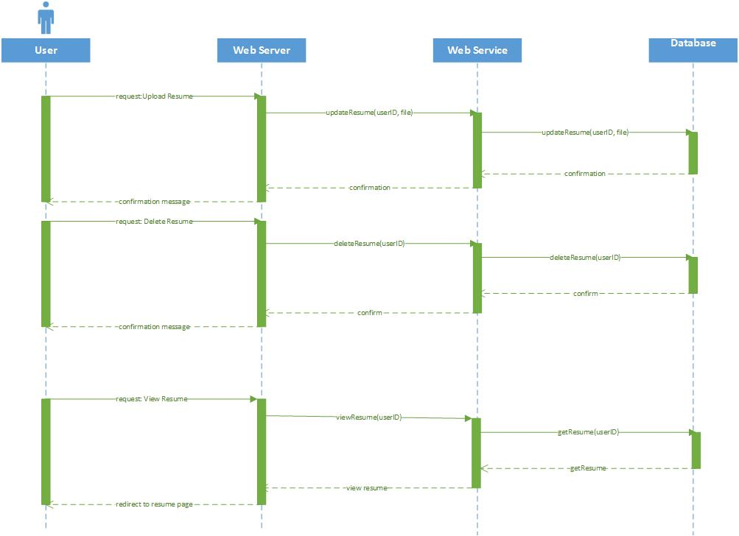

|  |  |
| --- | --- |
|  | **MODULE 4: PRIVATE MESSAGING** |
| **SC-PM-01** | **Read Messages** |
| Input | Parameters: current userID |
| Sample URL | http://cs.mun.ca/s77ajc/MUNSN/Messages |
| Output | Sets of text messages sent between two users. Grouped into conversations of unique participant pairs. |
| Sample JSON | {  “Conversation”:  [  {  “conversation_id”:”<conversation id>”,  “participant_one”:”<user id>”,  “participant_two”:”<user id>”,  “Messages”:  [  {  “user_id”:”<user id of sender>”,  “message_text”:”<message text>”,  “date_time”:”<date time stamp>”  },  {  “user_id”:”<user id of sender>”,  ...  },  ]  },  {  “conversation_id”:”<conversation id>”,  ...  },  ]  } |
| Explanation | Gets a list of all conversations involving the inputted user. For each unique pair of users that send a message to each other a conversation is returned along with all text messages for that conversation are given in chronological order. |
| Web-Server Request Type | GET |
| **SC-PM-02** | **Send Message** |
| Input | Parameters: sender userID, recipient userID  Data: message text |
| Sample URL | http://cs.mun.ca/s77ajc/MUNSN/Message/Send |
| Output | Verification of successful creation of message |
| Sample JSON | {“success”:”<1 or 0>”} |
| Explanation | When a message is sent from one user to another a unique Conversation object is created for that user pair if there was not one already. The Conversation can contain any number of text messages each associated with the sending user and sorted chronologically. |
| Web-Server  Request Type | POST |

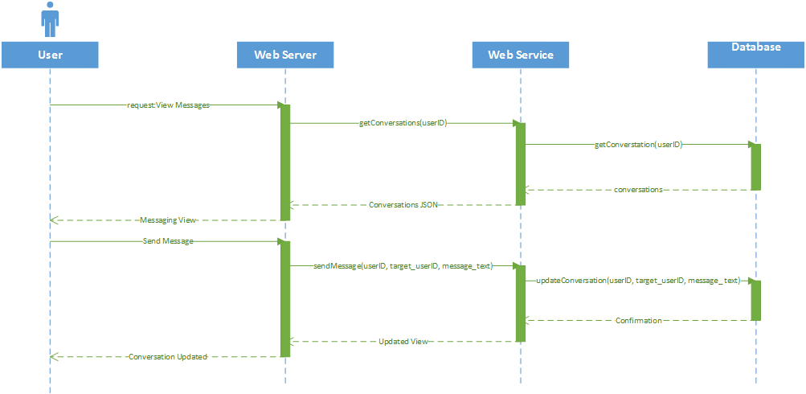

Figure SC-PM - VIEW/SEND

|  |  |
| --- | --- |
|  | **MODULE 5: LOST AND FOUND** |
| **SC-LF-01** | **CREATE LOST AND FOUND POST** |
| Input | UserID, Google API |
| Sample URL | http://cs.mun.ca/s77ajc/MUNSN/lostandfound/ |
| Output | A marker on a map of the Lost and Found item. |
| Sample JSON | var map;  // The JSON data  var json = [{"id":48,"title":"Helgelandskysten","longitude":"12.63376","latitude":"66.02219"},{"id":46,"title":"Tysfjord","longitude":"16.50279","latitude":"68.03515"},{"id":44,"title":"Sledehunds-ekspedisjon","longitude":"7.53744","latitude":"60.08929"},{"id":43,"title":"Amundsens sydpolferd","longitude":"11.38411","latitude":"62.57481"},{"id":39,"title":"Vikingtokt","longitude":"6.96781","latitude":"60.96335"},{"id":6,"title":"Tungtvann- sabotasjen","longitude":"8.49139","latitude":"59.87111"}];  function initialize() {    // Giving the map som options  var mapOptions = {  zoom: 4,  center: new google.maps.LatLng(66.02219,12.63376)  };    // Creating the map  map = new google.maps.Map(document.getElementById('map-canvas'), mapOptions);      // Looping through all the entries from the JSON data  for(var i = 0; i < json.length; i++) {    // Current object  var obj = json[i];  // Adding a new marker for the object  var marker = new google.maps.Marker({  position: new google.maps.LatLng(obj.latitude,obj.longitude),  map: map,  title: obj.title // this works, giving the marker a title with the correct title  });    // Adding a new info window for the object  var clicker = addClicker(marker, obj.title);  } // end loop      // Adding a new click event listener for the object  function addClicker(marker, content) {  google.maps.event.addListener(marker, 'click', function() {    if (infowindow) {infowindow.close();}  infowindow = new google.maps.InfoWindow({content: content});  infowindow.open(map, marker);    });  }    }  // Initialize the map  google.maps.event.addDomListener(window, 'load', initialize); |
| Explanation | A user can create a status to help a lost item be found with its location posted on a map and the item can be picked up from the user who created the post. The post is treated as a normal ‘create a post’ as done in the Timeline Module. |
| Web-Server Request Type | POST |

Figure SC-LF-01 - CREATE LOST AND FOUND POST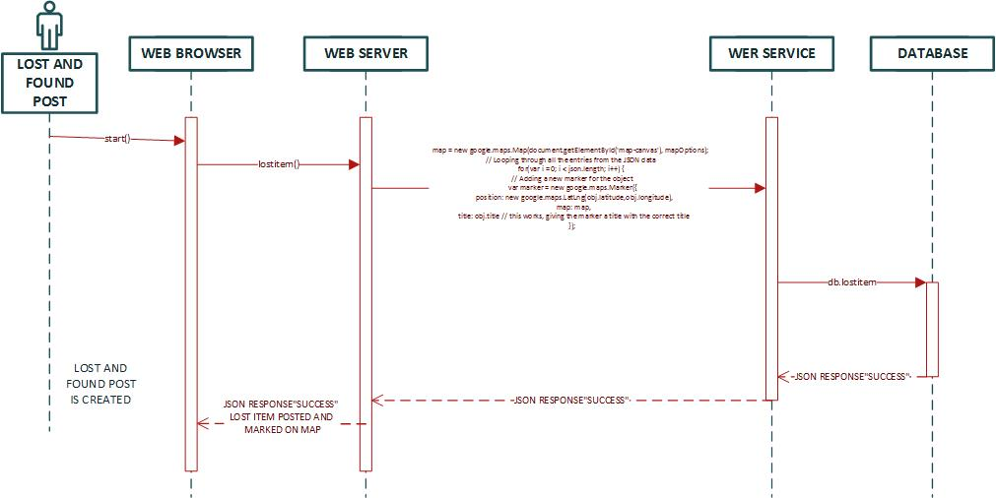

|  |  |
| --- | --- |
| **SC-LF-02** | **RETRIEVING LOST ITEM** |
| Input | USERid |
| Sample URL | http://cs.mun.ca/s77ajc/MUNSN/lostandfound/ |
| Output | User who lost the item will be directed to the Posters page and then provided a phone number so then the user may contact the poster. |
| Sample JSON |  |
| Explanation | A lost item can be retrieved by a user contacting the poster through a cell phone number or by private messaging where they will negotiate on how the lost item is going to be retrieved. |
| Web-Server Request Type | POST |

Figure SC-LF-02 - RETRIEVING LOST ITEM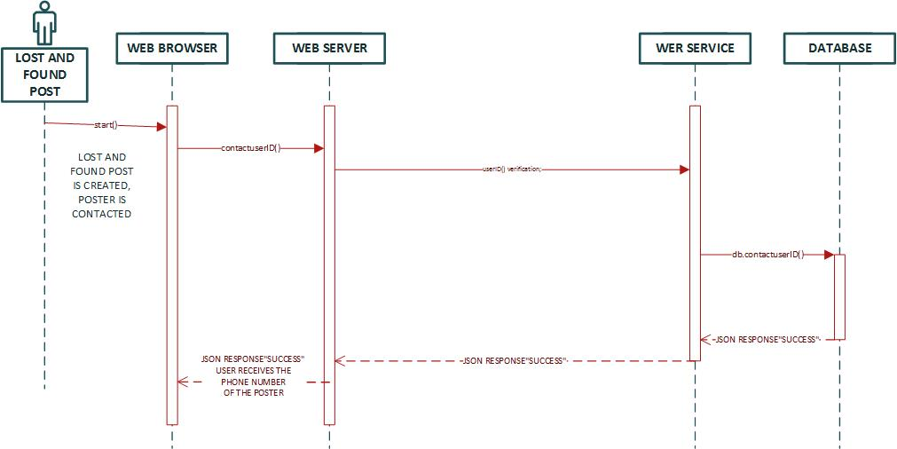

|  |  |
| --- | --- |
|  | **MODULE 6: POLLS** |
| **SC-PO-01** | **Create Poll** |
| Input | userID, classID(for specific class), pollContent(name of poll, options to vote on) |
| Sample URL | http://cs.mun.ca/s77ajc/MUNSN/timeline/view?timeline_id=1234567&user_id=7654321 |
| Output | Content; a poll viewable only by those who are authorized (have same course and are friends of poll creator) |
| Sample JSON | {“Poll”:  [  {“poll_ID”:”<poll identification number>”,  “pollOwner”:”userID”,  var poll = {  “topic” : “<title of poll>”, “option1”:”<option1>”, “option2”:”<option2>”,  “option3”:”<option3>”, “option4”:”<option4>”, “numVote1”:”0”,  “numVote2”:“0”, “numVote3”:”0”, ”numvote4”:”0”};  ]  } |
| Explanation | User creates a poll with a specific course as the topic and x number of options. |
| Web-Server Request Type | POST |
| **SC-PO-02** | **Vote on Poll** |
| Input | userID, pollVote |
| Sample URL | http://cs.mun.ca/s77ajc/MUNSN/timeline/view?timeline_id=1234567&user_id=7654321 |
| Output | Update to the poll results |
| Sample JSON | {“Poll”:  [  {“poll_ID”:”<poll identification number>”,  “pollOwner”:”userID”,  var poll = {  “topic” : “<title of poll>”, “option1”:”<option1>”, “option2”:”<option2>”,  “option3”:”<option3>”, “option4”:”<option4>”, “numVote1”:”<Number of  votes>”, “numVote2”:“<Number of votes>”, “numVote3”:”<Number of  votes>”, ”numvote4”:”<Number of votes>”};  ]  } |
| Explanation | A user votes on one of the options (pollVote) which is sent to the DB to update the results of the poll. The userID is also stored to prevent that user from voting again. |
| Web-Server Request Type | POST |

Figure SC-PO - CREATE/VOTE POLL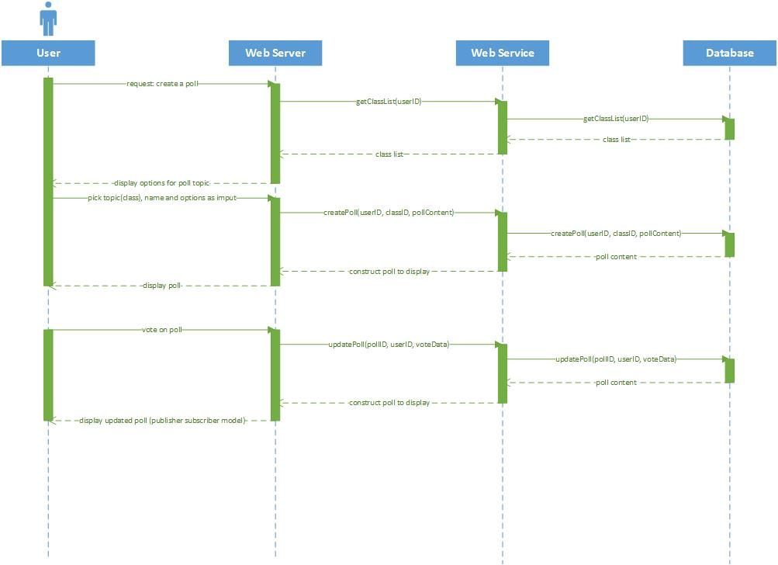

|  |  |
| --- | --- |
|  | **MODULE 7: FRIENDS** |
| **SC-FR-01** | **View Friend Recommendations** |
| Input | Parameters: userID |
| Sample URL | http://cs.mun.ca/s77ajc/MUNSN/Friends/Recomendations |
| Output | A sorted list of recommended friends customized for the current user. For each recommendation a name, userID and profile picture are given. |
| Sample JSON | {“Recommendations”:  [  {  “user_id”:”<recommended friend user id>”,  “username”:”<recommended friend username>”,  “profile_picture_url”:”<profile picture url>”,  },  {  “user_id”:”<next recommended friend user id>”,  ...  }  ]  } |
| Explanation | Upon request the software creates a list of recommended Friends for the current User. The list is based off weighted factors such as number of Friends in common and shared Study Groups. The list is returned in descending order from most connected to lowest. |
| Web-Server Request Type | GET |
| **SC-FR-02** | **Send Friend Request** |
| Input | Parameters: current userID, target userID |
| Sample URL | http://cs.mun.ca/s77ajc/MUNSN/Friends/Request |
| Output | A Friend connection is created between the current User and the target User. |
| Sample JSON |  |
| Explanation | Upon sending a Friend Request an object is created connect both Users. The object has a state variable that is initially set to “unaccepted”. If both Users send a request to the other than the state is changed to “accepted” and the Users will appear on each other's Friends lists. |
| Web-Server Request Type | POST |

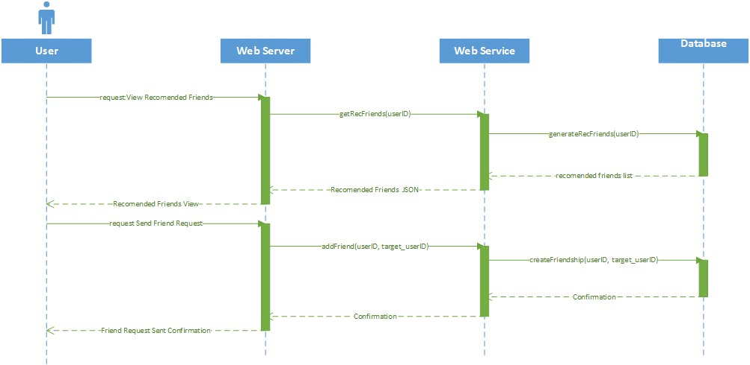

Figure SC-FR-01-02 - VIEW RECOMENDED/SEND REQUEST

|  |  |
| --- | --- |
|  | **MODULE 7: FRIENDS** |
| **SC-FR-03** | **View Friend List** |
| Input | Parameters: userID |
| Sample URL | http://cs.mun.ca/s77ajc/MUNSN/Friends |
| Output | A list of Friends of the current user sorted alphabetically. |
| Sample JSON | {“Friends”:  [  {  “user_id”:”<Friend user id>”,  “username”:”<Friend username>”,  “profile_picture_url”:”<profile picture url>”,  },  {  “user_id”:”<next friend user id>”,  ...  }  ]  } |
| Explanation | A list of all Friends of the current User is returned in alphabetical order. For each Friend a profile picture, username and userID are returned. |
| Web-Server Request Type | GET |

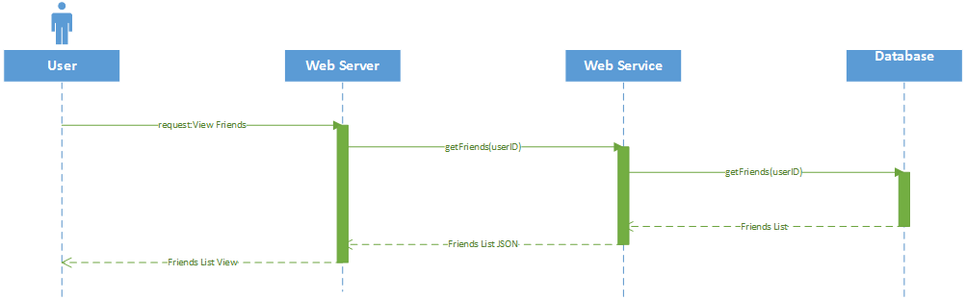

Figure SC-FR-03 - VIEW FRIENDS LIST

|  |  |
| --- | --- |
|  | **MODULE 8: USER ACCOUNT** |
| **SC-UA-01** | **Create Account** |
| Input | Parameters: username, password, email |
| Sample URL | http://cs.mun.ca/s77ajc/MUNSN/Account/Create |
| Output | Returns a success or failure. If success also sends a confirmation email to the given address. |
| Sample JSON |  |
| Explanation | The software confirms that each of the parameters meets their respective criteria e.g., the email must be unique and end in “@mun.ca”. If the confirmation succeeds a confirmation email is sent to the given email. If the confirmation fails a notification of failure is returned. |
| Web-Server Request Type | POST |
| **SC-UA-02** | **Confirm Account Email** |
| Input | Parameters: confirmation code |
| Sample URL | http://cs.mun.ca/s77ajc/MUNSN/Account/Confirm/avd142as7dg235 |
| Output | A success or failure notification depending on the validity of the code. |
| Sample JSON |  |
| Explanation | For email confirmation the user is given a code and a unique url to visit in order to submit the code. If the code entered on the page is the correct code for the url then the related account is confirmed valid and is unlocked for use. |
| Web-Server Request Type | POST |

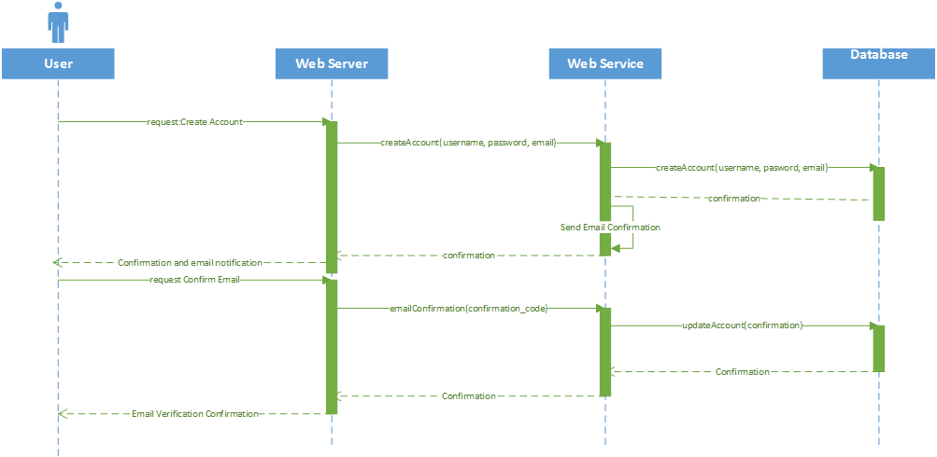

Figure SC-UA - CREATE/CONFIRM

|  |  |
| --- | --- |
|  | **MODULE 9: SCHEDULE** |
| **SC-SC-01** | **Add to Schedule** |
| Input | userID, classID |
| Sample URL | http://cs.mun.ca/s77ajc/MUNSN/schedule/ |
| Output | An updated version of the user's schedule. |
| Sample JSON | {“success”:”<1 or 0>”} |
| Explanation | User updates their existing schedule. A schedule that is empty still exists. |
| Web-Server Request Type | POST |
| **SC-SC-03** | **Remove from Schedule** |
| Input | userID, classID |
| Sample URL | http://cs.mun.ca/s77ajc/MUNSN/schedule/ |
| Output | An updated schedule with the removed item no longer present and verification to the user that the item was removed successfully. |
| Sample JSON |  |
| Explanation | Remove a class from the schedule. |
| Web-Server Request Type | POST |
| **SC-SC-03** | **View Schedule** |
| Input | userID |
| Sample URL | http://cs.mun.ca/s77ajc/MUNSN/schedule |
| Output | The current schedule of the user |
| Sample JSON | {“schedule”:  [  “classList”: {  “class1”:”<class 1>”,  “class2”:”<class 2>”,  “class3”:”<class 3>”,  ...  }  ]  } |
| Explanation | USer navigates to schedule page this will be the default call, they will be presented with their current schedule. |
| Web-Server Request Type | GET |

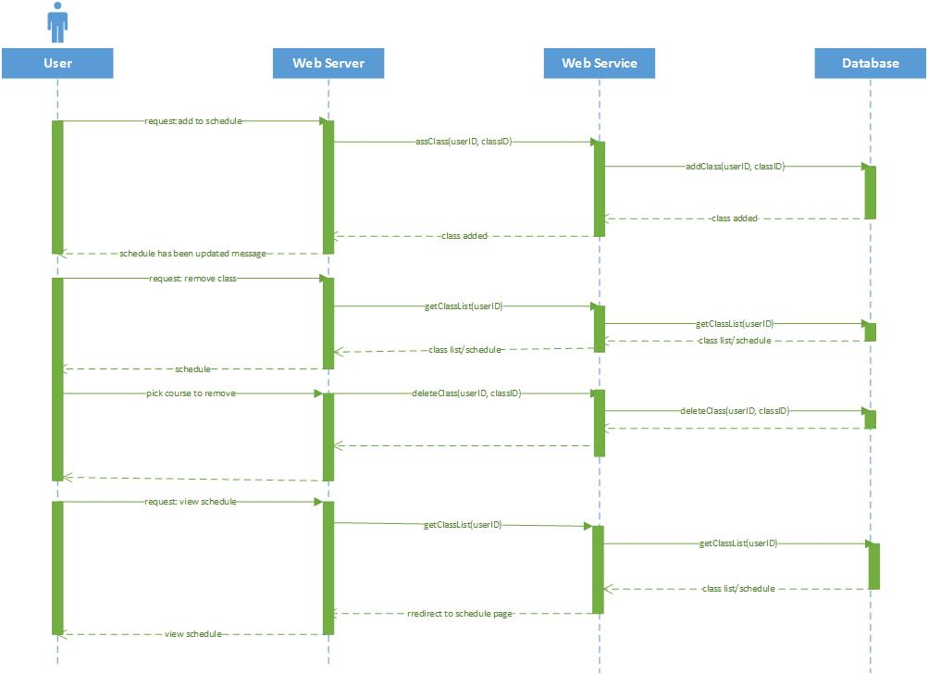

Figure SC-SC - ADD/REMOVE/VIEW SCHEDULE

# MongoDB Logical Model

The mongoDB schema is built according to access patterns. This is why we listed all the service calls to the web service. The table below shows which mongoDB collections are involved for each service call.

|  |  |  |
| --- | --- | --- |
| **Service Call** | **Input** | **MongoDB Collections** |
| **TIMELINE** |  |  |
| View a timeline | Timelines user_id | Posts, timelineRights |
| Create a Post | Timeline user_id, poster user_id, datetime, post text, | Posts, timelineRights |
| Comment on a Post | Post_id, commenter user_id, datetime, comment text | Posts, timelineRights |
| Edit a Comment | Post_id, comment_id, editor user_id, datetime | Posts, timelineRights |
| View comment edit history | Post_id, comment_id, user_id of viewer | Posts, timelineRights |
| Reply to a comment | Post_id, comment_id, user_id of replier, comment reply text | Posts, timelineRights |
| Change Timeline Posting Rights | User_id, posting right type | timelineRights |
| Change timeline Visibility Rights | User_id, timeline visibility right type | timelineRights |
| Change Timeline individual post visibility | User_id, post_id, visibility type | posts |
| **STUDY GROUP** |  |  |
| Create Study Group | User_id, GroupRight Type | Groups, GroupRights |
| Send Study Group Invite | Group_id, user_id of user who will receive request | Groups, GroupRights |
| Accept Study Group Invite | User_id, group_id | Groups, GroupRights |
| View Study Groups | user_id | Groups, GroupRights |
| View Individual Study Group | User_id, group_id | Groups, GroupRights |
| **RESUME** |  |  |
| View resume | User_id of resume page owner | Resume |
| Edit Resume | user_id | Resume |
| Delete Resume | user_id | Resume |
| **PRIVATE MESSAGING** |  |  |
| Read message | User_id, chat_id | n/a |
| Send message | User_id, chat_id | n/a |
| **LOST AND FOUND** |  |  |
| Create Lost and Found Post | User_id, image, coordinates, datetime | LostandFound |
| View Lost and Found Posts | None required | LostandFound |
| Reply to lost and Found Post | user_id | LostAndFound, Friends |
| Contact Poster | user_id | LostAndFound, Friends |
| **POLLS** |  |  |
| Create a poll | user_id | Polls, Users |
| View a Polls | user_id | Polls |
| Vote on a Poll | User_id, poll_id | Polls |
| **FRIENDS** |  |  |
| View Friends List | user_id | Friends |
| Send Friend Request | User_id, proposed_friend_user_id | Friends |
| Accept Friend Request | User_id, friend_user_id | Friends |
| View Suggested Friends List | user_id | Friends |
| **ACCOUNT** |  |  |
| Create Account | User_id, email | Users |
| Confirm email account | user_id | Users |
| **SCHEDULE** |  |  |
| View Schedule | user_id | Schedule |
| Add Class to Schedule | User_id, class, timeslot | Schedule |
| Remove class from Schedule | User_id, class_id | Schedule |

## MongoDB Collections

The following mongoDB collections are required according to the list of service calls.

1. Users
2. Posts - Comments are an embedded collection as comment history.
3. Timeline Rights
4. Groups
5. GroupRights
6. Resume
7. Friends
8. LostAndFound
9. Schedule

<logical model diagram goes here>

# Responsibilities

## Document Responsibilities

* Saahil - Study Group Module, Lost and Found Module, Class Model Diagram
* Mark - Polls Module, Resume Module, Schedule Module
* Allan - Timeline Module, Mongodb Logical Model, Overview, Document Structure
* Tyler - Account Module, Private Messaging Module, Friends Module

## Module Responsibilities

In keeping with an agile methodology we are only assigning responsibility for one module at a time. When that module has passed unit / integration and regression testing then the developer can get another module to work on. This way we are not locking up a block of work that another can be working on.

Currently assigned modules are as follows;

* Timeline Module - Allan - all notifications will use this
* Account Module - Tyler - we must be logged in to do any testing
* Study Group Module - Saahil
* Schedule Module - Mark - the study group module requires the data that schedule module will push to the mongodb back-end.

The plan for work going forward is that we will get the back-end set up and communicating with the front-end. The back-end lean is Allan and the front-end lead is Tyler. The back-end team will ensure that,

1. the mongodb database is set up
2. 9 collections are set up
3. Web server is set up
4. Web Service is set up
5. All components communicate with each other.

The front-end team will ensure that,

1. The HTML skeleton is set up using bootstrap
2. Skeleton is mobile friendly and responsive
3. WebCommunications module is set up and handles GET and POST requests and other functions can use it to send and recieve data.
4. The main model, main view, main controller are set up and adding the additional mvc models will be easy.

Once we have the front-end and back-end components in place and communicating we can begin work on the front-end angularjs mvc models.

# Scheduling

HTML skeleton, Client-Side MVC models, Web Server, and Web Service can all be developed independently.

### **Week 1**(5-1-17 to 13-1-17):

* **Tyler Vey**: Use Cases, Functional and Nonfunctional Requirements from project description 1-3.
* **Saahil Budhran**i:Use Cases, Functional and Nonfunctional Requirements from project description 7-9.
* **Mark Hewitt**:Use Cases, Functional and Nonfunctional Requirements from project description 9-12.
* **Allan Collins**:Use Cases, Functional and Nonfunctional Requirements from project description 4-6.

### **Week 2**(14-1-17 to 21-1-17):

* **Tyler Vey**: General improvements on SRS Formatting and distribution of sections 1, 2 and 4.
* **Saahil Budhrani**: General improvements on SRS Formatting and distribution of sections. Worked on sections 3.5(Use Case diagram), 3.6, 3.7, 4 and powerpoint presentation.
* **Mark Hewitt**: General improvements on SRS Formatting and distribution of sections. Worked on definitions and section 3.0 through 3.5
* **Allan Collins**: General improvements on SRS Formatting and distribution of sections. Worked on sections 1.2, 2.3, 2.4, 3.2 - 3.4, 3.5.4, 3.5.5, 3.5.6, 3.5.7, 3.6.

### **Week 3**(22-1-17 to 28-1-17):

* Finalization of SRS document as a group and minor formatting.

### **Week 4**(29-1-17 to 5-2-17):

* Powerpoint presentation
* Milestone 1 presentation.
* Work commences on Architectural Document, system’s decomposition   
  into modules.

### **Week 5**(6-1-17 to 12-2-17):

* Division of module responsibility between team members.
* Creation of UML and other visualisations.
* Progress on Architectural Document.

### **Week 6**(13-1-17 to 19-2-17):

* Finalization of Architectural Document.
* Work commences on Module Documents.

### **Week 7**(13-1-17 to 19-2-17):

* Work on descriptions of the functionality and interface of each module.
* Work on descriptions of module testing plans and demonstration.
* Back-end / Front-end teams commence work on back-end / commincations

### **Week 8**(20-1-17 to 26-2-17):

* Continued work on descriptions of the functionality and interface of each module.
* Continued work on descriptions of module testing plans and demonstration.
* Back-end is complete and front-end module work commences.

### **Week 9**(27-1-17 to 5-3-17):

* Finalization of Module Documents.
* Preliminary System Development.

### **Week 10**(6-17 to 12-3-17):

* Creation of Modules based on Module Documents.

### **Week 11**(13-17 to 19-3-17):

* Integration of all modules.
* Creation of System Testing Document.

### **Week 12**(20-3-17 to 25-3-17):

* Deployment of Integrated System.
* Creation of Data for System Demonstration and testing.
* Improvement upon System Testing Document.

### **Week 13**(26-17 to 2-4-17):

* Completion of Integrated System.
* Submission of System Testing Document.
* Milestone 4 presentation.