# How to install the “YoLink™ Device Service” app and Drivers on a Hubitat™ Hub

(Version 1.0)

The YoLink™ Device Service (hereafter referred to as simply, “the Service”) consists of the YoLink™ Device Service App and various Drivers that support the different YoLink™ devices.

The list of supported devices (and those currently under development) can be found at:

[**https://raw.githubusercontent.com/srbarcus/YoLink/master/Drivers.txt**](https://raw.githubusercontent.com/srbarcus/YoLink/master/Drivers.txt)

Due to the complexity of installing the Service and all the associated drivers, installation is only supported using the **Hubitat Package Manager App (HPM)**. Using **HPM** will drastically reduce installation time, reduce the chances of an incorrect installation, as well as simplify updating and modifying the Service as you acquire new YoLink™ devices.

There are many articles on how to install the **HPM** on your Hubitat™. Here is one that summarizes the process: <https://community.hubitat.com/t/how-to-install-hubitat-package-manager-or-any-other-user-app/92387>

Installation of the Service consists of the following steps:

1. Install the **HPM** app on your Hubitat™ (if it’s not already installed).
2. Connect all your YoLink™ devices to your YoLink™ Hub or YoLink™ Speaker Hub as documented in the Hub’s user manual.
3. Install the YoLink™ app on your mobile device and either Sign In to your existing account or Sign up for an account. Your app must be configured and showing all of the devices that you want to control from Hubitat™.
4. Install the Service as documented below

# Installing the “YoLink™ Device Service” app and Drivers using HPM

1. **Open the Hubitat mobile app and click on “Connect to hub”:**

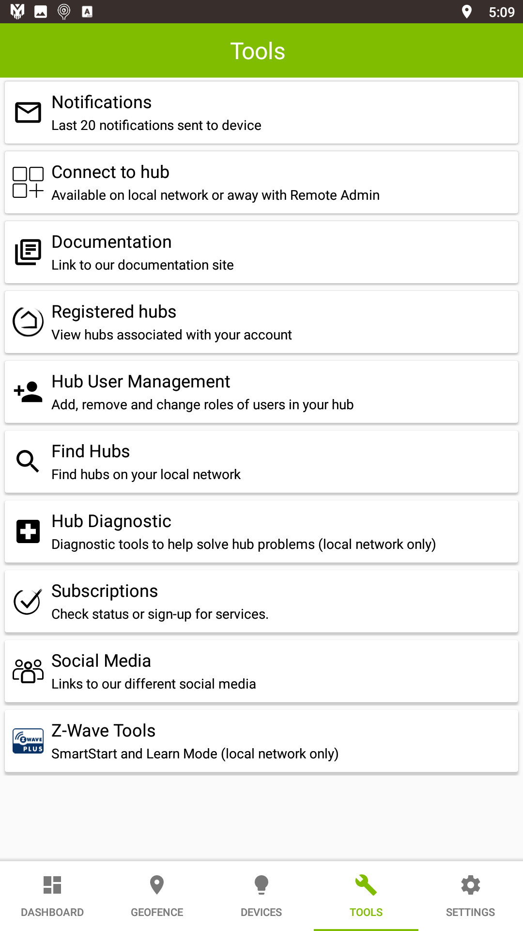

1. **Click on “Apps”:**

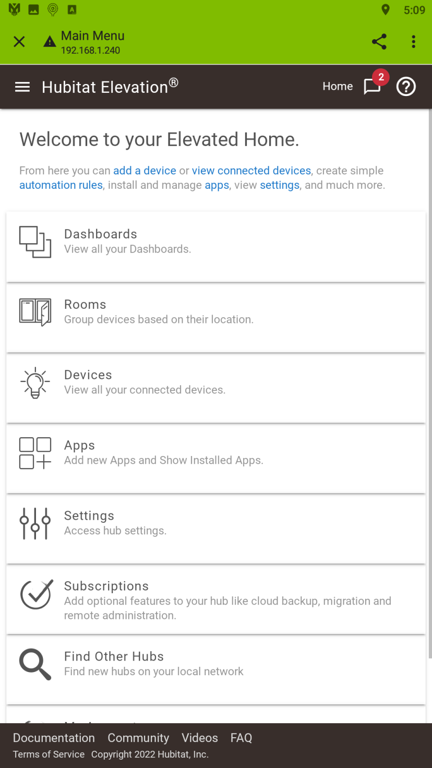

1. **Click on “Hubitat Package Manager”:**

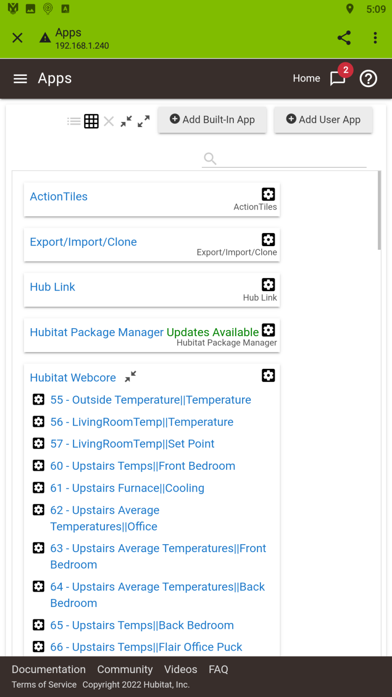

1. **Click on “Install”:**

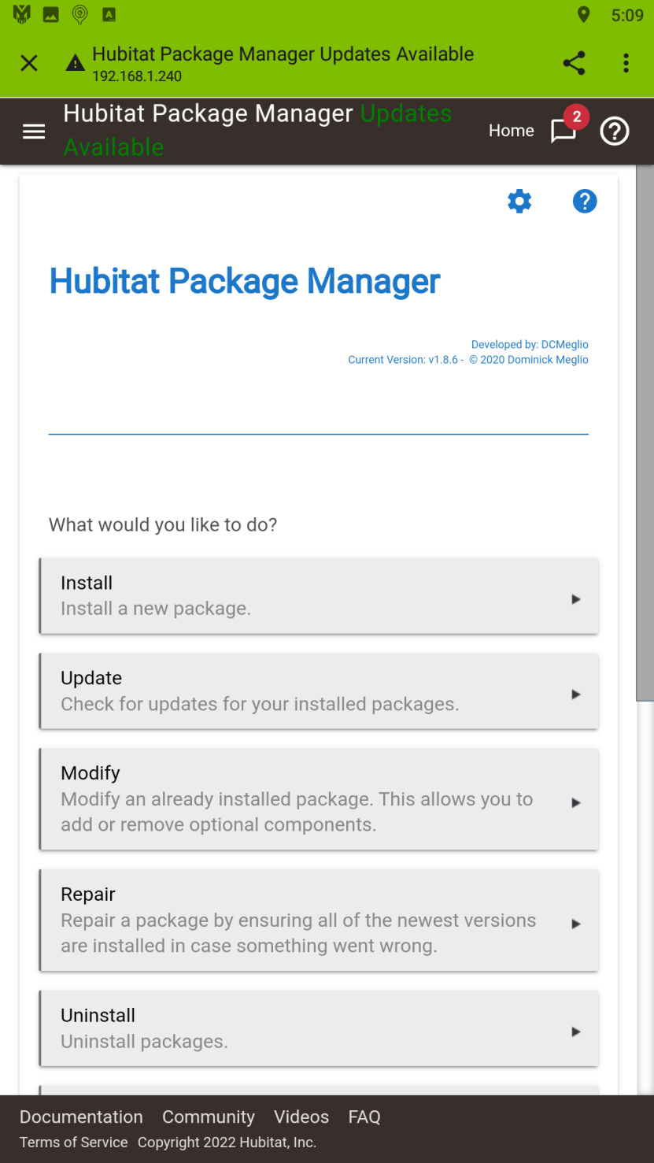

1. **Click on “From a URL”:**

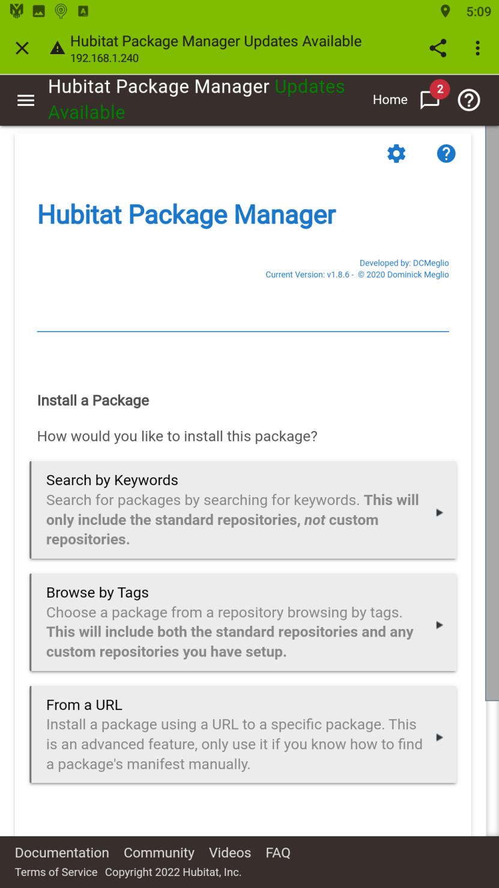

1. **Click on “Click to set”, enter the following URL, and then click “Next”:**

**https://raw.githubusercontent.com/srbarcus/YoLink/master/packageManifest.json**

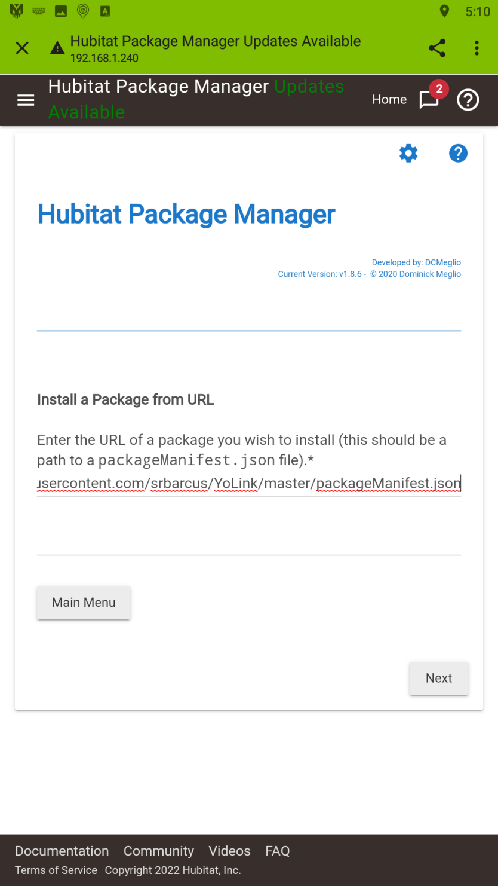

1. **Click on “Click to set” to open a drop-down list of the currently supported YoLink™ device drivers:**

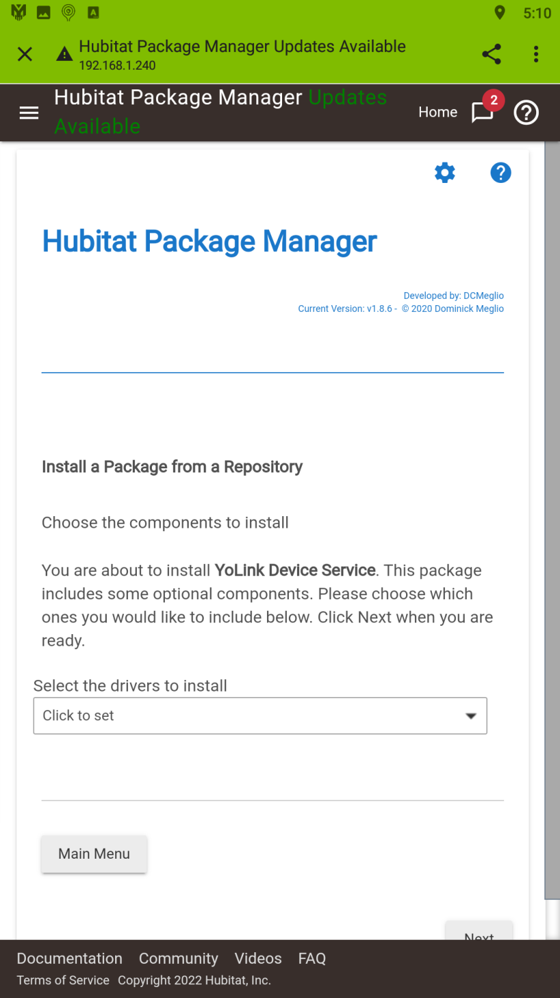

1. **Click on each device driver you want to install. Drivers for the YoLink™ Hub and YoLink™ Speaker Hub are installed automatically. The only downside of installing all of them is that they’ll take up memory on your Hubitat™ Hub. Therefore, it’s recommended that you only install the drivers that you need to support your current YoLink™ devices. You can always use the HPM’s “Modify” option to install or remove drivers as necessary:**

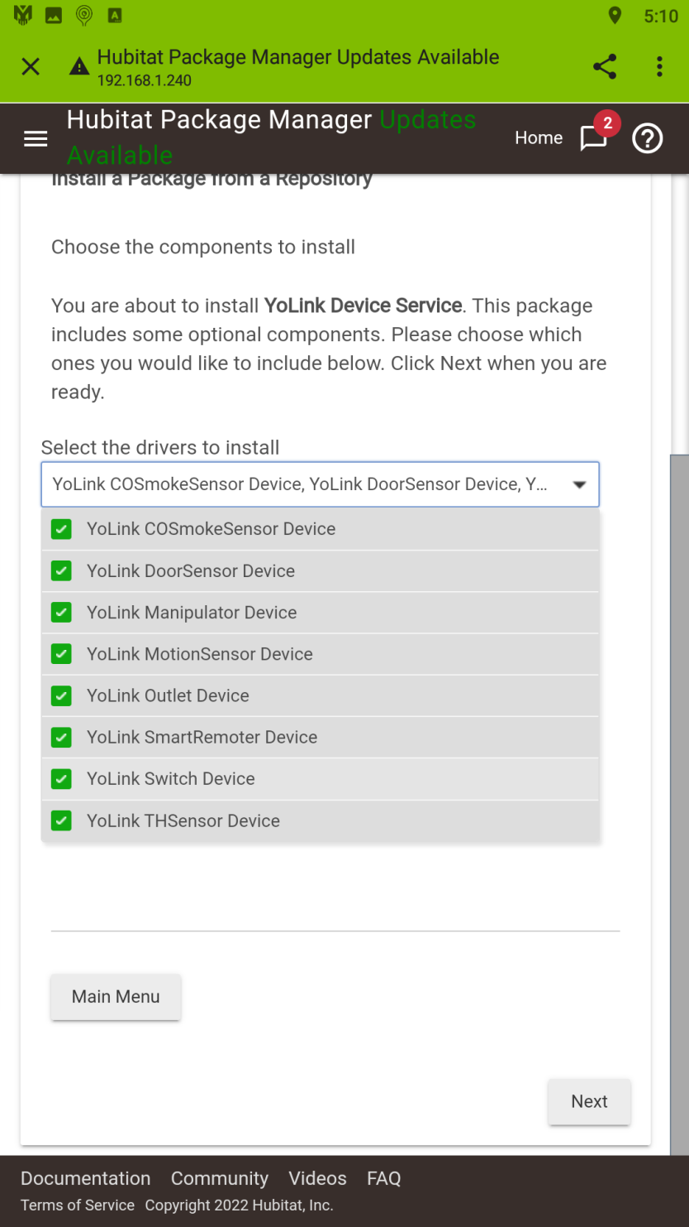

1. **Click on the selection box to close it, then click “Next”:**

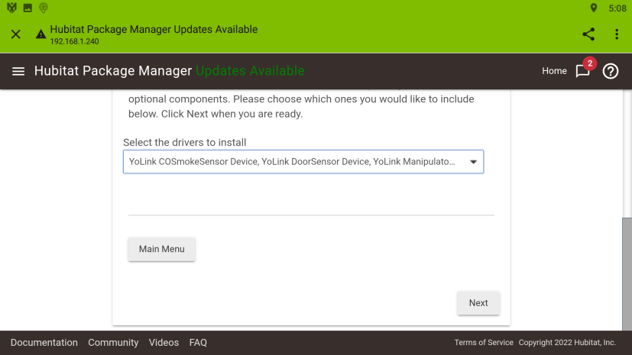

1. **Click on “Next” to begin the installation:**

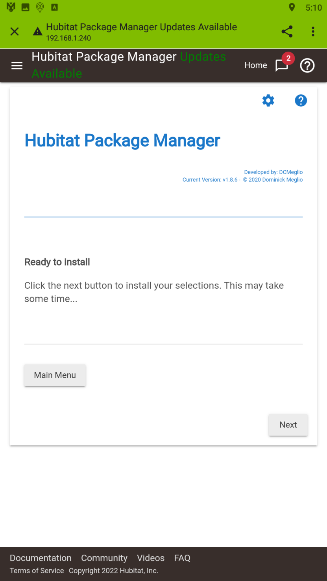

1. **Installation processes:**

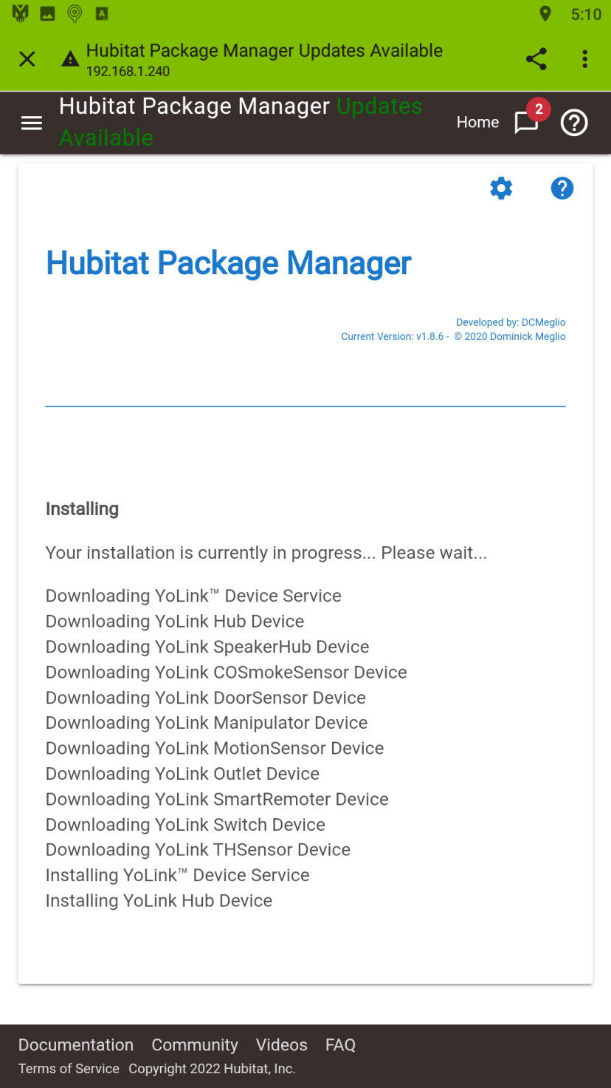

1. **Installation completes – click “Next” to return to the HPM main menu or close the Hubitat™ mobile app:**

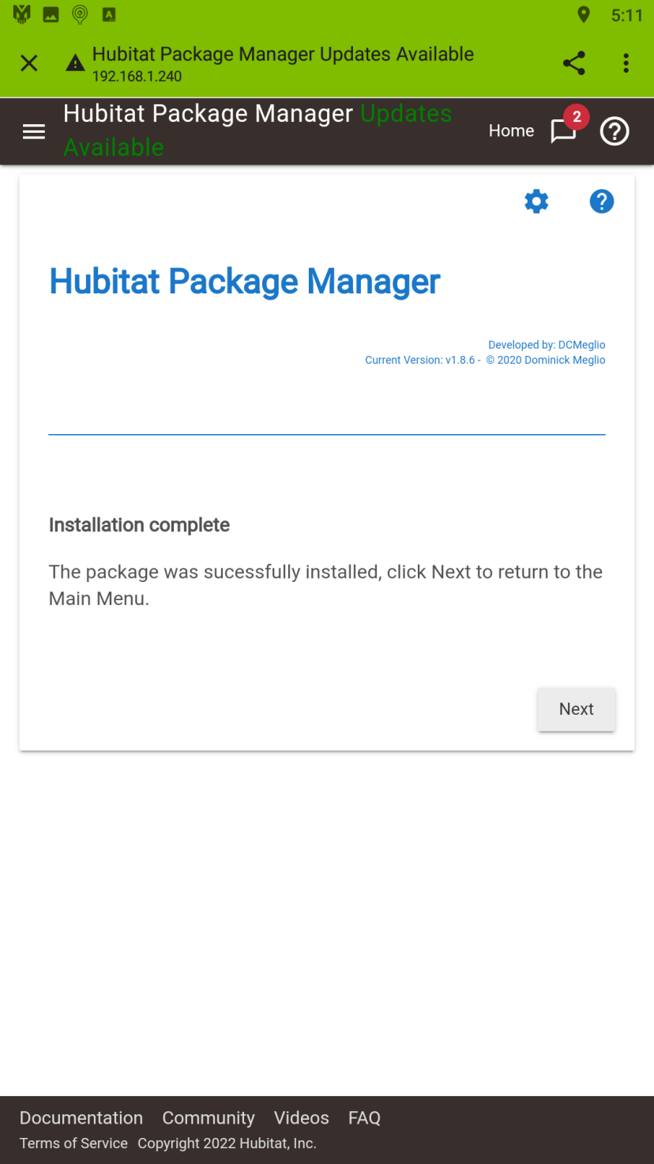

1. **Open the Hubitat™ “Apps” section and the “YoLink™ Device Service” should be listed:**

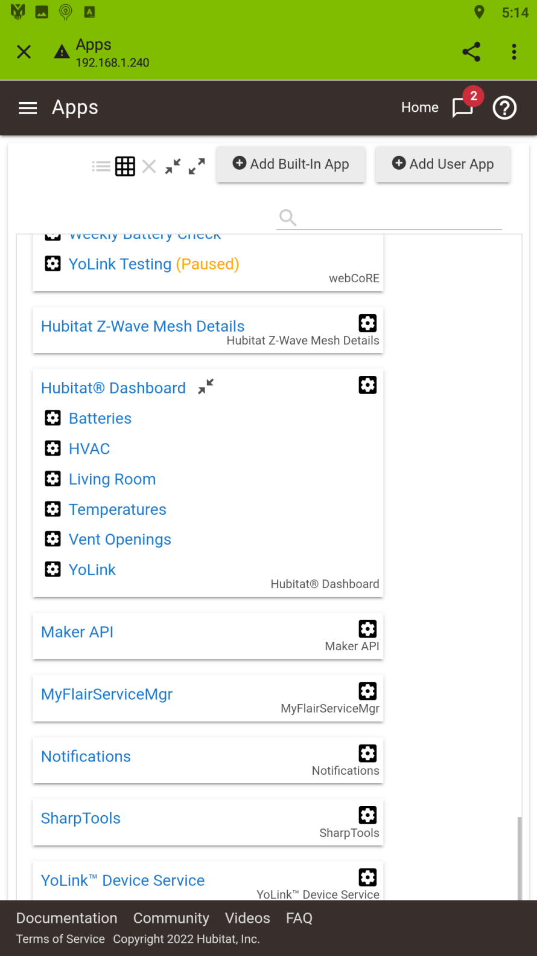

1. **Open the Hubitat™ “Drivers Code”” section and the various YoLink™ Device Drivers that you selected for installation should be listed:**

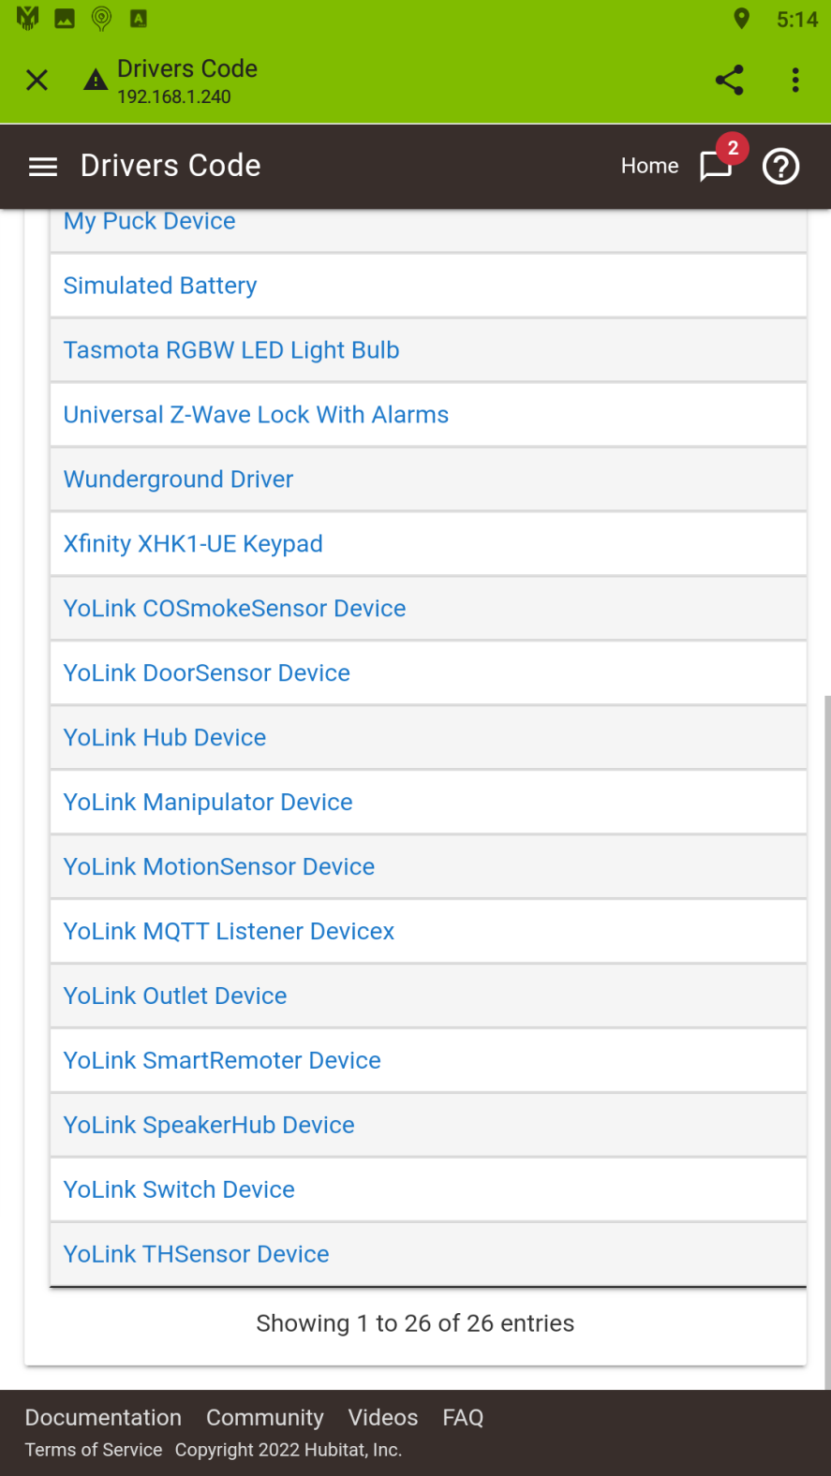

**IMPORTANT: At this point none of your YoLink™ devices are actually connected to your Hubitat™ hub, only the framework has been installed. You must now configure the YoLink™ Device Service app to connect to your YoLink™ home and create the actual devices on your hub. Please continue by referencing the following documents:**

[**https://github.com/srbarcus/yolink/blob/main/Help/Obtaining_your_Personal_Access_Credentials.pdf**](https://github.com/srbarcus/yolink/blob/main/Help/Obtaining_your_Personal_Access_Credentials.pdf)

**<https://github.com/srbarcus/yolink/blob/main/Help/How_to_use_the_YoLink_Service_App.pdf>**