# How to use the “YoLink™ Device Service” app a Hubitat™ Hub

(Version 1.0)

The YoLink™ Device Service app (hereafter referred to as simply, “the Service”) consists of the YoLink™ Device Service app and various device drivers that support the different YoLink™ devices.

This documentation assumes that you have already installed the Service and associated drivers on your Hubitat™ hub as detailed in the document:

[**https://raw.githubusercontent.com/srbarcus/YoLink/master/Help/How_to_use_the_YoLink_Service_App.pdf**](https://raw.githubusercontent.com/srbarcus/YoLink/master/Help/How_to_use_the_YoLink_Service_App.pdf)

1. **Open the Hubitat mobile app and click on “Connect to hub”:**

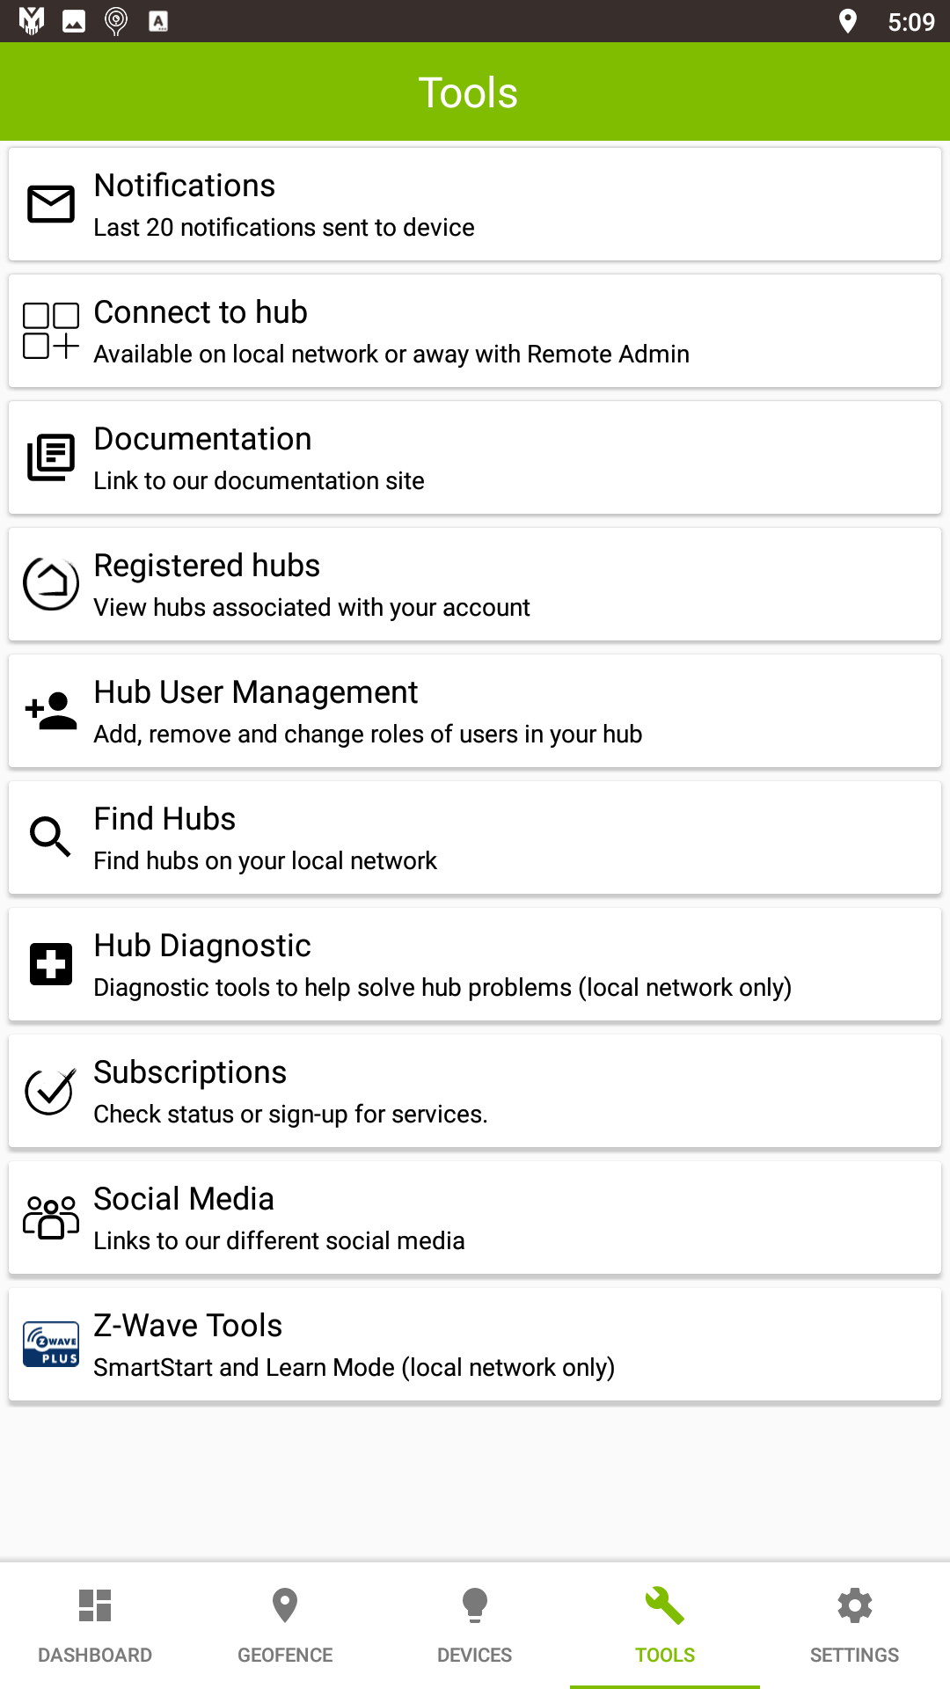

1. **Click on “Apps”:**

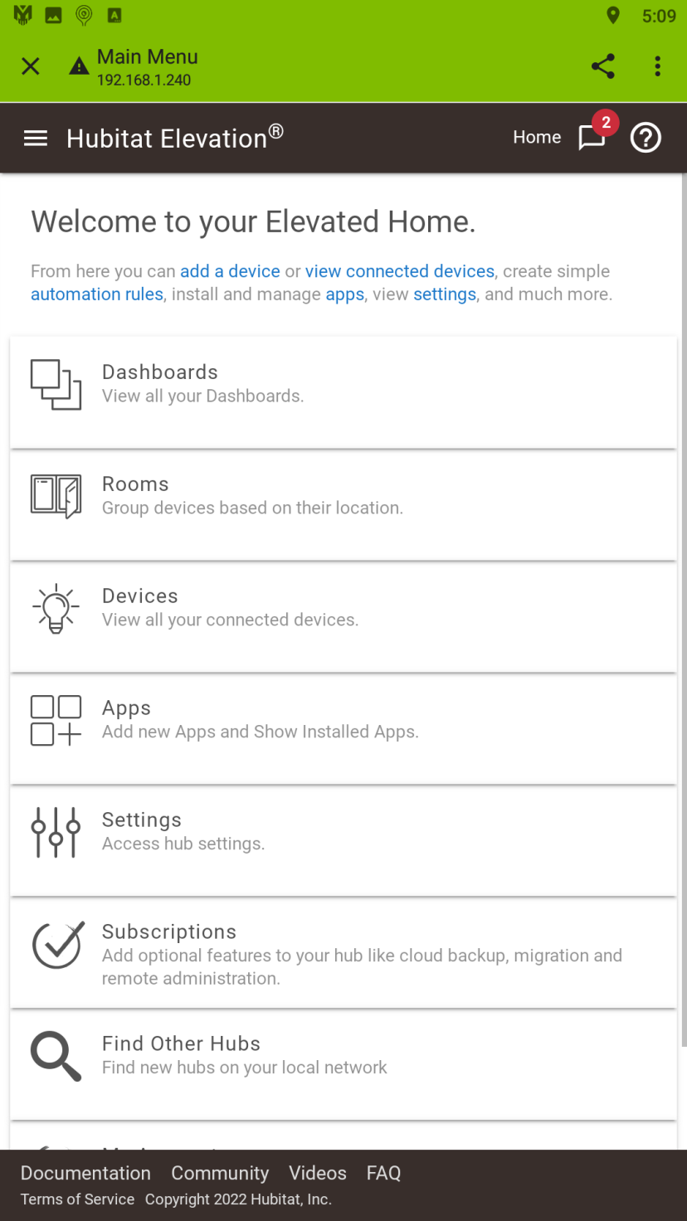

1. **Click on “YoLink™ Device Service”:**

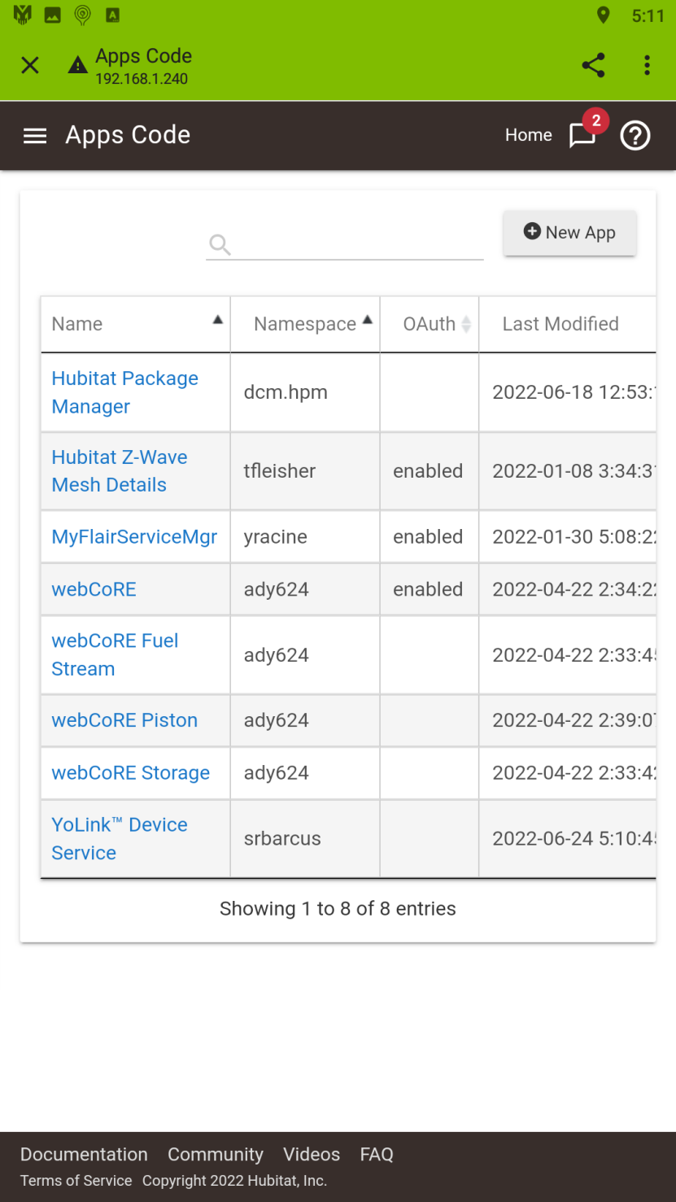

1. **Click “Next”:**

***Optional: Click on “Paypal donation…” to make a donation to the developer. This will allow me to purchase additional YoLink™ devices for development that I would not otherwise purchase because I have no need of them. Thank you in advance.***

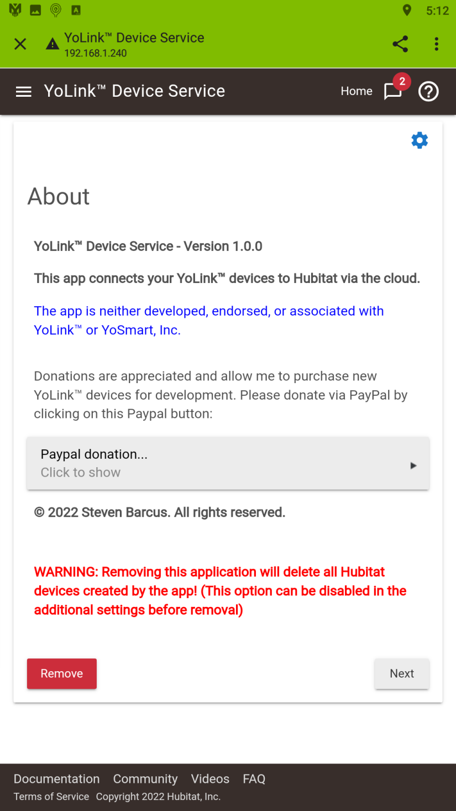

1. **Enter your Personal Access Credentials from the YoLink™ mobile app. You can click on the “How to obtain your User Access Credentials” to view the instructions on how to locate them in the YoLink™ mobile app. Insure upper and lowercase letters, as well as similar looking characters such as '0' (zero) and 'O' (oh) and '1' (one) and 'l' (ell), are specified exactly as shown in the YoLink™ mobile app:**

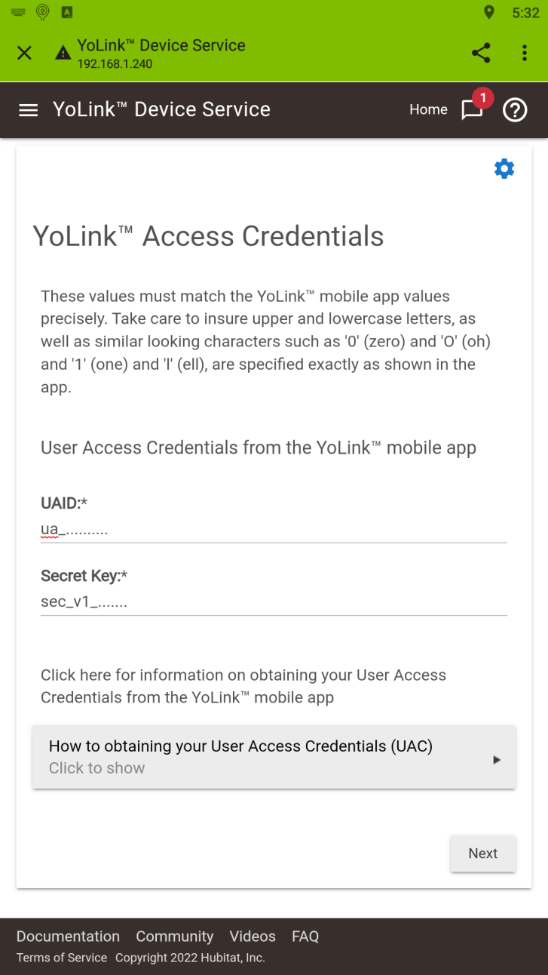

1. **If the credentials you enter are invalid, you will receive the following error panel. Click “Next” to re-enter the credentials:**

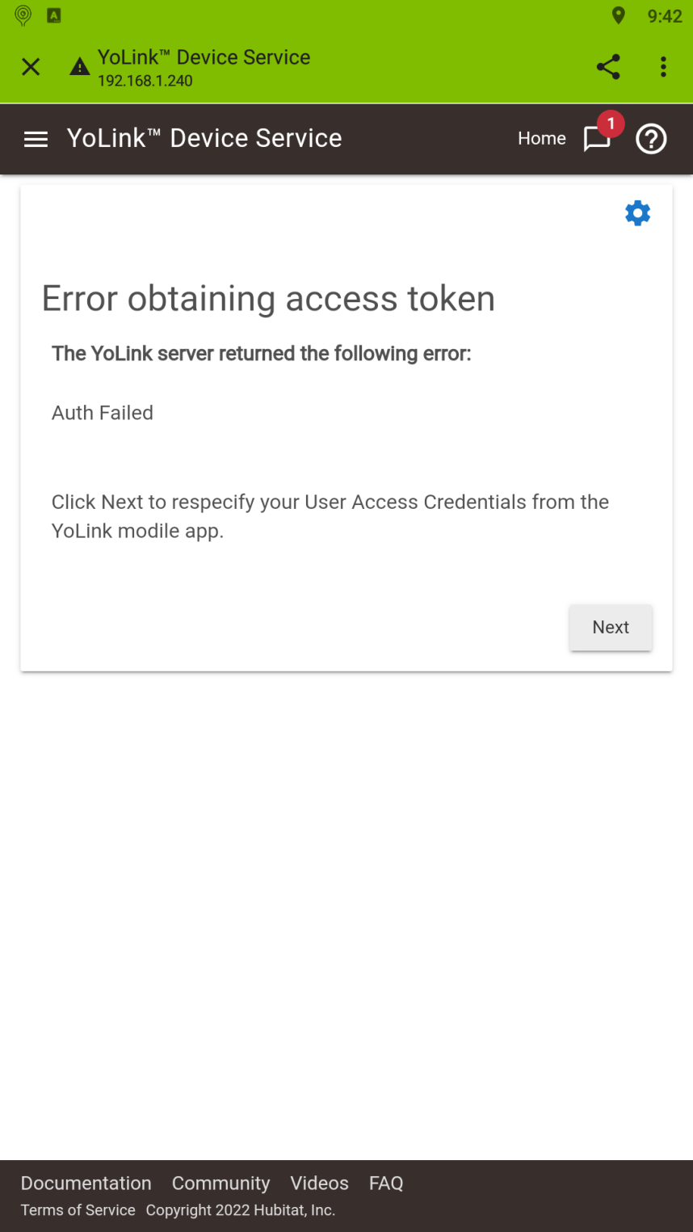

1. **If the YoLink™ Device Service connects to your YoLink™ home successfully, the following panel is displayed showing the number of YoLink™ devices that were found. Click on “Click to choose” to open a drop-down list of devices found:**

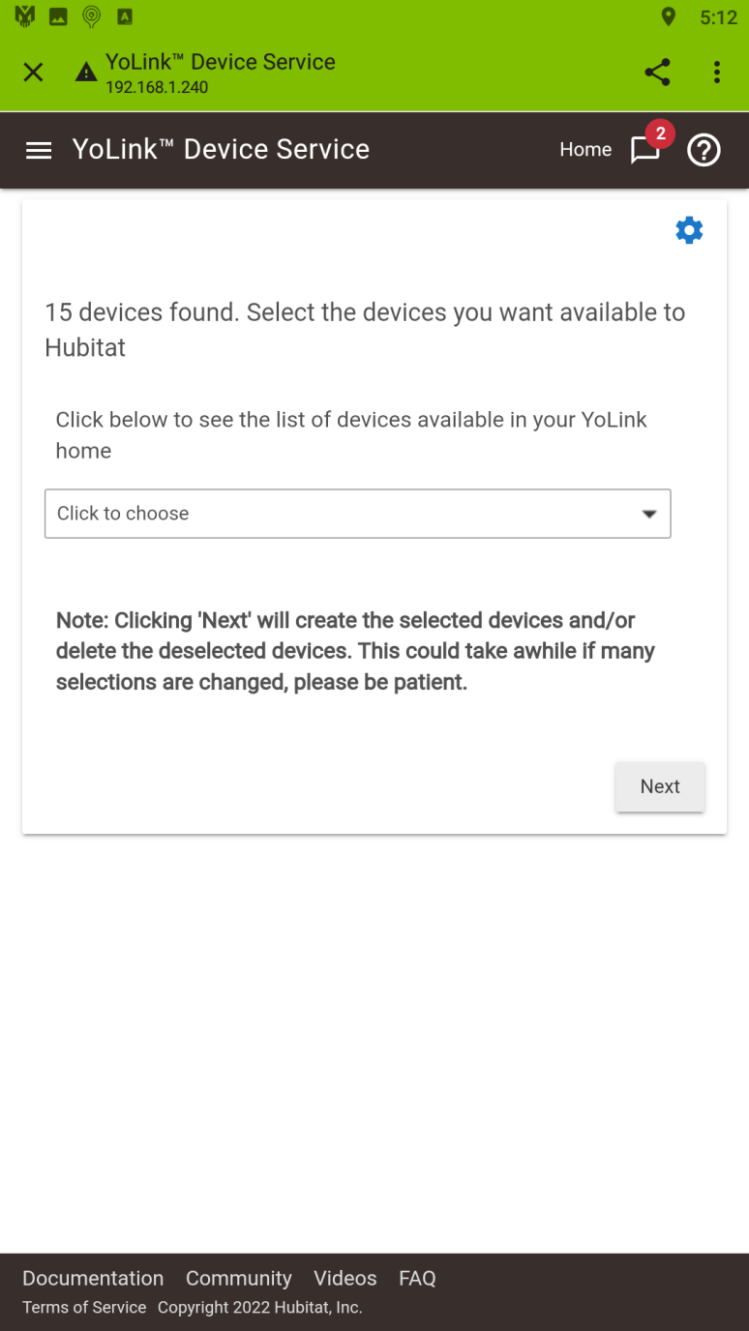

1. **Click on each of the devices that you want to install and control from your Hubitat™ hub:**

**Note: Not all YoLink™ devices are currently supported. Check your Hubitat™ hub’s log after installation is complete to see if there are any error messages indicating that an appropriate device driver was not found. The list of currently supported devices (and those currently under development) can be found at:**

[**https://raw.githubusercontent.com/srbarcus/YoLink/master/Drivers.txt**](https://raw.githubusercontent.com/srbarcus/YoLink/master/Drivers.txt)

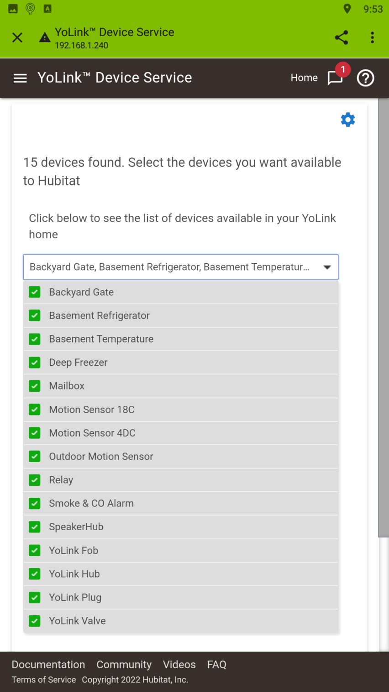

1. **Click on the selection box again to close the list of devices and then click “Next” to install the devices. NOTE: No new panel will appear immediate after clicking “Next”. If may take several minutes to install all the devices on the Hubitat™ hub, especially if your list of devices is extensive. A blue “spinner” will appear at the top of the panel indicating that the install is in progress. DO NOT INTERRUPT THE PROCESS! :**

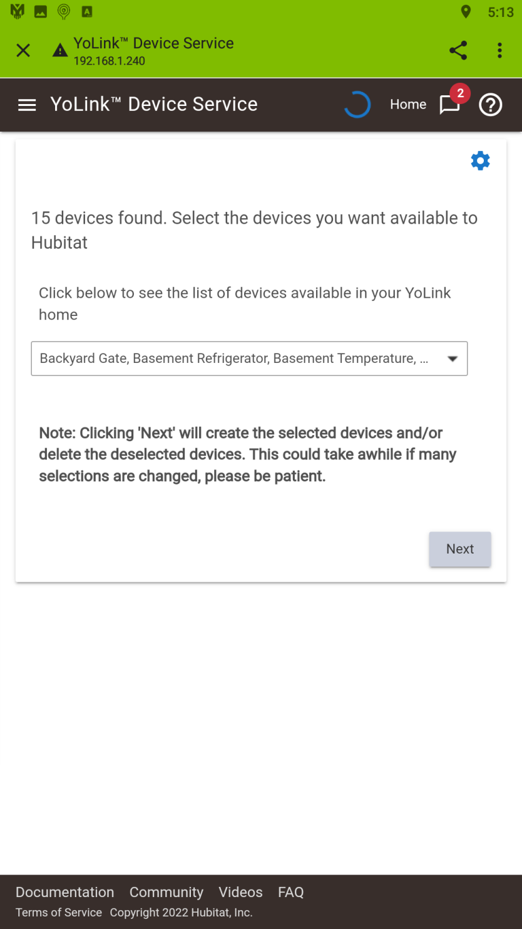

1. **When the installation of the selected devices is complete, the “Other Settings” panel will appear. Change any settings as per the following and then click “Done”:**

* **Select Temperature Scale – Select the temperature scale to be used for values received from YoLink™ devices.**
* **Select Polling Interval – Select the interval at which the Hubitat™ hub will poll the YoLink devices. This is mostly used to determine if the devices are still online. Most YoLink™ devices report changes immediately without being polled, so it’s not necessary to have a small Polling Interval. The default setting is recommended. Increasing the Poll Interval will reduce the load on your Hubitat™ hub.**
* **Remove Devices – Under normal circumstances, you would want any devices associated with the YoLink™ Device Service app to be uninstalled when the application is uninstalled. The installed devices are linked directly with that specific version of the Service and will not work without it. Therefore, it’s highly recommended that you do not change this setting.**

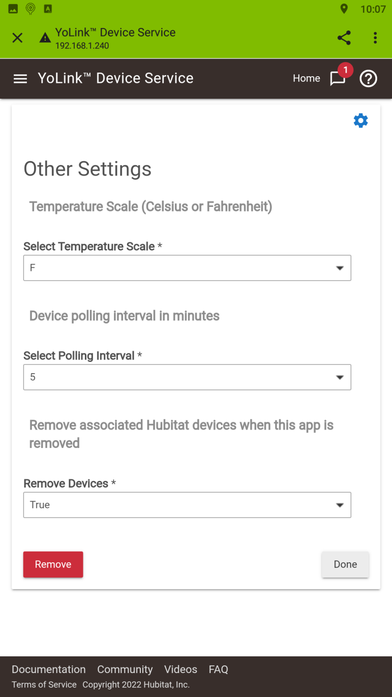

1. **Open the “Devices” section on your Hubitat™ hub and you should see all the (supported) devices – they all start with the work “YoLink”:**

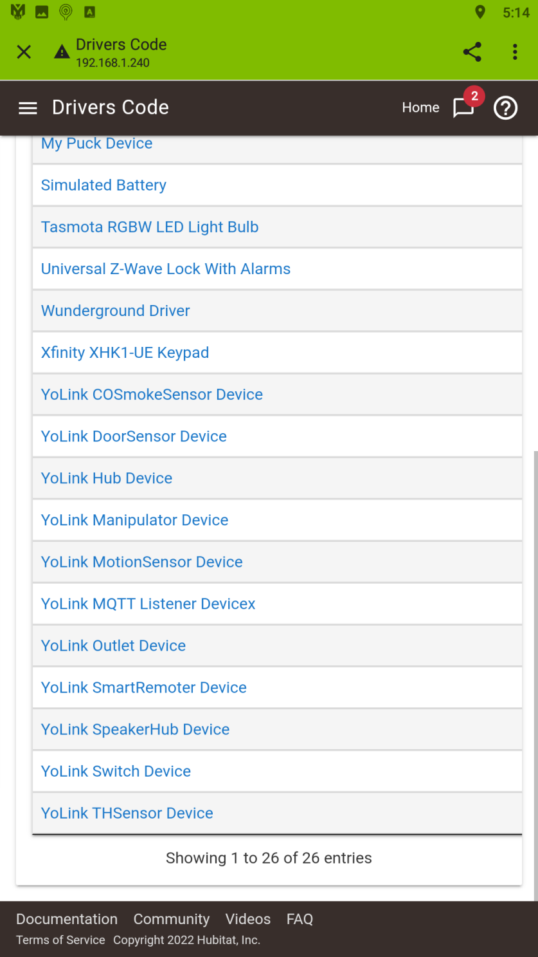

1. **Additional information:**
2. **You can use the “Modify” option of the “Hubitat Package Manager” app to install new device drivers if you acquire a new type of device or new drivers become available.**
3. **You can use the “YoLink™ Device Service” app to add or remove devices on your Hubitat™ hub, simply select or deselect the device(s) in the device list as shown in step 7 above. Note: If you uninstall a device and then reinstall it later, it will be a completely new device on the Hubitat™ hub.**