# How to install the “YoLink™ Device Service” app and Drivers on a Hubitat™ Hub

(Version 1.3)

The YoLink™ Device Service (hereafter referred to as simply, “the Service”) consists of the YoLink™ Device Service App and various Drivers that support the different YoLink™ devices.

The list of supported devices (and those currently under development) can be found at:

[**https://raw.githubusercontent.com/srbarcus/YoLink/master/Drivers.txt**](https://raw.githubusercontent.com/srbarcus/YoLink/master/Drivers.txt)

Due to the complexity of installing the Service and all the associated drivers, installation is only supported using the **Hubitat Package Manager App (HPM)**. Using **HPM** will drastically reduce installation time, reduce the chances of an incorrect installation, as well as simplify updating and modifying the Service as you acquire new YoLink™ devices.

There are many articles on how to install the **HPM** on your Hubitat™.

Here is one that details the manual process:

<https://community.hubitat.com/t/how-to-install-hubitat-package-manager-or-any-other-user-app/92387>

Official Installation:

<https://hubitatpackagemanager.hubitatcommunity.com/installing.html>

Installation of the YoLink™ Device Service App consists of the following steps:

1. Install the official YoLink™ app on your mobile device and either Sign In to your existing account or Sign up for an account. Your app must be configured and showing all of the devices that you want to control from Hubitat™.
2. Connect all your YoLink™ devices to your YoLink™ Hub or YoLink™ Speaker Hub as documented in the Hub’s user manual and the individual device manuals.
3. Install the **HPM** app on your Hubitat™ (if it’s not already installed).
4. Install the YoLink™ Device Service App as documented below.

# Installing the “YoLink™ Device Service” app and Drivers using HPM

1. **Open the Hubitat mobile app and click on “Connect to hub”:**

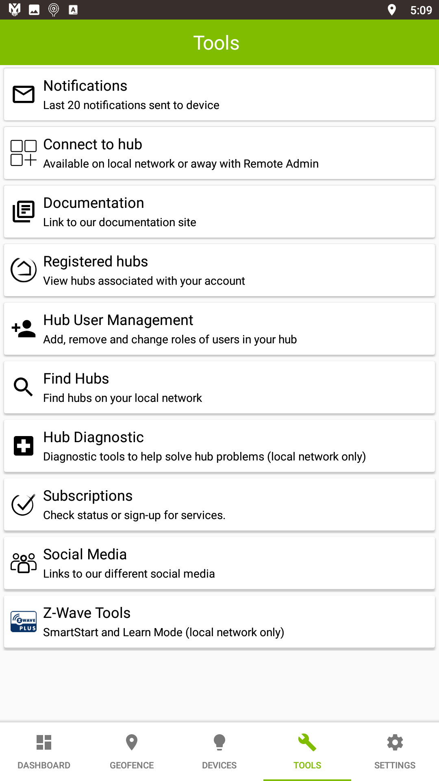

1. **Click on “Apps”:**

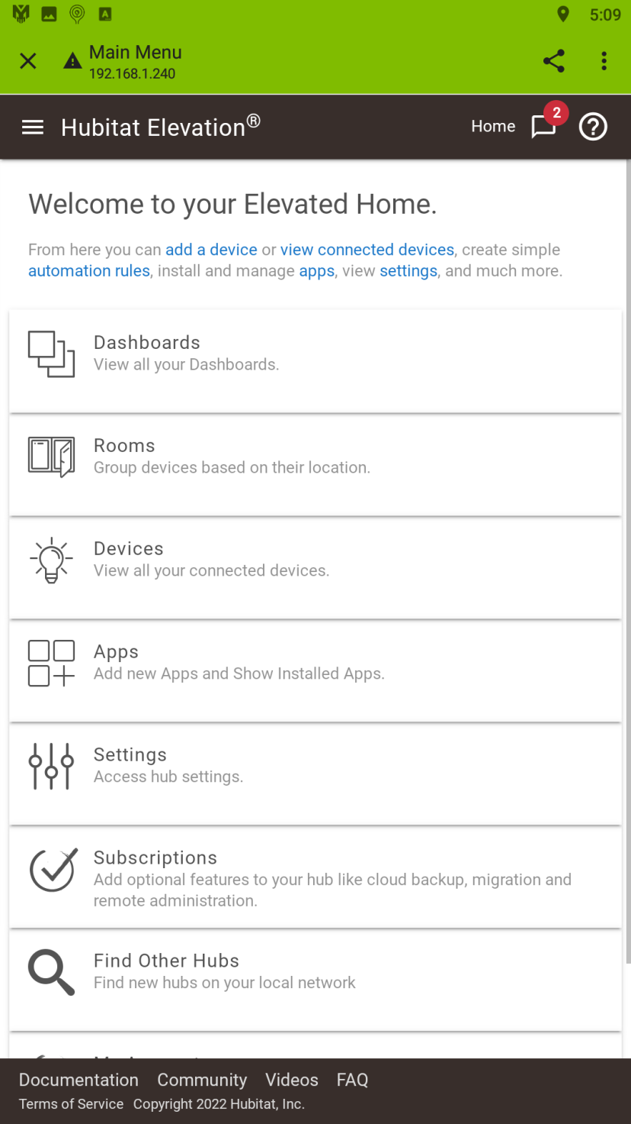

1. **Click on “Hubitat Package Manager”:**

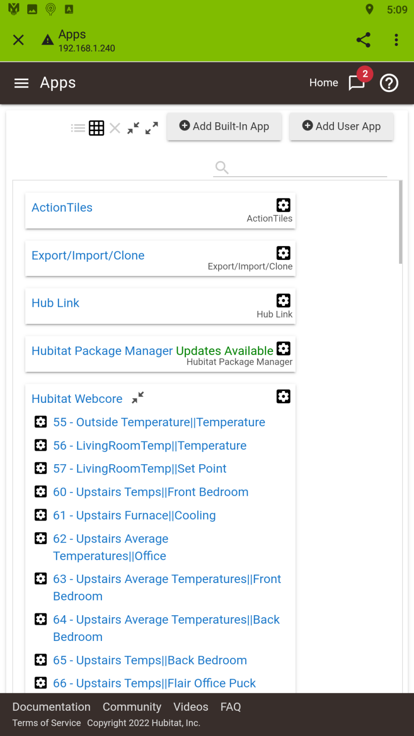

1. **Click on “Install”:**

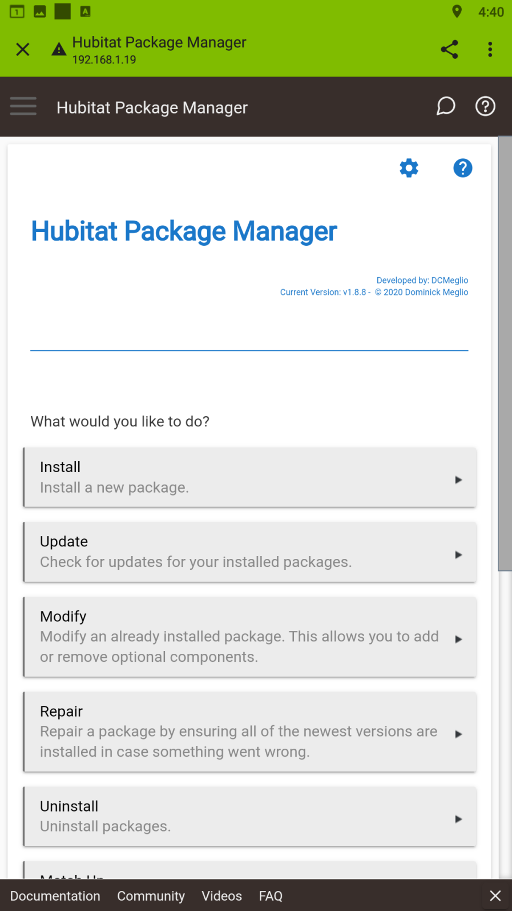

1. **Click on “Search by Keywords”:**

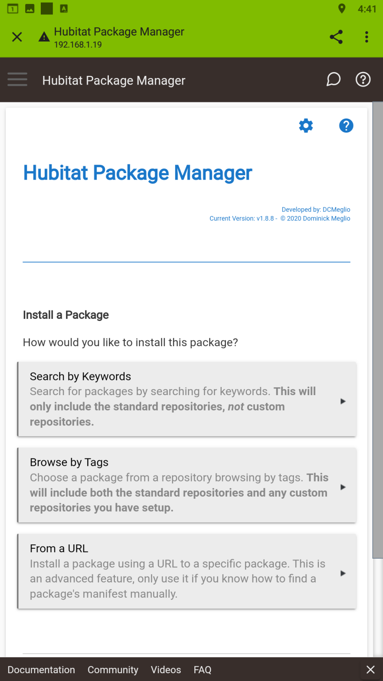

1. **Enter the keyword “yolink” and then click “Next”:**

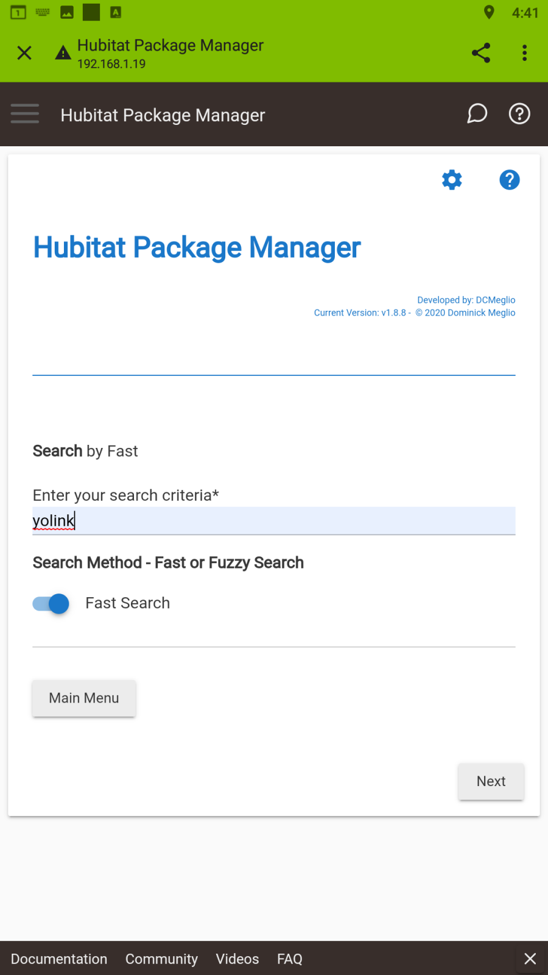

1. **Click on “YoLink Devices by Steven Barcus”:**

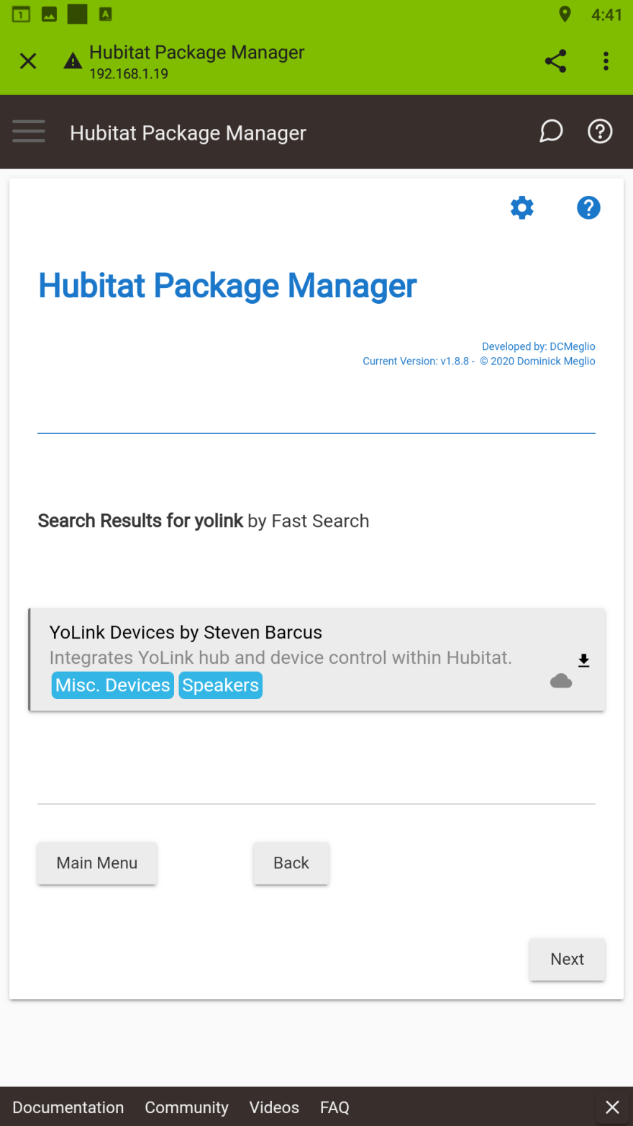

1. **Click on “Select the drivers to install” to open a drop-down list of the currently supported YoLink™ device drivers:**

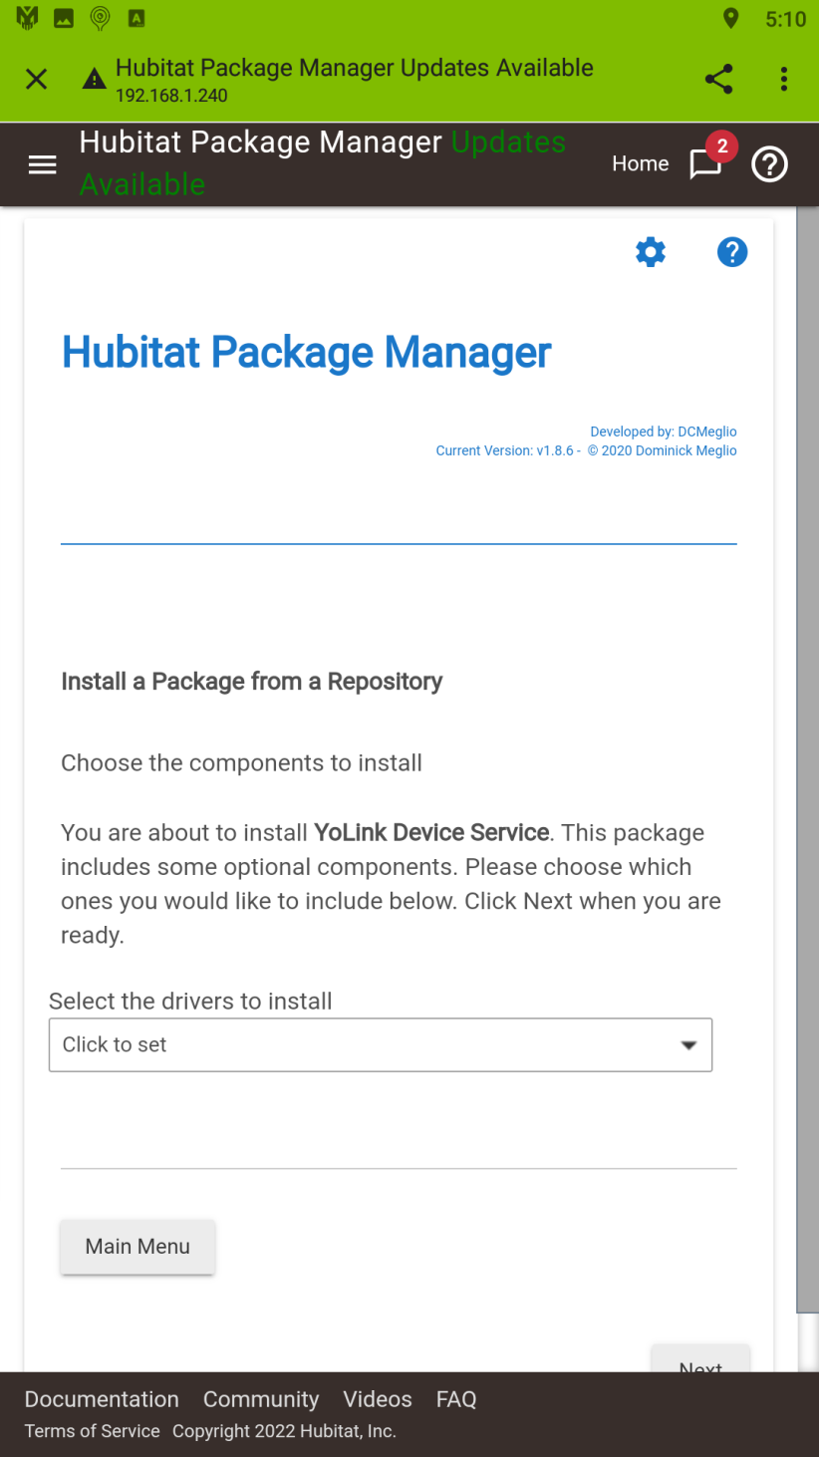

1. **Click on each device driver you want to install. Drivers for the YoLink™ Hub and YoLink™ Speaker Hub are installed automatically. The only downside of installing all of them is that they’ll take up memory on your Hubitat™ Hub. You can always use the HPM’s “Modify” option to install or remove drivers as necessary:**

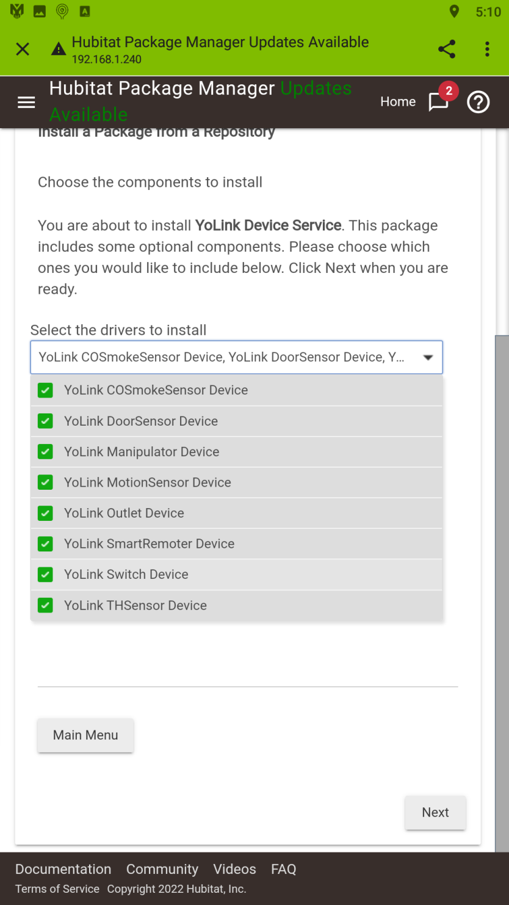

1. **Click on the selection box to close it, then click “Next”:**

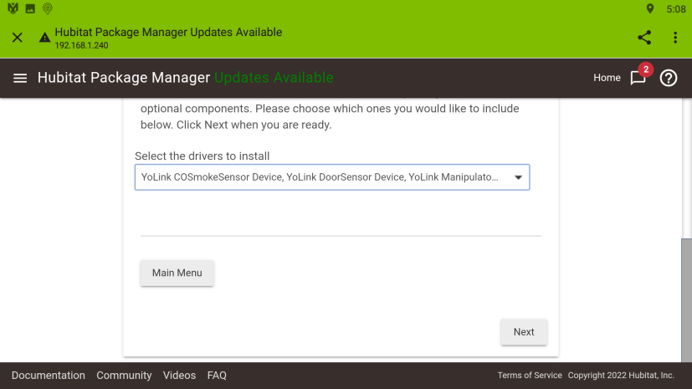

1. **Click on “Next” to begin the installation:**

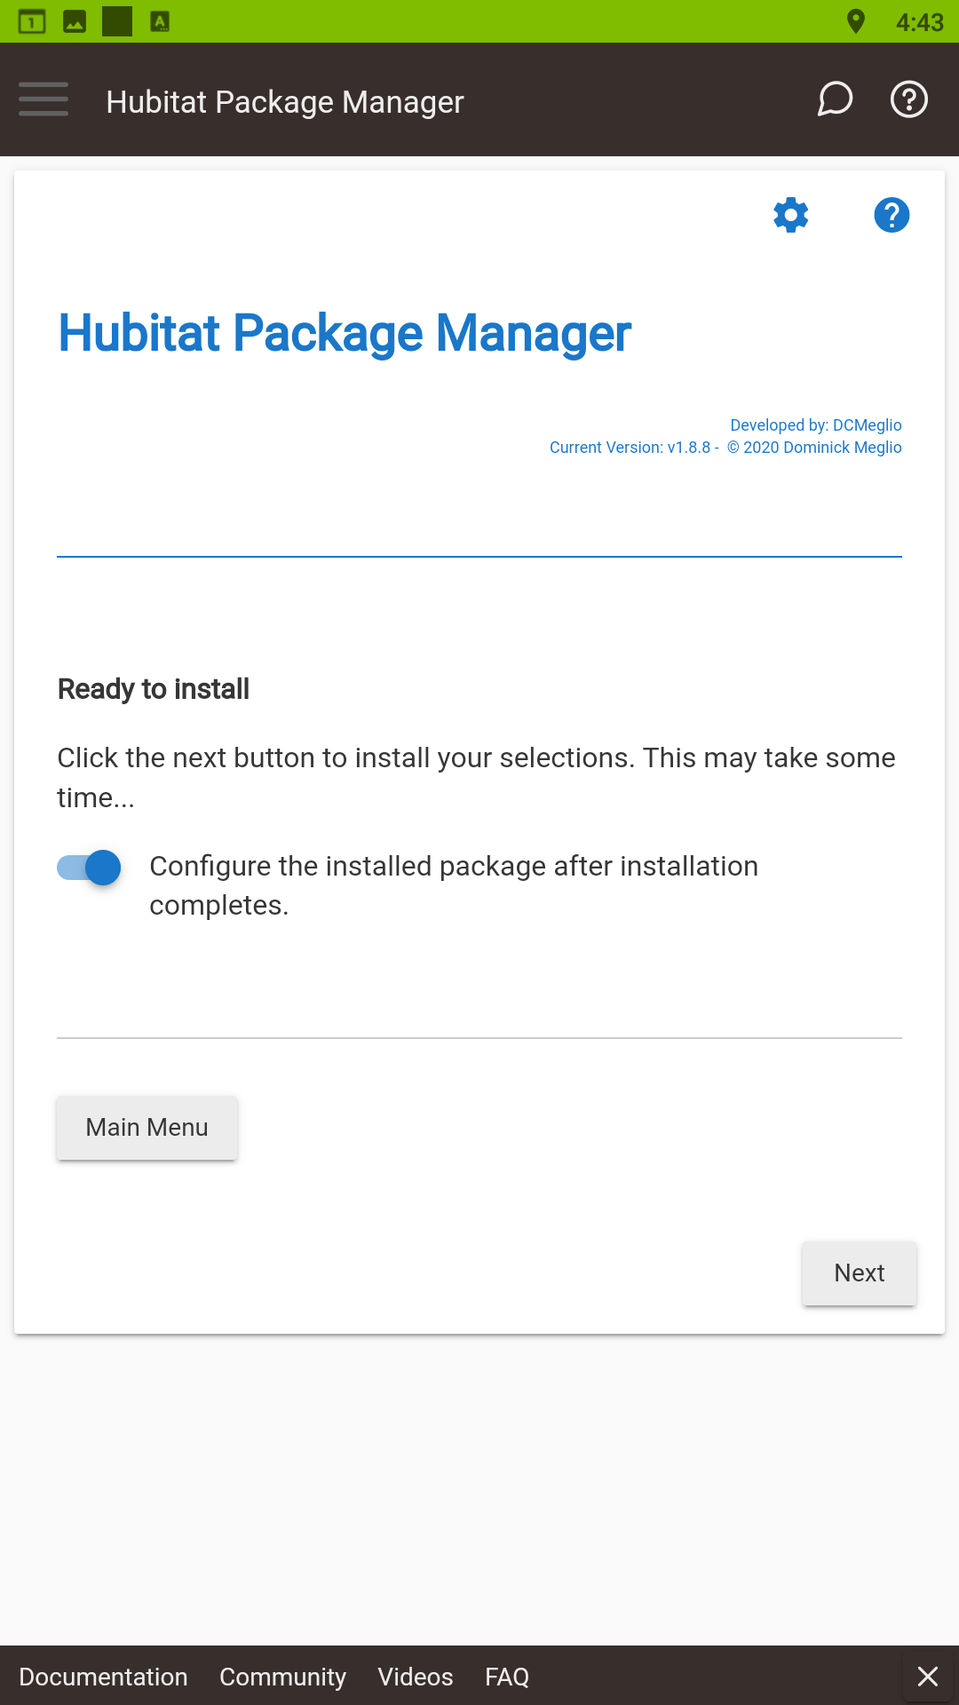

1. **Installation processes:**

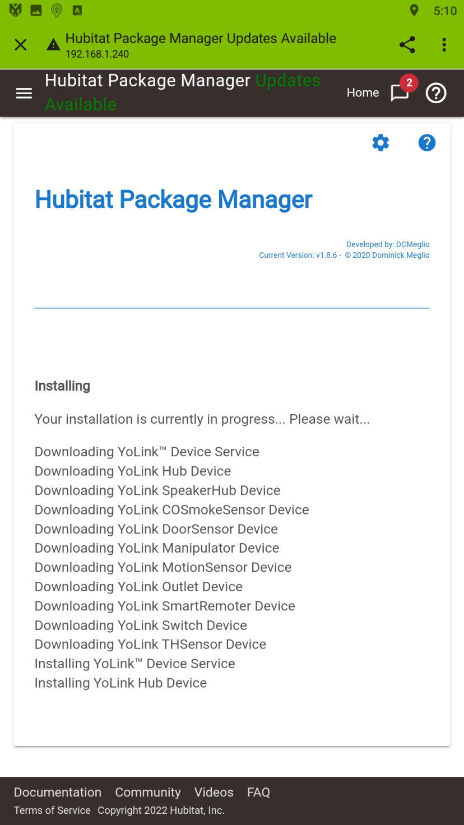

1. **Installation completes – click “Next” to start configuring the “YoLink™ Device Service” app:**

**You must complete the configuration of the YoLink™ Device Service app to connect to your YoLink™ home and create the actual devices on your hubitat. Please continue by referencing the following documents:**

**How to install the YoLink™ Service App** [**https://github.com/srbarcus/yolink/blob/main/Help/How_to_install_the_YoLink_Service_App.pdf**](https://github.com/srbarcus/yolink/blob/main/Help/How_to_install_the_YoLink_Service_App.pdf)

**Obtaining your Personal Access Credentials**

[**https://github.com/srbarcus/yolink/blob/main/Help/Obtaining_your_Personal_Access_Credentials.pdf**](https://github.com/srbarcus/yolink/blob/main/Help/Obtaining_your_Personal_Access_Credentials.pdf)

