Pedestrians Un-Signalized Crosswalk Effects Traffic Congestion
Shrabani Ghosh
Department of Modeling, Simulation and Visualization Engineering, Old Dominion University, Norfolk, VA-23529, sghos003@odu.edu

Abstract— In last few years, agent-based researches on traffic and transportation has grown enormously. Vehicles and pedestrian crossing extensively exists in cities. To study the characteristics of interference traffic flux, I developed a pedestrian-vehicle agent-based model to present the interaction between on a simple cross road. Unsignalized intersection of pedestrian crossing creates traffic congestion. Traffic congestion may cause accidents which takes valuable lives. This paper will introduce an agent-based model how pedestrian behavior impacts on traffic congestion.
Keywords—ABMS, Netlogo, UML.

Introduction (Heading 1)
Traffic Congestion has become a problem in big cities like New York City. The city traffic system composed of street, vehicles, pedestrians. City traffic does not only control by vehicles but also influenced by pedestrians. Pedestrian movement has taken a lot of interest by researchers. Several models have proposed to study the interaction between pedestrians and vehicles. I have proposed a model based on Agent based Modeling and Simulation (ABMS). ABMS is widely used a new modeling paradigm and is one of the most exciting practical developments in modeling. During the last decade, there has been a tremendous progress in transportation and traffic engineering due to the use of agent technology. Given the increasing complexity of transportation and traffic systems, which arises from the modern way of life and new means and organization of transportation, not only new techniques must be deployed, but also the individual choices must be better understood if the whole system is to become more efficient. Khaled et al. [1] studied pedestrian behavior at an unmarked midblock crossing using ABMS. Prayardarsini et al. [2] used ABMS for traffic simulation. Jon et al. [3] proposed a model of pedestrian movements to answer few questions. Khallouk et al. proposed a cellular automata model This use case diagram is used in the development. But it can be extended to include all the needed details. The figure describes the traffic simulation which includes two actors: car and pedestrian. Car move on the road maintain the traffic light rules. It waits when the signal is red and pass when its green.
Pedestrian walk on the road not maintain the traffic rules through the crosswalk. Cars wait if any pedestrian on the way of it is and pedestrians also wait if any car is on the way of the pedestrian. to see traffic flow behavior at un-signalized intersection with crossings pedestrians. However, seldom papers have focused on the effect of the pedestrian crossing on the traffic flow at an un-signalized intersection.
My aim in this paper is to create a agent based model to explore the interference between crossings pedestrian and vehicles flow at an un-signalized intersection. The remainder of the paper is organized as follows. In section 2, I represent the conceptual model. In section 3, the agent-based model, in Section 4 results and discussion, while section 5 is devoted to the conclusion..

Conceptual Model

A. UML Use case Diagram

A use case is a set of scenarios that describing an interaction between a user and a system. A use case diagram displays the relationship among actors and use cases. The two main components of a use case diagrams are use cases and actors.
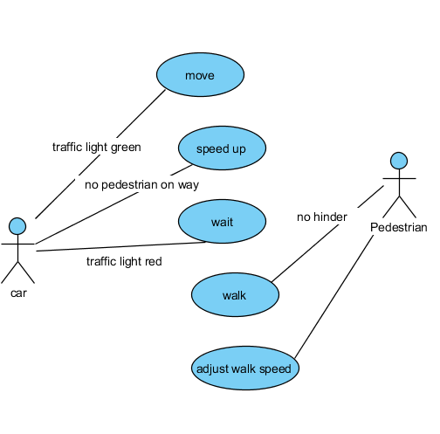
Figure 1: Use case Diagram

This use case diagram is used in the development. But it can be extended to include all the needed details. The figure describes the traffic simulation which includes two actors: car and pedestrian. Car move on the road maintain the traffic light rules. It waits when the signal is red and pass when its green. Pedestrian walk on the road not maintain the traffic rules through the crosswalk. Cars wait if any pedestrian on the way of it is and pedestrians also wait if any car is on the way of the pedestrian.

UML Class Diagram

Class diagram is a type of static structure diagram that describes the structure of a system by showing the system’s classes, their attributes and the relationships between the classes. Since the class diagram is the main building block in object-oriented modeling, It is used both for general conceptual modeling of the application and for detailed modeling; translating the models into programming code. I divided my model into few classes: car, pedestrian, accidents and report.
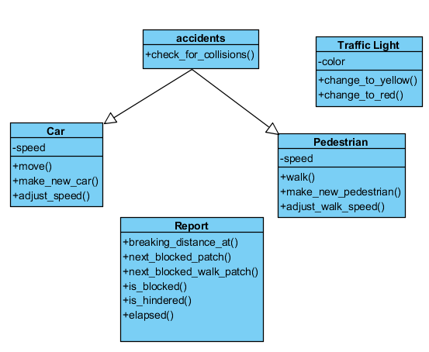
Figure 2: Class Diagram
The car class contains the information about car speed, movement similarly the pedestrian class contains the walk and speed adjustment. Traffic light class contains the method of signal change. And I kept a class report which contains the methods to report of turtles.

State Diagram
State Diagram displays the sequence of states that an object of an interaction goes through during its life in response to received stimuli, together with its responses and actions. State diagrams are used to describe the behavior of a system. State diagrams describe all the possible states of an object as events occur. Each diagram usually represents objects of a single agent and tracks the different states through the system.
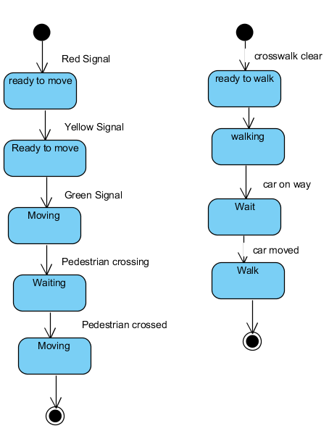
Figure 3 shows the state chart diagram of a car and a pedestrian.

Activity Diagram
Activity diagram depicts high-level business processes, including data flow, or to model the complex logic within a system. The figure (Fig 4) represents the activities that take place within the system. According to this model, the car moves based on the traffic lights and checking the road is free or not. If any passersby pass on the crosswalk, the car waits until it passes and then starts again.
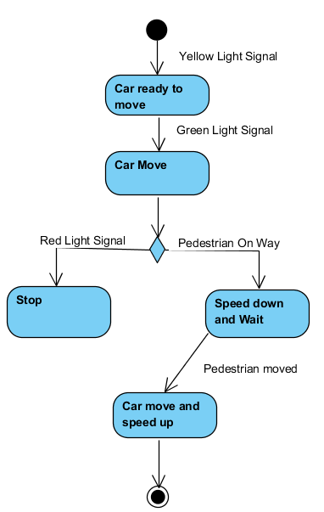
Figure 4: Activity Diagram

Model and methods

System Model
The system consists of two lanes intersecting in the middle. The chains are single lane and one way. Each chain is designed with two crosswalks. There are traffic lights in the middle section. There is greenery scenario outside of the road. The roads are considered as highways.

Crosswalk
In this model, we introduce two crosswalks at each road for accommodate crossing pedestrians. Crosswalks width is the same as the road width. Furthermore, pedestrians are generated at a waiting zone. They cross the road heading west and south.

Pedestrian Dynamic
For crossing pedestrian examines the available headway. If there is no car on its way, pedestrian continue crossing. If any car moves on the way, it waits until the car moved and then start crossing again. We note that on the crosswalk, when pedestrian cross road, they have the higher priority. The nearest vehicle should stop until the pedestrian finish crossing.

Vehicle Movement Rules
Car moves with an adjust speed.
Speed-limit, Acceleration -> user set value
Min-speed -> (speed – max-brake) to 0
Max-speed -> (speed + max-acceleration) to speed-limit
Vehicles near the crosswalk must decelerate and adapt velocity if there is any pedestrian.

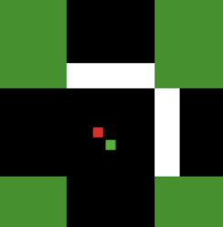
a b
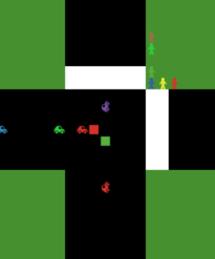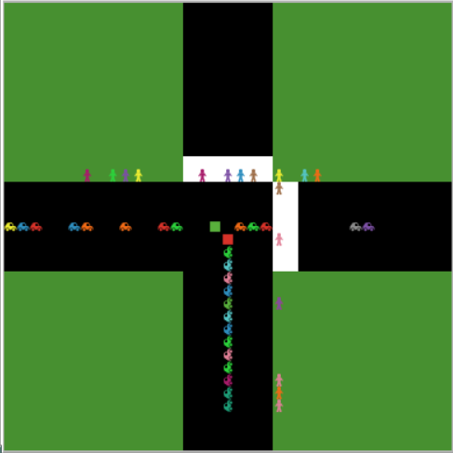
c d
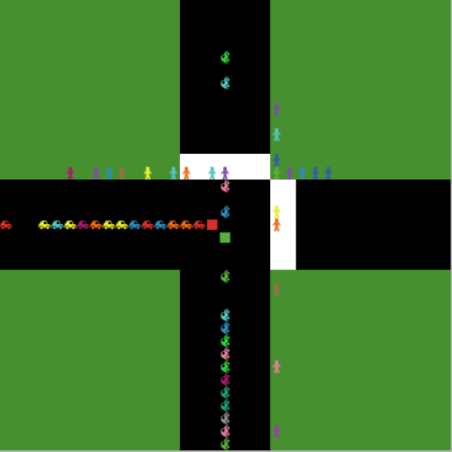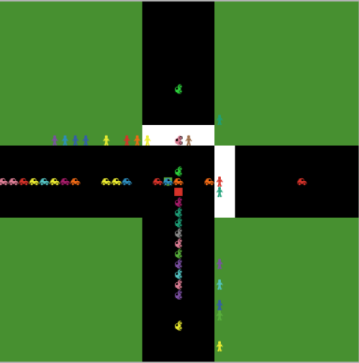
e f

Figure 5: (a) Intersection of two uni-directional single lane roads (b) Roads with crosswalk on the middle (c) waiting zone of pedestrians (d) Pedestrian crosses on the free road (e) car waits for the pedestrian to pass (f) Pedestrian waits until car passed

Results and Discussion

In this section, the simulation results are presented. The parameters are: Speed-limit = 5, max-accel=2, max-brake=4, freq-north=60%, freq-east=85%, green-length=12, yellow-length=3, walk-speed=1. The results are simulated over 1200 ticks.
My model is implemented based on the given model in Netlogo “Traffic Intersection”. In the Traffic Intersection original model, it shows the waiting time for eastbound and northbound.

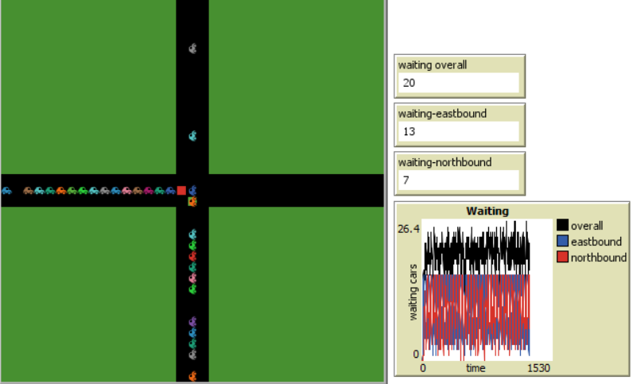
Figure 7: The highest overall waiting time is 26.4 after 1200 ticks.

In my model, unsignalized pedestrian crosswalk increased the waiting time. After 1200 ticks the increased time is 34.1. It may increase even more.

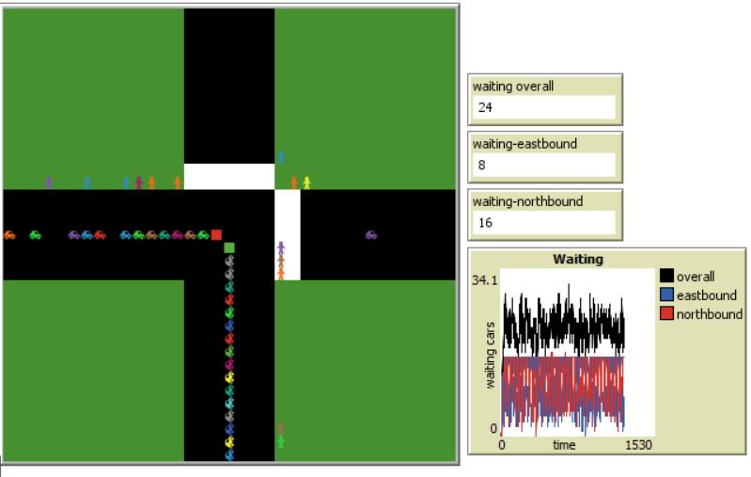

In my proposal, I asked the question to figure out if the changing location of crosswalk have any positive impact on the congestion or not.
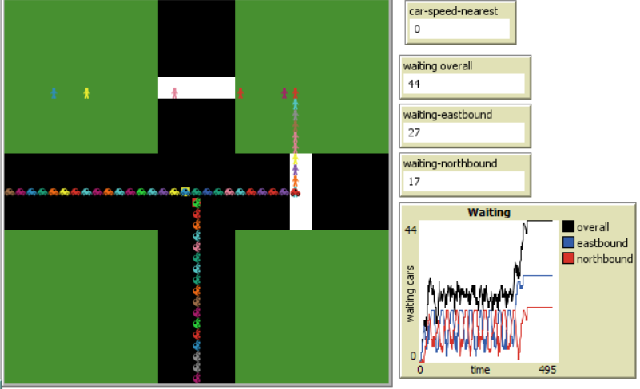

In my findings, I have seen that after 100 ticks on average, huge congestion creates because as the crosswalk is further from the midsection, for unsignalized pedestrian passing, after certain speed achieved cars cannot slow down speed easily. It causes accidents and creates huge congestion
That is why in real time crosswalks are always placed on the midsection. If pedestrians don’t maintain signal, still they won’t cause accidents.

Conclusion

In summary, I have proposed an agent-based model to study the interaction between vehicles and pedestrian’s crossings at an un-signalized intersection. The simulation results have shown that waiting time increases as the interference between vehicles and pedestrians become higher at the intersection and before the crosswalks., thus the traffic becomes congested. I have shown that the waiting time increases for pedestrian interaction. Shifting the crosswalk from midsection to further does not help. It created more congestion because of accidents in highways.

References

[1] Khallouk, A., et al. "Traffic flow behavior at un-signalized intersection with crossings pedestrians." Physics Letters A382.8 (2018): 566-573.
[2] Feng, Shumin, et al. "Simulation of pedestrian flow based on cellular automata: A case of pedestrian crossing street at section in China." Physica A: Statistical Mechanics and its Applications 392.13 (2013): 2847-2859.
[3] Hamed, Mohammed M. "Analysis of pedestrians’ behavior at pedestrian crossings." Safety science 38.1 (2001): 63-82.
[4] Lajunen, Timo, Dianne Parker, and Heikki Summala. "Does traffic congestion increase driver aggression?." Transportation Research Part F: Traffic Psychology and Behaviour 2.4 (1999): 225-236.
[5] Zhuang, Xiangling, and Changxu Wu. "Modeling pedestrian crossing paths at unmarked roadways." IEEE Transactions on Intelligent Transportation Systems 14.3 (2013): 1438-1448.
[6] Jin, Sheng, et al. "Dynamic characteristics of traffic flow with consideration of pedestrians’ road-crossing behavior." Physica A: Statistical Mechanics and its Applications 392.18 (2013): 3881-3890.
[7] Xin, Xiuying, et al. "Power-law in pedestrian crossing flow under the interference of vehicles at an un-signalized midblock crosswalk." Physica A: Statistical Mechanics and its Applications 406 (2014): 287-297.
[8] Hunt, J., and J. Griffiths. "PEDESTRIAN BEHAVIOUR AT MID-BLOCK CROSSINGS IN THE UNITED KINGDOM--ROAD USER BEHAVIOR. THEORY AND RESEARCH. PAPERS PRESENTED AT THE 2ND INTERNATIONAL CONFERENCE ON ROAD SAFETY HELD IN GRONINGEN, NETHERLANDS, AUGUST 1987." Publication of: VAN GORCUM & COMP BV (1988).
[9] Klügl, Franziska, and Ana LC Bazzan. "Agent-based modeling and simulation." AI Magazine 33.3 (2012): 29.

