TECHNICAL ANALYSIS USING R
Assignment 2 — Preliminary Stage (5%)
Student: Sumandeep Singh Brar | Course: BDA400 | Assignment: A02
Repository: github.com/srbrar1-hub/TechnicalAnalysis • Evidence collected September–October 2026

1. Objective and project overview
The objective is to establish an R/RStudio environment, create a GitHub repository, define a three-stock portfolio, retrieve historical market data, calculate basic descriptive statistics and moving averages, and display results. The portfolio contains Apple (AAPL), Microsoft (MSFT), and NVIDIA (NVDA). Screenshots below document the work performed.

2. GitHub repository setup
A public GitHub repository named TechnicalAnalysis was created under srbrar1-hub. The supplied repository screenshot confirms the initial commit and README.md. It does not confirm that the required Assignment_2 subdirectory and analysis files were uploaded; these should be added before final submission.
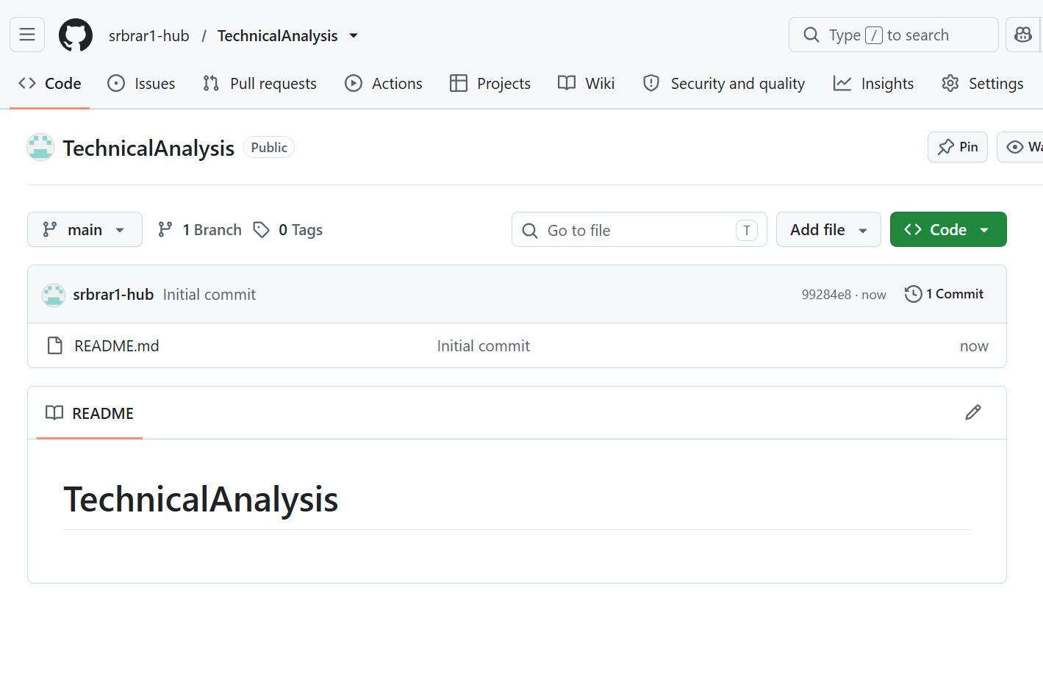
Figure 1. TechnicalAnalysis GitHub repository after initial commit.

3. R and RStudio setup
The screenshots show R version 4.6.1 and the RStudio environment running on Windows. Installation wizard screens were not supplied, so the evidence establishes successful launch rather than every installation step.
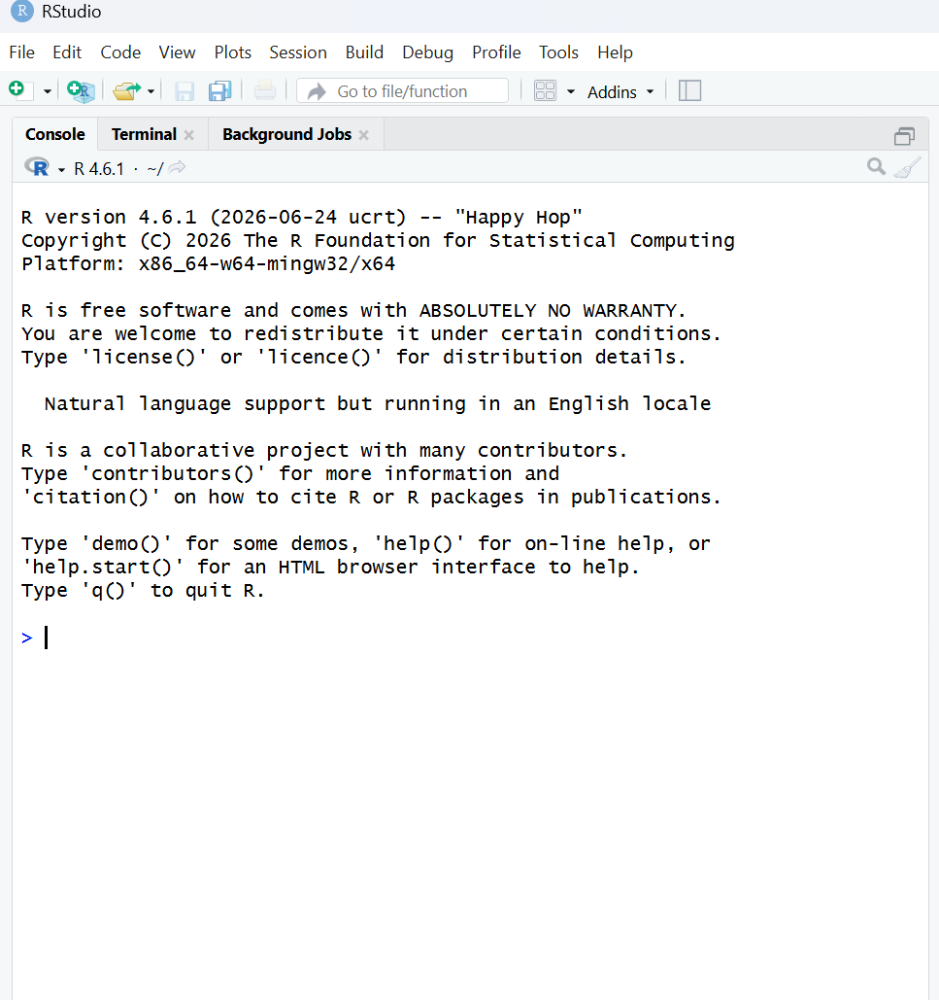
Figure 2. RStudio launched with R 4.6.1.

4. Required R packages
The analysis uses quantmod for market data retrieval and charting, and TTR for the simple moving average (SMA). Console evidence shows successful library() calls for both packages; package installation screens were not supplied.
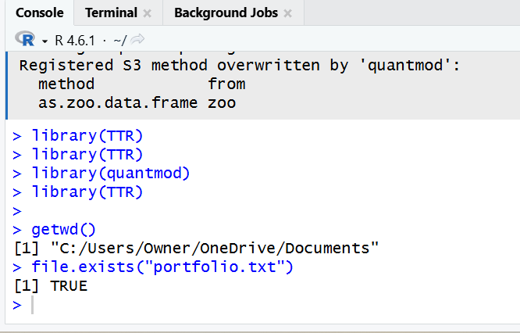
Figure 3. Loaded packages and verified working directory.

5. Portfolio configuration
The file portfolio.txt lists one ticker per line: AAPL, MSFT, NVDA. The console confirmed that the file exists and its content was read. A warning about the missing final newline is nonfatal; adding a trailing newline removes it.
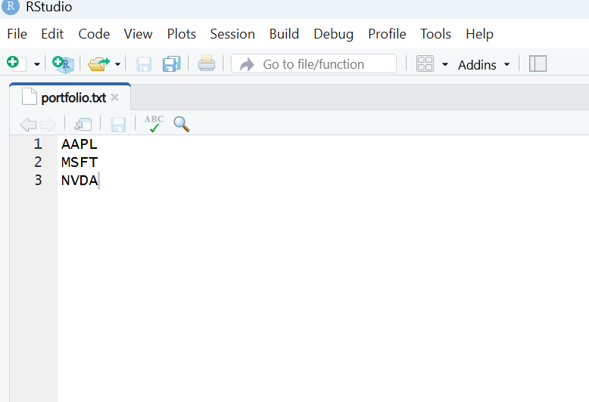
Figure 4. Portfolio text file containing three stock symbols.
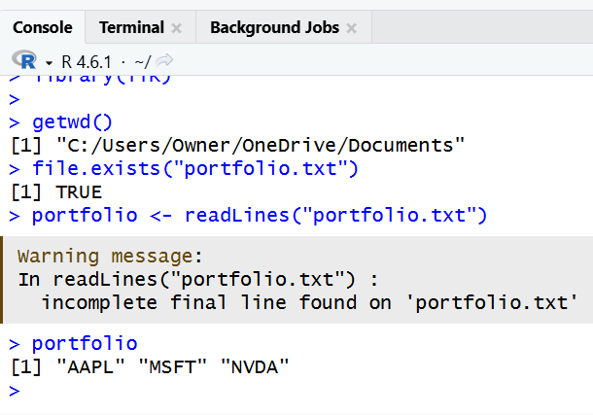
Figure 5. Portfolio file read in the R console.

6. Loading historical stock data
The analysis downloads historical price series for the three tickers, beginning January 3, 2007. The screenshots show stock data and computed daily returns. The end date depends on the downloaded dataset and is not necessarily the same as the requested upper bound.
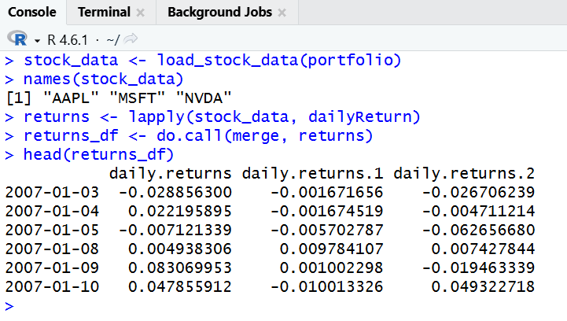
Figure 6. Loaded stock symbols and first rows of daily returns.

7. Descriptive statistics and correlations
The screenshots show the sample mean, median and standard deviation of daily returns. Values below come from the displayed console results and are rounded for readability.
Stock | Mean daily return | Median | Daily SD
AAPL | 0.001139517 | 0.001048856 | 0.01964845
MSFT | 0.000734432 | 0.000508626 | 0.01773180
NVDA | 0.001648632 | 0.001625822 | 0.03076033
The computed mode was 0 for all three return series. For near-continuous daily returns, the mode is sensitive to repeated or rounded values and is less informative than the other measures.
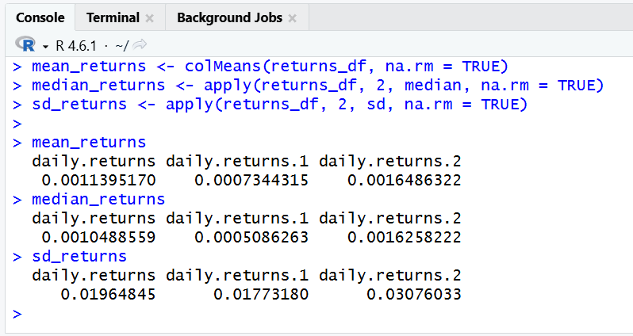
Figure 7. Computation of return means, medians and standard deviations.
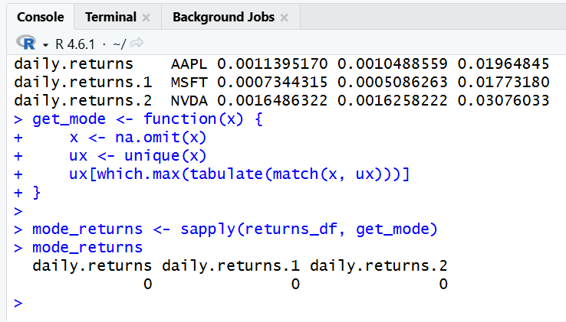
Figure 8. Structured statistics table for the three stocks.
Observed return correlations were approximately AAPL–MSFT 0.541, AAPL–NVDA 0.474 and MSFT–NVDA 0.526. All three are positive, indicating moderate co-movement over the sampled period.
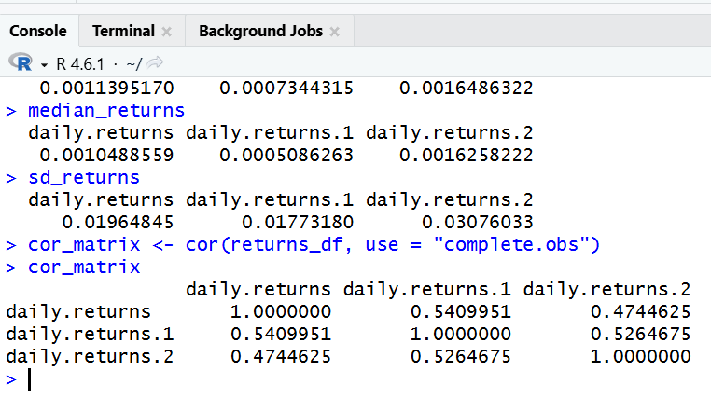
Figure 9. Return correlation matrix.

8. Equal-weight portfolio risk and return
With a weight of one-third per stock, the displayed calculations yielded a mean daily portfolio return of about 0.0011742, daily variance 0.0003523863, and daily standard deviation 0.01877195. The annualized volatility estimate was approximately 29.80%. A separate mean-based compounded annual return estimate was approximately 34.4–34.5%. These are historical sample estimates, not forecasts or guaranteed returns.
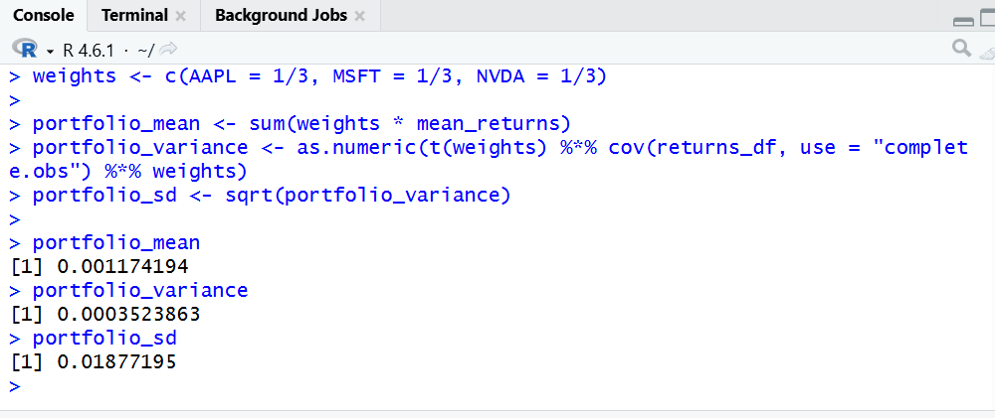
Figure 10. Portfolio weights, mean, variance and standard deviation.

9. Twenty-day simple moving averages and charts
The TTR SMA function was applied to closing prices using a 20-day window. The first 19 SMA observations are unavailable by definition because fewer than 20 price observations exist at that point. Price charts for each ticker were produced using quantmod chartSeries with addSMA(n = 20).
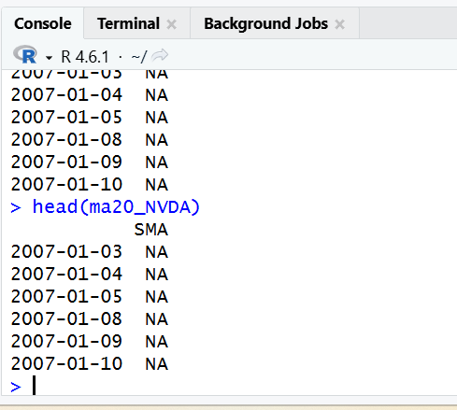
Figure 11. Twenty-day SMA calculation (initial values).
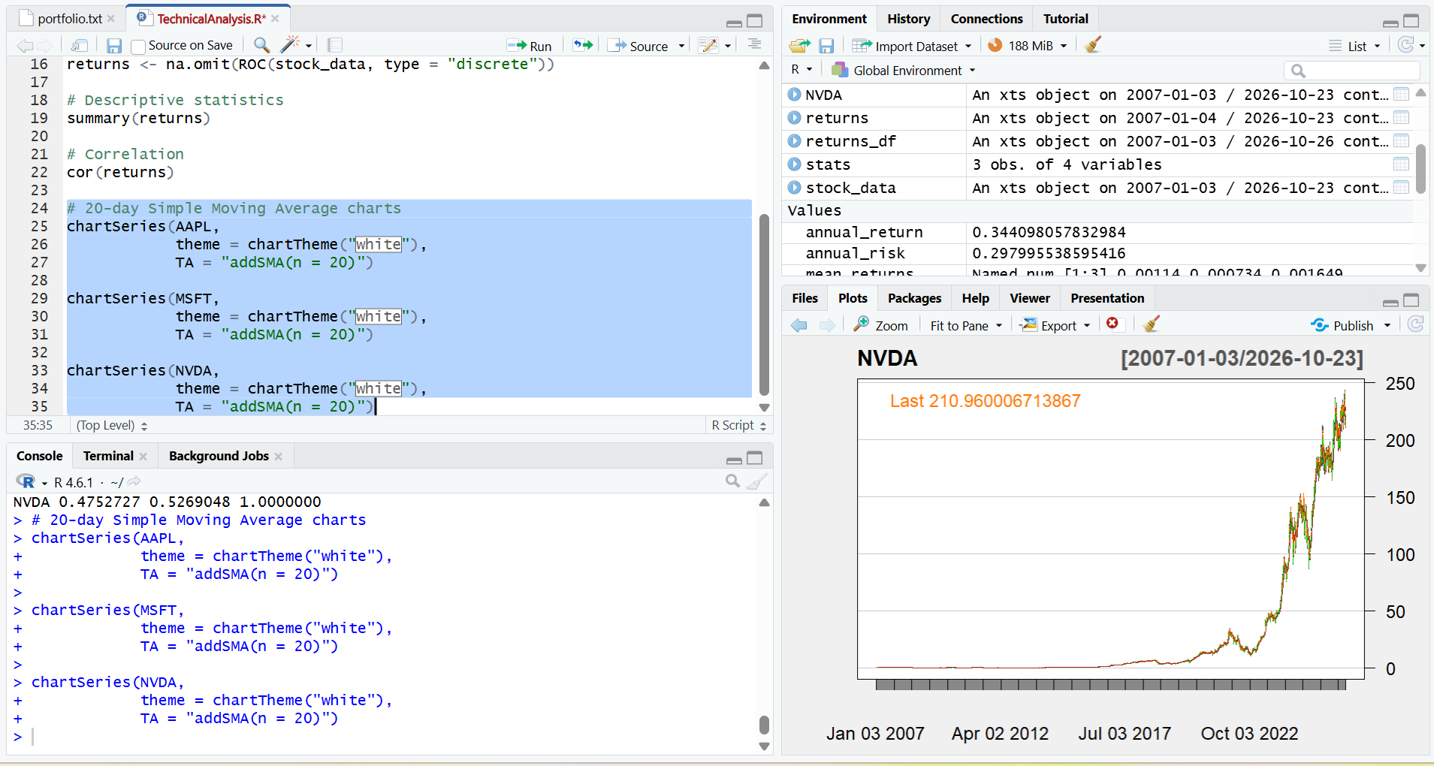
Figure. Apple (AAPL) historical chart with 20-day SMA overlay.
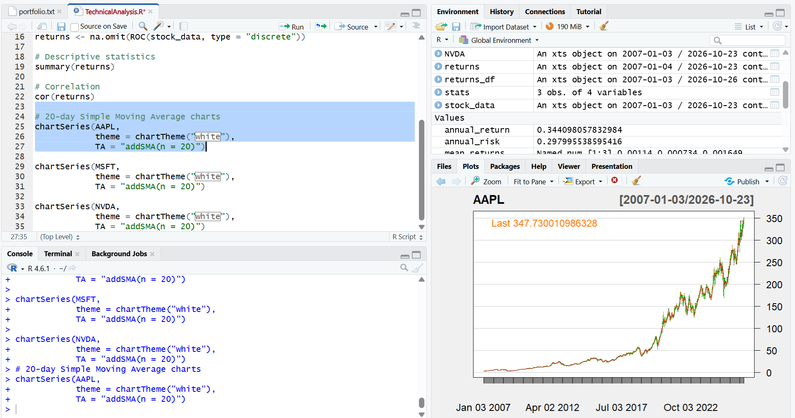
Figure. Microsoft (MSFT) historical chart with 20-day SMA overlay.
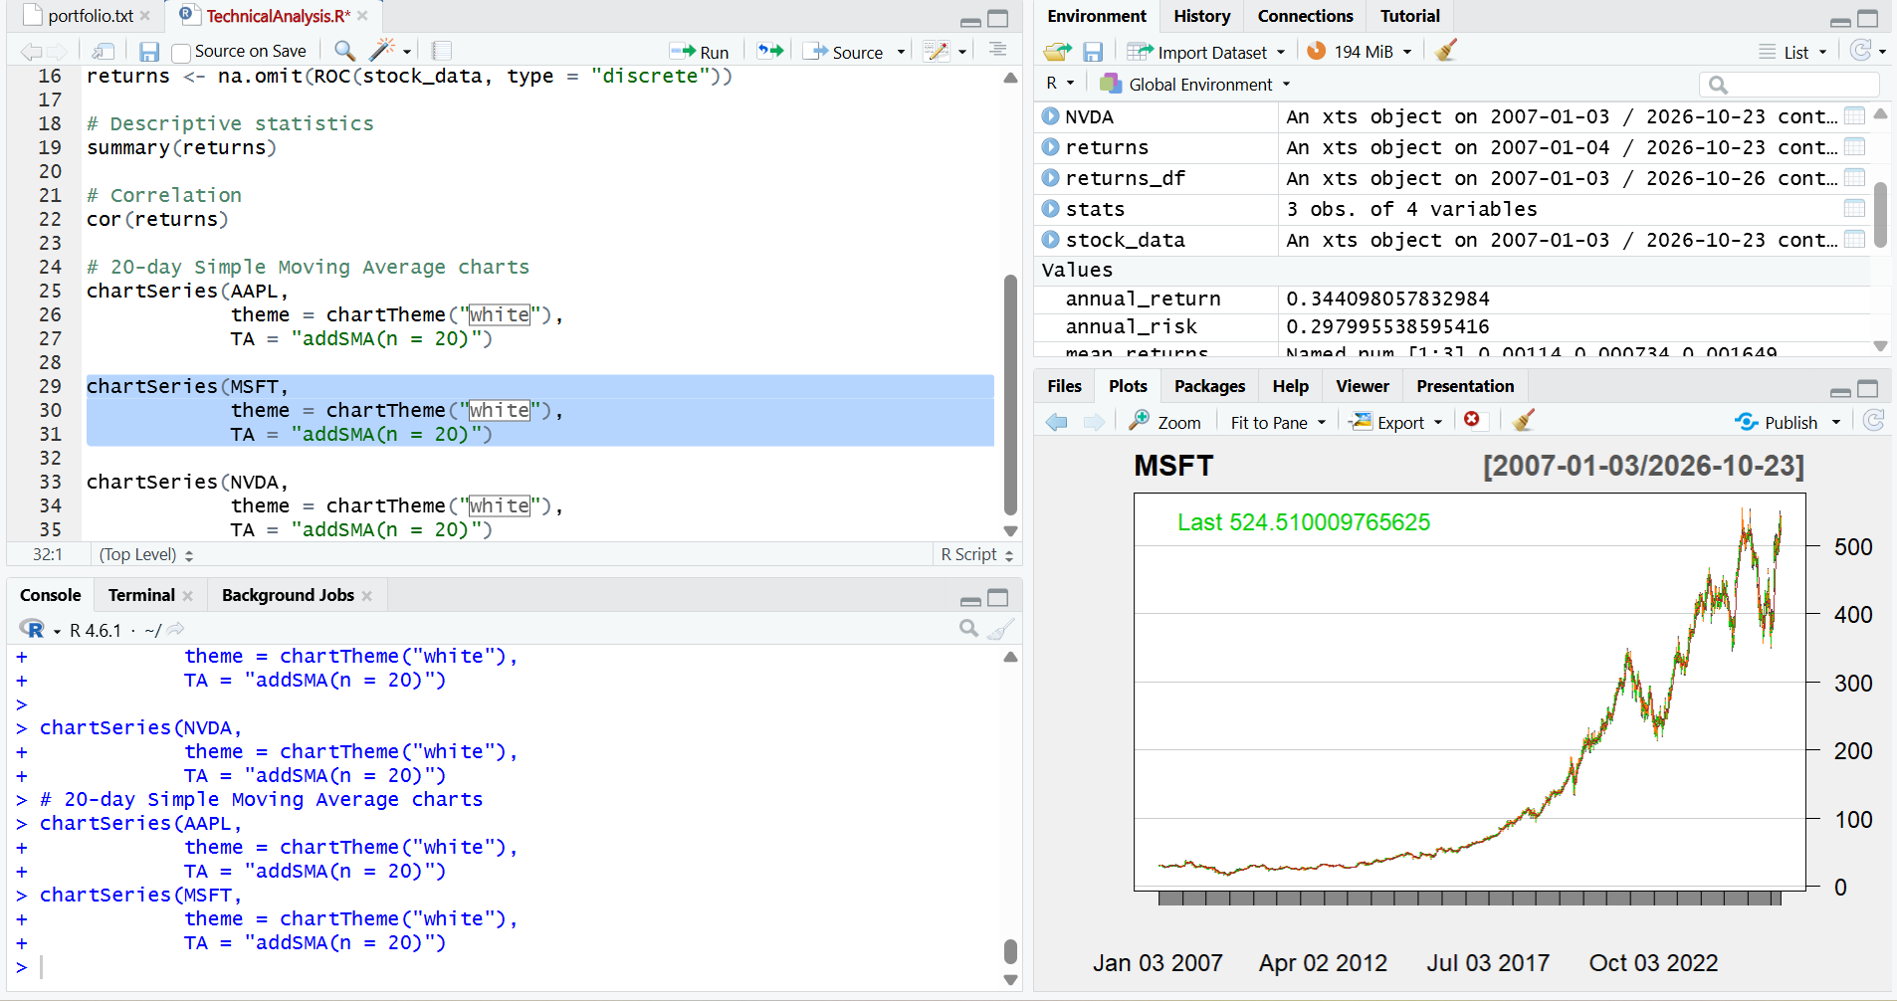
Figure. NVIDIA (NVDA) historical chart with 20-day SMA overlay.

10. Scope, observations and conclusion
R, RStudio and the required packages were available; portfolio symbols were loaded; historical data and daily returns were displayed; basic statistics, correlations and equal-weight portfolio metrics were computed; and charts with 20-day moving averages were produced. The next step is to upload the final R script, portfolio.txt, and report into an Assignment_2 directory within the GitHub repository, then verify the files appear online. The submitted screenshots do not prove that this upload has occurred.
Note on evidence: Some intermediate screenshots show corrected command errors or slightly different end dates and values from separate runs. Only successful representative outputs are emphasized in this report.

