fMRI data – from Mary, 9/17/14

Data from 3 participants, V1. Subjects participated in 8 blocks (36 trials each) of a task in which they were presented two flickering oriented square wave gratings and asked to attend to one of the two gratings, as indicated by the attention cue (small bar near fixation point) while keeping their eyes at fixation. During the trial (3 s duration), the attended grating would change spatial frequency and participants responded as to whether spatial frequency was briefly higher or lower.

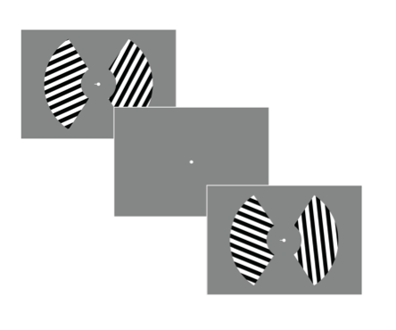

sXX_data.mat for 3 subj – contains:

**myAttnSide** – 1 for attend left, 2 for attend right (side of screen – so 1 = RH attended, 2 = LH attended)

**myLbetas** – n_trials x n_voxels for left hemisphere V1, response amplitudes for each trial, Z-scored within run, 36 trials per block

**myRbetas** – same, for right hemisphere

**myOrL** – orientation labels (1-9) for stimulus presented to left hemisphere (on *right* side of screen) (1 is vertical, 9 is 160 deg clockwise from vertical)

**myOrR** – orientation labels (1-9) for stimulus presented to right hemisphere (on *left* side of screen)

Things to try:

1. A common fMRI result is that neural responses associated with an attended stimulus are higher than those associated with an unattended stimulus. When you sort signals from each hemisphere based on whether the corresponding visual field was attended, do you see attentional enhancements of BOLD signal?
2. Though fMRI voxels are large relative to neurons or small neural populations (e.g., cortical columns), the sensitivity of voxels to different feature values (e.g., orientations) can be nonuniform, and the average tuning profile across many voxels often looks similar to neural tuning functions. Try computing orientation tuning functions for each voxel. Do any voxels show clear orientation tuning? For simplicity, let’s assume the voxel’s preferred orientation is the orientation which evokes the maximum response over all others. Is there a uniform distribution of preferred orientations across all voxels? Plot a histogram. Finally, try rearranging each voxel’s orientation tuning function (its voxel tuning function, or VTF) so that the preferred orientation is 80° by circularly shifting them. Then, average all VTFs and plot (with error bars).
3. <sort voxels by informativeness and plot VTFs>
4. <look for attentional modulation of VTFs using cross-validation>
5. Can a linear decoder classify which orientation the participant was viewing? Does classification performance improve when attention is directed towards a stimulus?