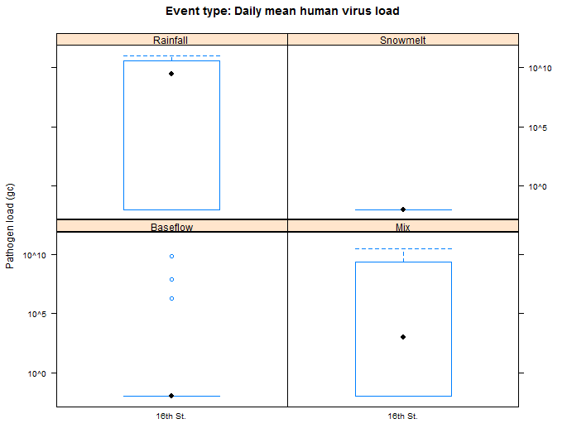

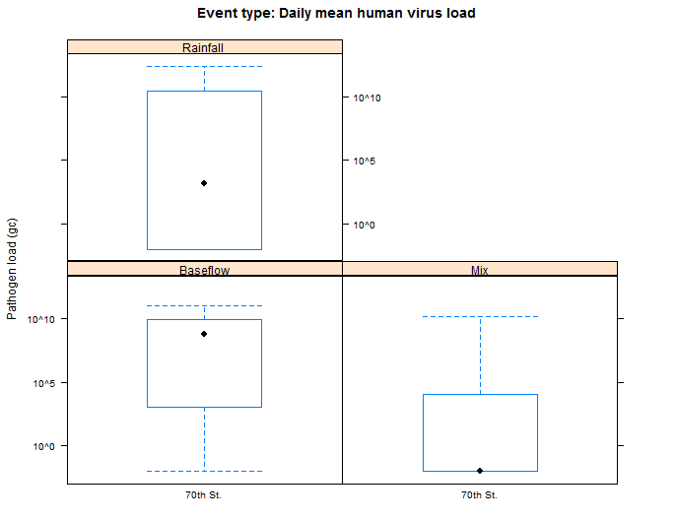

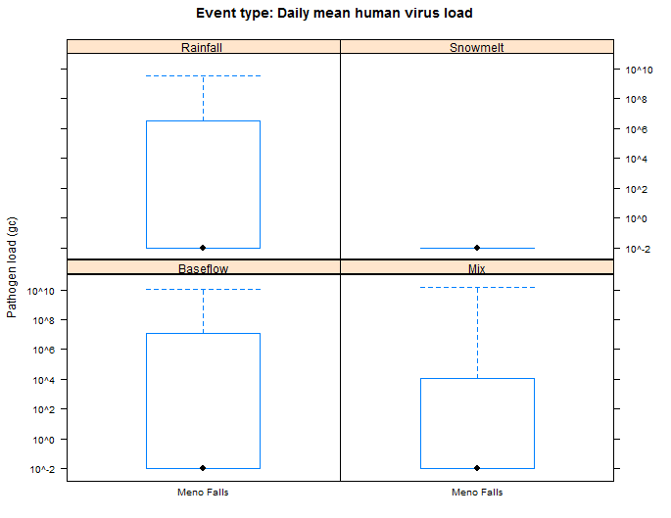

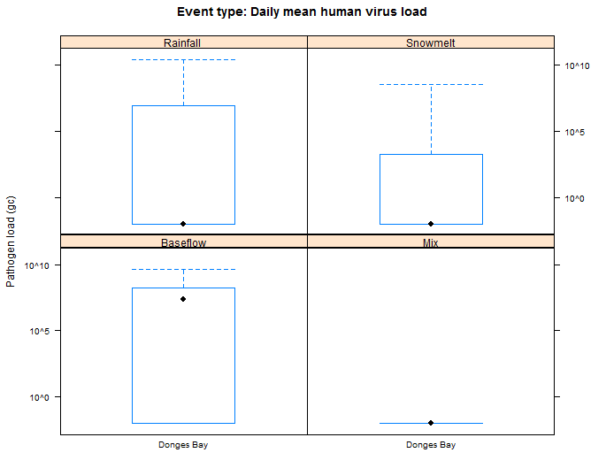

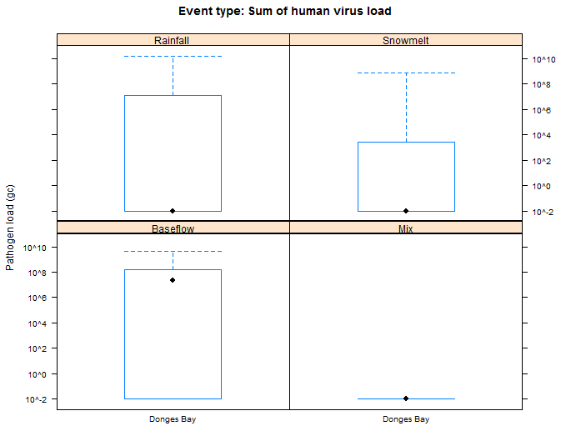

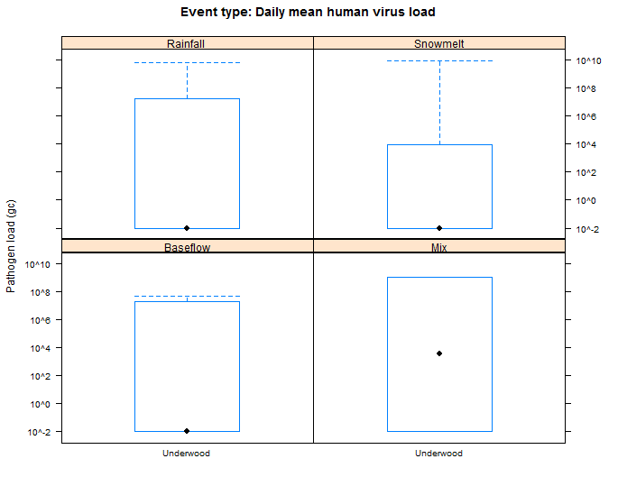

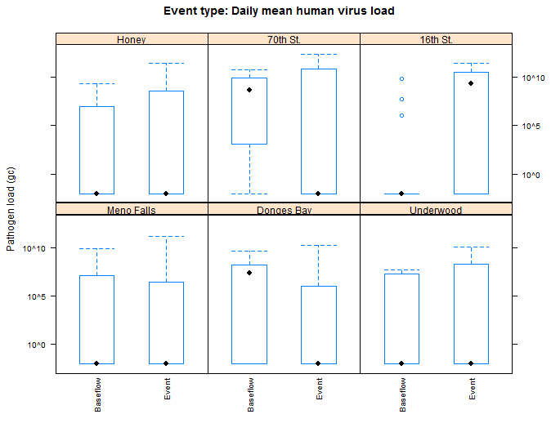

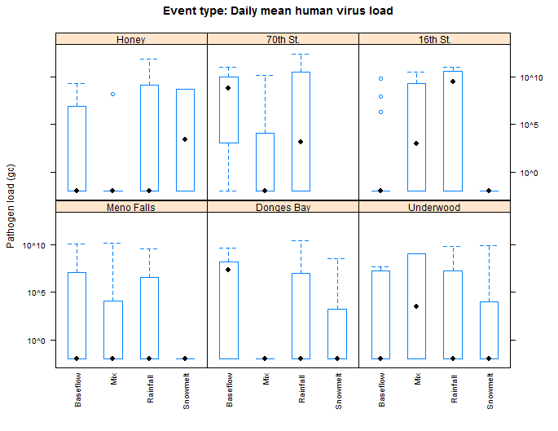

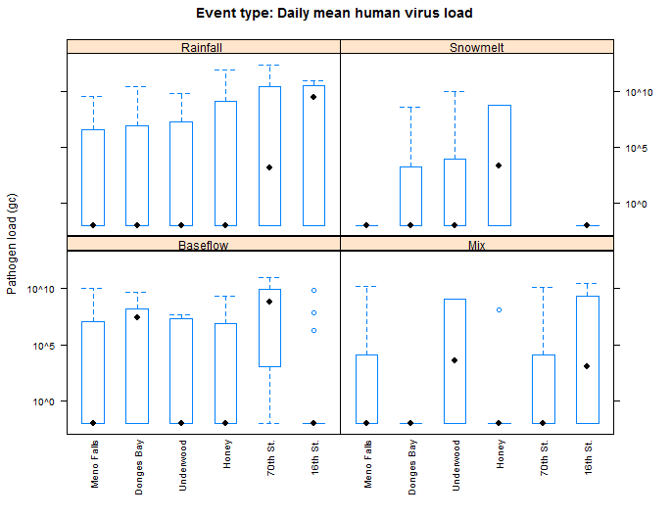

# Linear Scale: Rain depth vs Human Virus

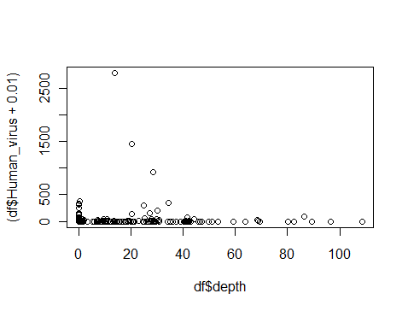

# Log Scale: Rain depth vs Human Virus

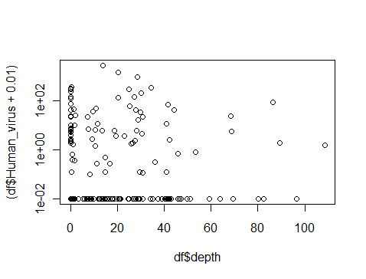

# Event samples only

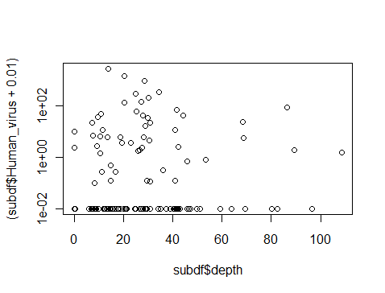

# Human virus = 0 removed

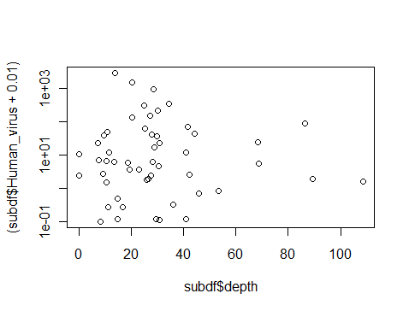

# Next Steps

1. Rainfall Data
   1. Refine rainfall definitions: examine event timing vs rainfall
   2. Add intensities
   3. Add antecedent rain
2. Streamflow
   1. Add antecedent baseflow
3. Water Quality data
   1. Add all
4. Event type
   1. Separate analysis: events from baseflow
   2. Add CSO event type
5. Wastewater
   1. Add in wastewater sample results (1-2 month samples for two yrs)
6. Indicator bacteria
   1. Add all
7. Go fishing
   1. Model development for entire data set
   2. Model development for CDC climate change