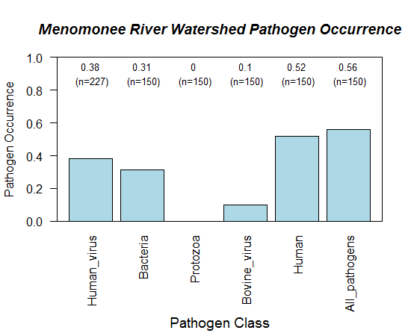

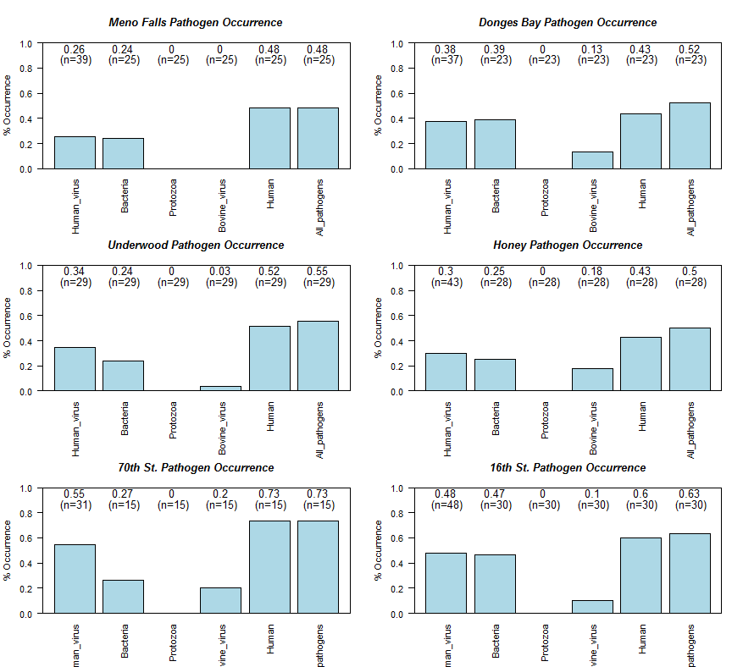 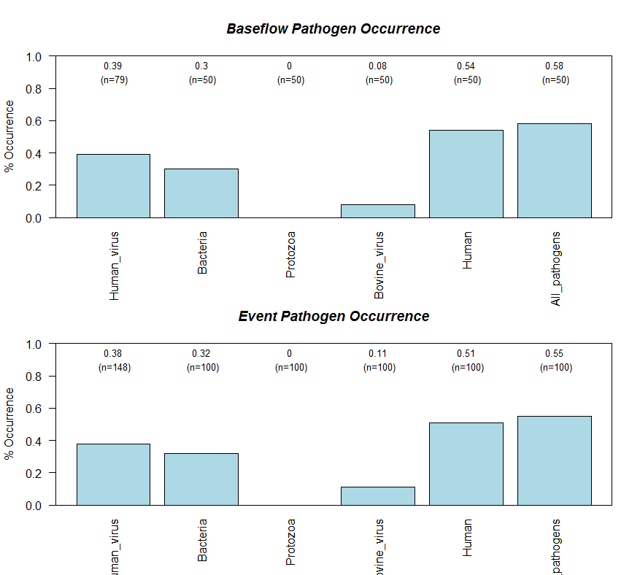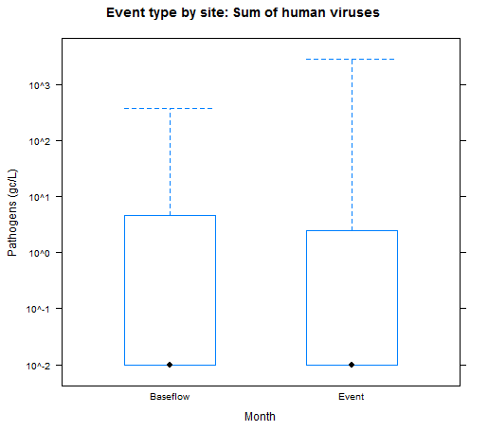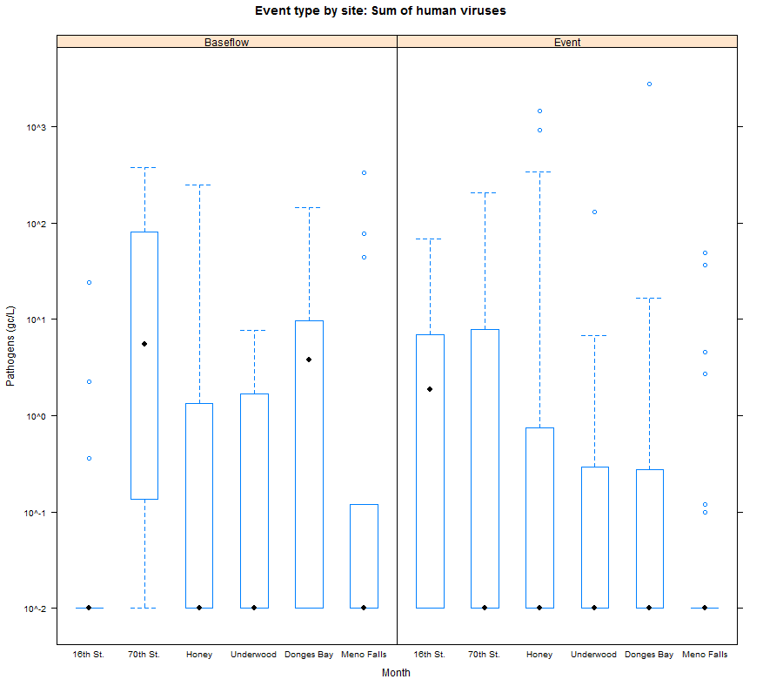

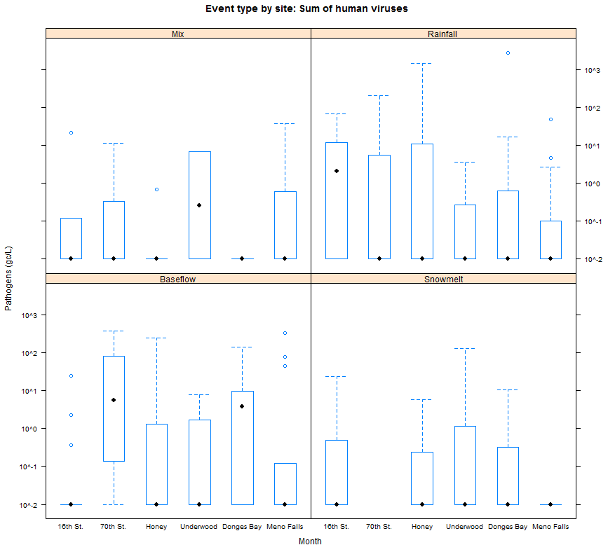

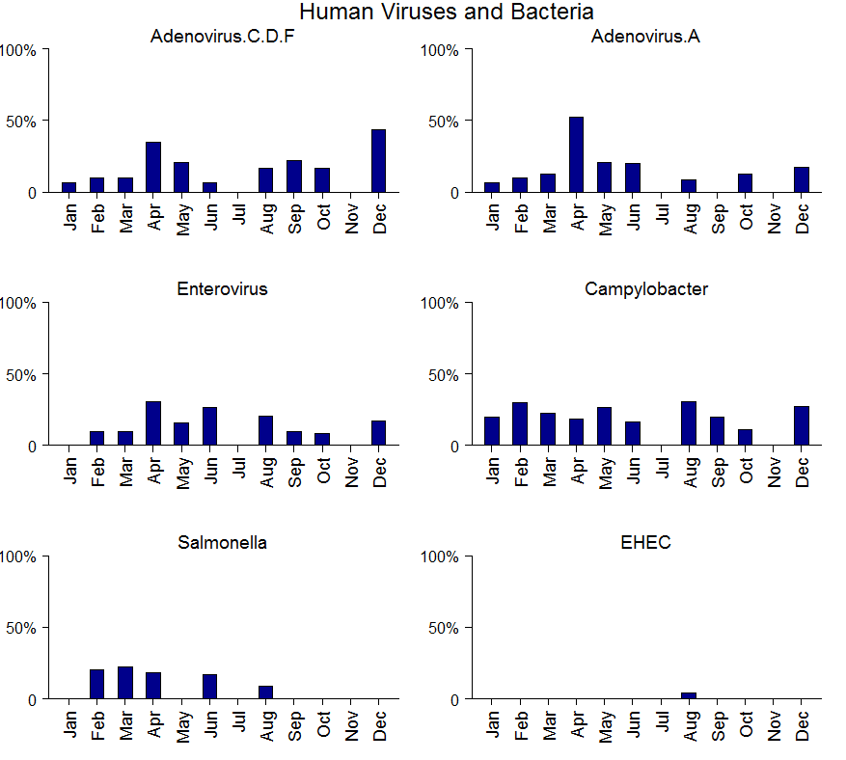

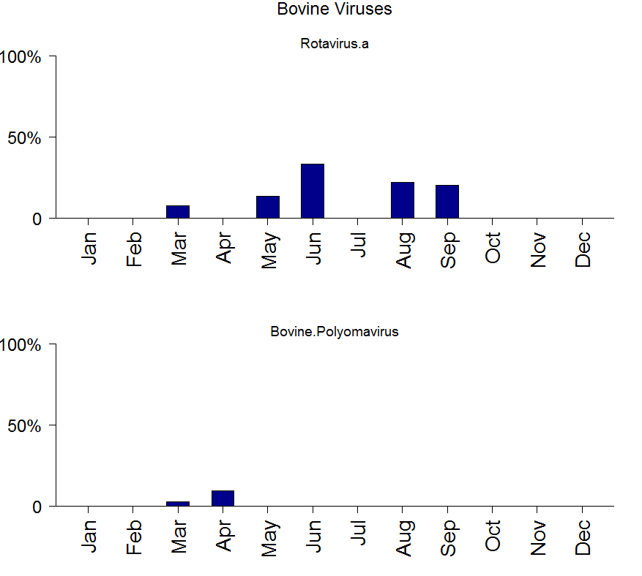

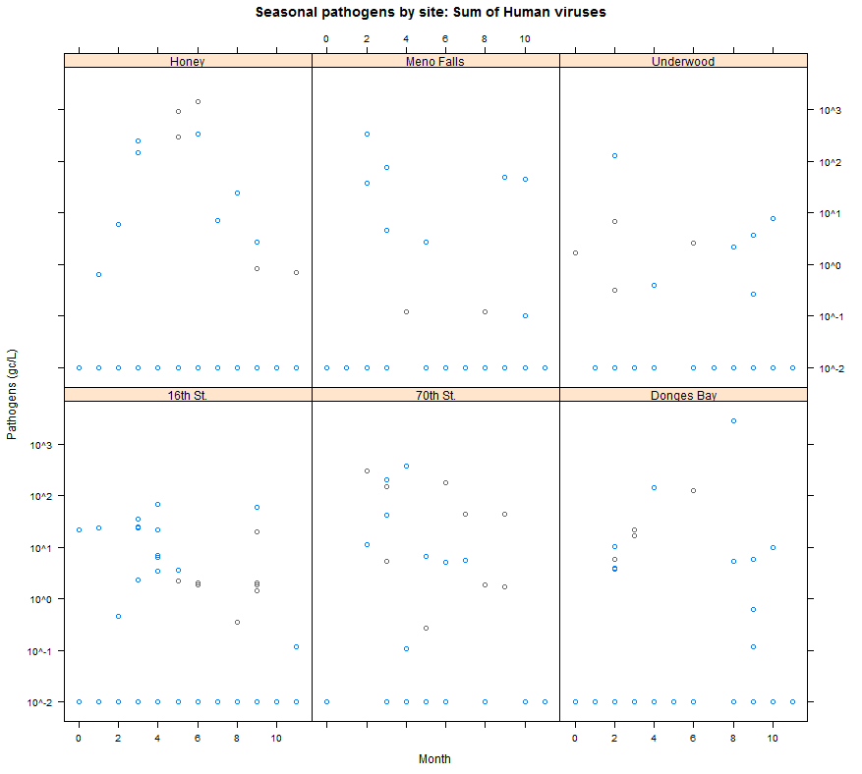

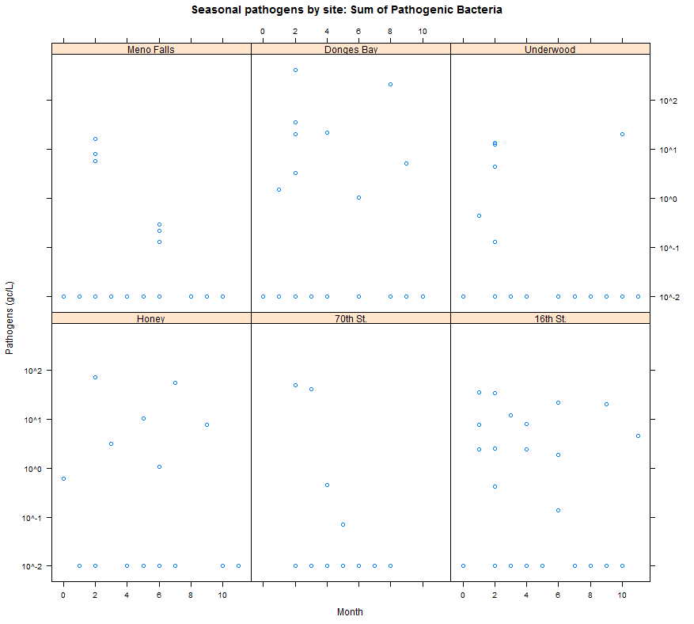

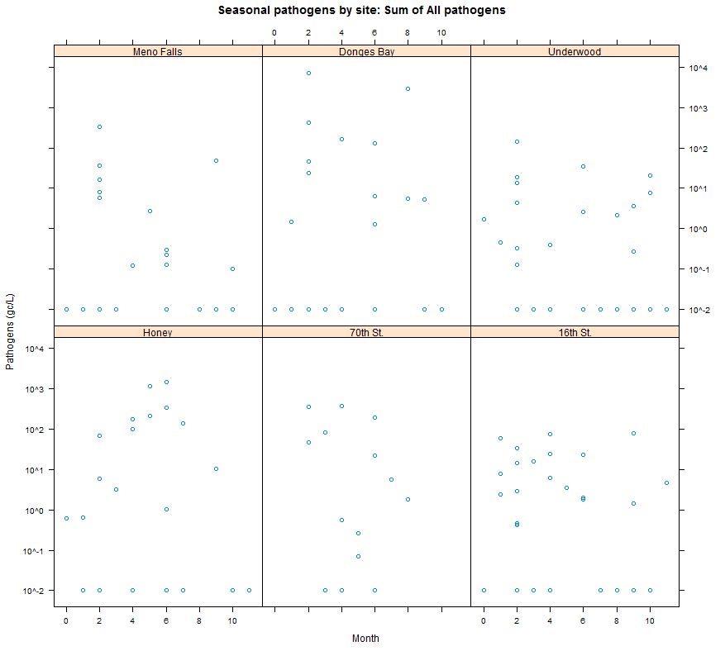

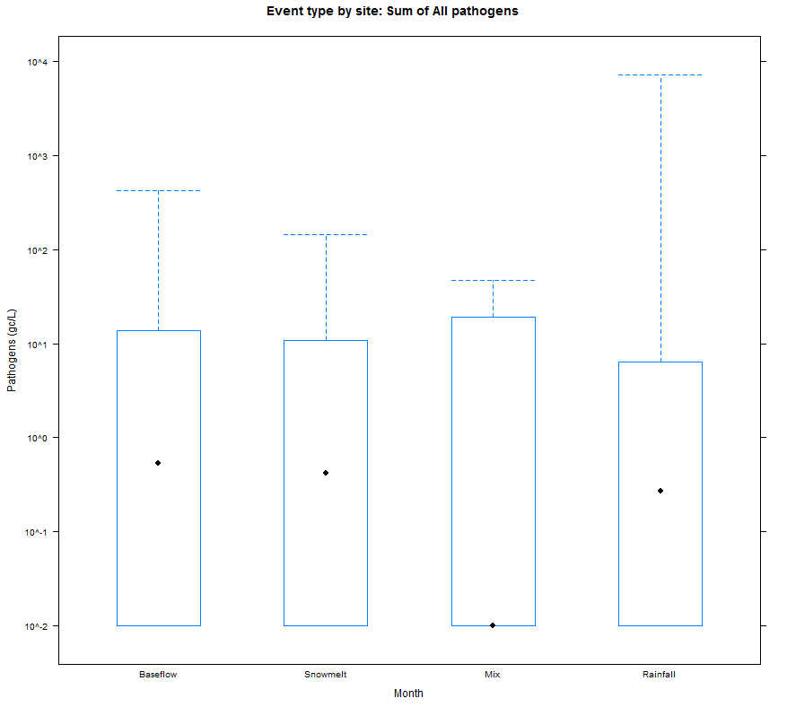

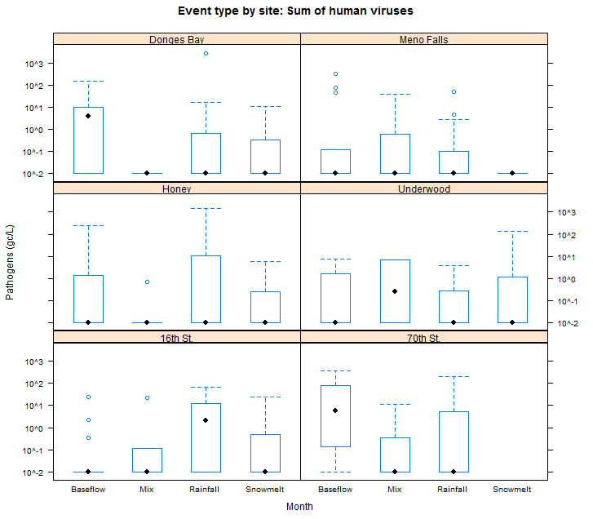

# Data analysis and reporting

1. Exploratory analysis
   1. Event vs baseflow
   2. Snow vs rain
   3. Site comparisons: watershed location: land use
      1. Loadings analysis
   4. Seasonal signals
2. Comparison to WW influent
3. Context with other water quality results:
   1. Comparison of human viruses, pathogenic bacteria and bovine viruses
      1. Human-specific bacteria
      2. Other source-specific bacteria from UW-M GLWI
      3. Real-time: Turbidity, SC, WT, DO
      4. Optical properties of wastewater
      5. Chemical wastewater indicators
   2. Comparison of Human-specific bacteria
      1. Real-time: Turbidity, SC, WT, DO
      2. Optical properties of wastewater
      3. Chemical wastewater indicators