Test1
1D
Linux
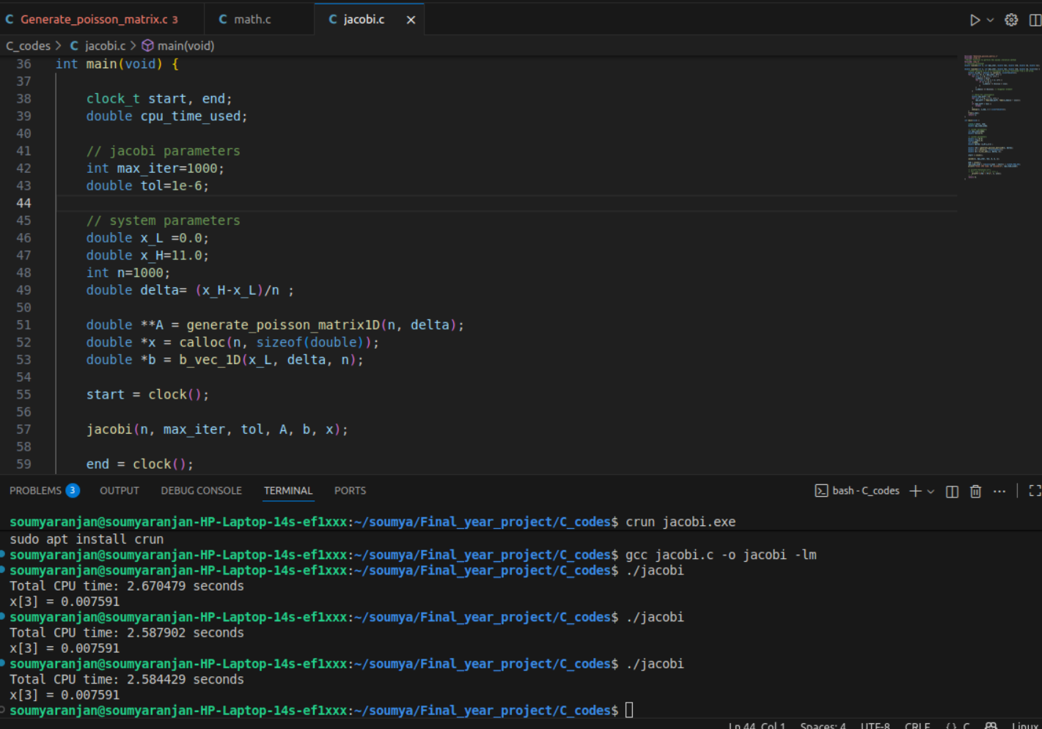
PPT: https://www.canva.com/design/DAG4qg25y2A/0-xfIJ1lHQ2wr3-zfHC7eg/edit?utm_content=DAG4qg25y2A&utm_campaign=designshare&utm_medium=link2&utm_source=sharebutton

