CE203 Assignment 1 Report

When adding an ID in the text field it only allows the user to enter 6 characters. It shows a dialog box telling the user the ID is not valid if the user entered an invalid ID and another dialog box telling the user the ID was added to the array successfully.

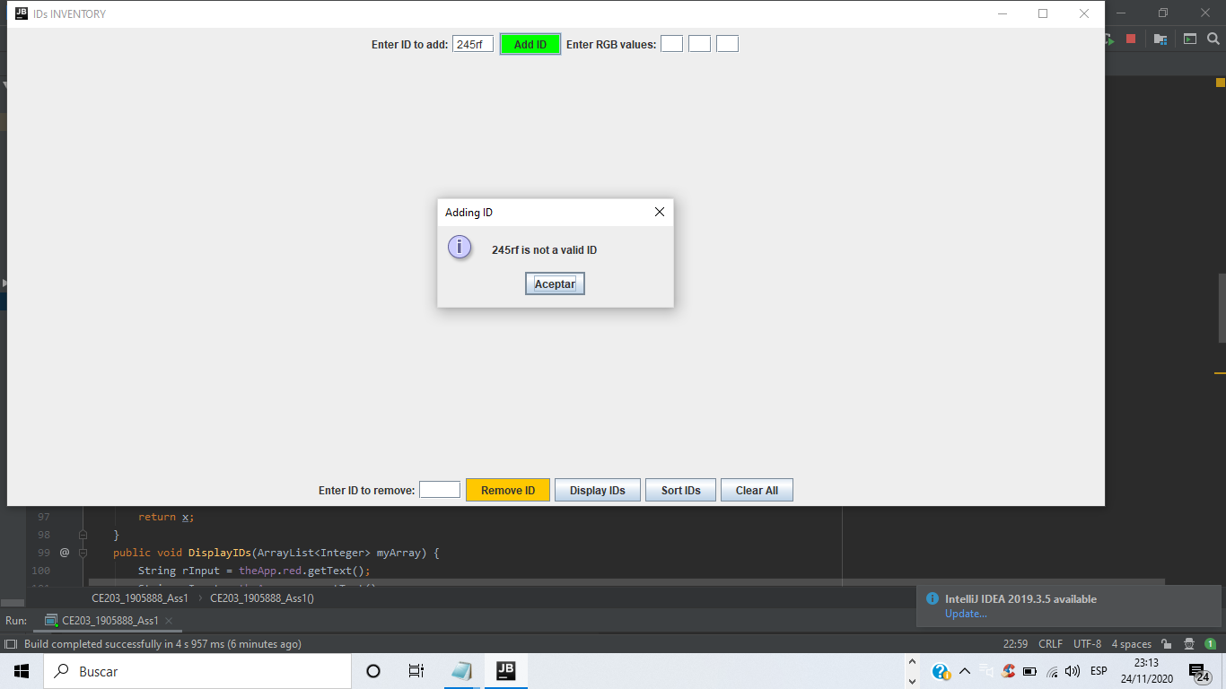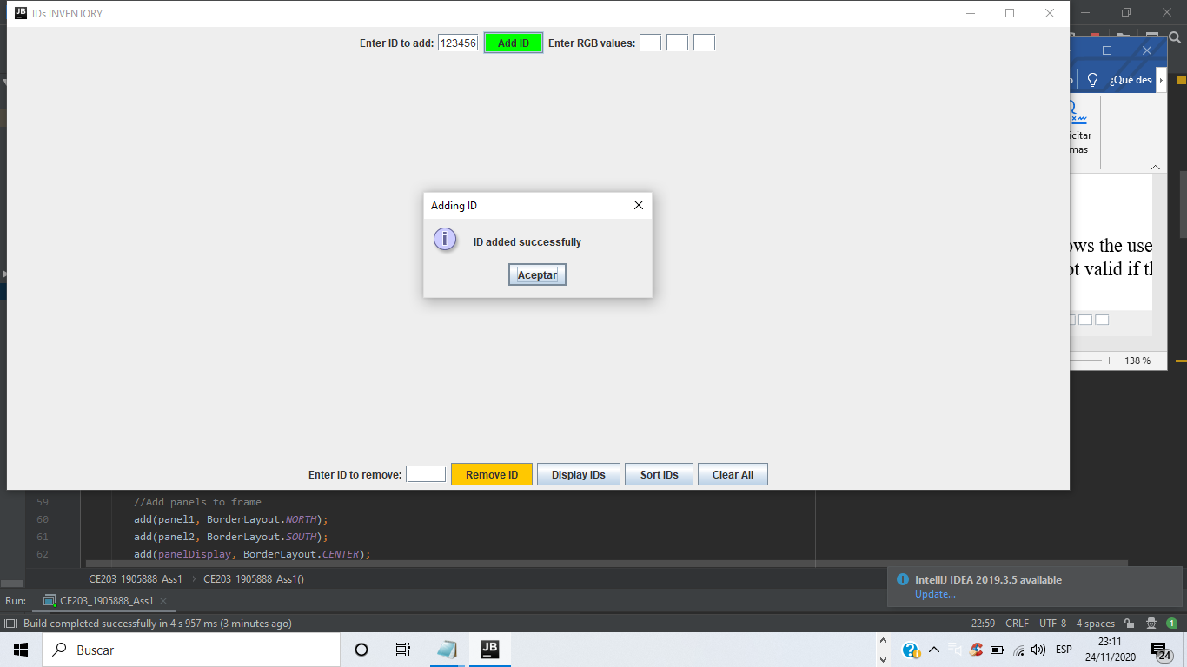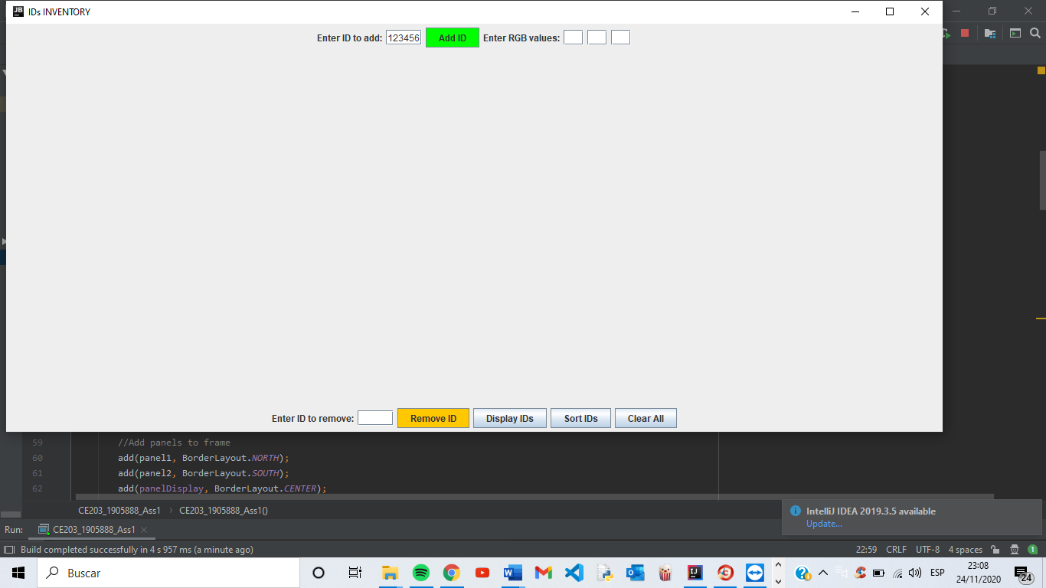

When the Display IDs button is pressed all the IDs in the array are displayed. If there are no specified RGB values or the RGB values entered are not valid a dialog box will pop up informing the user that it is not a valid color and the IDs will be displayed in black as default color.

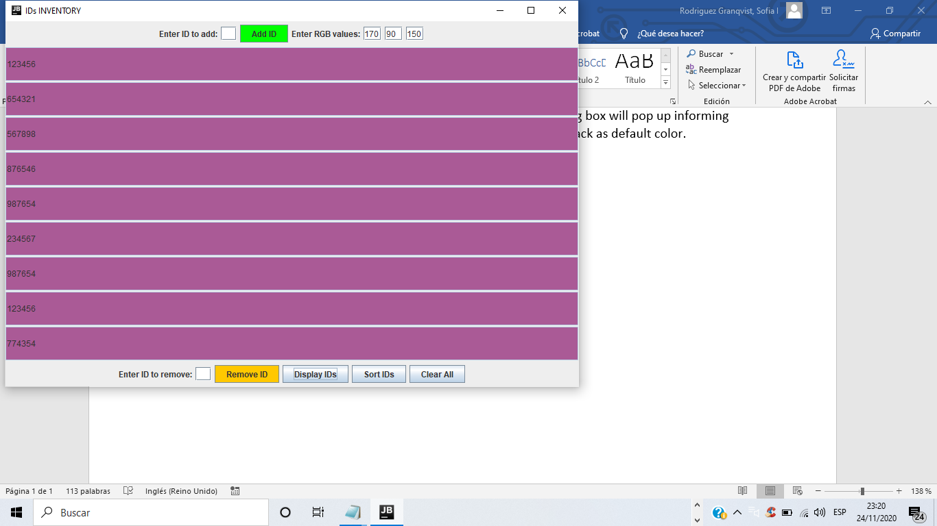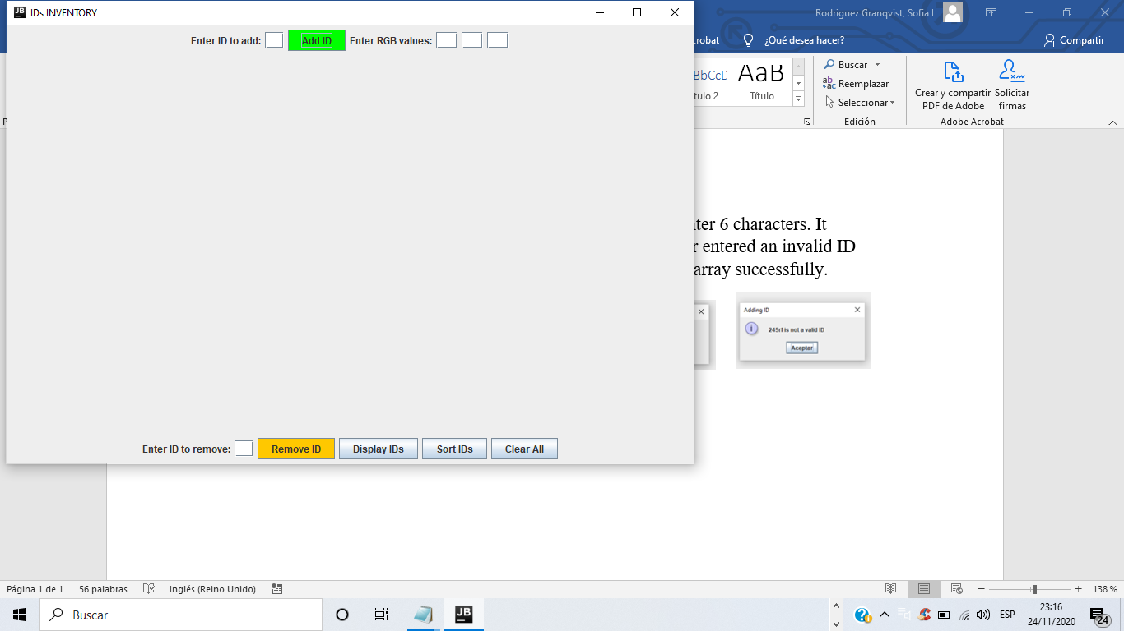

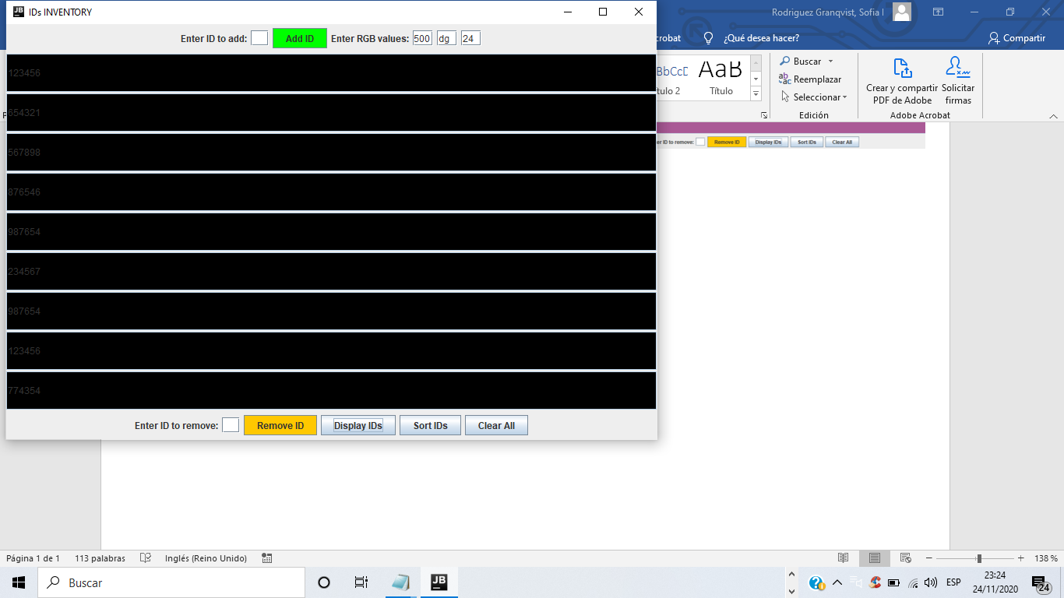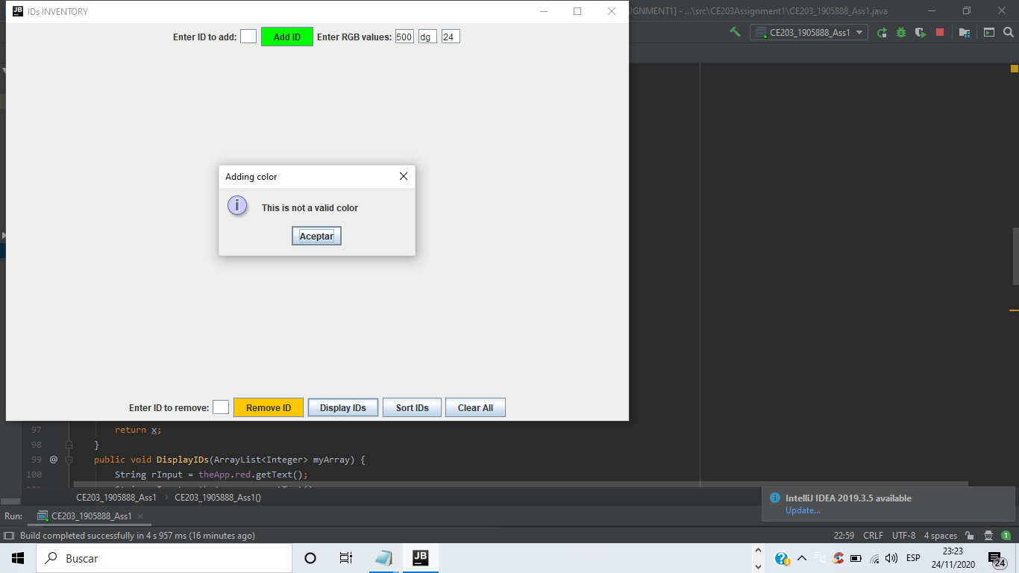

When the user enters an ID on the remove text field and presses the Remove ID button, all instances of that ID are removed from the array and instantly displays the updated array and a dialog box message informs the user that all instances of the id have been removed. If the ID entered is not valid a dialog box pops up informing the user that the ID entered is not valid.

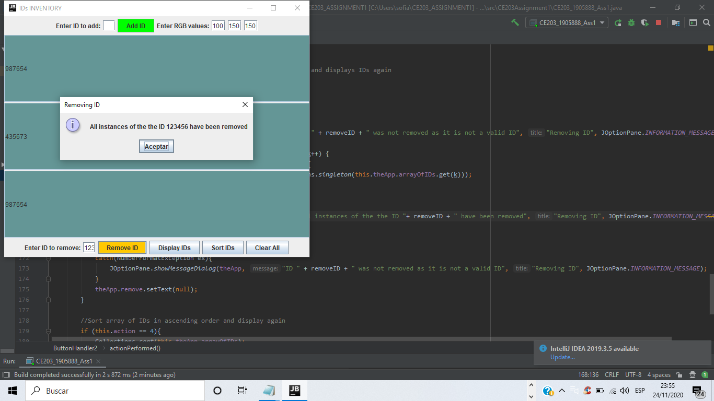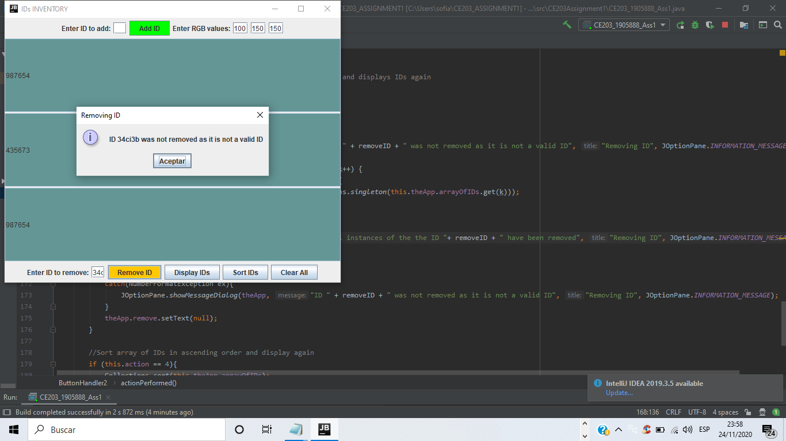

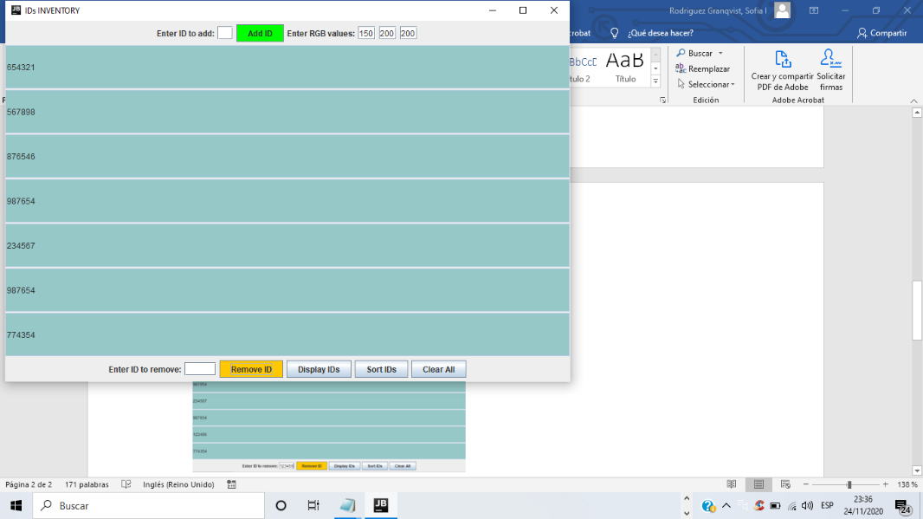Before pressing remove button After pressing remove button

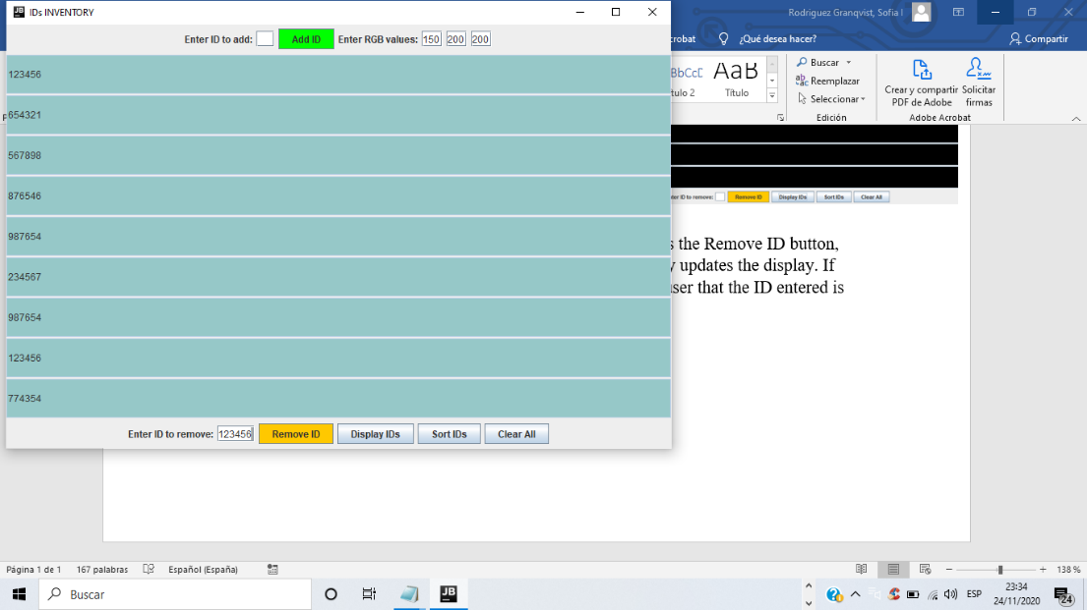

When the Sort IDs button is pressed, the Ids in the array are sorted in ascending order, a dialog box pops up informing the user that the IDs have been sorted and the updated array is instantly displayed.

Before pressing the button After pressing the button

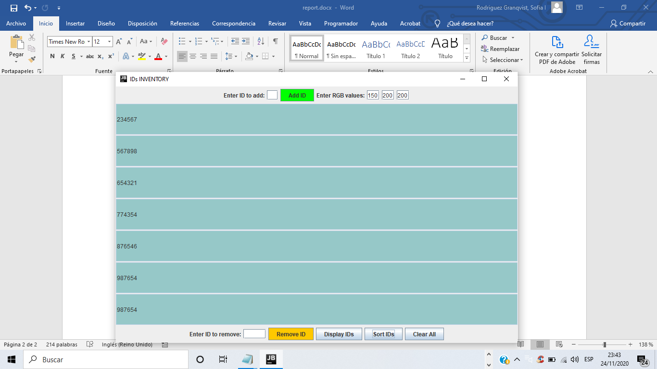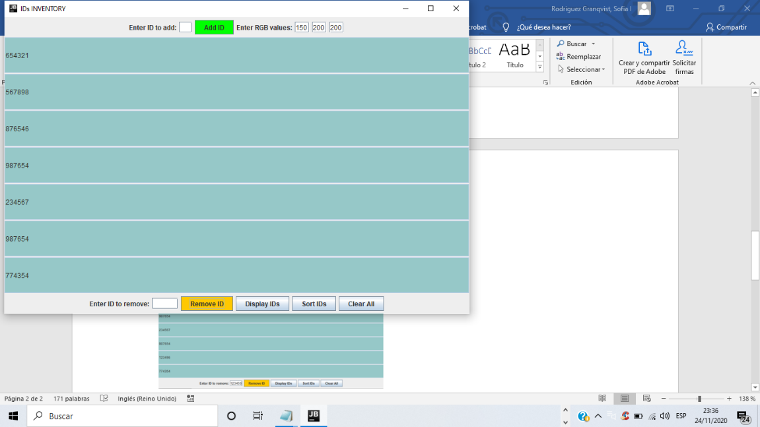

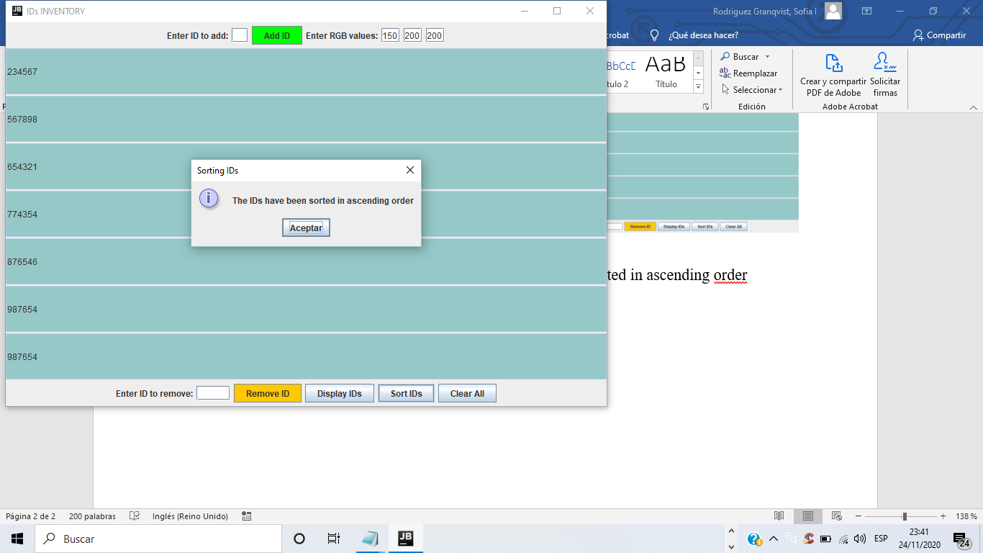

When the clear IDs button is pressed all Ids are removed from the array and the updated array is instantly displayed and a dialog box pops up informing the user that all Ids have been removed.

