**Test Automation – Assignment VI**

Navigate to : <https://angular-university.io/>

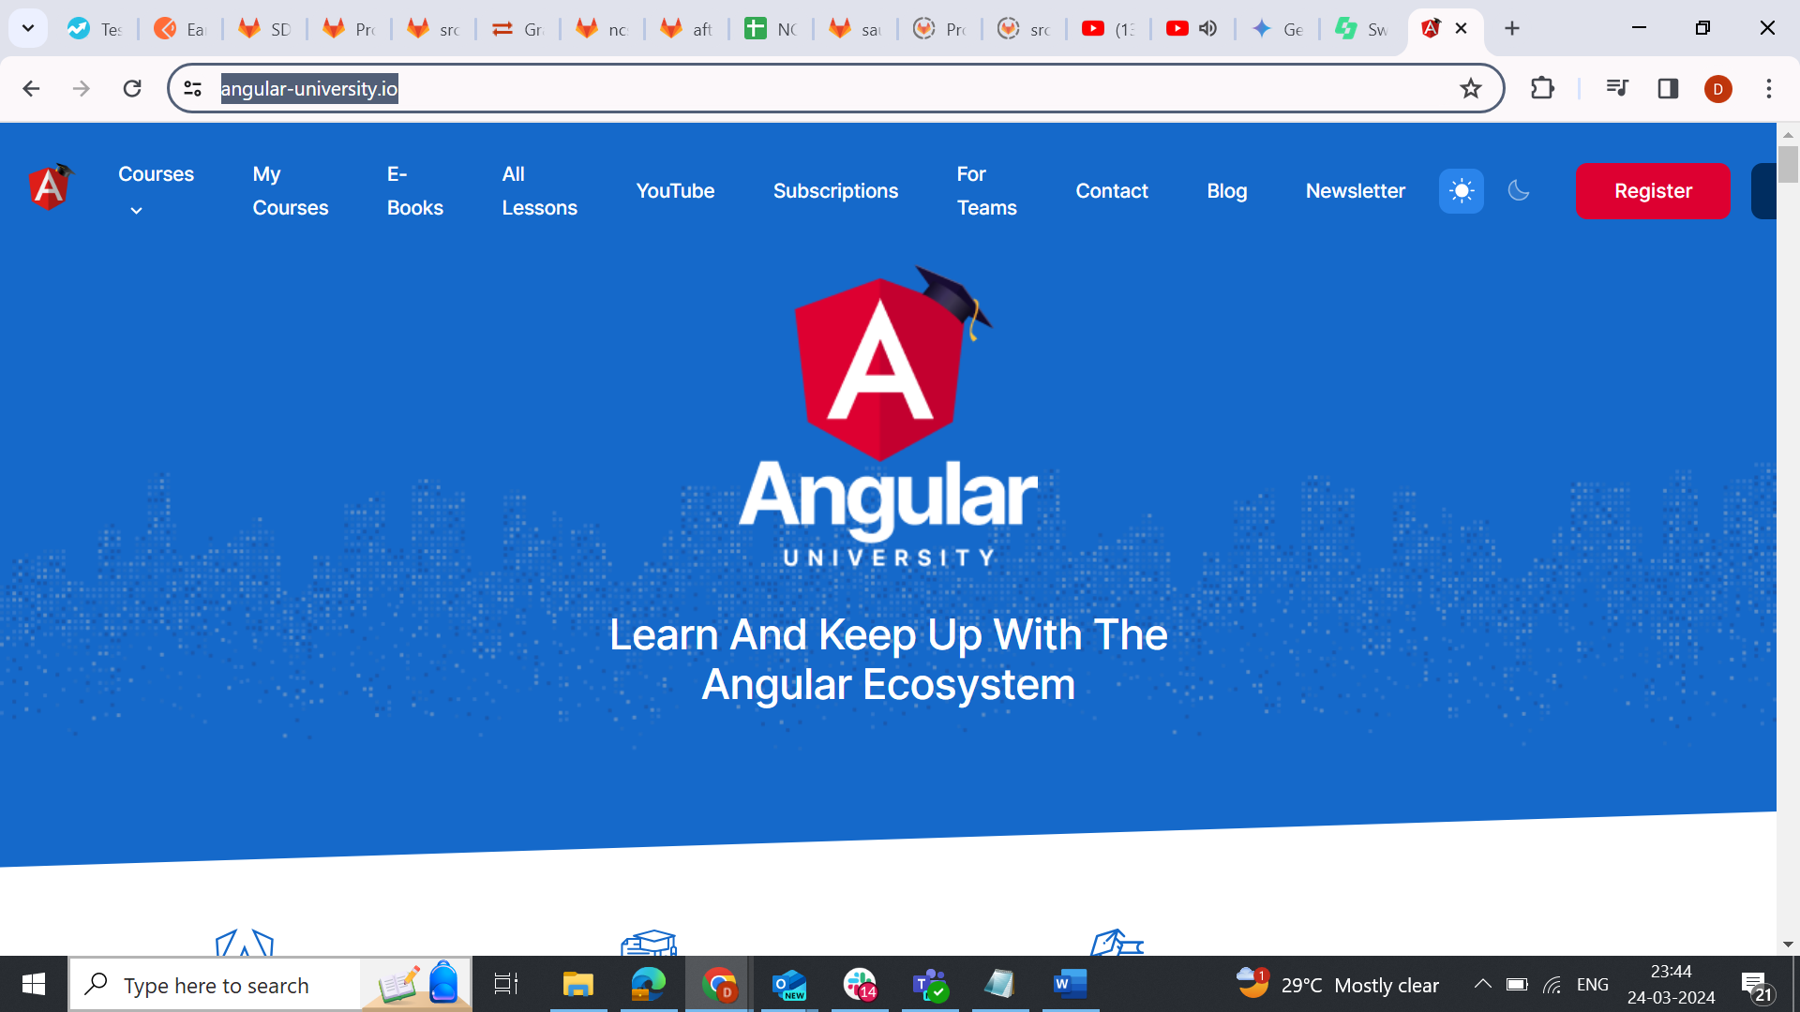

Click My courses link in the header

Click Angular for Beginner’s course link

In that course page, select checkbox of Angular for Beginner’s – Helicopter view

On selecting that checkboxy, you should see a message “information” as shown in the below screenshot

**Test Automation – Assignment VII**

**Application to be tested:**

URL: <https://www.saucedemo.com/>

**Login credentials:**

1. standard_user / secret_sauce
2. locked_out_user / secret_sauce
3. problem_user / secret_sauce
4. performance_glitch_user / secret_sauce
5. error_user / secret_sauce
6. visual_user / secret_sauce

**Test Automation – Assignment VIII**

**Application to be tested:**

URL: <https://www.jenkins.io>

**Test Steps:**

1. Launch the Firefox browser
2. Navigate to Jenkins.io
3. Click “Documentation” button
4. In the document page, in the Tutorials section click Guided Tour
5. In the “Getting started with the guided tour section, Click “[Was this page helpful?](https://www.jenkins.io/doc/pipeline/tour/getting-started/#feedback)” link
6. Select “Yes” radio button.
7. In the “type the answer” text field enter the sum based on the values provided in the line above the text field.
8. Click submit button.
9. Page “Thank you for your feedback!” should be displayed.

**Test Automation – Assignment IX**

**Application to be tested:**

URL: https://www.ust.com/en/careers

**Test Steps:**

1. Launch the Edge browser
2. Navigate to https://www.ust.com/en/careers
3. Click “India Careers”
4. Enter “test automation” in type a job name, role, skill
5. Select “Thiruvananthapuram” as the location
6. Select 4 years of experience
7. Click Search button and validate

**Test Automation – Assignment X**

**Application to be tested:**

URL: https://weather.com

**Test Steps:**

1. Search for “Bengaluru”
2. Select “Bengaluru, Karnataka”
3. Click 10 Day
4. Click More Forecasts dropdown
5. Select “Air quality forecast”.
6. In “All pollutants” section, click “Air Quality Index” and validate the message

**Test Automation – Assignment XI**

**Application to be tested:**

**URL**: https://www.practo.com/

**Test Steps:**

1. In the practo.com home page, select “Thiruvananthapuram” as the city
2. Search for Physician
3. Select “Male” for Gender
4. Select 10+ years of experience
5. In “All filters” select the following:
   1. Fees Above 500
6. Sort by “Experience – High to Low”
   1. Validate the results page