CognixAI
Cognitive Decline Prediction
Explainable AI for Chronic Disease Progression

Internship Project Report
Submitted by: Sredha Gopan
Date: July 14, 2026

Acknowledgement

I take this opportunity to express my sincere gratitude to the Almighty for His blessings and guidance throughout the successful completion of this internship project.
I would like to express my heartfelt gratitude to UST Innovation Labs Trivandrum for providing me with the opportunity to undertake this internship and work on a real-world artificial intelligence project. The experience and practical exposure gained during this internship have significantly enhanced my technical knowledge and professional skills.
I would also like to express my sincere gratitude to Mr. Ashok G. Nair, Head of UST Innovation Labs Trivandrum, for providing me with the opportunity to be a part of this internship program and for fostering an environment that encourages learning, innovation, and professional growth.
I extend my sincere gratitude to my mentor, Ms. Samhitha Nair, for her continuous guidance, valuable suggestions, constructive feedback, and constant encouragement throughout the project. Her technical support and insightful discussions played a vital role in the successful completion of this work.
I would also like to thank my reporting manager, Mrs. Gopika Bindu, for her support, coordination, and encouragement throughout the internship. Her guidance and assistance ensured the smooth progress of the internship and provided me with a positive learning environment.
I am also grateful to all the members of the UST Innovation Labs team for their support and for providing an excellent environment to learn and grow professionally.
Finally, I express my heartfelt gratitude to my parents, family, and friends for their constant encouragement, motivation, and unwavering support, which enabled me to successfully complete this internship project.

Abstract

CognixAI is a full-stack explainable artificial intelligence system for chronic disease progression monitoring. Using a synthetic longitudinal healthcare dataset containing 500 patients across Alzheimer's disease, Diabetes, and Parkinson's disease, the system predicts each patient's future cognitive score using an XGBoost regression model. To improve transparency, SHAP (SHapley Additive exPlanations) is integrated to explain individual predictions and identify the key factors influencing model decisions. These explanations are further used to automatically group patients into clinically meaningful phenotypes, enabling comparison among patients with similar characteristics.
The system also includes an interactive what-if simulation engine that allows clinicians to explore how hypothetical changes in modifiable risk factors may influence predicted cognitive outcomes. A locally hosted large language model (LLM) using Ollama provides a conversational interface that explains patient predictions, SHAP results, phenotype information, and simulation outcomes using structured evidence generated by the prediction pipeline. The application is implemented using a Flask backend and a React-based frontend, ensuring that all computation and patient information remain on the local machine.
The project demonstrates how explainable machine learning and local LLMs can be combined to create an interpretable clinical decision-support prototype while maintaining data privacy and transparency.

Table of Contents
(Right-click below and choose "Update Field" → "Update entire table" in Word to populate page numbers.)
Acknowledgement 2
Abstract 3
Table of Contents 4
Chapter 1: Introduction 7
1.1 Project Introduction 7
1.2 Background and Motivation 7
1.3 Objectives 8
1.4 Scope 8
Chapter 2: System Overview 9
2.1 System Functions 9
2.2 Module Description 9
2.3 Operating Environment 10
2.4 Implementation Constraints 10
Chapter 3: System Design 11
3.1 System Architecture 11
3.2 Data Description (Dataset) 11
3.3 Methodology 12
3.3.1 Data Pipeline & Feature Engineering 12
3.3.2 Predictive Model (XGBoost) 12
3.3.3 Explainability (SHAP) 13
3.3.4 Patient Phenotyping 13
3.3.5 What-If Simulation Engine 13
3.3.6 LLM Chatbot (Context-Grounded Prompting) 14
Chapter 4: Tools and Technologies Used 15
4.1 Development Languages 15
4.2 Machine Learning & Explainability Tools 15
4.3 Front-End Tools 15
4.4 Other Tools Used 16
Chapter 5: Implementation and Results 17
5.1 Backend Implementation (API) 17
5.2 Model Performance Results 17
5.3 Feature Importance 19
5.4 Subgroup Performance 21
5.5 Patient Phenotypes 22
5.6 Frontend Result 23
Frontend Result Screenshots (Patient PID0000) 24
Chapter 6: Engineering Improvements & Fixes 28
6.1 Data-Handling Fixes 28
6.2 Chatbot Response-Quality Fixes 28
6.3 Other Production Improvements 29
Chapter 7: Deployment 30
7.1 Prerequisites 30
7.2 Setup Summary 30
7.3 Environment Variables 30
7.4 Production Recommendations 30
Chapter 8: Timeline 32
Chapter 9: Limitations and Future Work 33
9.1 Limitations 33
9.2 Future Work 33
Chapter 10: Conclusion 34
Chapter 11: References 35
Appendices 36
Appendix I: Disclaimer 36
Appendix II: Glossary of Abbreviations 36

Chapter 1: Introduction

1.1 Project Introduction
CognixAI is a full-stack, explainable machine-learning system for chronic disease progression monitoring. It predicts a patient's future cognitive score from longitudinal clinical visit data using a gradient-boosted regression model (XGBoost), explains each prediction with SHAP (SHapley Additive exPlanations) values, automatically groups patients into clinically meaningful phenotypes based on their dominant risk drivers, and exposes all of this through a React dashboard backed by a Flask API. A locally hosted large language model (via Ollama) acts as a conversational assistant that answers natural-language questions about a patient, grounded entirely in that patient's SHAP factors, phenotype, and peer comparisons — with no patient data leaving the machine.
The codebase totals roughly 5,050 lines of Python across ten backend modules, plus a modular React + TypeScript frontend with dedicated pages for overview, SHAP explanations, peer comparison, phenotypes, what-if simulation, and chat.

1.2 Background and Motivation
Machine learning models are increasingly proposed for clinical decision support, but black-box predictions are difficult for clinicians to trust or act on. A model that simply outputs "cognitive score will decline" is far less useful than one that also explains which factors are driving that decline, whether the patient resembles others with similar risk profiles, and what a hypothetical intervention might change. This motivated the design of CognixAI around three pillars: an accurate predictive model, transparent SHAP-based explainability, and a grounded conversational layer that translates quantitative model output into clinician-readable language — without letting the language model invent facts not supported by the underlying data.
A further motivation was data privacy: many clinical AI assistants rely on cloud-hosted LLM APIs, which is often unacceptable for sensitive health data. Running the LLM locally via Ollama demonstrates that a useful clinical chatbot can be built without any patient data leaving the host machine.

1.3 Objectives
- Predict a patient's future cognitive score from their historical visit data using a supervised regression model.
- Explain individual predictions transparently, so clinicians can see which factors drove a given forecast rather than treating the model as a black box.
- Automatically cluster patients into phenotype groups sharing similar dominant risk drivers, to support cohort-level clinical insight.
- Allow exploration of hypothetical interventions ("what if BMI dropped by 5 points?") and surface their predicted effect on outcome.
- Provide a natural-language chat interface, grounded strictly in each patient's real data (SHAP factors, phenotype, peer statistics), so clinicians can ask free-form questions without the model hallucinating facts.
- Keep all patient data local — no external API calls for the language model — by running inference through a self-hosted Ollama instance.

1.4 Scope
In scope:
- A single predicted outcome — future CognitiveScore — for three chronic conditions (Alzheimer's, Diabetes, Parkinson's).
- Explainability, phenotyping, simulation, and chat for a fixed, pre-generated cohort of 500 synthetic patients.
- A locally deployable single-process web application (Flask + React) with no cloud dependency for inference.
Out of scope:
- Real, IRB-approved patient data — the current dataset is synthetic and used for research/educational purposes only (see Appendix I: Disclaimer).
- Multi-outcome prediction (e.g. comorbidity risk, hospitalization likelihood) — noted as future work.
- Authentication, multi-tenant access control, and production-grade deployment tooling (Docker, CI/CD) — noted as future work.
- Grounding chatbot responses in external medical literature or clinical guidelines.

Chapter 2: System Overview

2.1 System Functions
- Cognitive score prediction — forecasts a patient's next-visit cognitive score from longitudinal features.
- SHAP-based explanation — shows which features drove a given prediction, per patient and cohort-wide.
- Automatic phenotyping — groups patients by dominant SHAP risk driver into four clinically named phenotypes.
- Peer comparison — situates a patient's values relative to similar patients.
- What-if simulation — re-runs the model under hypothetical feature changes chosen by the user.
- Conversational assistant — answers free-form questions about a patient, grounded in their SHAP factors, phenotype, and peer data, streamed live via Server-Sent Events.

2.2 Module Description
Module | Responsibility
api.py | Flask REST + Server-Sent-Events API; serves the built frontend
pipeline.py | Data cleaning, feature engineering, chronological train/test split
xgboost_and_shap.py | Trains the XGBoost model, computes SHAP values, generates plots and the performance report
generate_shap_phenotype.py | Clusters patients into phenotypes; builds the phenotype-template lookup used to ground chatbot responses
prompt_builder.py | Assembles per-patient context and the system prompt for the LLM
reasoning.py | Clinical reasoning layer — actionable factors, cautions, peer comparisons, qualitative language rules
simulation_engine.py | Runs "what-if" feature-change simulations through the trained model
llm_backend.py | Thin HTTP client for the Ollama API, with retry/backoff
llm_chatbot.py | Standalone CLI chatbot (same backend, no web UI) for quick testing
utils.py | Shared constants — XGBoost hyperparameters, adherence label mapping

2.3 Operating Environment
Requirement | Detail
Operating System | Linux (developed/tested), platform-independent Python/Node stack
Language runtimes | Python 3.10, Node.js (for the frontend build)
LLM runtime | Ollama, running locally with a pulled model (default llama3.1:8b)
Web server (dev) | Flask development server, binds 0.0.0.0:5000
Browser | Any modern browser for the React SPA

2.4 Implementation Constraints
- Training data is synthetic (3,000 visit rows, 500 patients), not a real clinical dataset — constrains all results to a research/prototype context.
- The chatbot's knowledge is limited to each patient's own SHAP/phenotype context; it has no access to external medical literature.
- Flask's built-in server is used in development; production deployment requires a WSGI server (Gunicorn/Waitress) and reverse proxy (Nginx), as it is not included by default.
- The system assumes a single local Ollama instance is reachable; response quality and latency depend on the chosen local model's capability and the host machine's hardware.
- No authentication layer — the current design targets single-user/local research use, not multi-clinician production deployment.

Chapter 3: System Design

3.1 System Architecture
The system separates a one-time offline pipeline (data preparation, model training, explainability, phenotyping) from a lightweight runtime application (Flask API + React dashboard) that only reads the pipeline's generated artifacts. This keeps the web application fast and free of any training-time dependencies.
chronic_disease_progression.csv
│
▼
pipeline.py — cleaning, feature engineering, train/test split
│
▼
xgboost_and_shap.py — trains the model, computes SHAP values;
│ writes predictions_*.csv, shap_values.pkl,
│ feature_importance.csv, model_report.txt
▼
generate_shap_phenotype.py — clusters patients into phenotypes;
│ builds the phenotype-template lookup for the chatbot
▼
outputs/ — generated CSVs, plots, and phenotype-template JSON
│
▼
api.py (Flask) ──► frontend/dist (built React app)
│
▼
Ollama (local LLM) — chat replies / simulation explanations
Figure 3.1 — End-to-end data and control flow, from raw CSV to served application.
Note: this project uses flat-file artifacts (CSV, pickle, JSON) generated by the offline pipeline rather than a relational database, so an ER diagram, normalization, and trigger design are not applicable; the equivalent design concern here is the artifact/data flow shown above and the data schema described in Section 3.2.

3.2 Data Description (Dataset)
The model is trained on a synthetic longitudinal chronic-disease dataset (chronic_disease_progression.csv) containing 3,000 visit records for 500 patients (6 visits per patient), spanning three conditions: Alzheimer's, Diabetes, and Parkinson's.
Property | Value
Total visit rows | 3,000
Unique patients | 500
Visits per patient | 6
Diseases represented | Alzheimer's, Diabetes, Parkinson's
Patient ID format | String, e.g. "PID0000" (not numeric)
Target variable | Future CognitiveScore (next visit)

Raw columns include:
- Demographics: Age, Gender, EmploymentStatus, SupportSystem, HasCaregiver
- Clinical measurements: BiomarkerScore, HeartRate, BloodPressure (Systolic/Diastolic), Cholesterol, BMI, CognitiveScore, MoodScore
- Lifestyle & behavior: SleepHours, StepsPerDay, StressLevel, Smoker, AlcoholUse
- Treatment: MedicationDose, MedicationAdherence
- Disease context: Disease, MedicalHistory, Stage

3.3 Methodology

3.3.1 Data Pipeline & Feature Engineering
pipeline.py cleans the raw visit-level data and engineers a rich feature set (78 features used for modeling) capturing not just a patient's current state but also their trajectory:
- Baseline values — a patient's first recorded measurement for each vital (e.g. CognitiveScore_baseline, HeartRate_baseline).
- Previous-visit values (_prev) and deltas (_delta) between consecutive visits.
- Rolling statistics (_roll3) to smooth short-term noise.
- Change-from-baseline features (e.g. CognitiveScore_from_baseline).
- Time features — days_since_first and gap_days between visits.
- Encoded categorical variables, including MedicationAdherence_enc (0=Low, 1=Medium, 2=High).
The dataset is split chronologically per patient (not randomly) to avoid leaking future visits into training, and cross-validation uses GroupKFold, grouped by PatientID, so no patient's visits appear in both the train and validation folds simultaneously.

3.3.2 Predictive Model (XGBoost)
xgboost_and_shap.py trains an XGBoost regressor to forecast each patient's CognitiveScore at their next visit. Shared hyperparameters live in utils.py (XGB_PARAMS) so the same configuration is used consistently across training and cross-validation. Model quality is evaluated against a naive baseline (predicting the current score as the future score) to quantify genuine predictive value over the trivial forecast.

3.3.3 Explainability (SHAP)
SHAP (SHapley Additive exPlanations) values are computed for every visit row in the test set, attributing the model's prediction to individual input features. These values power:
- Per-patient factor breakdowns ("strongest driver", "notable factor") shown in the UI and used by the chatbot.
- Cohort-level visualizations — a beeswarm plot and bar chart of the top 15 features by mean |SHAP| — plus a waterfall plot for a single sample patient and dependence plots for the top 3 actionable features.
- Phenotype clustering (Section 3.3.4), which groups patients by their dominant SHAP driver.
A key data-handling detail: shap_values.pkl stores one row per visit (3,000 rows across 500 patients), so any per-patient aggregation — such as assigning one phenotype per patient — must first deduplicate by taking the statistical mode across a patient's visits (groupby("PatientID").agg(lambda x: x.mode().iloc[0])) rather than using the raw table directly, otherwise a single patient could appear to belong to multiple phenotype groups.

3.3.4 Patient Phenotyping
generate_shap_phenotype.py assigns each of the 500 patients to a phenotype group based on their dominant SHAP-driven risk factor (e.g. BMI-dominant, cholesterol-dominant, heart-rate-dominant, medication-dose-dominant). This gives clinicians a cohort-level lens: rather than viewing 500 individuals independently, patients are grouped by "what is driving their risk", each with its own outcome distribution (see Section 5.5).

3.3.5 What-If Simulation Engine
simulation_engine.py lets a user hypothetically change one or more of a patient's features (e.g. "what if BMI dropped by 5 points?") and re-runs the trained model to show the predicted change in outcome in real time. It reuses reasoning.py's human-readable feature naming (_DISPLAY) and decodes categorical fields such as MedicationAdherence_enc back into Low/Medium/High for display.

3.3.6 LLM Chatbot (Context-Grounded Prompting)
Rather than letting the language model answer freely, every chatbot response is grounded in a structured context object assembled deterministically from that patient's real data — their SHAP factors, phenotype, prediction, and peer statistics.
- prompt_builder.py looks up the patient's SHAP factors, phenotype, prediction, and peer statistics by exact PatientID / phenotype key and assembles a structured system prompt.
- reasoning.py converts raw numeric values (SHAP magnitudes, percentiles) into qualitative, clinician-friendly language, and enforces a set of language/consistency rules (see Chapter 6).
- llm_backend.py sends the prompt to a locally running Ollama model (default llama3.1:8b) over HTTP, with configurable timeout and retry/backoff.
- api.py streams the response back to the frontend over Server-Sent Events for a live-typing chat experience.
Because the model runs entirely through a local Ollama instance, no patient data is sent to an external API.
Note on terminology: the codebase and UI refer to this feature informally as "RAG" (outputs/rag_phenotype_responses.json, a "RAG-powered" badge in the Phenotype page). Strictly, however, this is not Retrieval-Augmented Generation in the standard ML sense — there is no embedding index or similarity search executed at query time. All context is exact-key lookup (by PatientID or phenotype name) from small, pre-computed files. The one place similarity is used (grouping small phenotype clusters by SHAP-vector distance) runs once, offline, during phenotype-template generation, not at chat time. The architecturally precise term is structured, template-based context grounding.

Chapter 4: Tools and Technologies Used

4.1 Development Languages
Language | Used For
Python 3.10 | Data pipeline, model training, SHAP computation, Flask API, chatbot logic
TypeScript | React frontend application logic and typed API layer
Bash | start.sh launch script

4.2 Machine Learning & Explainability Tools
Library | Role
XGBoost | Gradient-boosted regression model for cognitive score prediction
SHAP | Per-feature attribution / explainability for individual and cohort predictions
scikit-learn | Train/test splitting, GroupKFold cross-validation, evaluation metrics
pandas / NumPy | Data cleaning, feature engineering, aggregation
Matplotlib | Confusion matrix, residual analysis, SHAP bar/beeswarm/waterfall/dependence plots

4.3 Front-End Tools
Tool | Role
React | Component-based single-page application
Vite | Frontend build tool and dev server
TypeScript | Static typing across components, hooks, and the API service layer

4.4 Other Tools Used
Tool | Role
Flask | Backend REST + Server-Sent-Events API framework
Ollama | Local LLM runtime serving the chat/reasoning model (default llama3.1:8b)
Visual Studio Code | Primary development IDE
Git / GitHub (self-hosted Git) | Version control and source history

Chapter 5: Implementation and Results

5.1 Backend Implementation (API)
api.py exposes a Flask REST + Server-Sent-Events API consumed by the React dashboard and serving the built frontend from a single process.
Endpoint | Purpose
GET /api/health | Health check; reports patients_loaded count
GET /api/patients | List all patients
GET /api/patient/<id> | Full patient record, prediction, and SHAP factors
GET /api/patient/<id>/intro | LLM-generated introductory summary for a patient
POST /api/patient/<id>/chat | Chat with the LLM about a patient (streamed via SSE)
POST /api/patient/<id>/simulate | Run a what-if feature-change simulation
GET /api/feature-importance | Cohort-level feature importance data
GET /api/plots, /api/plots/<file> | Serves generated SHAP/model plot images
GET /api/simulation-meta | Metadata describing simulatable features

5.2 Model Performance Results
Evaluated on a held-out test set of 526 visit rows (99 patients), the model was compared against a naive baseline that simply predicts the current score as the future score.
Metric | Model | Naive Baseline
MAE | 4.294 | 6.481
Improvement over baseline | +2.187 MAE | —
RMSE | 5.217 | —
R² | 0.147 | —
Pearson r | 0.396 | —

5-fold GroupKFold cross-validation (grouped by patient, so no patient appears in both train and validation) confirms the held-out result is stable rather than a lucky split:
CV Metric | Mean ± Std
MAE | 4.472 ± 0.189
RMSE | 5.429 ± 0.195
R² | 0.117 ± 0.010

Progression-label agreement (classifying each patient as Improving / Stable / Deteriorating using a ±2-point threshold) was 62.5% overall.
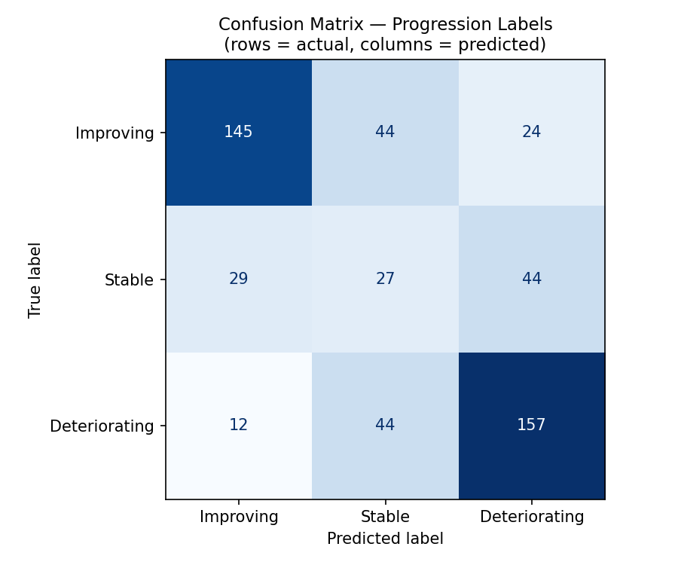
Figure 5.1 — Confusion matrix: actual vs. predicted progression label.
Actual \ Predicted | Improving | Stable | Deteriorating
Improving | 145 | 44 | 24
Stable | 29 | 27 | 44
Deteriorating | 12 | 44 | 157

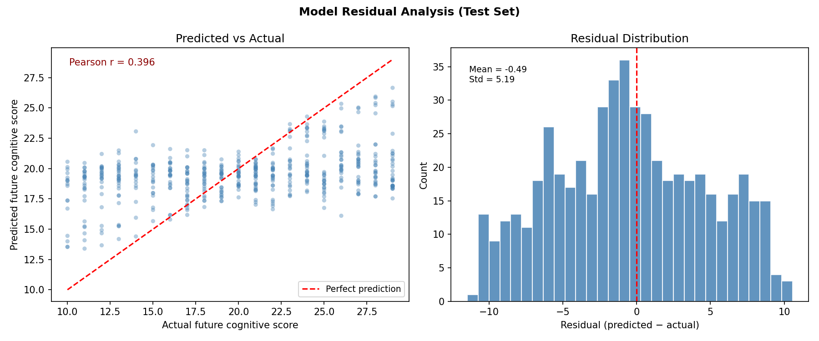
Figure 5.2 — Predicted vs. actual scores and residual distribution.

5.3 Feature Importance
SHAP mean |value| across the test set identifies the features most responsible for the model's predictions, out of 82 total ranked features.
Rank | Feature | Mean |SHAP|
1 | CognitiveScore_baseline | 0.6170
2 | CognitiveScore_from_baseline | 0.5675
3 | BMI_prev | 0.3186
4 | days_since_first | 0.2343
5 | MedicationDose_delta | 0.2091
6 | MedicationDose_prev | 0.2040
7 | gap_days | 0.1996
8 | SleepHours_prev | 0.1827
9 | Cholesterol_delta | 0.1350
10 | BiomarkerScore_prev | 0.1337

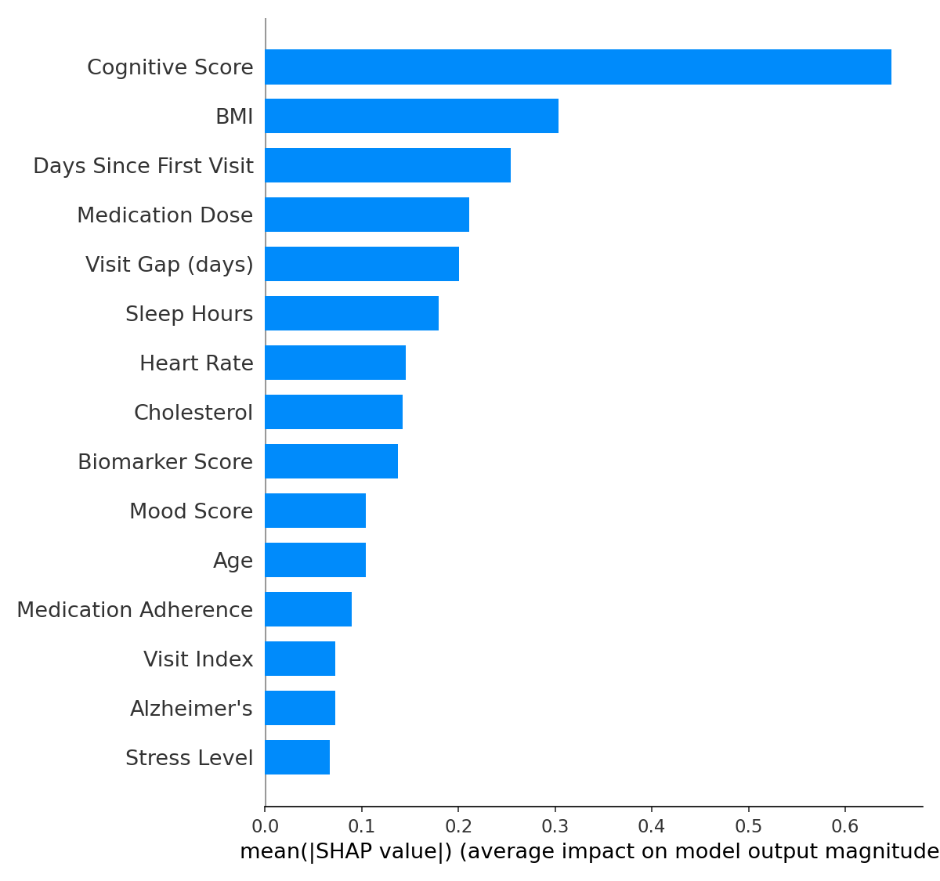
Figure 5.3 — Top 15 features ranked by mean |SHAP| value.
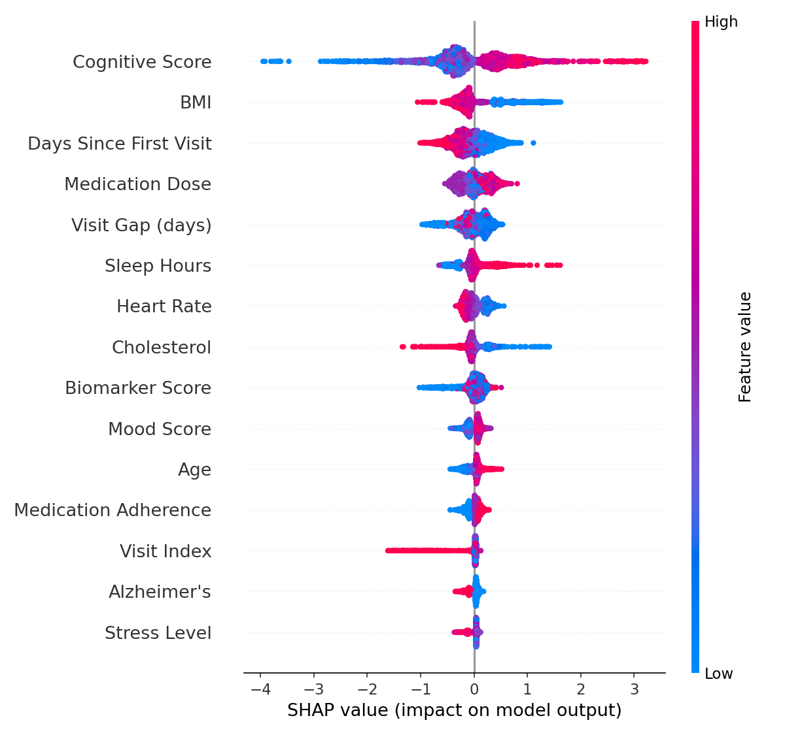
Figure 5.4 — SHAP beeswarm plot showing feature effect direction and magnitude per visit.
A patient's own baseline cognitive score and their change from that baseline dominate the prediction, followed by BMI trend, visit timing, and medication-dose changes — a clinically plausible ordering that supports the model's face validity.

5.4 Subgroup Performance
Disease | N | MAE | Agreement
Alzheimer's | 224 | 4.505 | 63.4%
Diabetes | 193 | 4.217 | 62.2%
Parkinson's | 109 | 3.995 | 61.5%

Actual Label | N | MAE | Agreement
Deteriorating | 213 | 4.207 | 73.7%
Improving | 213 | 4.345 | 68.1%
Stable | 100 | 4.370 | 27.0%

Performance is fairly consistent across the three diseases. Label agreement is weakest for the "Stable" class (27.0%) — the model tends to predict a directional change even when the patient is actually stable, which is a known tendency of regression-derived classification thresholds and a candidate area for future tuning.

5.5 Patient Phenotypes
All 500 patients were assigned to one of four SHAP-derived phenotype groups:
Phenotype | N Patients | % of Population | Improving % | Stable % | Deteriorating %
Cardiometabolic / BMI Dominant | 261 | 52.2 | 42.1 | 24.1 | 33.7
Cardiometabolic / Cholesterol Dominant | 103 | 20.6 | 42.7 | 18.4 | 38.8
Cardiometabolic / Heart Rate Dominant | 70 | 14.0 | 37.1 | 17.1 | 45.7
Treatment / Medication Dose Dominant | 66 | 13.2 | 36.4 | 16.7 | 47.0

Over half of patients (52.2%) fall into the BMI-dominant cardiometabolic phenotype. Notably, the Medication-Dose-Dominant group has both the lowest improvement rate (36.4%) and the highest deterioration rate (47.0%) of any phenotype, suggesting this cohort may benefit most from closer treatment-adherence monitoring.

5.6 Frontend Result
The React frontend presents the above results through six patient-centric pages:
Page | Purpose
OverviewPage.tsx | Patient summary, predicted score, and headline explanation
SHAPPage.tsx | Per-patient SHAP factor breakdown and visualizations
PeersPage.tsx | Comparison against similar/peer patients
PhenotypePage.tsx | Displays the patient's assigned phenotype group and cohort stats
SimulationPage.tsx | Interactive what-if simulation of feature changes
ChatPage.tsx | Conversational interface to the local LLM chatbot

Shared UI primitives (Badge, Button, Card, EmptyState, Spinner, Tabs) live under components/ui/, with layout handled by a persistent Sidebar. Data fetching is centralized in services/api.ts and a usePatient hook. Recorded walkthroughs of the dashboard and chatbot are included in the project's Demo/ folder (Dashboard.webm, Chatbot.webm).

Frontend Result Screenshots (Patient PID0000)
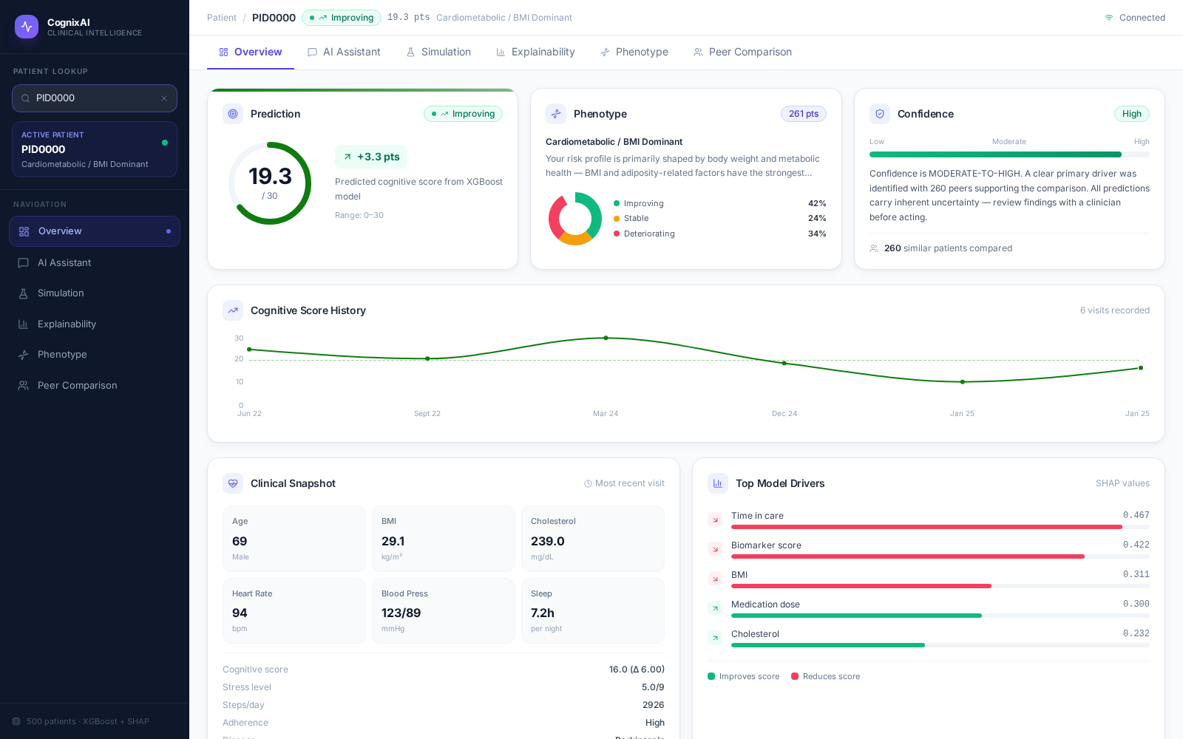Figure 5.5 — Overview page: prediction, phenotype, confidence, cognitive score history, top model drivers.

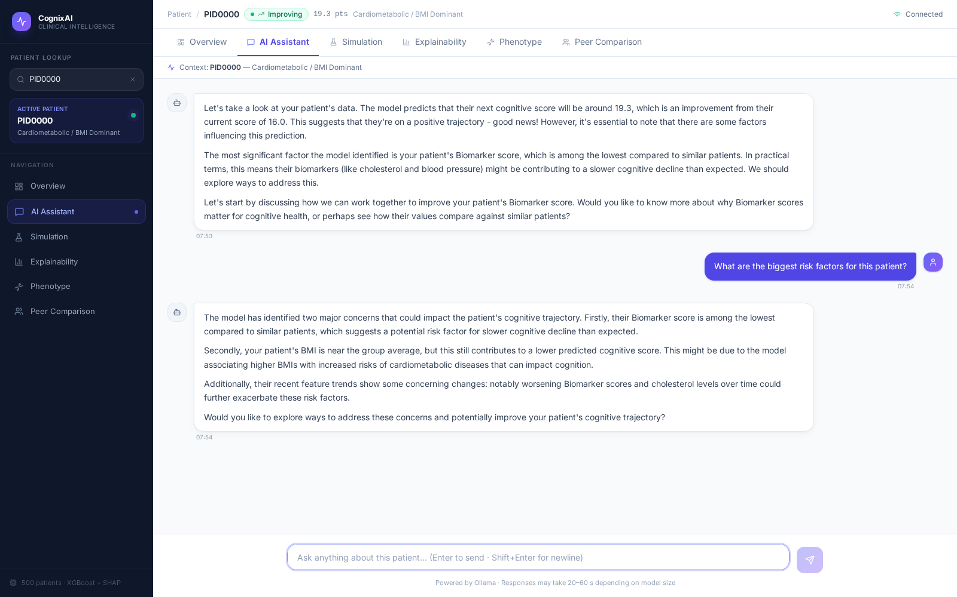
Figure 5.6 — AI Assistant page: grounded conversational chat about the patient.
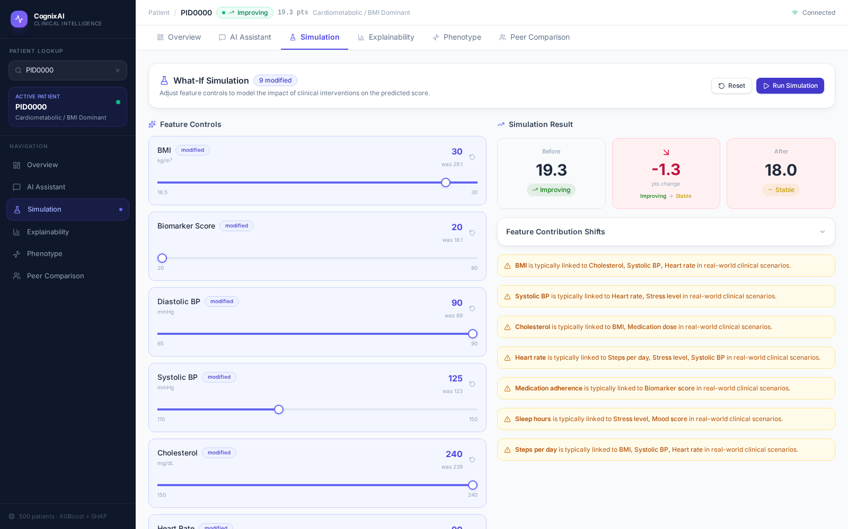
Figure 5.7 — Simulation page: what-if feature-change sliders and predicted outcome shift.
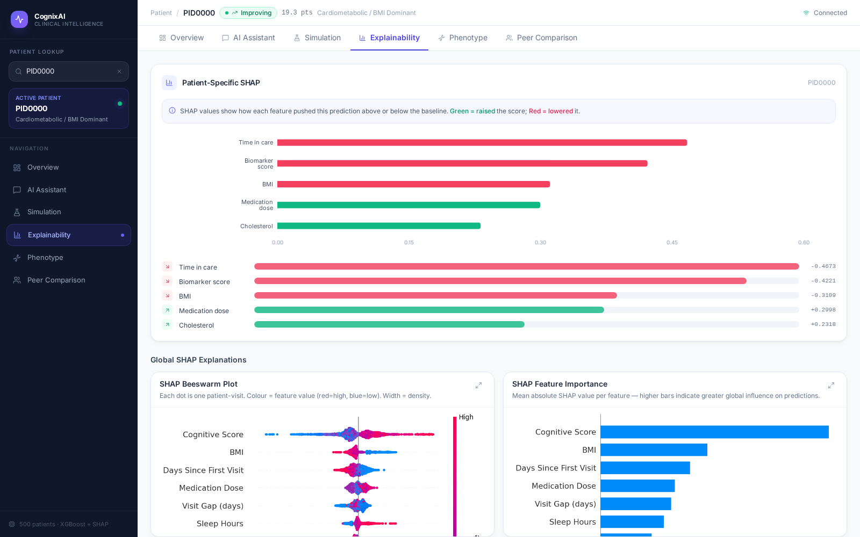
Figure 5.8 — Explainability page: patient-specific SHAP factors, beeswarm plot, confusion matrix of model performance and feature importance.
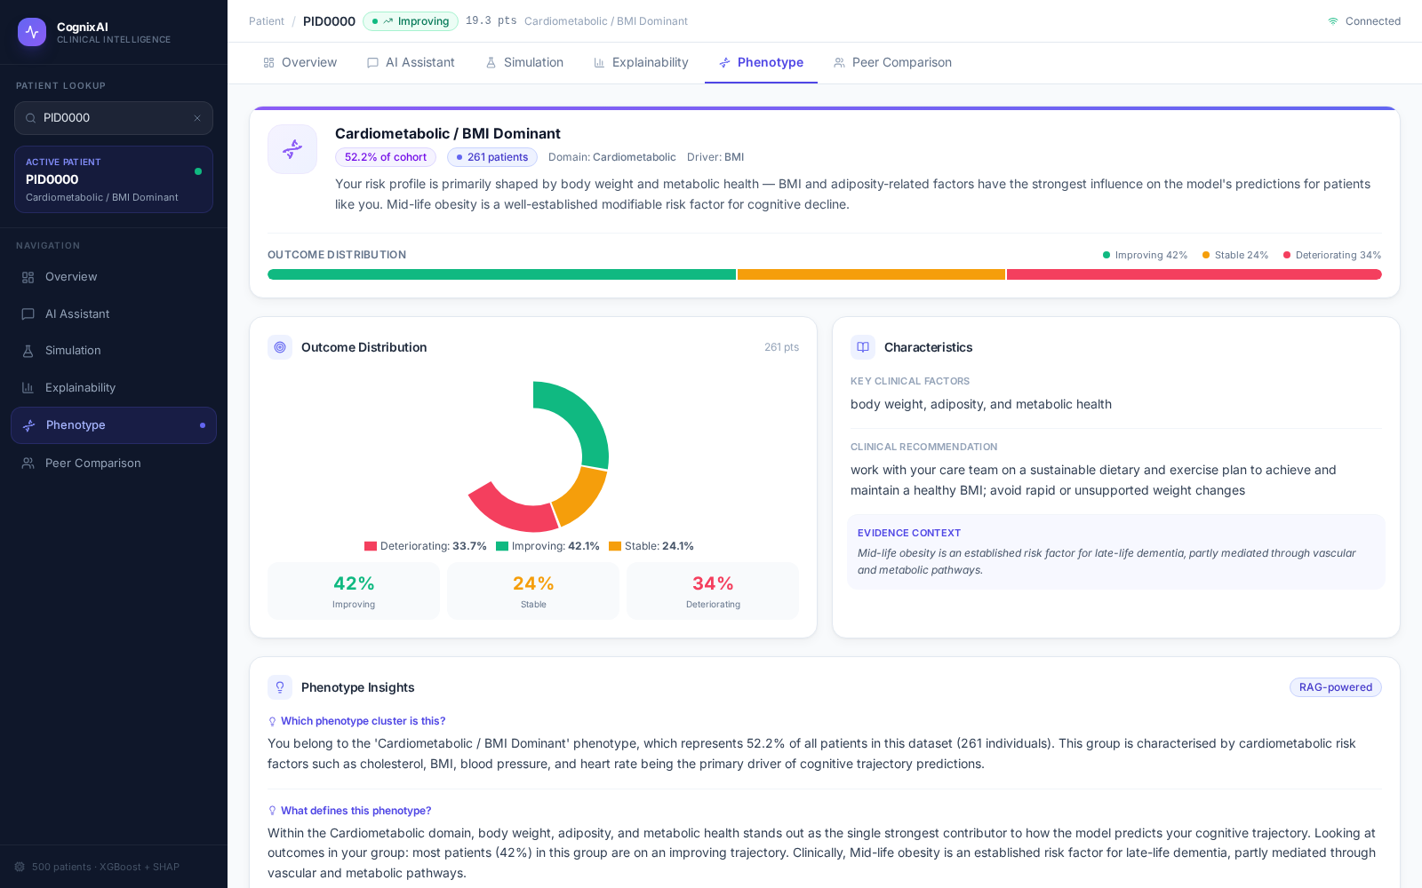
Figure 5.9 — Phenotype page: cohort membership, outcome distribution, and phenotype insights.

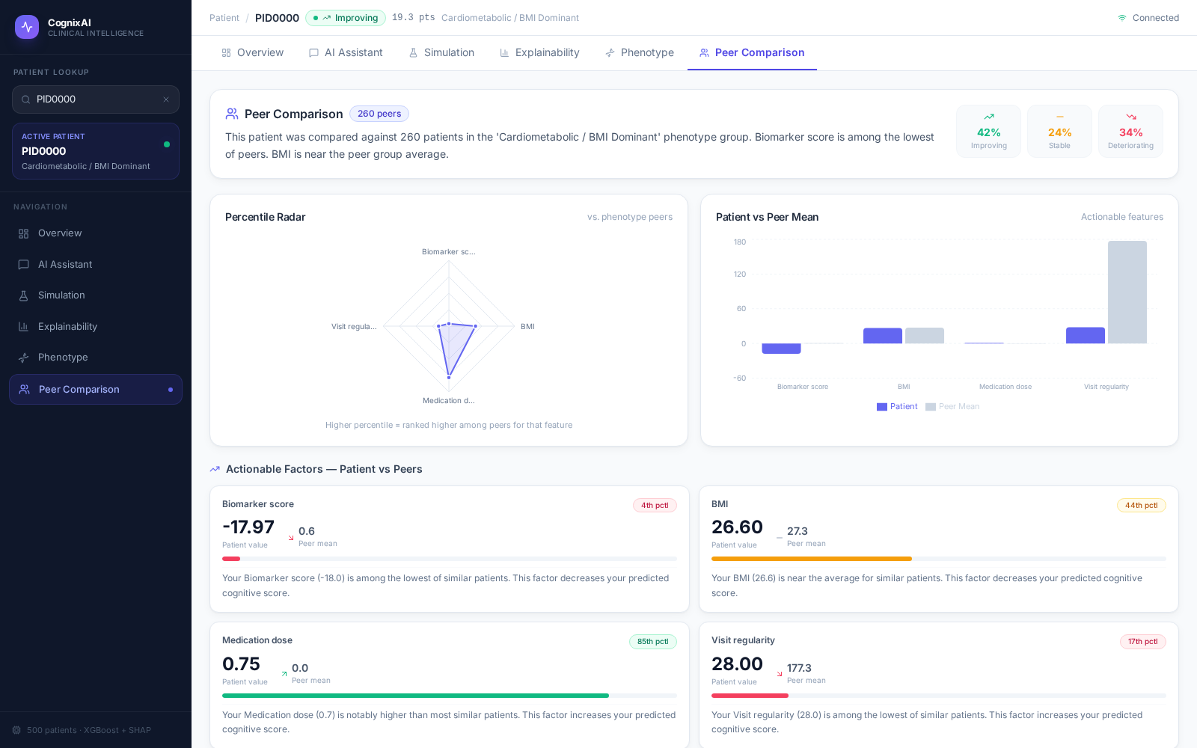
Figure 5.10 — Peer Comparison page: percentile radar and patient-vs-peer actionable factors.
Recorded video walkthroughs of the dashboard and chatbot are also included in the project's Demo/ folder (Dashboard.webm, Chatbot.webm).

Chapter 6: Engineering Improvements & Fixes
Beyond the initial modeling work, a dedicated hardening pass improved data-handling correctness and chatbot response quality.

6.1 Data-Handling Fixes
- PatientID is a string in "PID0000" format; code was audited to remove int() casts that crashed on this format.
- shap_values.pkl contains one row per visit rather than one per patient; phenotype aggregation now explicitly deduplicates via groupby("PatientID").agg(mode) before use.
- generate_shap_phenotype.py was refactored to wrap all logic in main(), making it safe to import without side effects.
- pipeline.py's __main__ block now correctly unpacks all 7 return values from run_pipeline().
- predictions_all.csv (500 rows, one per patient) replaced the older predictions_ALL.csv (3,000 rows) as the single source used at runtime.

6.2 Chatbot Response-Quality Fixes
Systematic testing across 7 sample patients and 10 question categories surfaced several response-quality issues, each addressed in reasoning.py / prompt_builder.py:
- Raw SHAP numbers leaking into responses — replaced with qualitative labels (e.g. "strongest driver") so the model cannot quote exact values.
- Raw percentiles leaking into responses — added a percentile-tiering helper and an explicit prohibition on reverse-translating qualitative language back into numbers.
- Internal feature names (e.g. BMI_prev) appearing in chat — added a suppression list and cleaner display-name mapping.
- Protective factors mislabeled as risks — added an explicit direction-consistency rule.
- Chatbot claiming not to know the predicted score — added a quick-reference block with the score at the very top of the system prompt.
- Missing follow-up question at the end of responses — fixed with a three-layer approach: a mandatory rule in the system prompt, a final reminder appended to the prompt, and a reminder injected into every user message.
- Hallucinated individual peer patients — added an explicit rule against inventing or enumerating specific peers.
- Chatbot recommending patients "maintain" a clinically undesirable high value (e.g. high cholesterol) — added a set of features where high is explicitly bad.
A dedicated test harness (7 patients × 10 question categories) and a targeted verification script (checking for missing follow-ups, raw SHAP leakage, raw percentile leakage, and improper refusals) were used to confirm the fixes; the final verification pass achieved 8/8 clean checks.

6.3 Other Production Improvements
- xgboost_and_shap.py now runs 5-fold GroupKFold cross-validation and outputs an expanded set of diagnostic plots (residual analysis, SHAP waterfall, SHAP dependence) alongside the original confusion matrix and bar/beeswarm plots.
- llm_backend.py adds retry logic with exponential backoff and configurable timeouts via environment variables.
- utils.py centralizes shared constants (XGB_PARAMS, ADHERENCE_LABELS) to keep training and inference consistent.
- README.md, requirements.txt, and .gitignore were added for reproducible setup.

Chapter 7: Deployment
The application is a single Flask process serving both the API and the pre-built static frontend, with a dependency on a reachable Ollama instance. There is currently no Docker image or CI pipeline; deployment is manual.

7.1 Prerequisites
- Python 3.10
- Node.js with npm (for the frontend build)
- Ollama, running locally with a pulled model (default llama3.1:8b)

7.2 Setup Summary
- Create a Python virtual environment and install requirements.txt.
- Install frontend dependencies with npm install.
- Run ollama serve and pull the target model.
- Generate model outputs once: pipeline.py → xgboost_and_shap.py → generate_shap_phenotype.py.
- Build the frontend: npm run build.
- Start the app: ./start.sh (or ./start.sh --dev for hot-reload frontend development).

7.3 Environment Variables
Variable | Default | Purpose
OLLAMA_URL | http://localhost:11434 | Ollama server address
OLLAMA_MODEL | llama3.1:8b | Model used for chat and intro generation
OLLAMA_TIMEOUT_S | 120 | Per-request timeout, in seconds
OLLAMA_MAX_RETRIES | 2 | Retries on timeout or 5xx server errors

7.4 Production Recommendations
The README recommends running behind Gunicorn or Waitress with Nginx as a reverse proxy, managed by a process supervisor (systemd, supervisord, or pm2), since Flask's built-in server is development-grade only. Redeployment after a frontend-only change requires rebuilding the frontend and restarting api.py; a backend or model-logic change requires re-running the offline pipeline before rebuilding and restarting.

Chapter 8: Timeline
Phase / Date | Milestone
18-05-2026 | Initial commit — project scaffold established
Early phase | Data pipeline, XGBoost model, and SHAP explainability implemented
28-05-2026 | Production-hardening pass: safe-import refactors, pipeline return-value fix, shared constants (XGB_PARAMS, ADHERENCE_LABELS), expanded SHAP diagnostics/plots, Ollama retry/backoff logic, README and requirements added
17-06-2026 | Chatbot response-quality testing and fixes: qualitative-language rules, follow-up enforcement, peer-hallucination and direction-consistency guards; verification harness reached 8/8 clean checks
23-06-2026 | Model diagnostics regenerated (confusion matrix, residual analysis plots)
03-07-2026 | SHAP visualizations regenerated (bar, beeswarm plots)
10-07-2026 | Final integration ('cognixAI' changes), README edits, and project documentation completed
13-07-2026 | Final presentation

Chapter 9: Limitations and Future Work

9.1 Limitations
- The training data is synthetic, not a real, IRB-approved clinical dataset; predictions and phenotypes should not be interpreted as clinically validated.
- R² (0.147 held-out, 0.117 cross-validated) indicates the model explains a modest share of outcome variance — it clearly outperforms the naive baseline but leaves substantial unexplained variation, appropriate for a prototype rather than a deployed clinical tool.
- "Stable" progression is the hardest label to predict correctly (27.0% agreement); future work could revisit the ±2-point labeling threshold or model the label directly.
- The chatbot's medical knowledge is limited to the patient's own SHAP/phenotype context; it is not grounded in external clinical literature or guidelines.
- No authentication or multi-tenant support yet — appropriate for a local research prototype, not multi-clinician production use.
- No Docker image or CI pipeline; deployment is currently a manual, documented process.

9.2 Future Work
Planned future directions:
- Integrate real, IRB-approved clinical datasets in place of the synthetic sample data.
- Upgrade to a stronger LLM (larger local model or hosted frontier model) for richer reasoning.
- Ground chatbot responses in external medical knowledge sources (clinical guidelines, literature retrieval) rather than SHAP context alone.
- Extend prediction to additional outcomes beyond cognitive score (e.g. comorbidity risk, hospitalization likelihood).
- Add Docker support for reproducible, one-command deployment.
- Add authentication and user management for multi-clinician / multi-tenant use.

Chapter 10: Conclusion
CognixAI successfully demonstrates an end-to-end explainable artificial intelligence framework for chronic disease progression monitoring. The project integrates temporal feature engineering, an XGBoost prediction model, SHAP-based explainability, patient phenotyping, an interactive what-if simulation engine, and a locally hosted LLM chatbot into a unified full-stack application. Together, these components provide not only accurate cognitive score prediction but also transparent, patient-specific explanations and interactive clinical reasoning.
The developed system achieved meaningful improvement over a naive baseline while maintaining complete local execution, ensuring patient data privacy and enabling explainable decision support. Systematic testing and refinement of the chatbot further improved the reliability and consistency of its responses, resulting in a robust prototype capable of explaining predictions, simulations, and phenotype-specific insights.
Although the current implementation is based on a synthetic longitudinal dataset, the overall architecture is designed to be extensible to real clinical data. Future work will focus on validating the framework using real-world healthcare datasets under appropriate ethical approval, improving predictive performance, incorporating additional clinical outcomes, and enhancing the conversational capabilities of the LLM. Overall, CognixAI demonstrates how explainable machine learning and local language models can be combined to create an interpretable, privacy-preserving clinical decision-support system.

Chapter 11: References
- Chen, T. and Guestrin, C. (2016). XGBoost: A Scalable Tree Boosting System. Proceedings of the 22nd ACM SIGKDD International Conference on Knowledge Discovery and Data Mining.
- Lundberg, S. M. and Lee, S.-I. (2017). A Unified Approach to Interpreting Model Predictions (SHAP). Advances in Neural Information Processing Systems 30.
- Pedregosa, F. et al. (2011). Scikit-learn: Machine Learning in Python. Journal of Machine Learning Research, 12, 2825-2830.
- McKinney, W. (2010). Data Structures for Statistical Computing in Python. Proceedings of the 9th Python in Science Conference.
- Flask Documentation — https://flask.palletsprojects.com/
- React Documentation — https://react.dev/
- Vite Documentation — https://vitejs.dev/
- Ollama Documentation — https://ollama.com/

Appendices

Appendix I: Disclaimer
This project is a research prototype intended for educational purposes. Predictions, explanations, and simulations are generated by machine learning models and should not be interpreted as medical advice or used for clinical decision-making without professional validation.

Appendix II: Glossary of Abbreviations
Abbreviation | Meaning
AI | Artificial Intelligence
API | Application Programming Interface
BMI | Body Mass Index
CV | Cross-Validation
LLM | Large Language Model
MAE | Mean Absolute Error
RAG | Retrieval-Augmented Generation (used informally in the codebase/UI; see note in Section 3.3.6)
RMSE | Root Mean Squared Error
R² | Coefficient of Determination
SHAP | SHapley Additive exPlanations
SPA | Single-Page Application
SSE | Server-Sent Events
WSGI | Web Server Gateway Interface

