SELENIUM

DAY-9

1) **package** day9;

**import** org.testng.annotations.Test;

**import** org.testng.annotations.DataProvider;

**public** **class** seleniumday9{

**int** a,b,c;

@Test(dataProvider = "dp")

**public** **void** Add(Integer a, Integer b) {

c=a+b;

System.***out***.println("sum-"+c);

}

@DataProvider

**public** Object[][] dp() {

**return** **new** Object[][] {

**new** Object[] { 10, 5 },

**new** Object[] { 12, 6 },

};

}

}

OUTPUT:

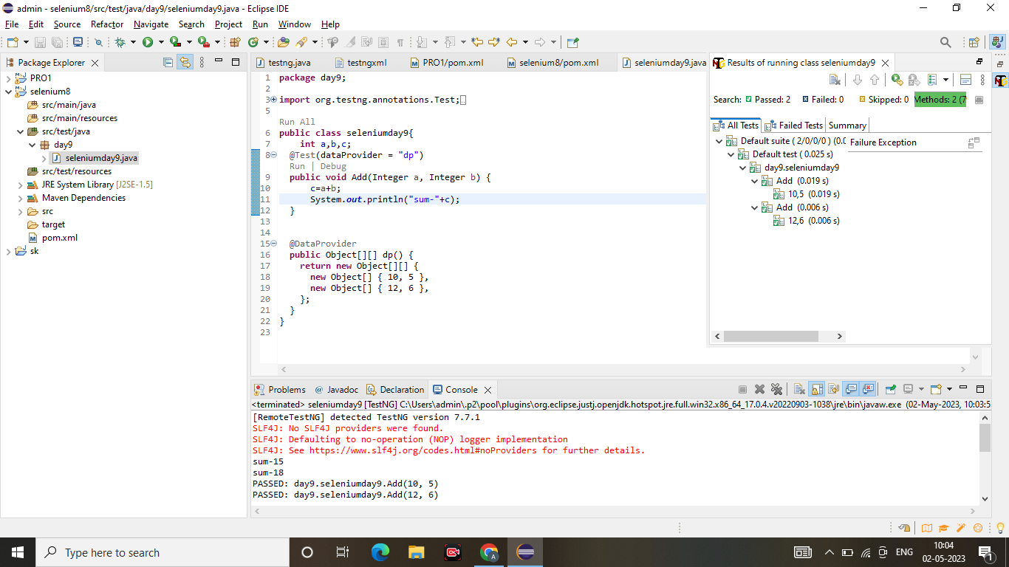

2)

**package** day9;

**import** org.testng.annotations.Test;

**import** org.testng.annotations.DataProvider;

**public** **class** seleniumday9{

**int** a,b,c;

@Test(dataProvider = "dp")

**public** **void** Add(Integer a, Integer b) {

c=a+b;

System.***out***.println("sum-"+c);

}

@Test(dataProvider = "dp")

**public** **void** Subtract(Integer a, Integer b) {

c=a-b;

System.***out***.println("sum-"+c);

}

@Test(dataProvider = "dp")

**public** **void** Multiply(Integer a, Integer b) {

c=a*b;

System.***out***.println("sum-"+c);

}

@Test(dataProvider = "dp")

**public** **void** division(Integer a, Integer b) {

c=a/b;

System.***out***.println("sum-"+c);

}

@DataProvider

**public** Object[][] dp() {

**return** **new** Object[][] {

**new** Object[] { 10, 5 },

**new** Object[] { 12, 6 },

};

}

}

OUTPUT:

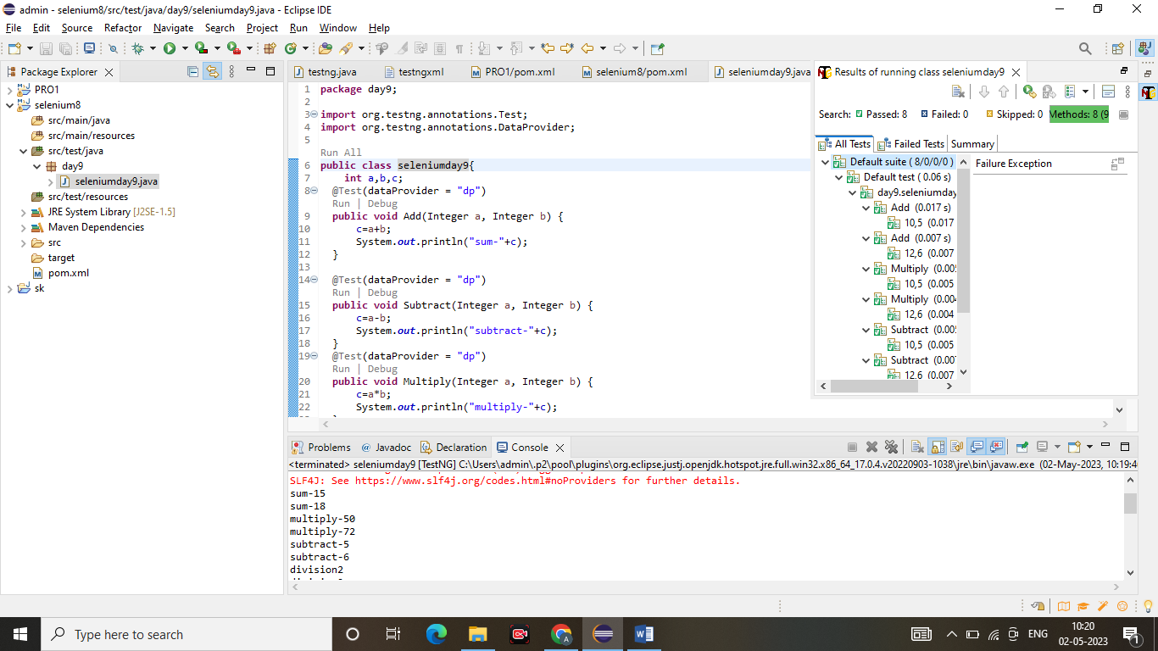

3)

**package** day9;

**import** org.testng.annotations.Test;

**import** com.google.common.base.Verify;

**import** io.github.bonigarcia.wdm.WebDriverManager;

**import** java.util.concurrent.TimeUnit;

**import** org.openqa.selenium.By;

**import** org.openqa.selenium.WebDriver;

**import** org.openqa.selenium.WebElement;

**import** org.openqa.selenium.chrome.ChromeDriver;

**import** org.openqa.selenium.chrome.ChromeOptions;

**import** org.testng.Assert;

**import** org.testng.annotations.DataProvider;

**public** **class** NewTest {

@Test

**public** **void** Testcase01() {

WebDriverManager.*chromedriver*().setup();

ChromeOptions ed= **new** ChromeOptions();

WebDriver driver=**new** ChromeDriver(ed);

driver.get("https://www.godaddy.com");

driver.manage().window().maximize();

Assert.*assertEquals*(driver.getTitle(),"Domain Names, Websites, Hosting & Online Marketing Tools - GoDaddy IN");

Assert.*assertEquals*(driver.getCurrentUrl(),"https://www.godaddy.com/en-in" );

}

@Test

**public** **void** Testcase02() {

WebDriverManager.*chromedriver*().setup();

ChromeOptions ed= **new** ChromeOptions();

WebDriver driver=**new** ChromeDriver(ed);

driver.get("https://www.godaddy.com");

driver.manage().window().maximize();

driver.manage().timeouts().~~implicitlyWait~~(5, TimeUnit.***SECONDS***);

driver.findElement(By.*xpath*("//*[@id=\"id-631b049a-e9c0-4d24-8710-c504745206dd\"]/div[2]/div[1]/ul/li[1]/button")).click();

**try** {

Thread.*sleep*(2000);

} **catch** (InterruptedException e) {

// **TODO** Auto-generated catch block

e.printStackTrace();

}

driver.findElement(By.*xpath*("//*[@id=\"id-631b049a-e9c0-4d24-8710-c504745206dd\"]/div[2]/div[1]/ul/li[1]/div/div[2]/div[1]/ul/li[2]/a")).click();

}

@Test

**public** **void** Testcase03() {

WebDriverManager.*chromedriver*().setup();

ChromeOptions ed= **new** ChromeOptions();

WebDriver driver=**new** ChromeDriver(ed);

driver.get("https://www.godaddy.com");

driver.manage().window().maximize();

driver.manage().timeouts().~~implicitlyWait~~(5, TimeUnit.***SECONDS***);

driver.findElement(By.*xpath*("//*[@id=\"id-631b049a-e9c0-4d24-8710-c504745206dd\"]/div[2]/div[1]/ul/li[1]/button")).click();

**try** {

Thread.*sleep*(2000);

} **catch** (InterruptedException e) {

// **TODO** Auto-generated catch block

e.printStackTrace();

}

driver.findElement(By.*xpath*("//*[@id=\"id-631b049a-e9c0-4d24-8710-c504745206dd\"]/div[2]/div[1]/ul/li[1]/div/div[2]/div[1]/ul/li[2]/a")).click();

**try** {

Thread.*sleep*(4000);

} **catch** (InterruptedException e) {

// **TODO** Auto-generated catch block

e.printStackTrace();

}

System.***out***.println(driver.getTitle());

**if**(driver.getTitle().equals("GoDaddy Domain Search - Buy and Register Available Domain Names")) {

WebElement search= driver.findElement(By.*name*("searchText"));

System.***out***.println(search.isDisplayed());

System.***out***.println(search.isEnabled());

WebElement buyit=driver.findElement(By.*xpath*("//*[@id=\"id-1467954b-c5e3-4b0c-9046-9fc94d8ca892\"]/section/div/div/section/div/div[1]/div/div/div[2]/button"));

System.***out***.println(buyit.isDisplayed());

System.***out***.println(buyit.isEnabled());

search.sendKeys("monkyhomie");

**try** {

Thread.*sleep*(2000);

} **catch** (InterruptedException e) {

// **TODO** Auto-generated catch block

e.printStackTrace();

}

buyit.click();

**try** {

Thread.*sleep*(6000);

} **catch** (InterruptedException e) {

// **TODO** Auto-generated catch block

e.printStackTrace();

}

Assert.*assertEquals*(driver.findElement(By.*xpath*("//*[@id=\"search-app\"]/div/div/div/div[2]/div[1]/div[2]/div[1]/div[2]/div/div[1]/span")).getText(),"EXACT MATCH");

Verify.*verify*((driver.findElement(By.*xpath*("//*[@id=\"search-app\"]/div/div/div/div[2]/div[1]/div[2]/div[1]/div[2]/div/div[4]/div/div/div/div[2]/button")).getText()).equals("Add to Cart"));

Verify.*verify*(driver.findElement(By.*xpath*("//*[@id=\"search-app\"]/div/div/div/div[2]/div[1]/div[2]/div[1]/div[2]/div/div[3]/div/div[1]/div[1]/div/span[1]/span")).isDisplayed());

}

**else** Assert.*assertTrue*(**false**);

}

}

OUTPUT:

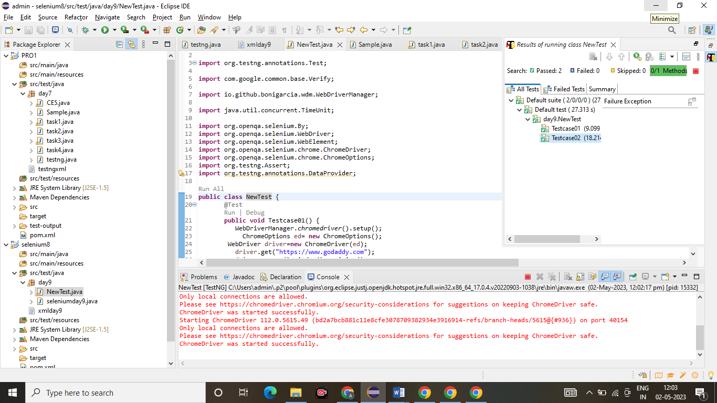

4)

**package** day9;

**import** org.testng.annotations.Test;

//import io.github.bonigarcia.wdm.WebDriverManager;

**import** org.testng.annotations.BeforeSuite;

**import** org.testng.annotations.AfterSuite;

**import** org.openqa.selenium.By;

**import** org.openqa.selenium.WebDriver;

**import** org.openqa.selenium.WebElement;

**import** org.openqa.selenium.chrome.ChromeDriver;

**import** org.openqa.selenium.chrome.ChromeOptions;

**import** org.testng.Assert;

**public** **class** task4 {

WebDriver driver;

@Test

**public** **void** openURL() **throws** InterruptedException {

Thread.*sleep*(3000);

WebElement userName = driver.findElement(By.*name*("username"));

WebElement password = driver.findElement(By.*name*("password"));

WebElement submit = driver.findElement(By.*xpath*("//*[@class='oxd-button oxd-button--medium oxd-button--main orangehrm-login-button']"));

userName.sendKeys("Admin");

password.sendKeys("admin123");

submit.click();

Thread.*sleep*(3000);

String expectedURL = "https://opensource-demo.orangehrmlive.com/web/index.php/dashboard/index";

//String expectedURL = "https://opensource-demo.orangehrmlive.com/web/index.php/auth/login";

String actualURL = driver.getCurrentUrl();

Assert.*assertEquals*(expectedURL, actualURL);

}

@BeforeSuite

**public** **void** setup() {

System.*setProperty*("webdriver.chrome.driver","C:\\drivers\\chromedriver.exe");

//WebDriverManager.chromedriver().setup();

ChromeOptions co = **new** ChromeOptions();

co.addArguments("--remote-allow-origins=*");

driver = **new** ChromeDriver(co);

driver.manage().window().maximize();

String url = "https://opensource-demo.orangehrmlive.com/web/index.php/auth/login";

driver.get(url);

driver.manage().window().maximize();

}

@AfterSuite

**public** **void** teardown() {

driver.close();

}

}

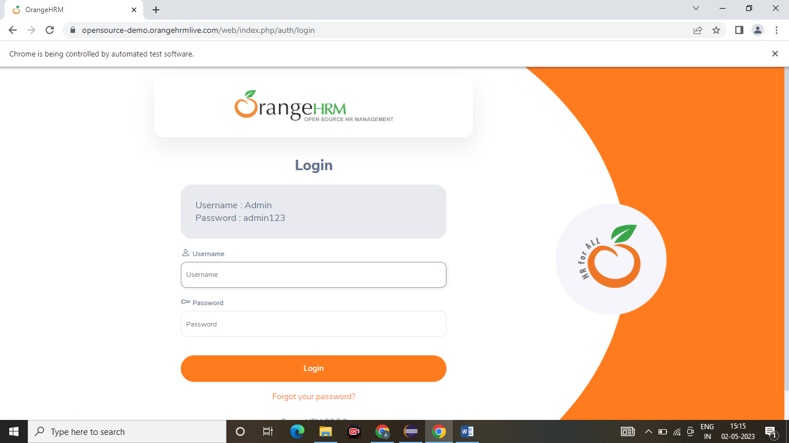

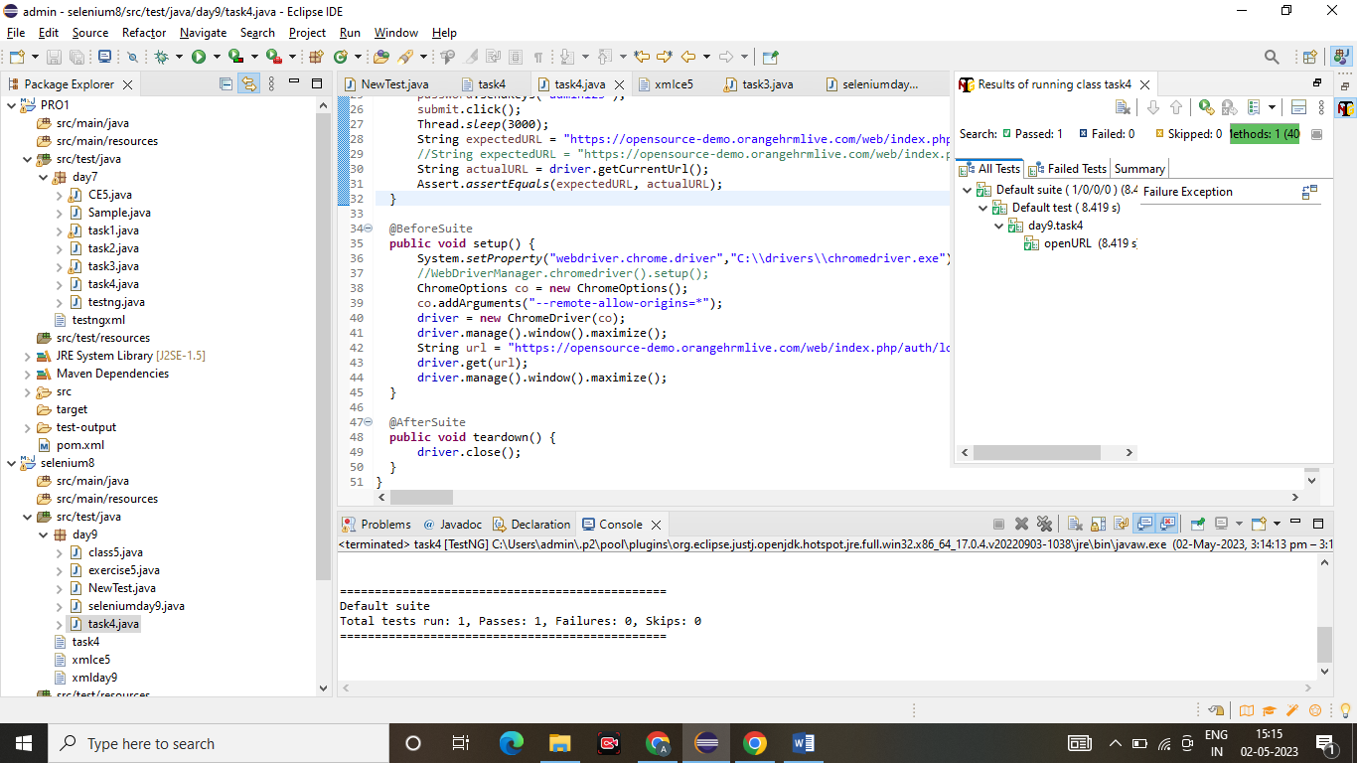

5)

<?xml version="1.0" encoding="UTF-8"?>

<suite parallel="false" name="Suite">

<test name="Test">

<listeners>

<listener class-name="day9.exercise5"/>

</listeners>

<classes>

<class name="day9.class5"/>

</classes>

</test> <!-- Test -->

</suite> <!-- Suite -->

**package** day9;

**import** org.testng.ITestContext;

**import** org.testng.ITestListener;

**import** org.testng.ITestResult;

**public** **class** exercise5 **implements** ITestListener{

**public** **void** onTestStart(ITestResult result) {

// **TODO** Auto-generated method stub

System.***out***.println("on Test Start "+result.getName());

}

**public** **void** onTestSuccess(ITestResult result) {

// **TODO** Auto-generated method stub

System.***out***.println("on Test Success "+result.getName());

}

**public** **void** onTestFailure(ITestResult result) {

// **TODO** Auto-generated method stub

System.***out***.println("on Test Failure "+result.getName());

}

**public** **void** onTestSkipped(ITestResult result) {

// **TODO** Auto-generated method stub

System.***out***.println("on Test Skipped "+result.getName());

}

**public** **void** onTestFailedButWithinSuccessPercentage(ITestResult result) {

// **TODO** Auto-generated method stub

System.***out***.println("on Test Failed But Within Success Percentage "+result.getName());

}

**public** **void** onTestFailedWithTimeout(ITestResult result) {

// **TODO** Auto-generated method stub

System.***out***.println("on Test Failed With Timeout "+result.getName());

}

**public** **void** onStart(ITestContext context) {

// **TODO** Auto-generated method stub

System.***out***.println("on Start "+context.getName());

}

**public** **void** onFinish(ITestContext context) {

// **TODO** Auto-generated method stub

System.***out***.println("on Finish "+context.getName());

}

**public** **static** **void** main(String[] args) {

}

}

**package** day9;

**import** org.testng.annotations.Test;

//import io.github.bonigarcia.wdm.WebDriverManager;

**import** org.testng.annotations.BeforeSuite;

**import** org.testng.annotations.AfterSuite;

**import** org.openqa.selenium.By;

**import** org.openqa.selenium.WebDriver;

**import** org.openqa.selenium.WebElement;

**import** org.openqa.selenium.chrome.ChromeDriver;

**import** org.openqa.selenium.chrome.ChromeOptions;

**import** org.testng.Assert;

**public** **class** class5 {

WebDriver driver;

@Test

**public** **void** openURL() **throws** InterruptedException {

Thread.*sleep*(3000);

WebElement userName = driver.findElement(By.*name*("username"));

WebElement password = driver.findElement(By.*name*("password"));

WebElement submit = driver.findElement(By.*xpath*("//*[@class='oxd-button oxd-button--medium oxd-button--main orangehrm-login-button']"));

userName.sendKeys("Suvitha");

password.sendKeys("12345");

submit.click();

Thread.*sleep*(3000);

String expectedURL = "https://opensource-demo.orangehrmlive.com/web/index.php/dashboard/index";

//String expectedURL = "https://opensource-demo.orangehrmlive.com/web/index.php/auth/login";

String actualURL = driver.getCurrentUrl();

Assert.*assertEquals*(expectedURL, actualURL);

}

@BeforeSuite

**public** **void** setup() {

System.*setProperty*("webdriver.chrome.driver","C:\\drivers\\chromedriver.exe");

//WebDriverManager.chromedriver().setup();

ChromeOptions co = **new** ChromeOptions();

co.addArguments("--remote-allow-origins=*");

driver = **new** ChromeDriver(co);

driver.manage().window().maximize();

String url = "https://opensource-demo.orangehrmlive.com/web/index.php/auth/login";

driver.get(url);

driver.manage().window().maximize();

}

@AfterSuite

**public** **void** teardown() {

driver.close();

}

}

