**Problem 2:Cascading Style Sheets**

## AIM:

## Create a web page that displays college information using various style sheets.

## (i)Inline

## (ii)Internal

## (iii)External

## PROGRAM CODE:

## 

|  |  |
| --- | --- |
| inline.html | <html><body><h1 style="color:green;">TKM COLLEGE OF ENGINEERING</h1><img src="tkm.png" width="300" height="300"><h2 style="color:pink;">Departments</h2><h3>Vision</h3><h4>Excellence in education and research with socio-economic and environmental outlook</h4><h3>Mission</h3><h4>To offer state-of-the-art Undergraduate, Postgraduate and Doctoral programmesTo enhance knowledge by engaging in cutting edge research and by undertaking collaborative projects with industryTo instill ethical, social and environmental perspectives in designing systems for sustainable developmentTo nurture creativity, self learning and interpersonal skills</h4></body></html> |
| internalcss.html | <html><head><style>body {background-color: rgb(218, 162, 213);}h1 {color: blue;font-family: verdana;font-size: 250%;}h2 {color: rgb(11, 45, 48);}h5 {color: black;font-family: verdana;font-size: 200%;border: 1px solid black;}</style></head><body><h1><center><u>Placement</u></center></h1><br><img src="tkm.png" width="300" height="300"><h2>Career Guidance and Placement Unit (CGPU) has played a vital role in ensuring that the alumni of the institution are well placed the world over.With a close watch on the changing<br>employment scenario, the Unit has always guided students in their career options and facilitated recruitment drives of prestigious companies.<br>CGPU operates on a four-tier system, the upper most being the Advisory Council, comprising of a member of the TKM Trust, Principal, Dean, Heads of all Departments and the CGPU core team.<br>The second tier which is the Core team consists of the Head of the Unit, Placement Officer, Faculty in charge of Finance and Faculty in charge of Drives and Database. The third tier consists<br>of coordinators from all Departments. The fourth and the most important tier is formed of final year student representatives from all branches.</body></html> |
| extrnal.html | <html><head><link rel="stylesheet" href="ext.css"></head><body><h1><center><u>Students</center></h1><center><img src="tkm.png" width="300" height="300"></center><br><h2><b><u>Film and Drama Club</b></u></h2><p><b>Staff Coordinator:</b> Prof. Sudheer, Department of Mechanical Engineering. EXECUTIVE COMMITTEE Student Coordinators: Jishnuraj R & MariyaVimala Augustine<br>Online media coordinator:Govind R G Technical head: Jerin Tom Public Relations Coordinator : Keerthana Film Festival Coordinator […]</p><br><b>Women Cell</b><br>Women’s Cell is a community of girl students in T K M College of Engineering, who share a common purpose to learn, educate and collaborate on ideas that have<br>the power to effect meaningful and positive change while fighting the odds they face. It is an expanding network that brings them together to learn, laugh, and […].</p></body></html> |
| external.css | body {background-color: lightblue;}h1 {color: red;}p {color: orange;} |

## RESULT:

## We can create a web page that displays college information using various style sheets like Inline, Internal &External

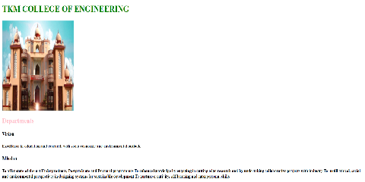

## 

## Figure 1:College department details using Inline css.

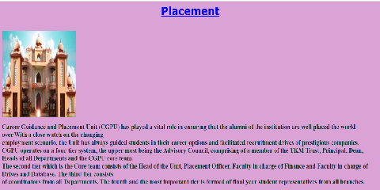

## Figure 2:Contact details using Internal css.

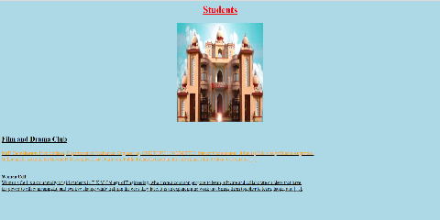

## Figure 3:Accademic details using External css.