**Problem 1 :Sample Webpage**

## AIM:

Design a sample personal webpage using three separate pages such as

1.Home Page

2.Educational Qualification

3.Contact Me

## PROGRAM CODE:

|  |  |
| --- | --- |
| home.html | <html><head><title>Sample</title></head><body><h1><center><U><B>PERSONAL DETAILS</h1></center></U></B><p><ul style="list-style-type:none;" ><center><img src="sree.jpg" width="150" height="150"></center></br></br><p><b>My name is SREELAKSHMI.S.I have a Master's Degree in Computer Application and I am looking for a job in an IT field.I have 3 years of expirience working in Infotech.I will work hard and will do my level best.</br><center><a href="qualificationdetails.html">qualificationdetails</a></center></br><center><a href="contacts.html">contact</a></center></body></html> |
| quali.html | <html><head><title></title></head><p><U><B><center>QUALIFICATION DETAILS</B></U></center><br><br><style>table {font-family: arial, sans-serif;border-collapse: collapse;width: 100%;}td, th {border: 1px solid #dddddd;text-align: left;padding: 8px;}tr:nth-child(even) {background-color: #dddddd;}</style></head><body><table><tr><th>COURSE</th><th>BOARD/UNIVERSITY</th><th>NAME OF THE INSTITUTE</th><th>YEAR</th></tr><tr><td>MCA</td><td>KERALA TECHNICAL UNIVERSITY</td><td>TKM COLLEGE OF ENGINEERING</td><td>2021</td></tr><tr><td>BCA</td><td>KERALA UNIVERSITY</td><td>SREE VIDYADHIRAJA COLLEGE</td><td>2018</td></tr><tr><td>12</td><td>CBSE</td><td>SABARIGIRI RESIDENTIAL SCHOOL</td><td>2015</td></tr><tr><td>10</td><td>CBSE</td><td>SABARIGIRI RESIDENTIAL SCHOOL</td><td>2013</td></tr><tr></table></body></html> |
| contact.html | <html><head><title>Website</title></head><body><h1><center><U><B>CONTACT DETAILS</h1></center></U></B><center><img src="call.jpg" width="150" height="150"></center></br></br><p><b><li>Contact Number:9744201881</li></br><li>E-Mail: sreekollam1997@gmail.com</li></br><li>Address:Ponal Shivakripa,Njakkanal(P.o),Oachira,Kollam</li></b></br></br><center><img src="HOME.jpg" width="50" height="50"></center><center><b><a href="file:///E:/S3WEB/personaldetails.html">Home</a></b></center></body></html> |

## RESULT

## We can create a webpage inside another web page using html.



## 

## Figure 1: Homepage

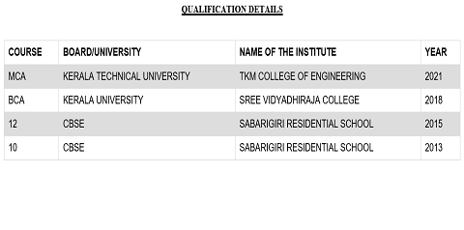

## Figure 2: Educational Qualification Page

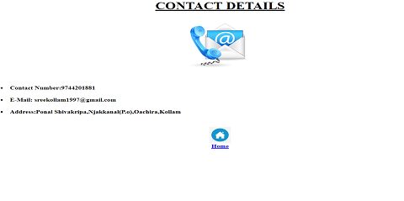

## Figure 3: Contact Details