**Problem 2 :Image Mapping**

## AIM:

Create a web page with the following using HTML5

(i) To embed an image map in a web page

(ii) To fix the hot spots

(iii) Show all the related information when the hot spots are clicked.

## PROGRAM CODE:

|  |  |
| --- | --- |
| parrot.html | <html><head><title>Image map </title></head><body><p><h4> My Image Map</h4></p><img src="parrot.jpeg" width="500" height="500" usemap="#parrotmap" class="center"><map name="parrotmap"><area shape="rect" coords="0,0,82,126" href="parrot1.html" class="center"><area shape="rect" coords="0,180,250,225" href="parrot2.html" class="center"></map></body></html> |
| Parrot1.html | <html><head><title>html2</title></head><img src="parrot1.jpeg" width="745" height="526" usemap="#paretmap"></body></html> |
| Parrot2.html | <html><head><title>html2</title></head><img src="parrot2.jpeg" width="745" height="526" usemap="#paretmap"></body></html> |

## RESULT

## We can embedded image map into a webpage.



## 

## Figure 1:Image1



## Figure 2: Image2

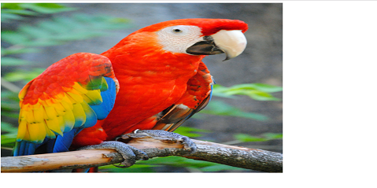

## Figure 3: Image3