Week1:
1)Aim : Download and installation of java
Step 1: Search for java development kit in chrome to download java
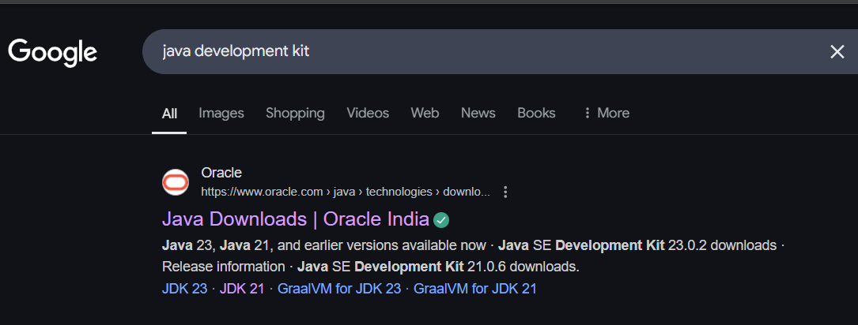
Step 2:Open oracle website .Then select JDK21 and download the type of version for your computer
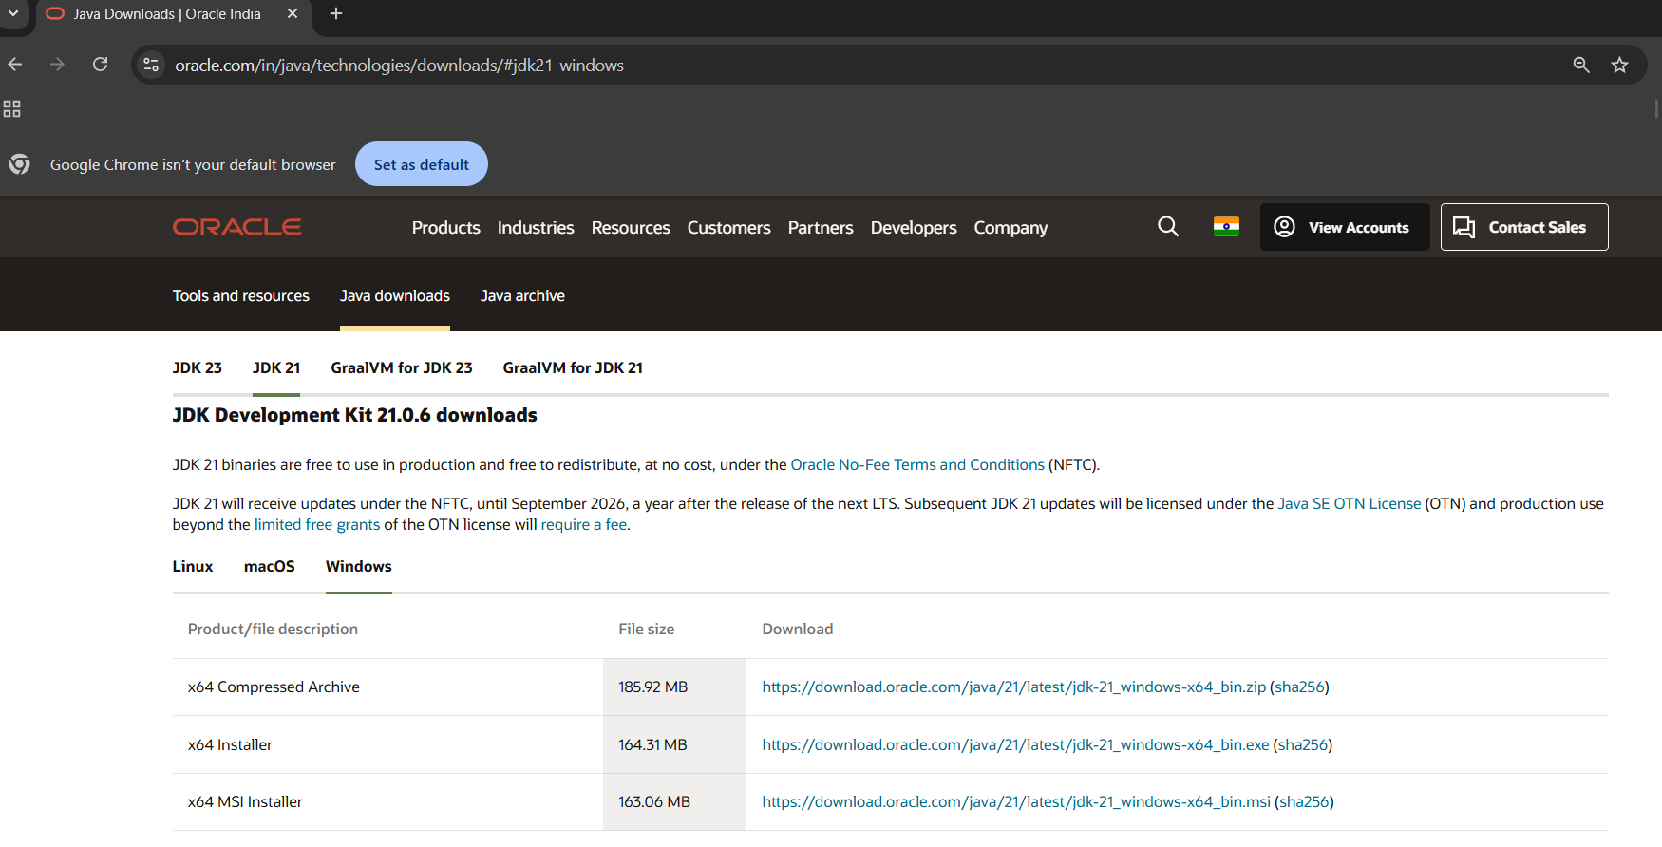

Step 3:After downloading it will appear like the link below. Click on the link for further installation of java software
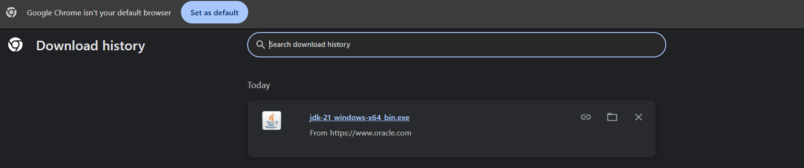
Step 4:Click on next button for further process
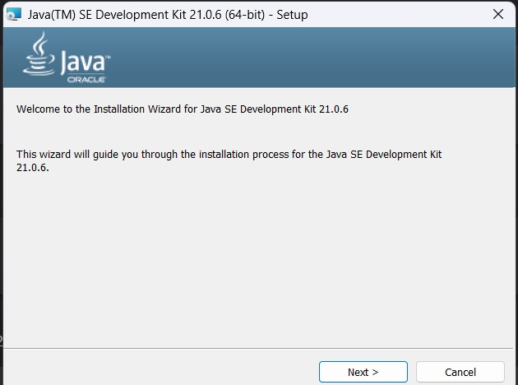
Step 5:Click on next button for final installation.
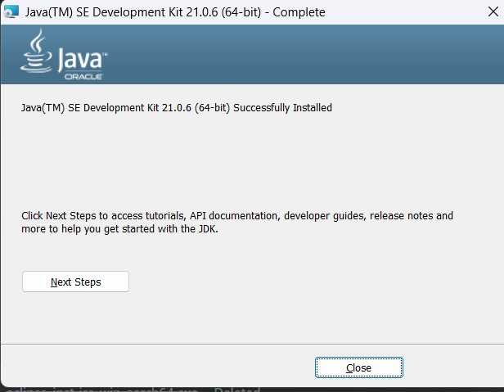
Step 6:To copy the path click on this pc then windows(c:) then program files then java to set path for environment variables
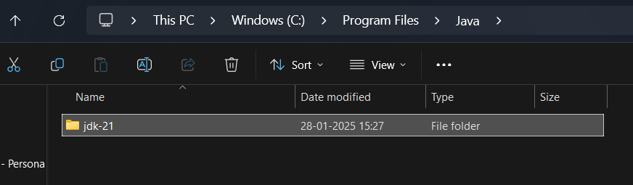
Step 7: Now Copy the path.
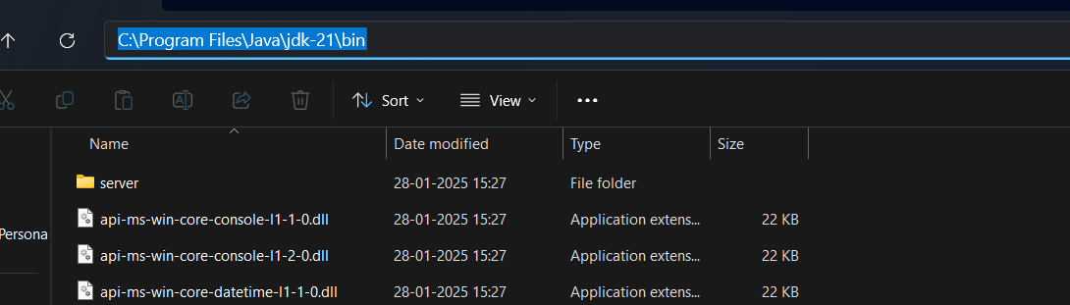
Step 8: Now open environment variables which is displayed below.
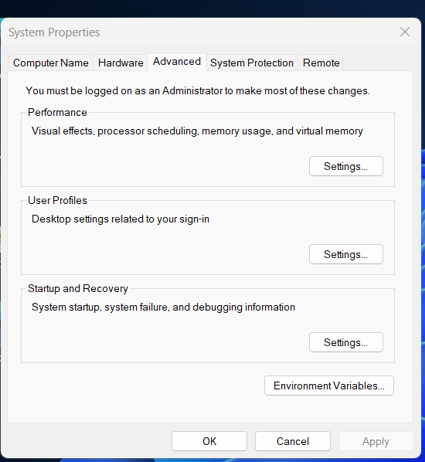
Step 9:After clicking environment variables .It will appear like this.
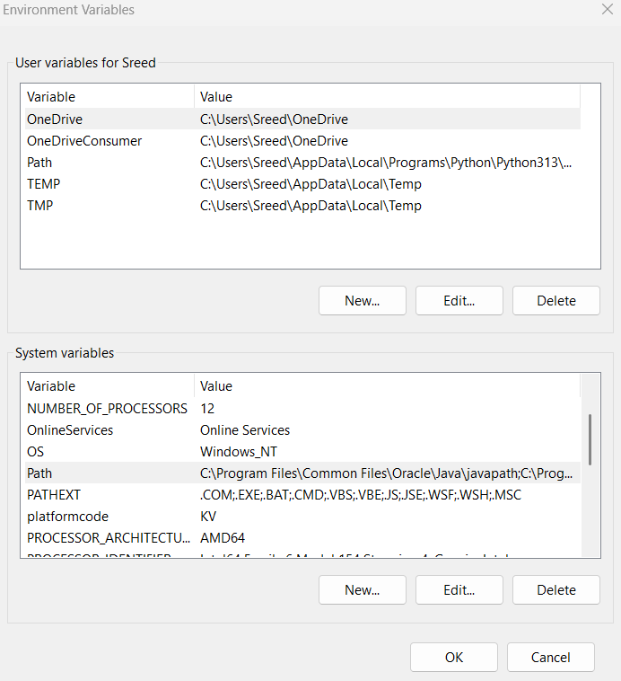
Step 10:To set path click on edit button then paste the copied path here then finally jdk installation is completed.
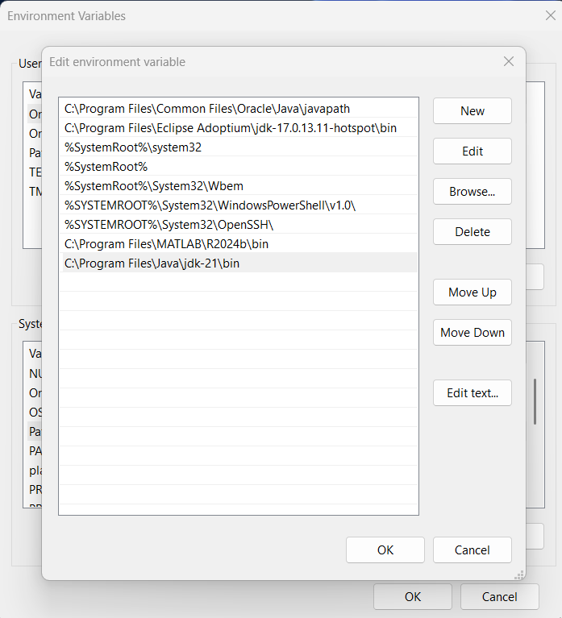
Step 11:To check the installed version.Open command prompt type java –version then enter. The installed version is displayed.
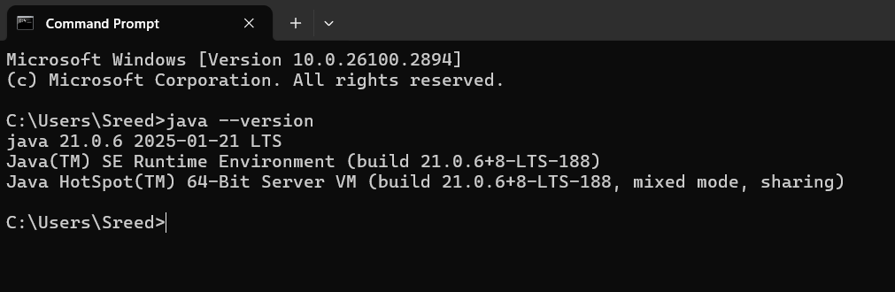

Week 1:
Program 1
1)Aim: To write a java program to print the message “Welcome to java programming”
Step 1:open notepad<<save the note pad in the path[desktop<<oops<<week 1<<Name.java
CODE:
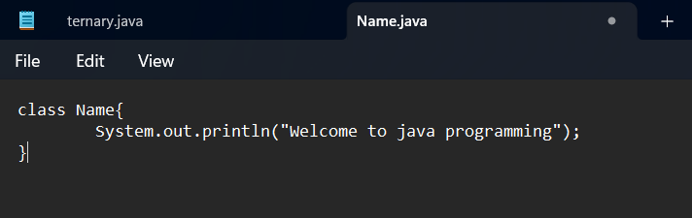

Step 2: to the path clear it and type cmd for running the program.
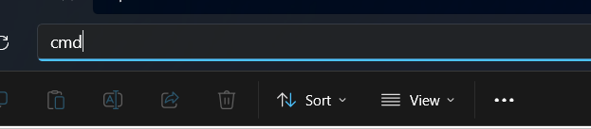

Step 3:Follow commands as: javac Name.java<<enter<<java Name
The program runs successfully.And creates a java class as shown below .
Output:
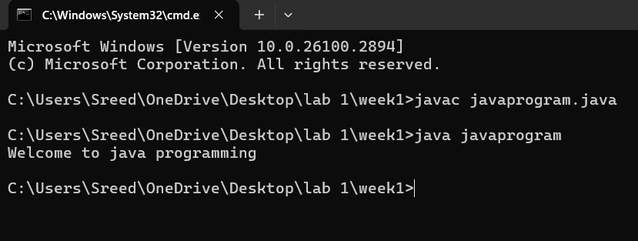
Step 4:After runner the program system automatically creates a class of it.

ERRORS:
S.NO | ERROR MEASSAGE | ERROR RECTIFICATION
1. | Error:”;”expected | Inserted “;”in line 2
2. | Error:”}” expected | Inserted “}” in line 3

Program 2

3)Aim: To write a java program that print name,rollno and section of a student
Step 1:open notepad<<save the note pad in the path[desktop<<oops<<week 1<<Name.java
CODE:

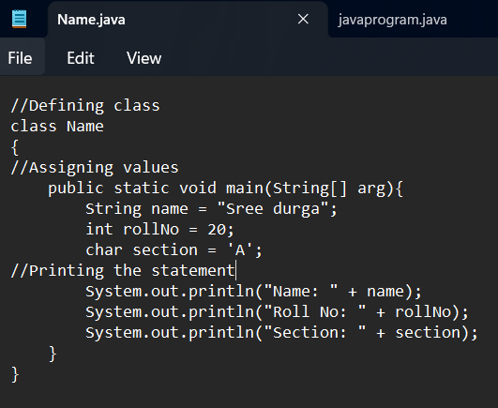
Step 2: to the path clear it and type cmd for running the program.

Step 3:follow commands as: javac Name.java<<enter<<java Name.
The program runs successfully.And creates a java clsss as shown below .

Output:

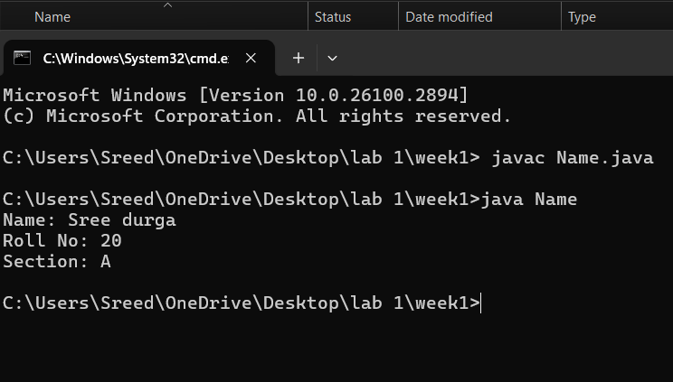
Step 4:After runner the program system automatically creates a class of it.
ERRORS:
S.NO | ERROR MEASSAGE | ERROR RECTIFICATION
1. | Error:”;”expected | Inserted “;”in line4
2. | Error:”/”unkown sysmbol | Replaced”/”with “:”

Week-2:
Program 1:
Aim: To write a java program for calculating area of rectangle.
Step 1:open notepad<<save the note pad in the path[desktop<<oops<<week 1<rectangle.java
CODE:

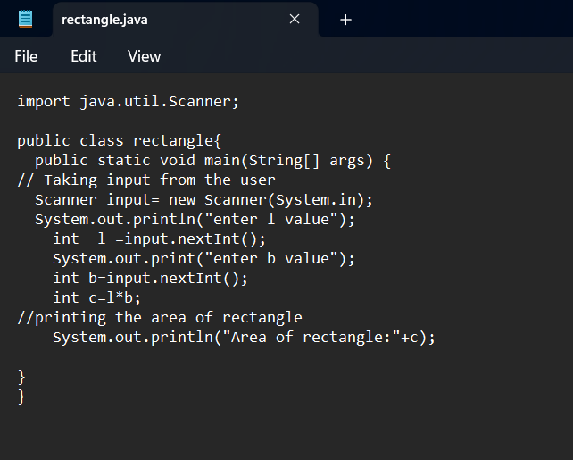
Step 2:open code in command prompt and run it.
Step 3:Enter the commands as javac rectangle.java <<java rectangle program is excuted successfully.

Output:
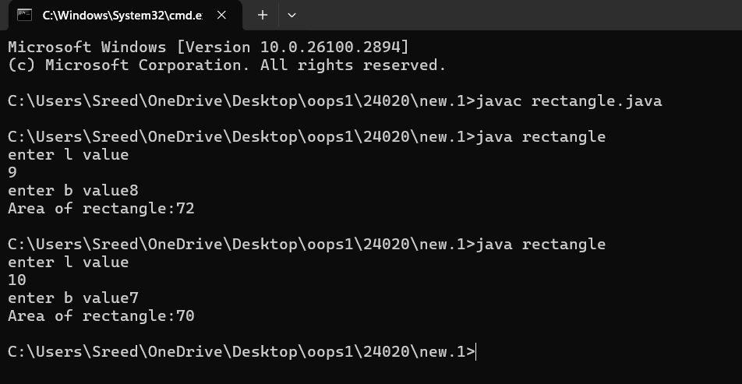
Step 4:after runner the program system automatically creates a class
For it.
ERRORS:
S.NO | ERROR MESSAGE | ERROR RECTIFICATION
1. | Error:”;”expected | Inserted “;”in line7
2. | Error:”?”unkown sysmbol | Replaced”?”with “:”
IMPORTANT POINTS:
1. Used Scanner library to get input from user in run time .
2. ”import java.util.Scanner;”-step to import library.
3. “Scanner input=new Scanner(System.in);”-step to use the scanner .

Program 2:
A.AIM: To write java program to convert temperature from celcius to farenheit and vice via.
Step 1:open notepad<<save the note pad in the path[desktop<<oops<<week 1<<temp.java
CODE:
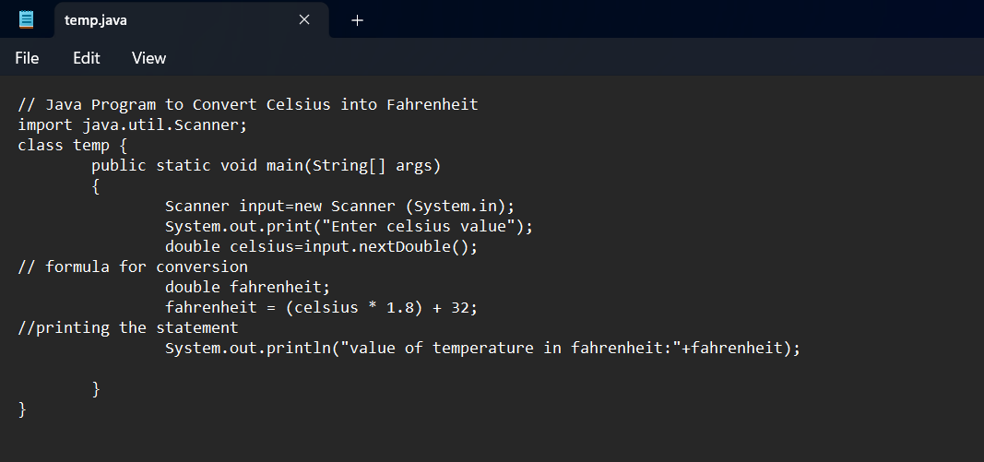
Step 2:Open in command prompt and run it.
Step 3: enter the commands as javac temp<<java temp the program is excuted successfully.
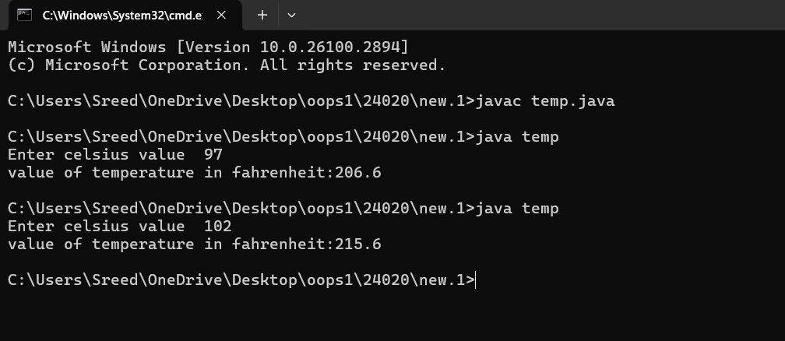
Step 4:After runner the program system automatically creates a class of it.
ERRORS:
S.NO | ERROR MESSAGE | ERROR RECTIFICATION
1. | Error :”:” unknow symbol | Replace”:” with”=”
2. | Error: “scanner”small letter case censitive | “Scanner”

IMPORTANT POINTS:
1.used Scanner library to get input from user in run time.
2.”import java.util.Scanner;”-step to import library.
3.”Scanner input= new Scanner(System.in);”-step to use the scanner.

B.AIM: To write java program to convert temperature from farenheit to celsius.
Step 1:open notepad<<save the note pad in the path[desktop<<oops<<week 1<<Celsius.java
CODE:
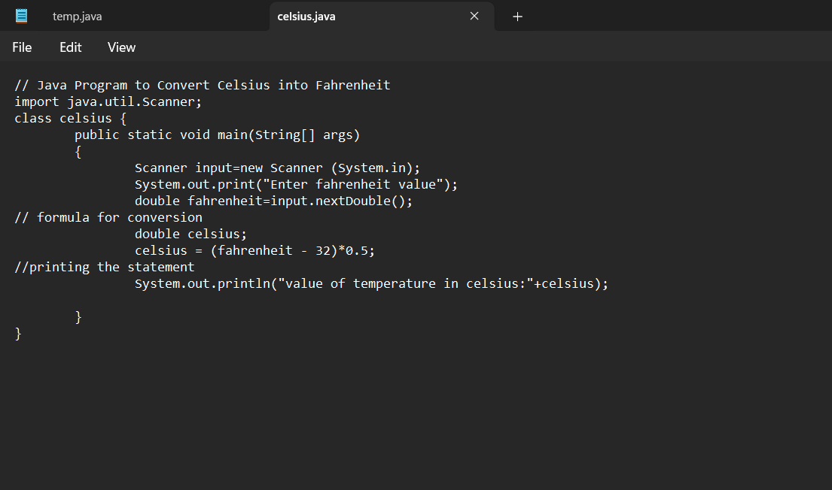
Step 2:open in command prompt and run it.
Step 3: enter the commands as javac celusis <<java Celsius the program is excuted successfully.
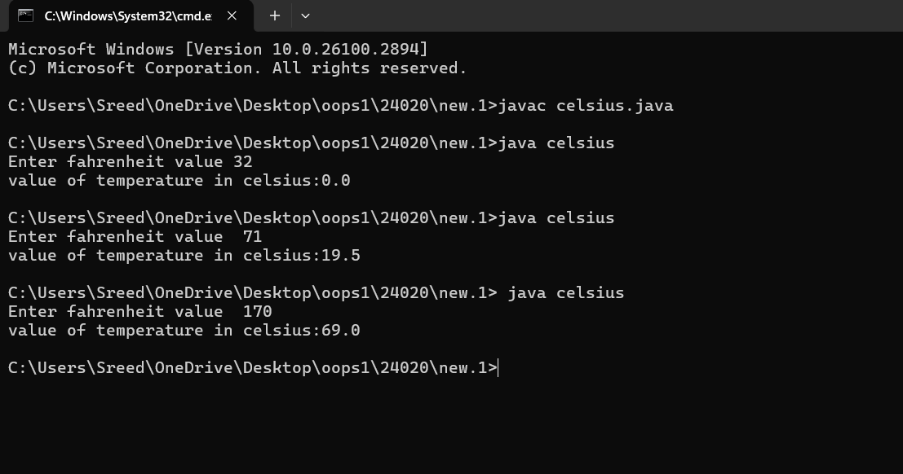

Step 4:After runner the program system automatically creates a class of it.
ERRORS:
S.NO | ERROR MESSAGE | ERROR RECTIFICATION
1. | Error :Celsius file not found | Replaced with Celsius.
2. | Error: “scanner”small letter case sensitive | “Scanner”
IMPORTANT POINTS:
1.Used Scanner library to get input from user in run time.
2.”import java.util.Scanner;”-step to import library.
3.”Scanner input= new Scanner(System.in);”-step to use the scanner.

Program 3:
Aim: To write a java program for calculating simple interest.
Step 1:open notepad<<save the note pad in the path[desktop<<oops<<week 1<<simple_interest.java
Code:
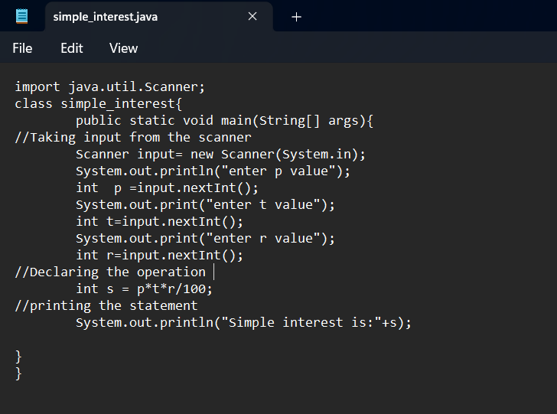
Step 2:Open in command prompt and run it.
Step 3: enter the commands as javac simple_interest <<java simple interest the program is excuted successfully.

Output:
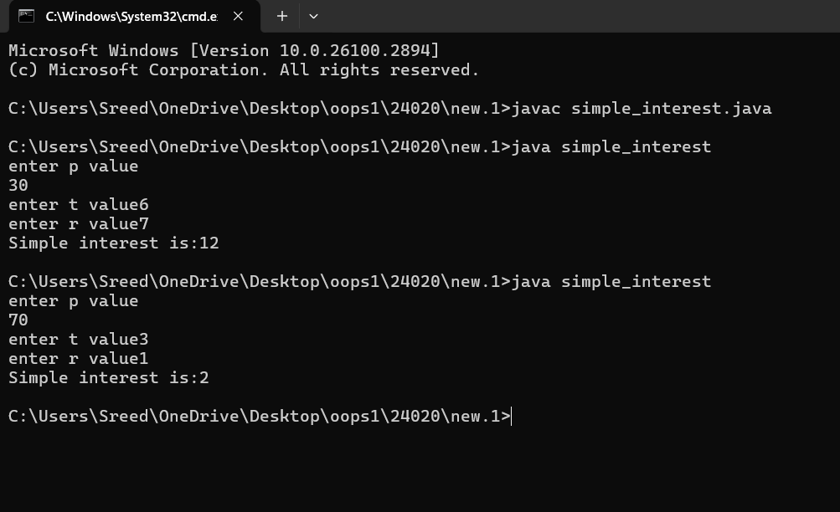
Step 4:After runner the program system automatically creates a class of it.

ERRORS:
S.NO | ERROR MESSAGE | ERROR RECTIFICATION
1. | Error :”T” is not declared | Replaced ”T” with”t”
2. | Error : expected’;’ in line 8 | Insert ‘;’ in line 8 end
IMPORTANT POINTS:
1.java is a case sensitive language so “apple” is different from “APPLE”,so clear declaration of variables is important..
2.”Scanner input= new Scanner(System.in);”-step to use the scanner.
Program 4:
Aim: Writing a java program to find biggest among 3 numbers using ternary operator.
Step 1:open notepad<<save the note pad in the path[desktop<<oops<<week 1<<ternary.java
CODE:
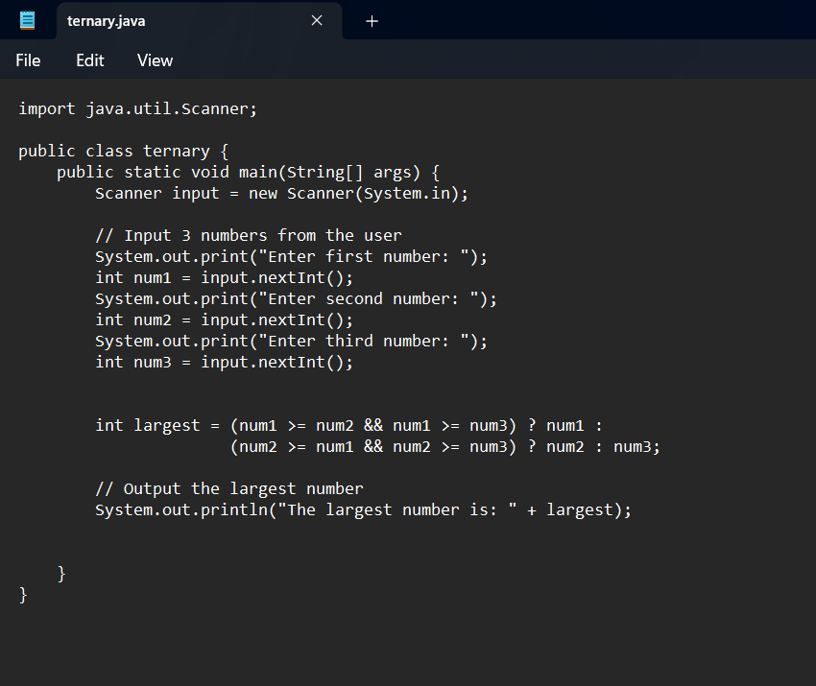
Step 2:Open in command prompt and run it.
Step 3: enter the commands as javac ternary <<java ternary the program is excuted successfully.

Output: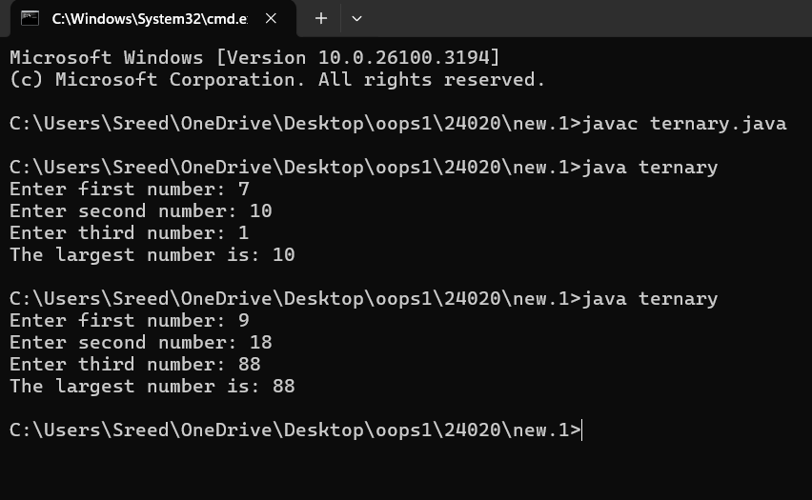
Step 4:After runner the program system automatically creates a class of it.
ERRORS:
S.NO | ERROR MESSAGE | ERROR RECTIFICATION
 | Error :”;” expected in line 6 | Insert”;” in end of line 6
 | Error :”nextint();” non identified | Replace”next.Int();”
IMPORTANT POINTS:
1.Ternary operators: a shorthand for the if-else statement, used to execute condition-based operations in a single line.
2.It evaluates a Boolean condition and returns trueValue if the condition is true, otherwise it returns falseValue.
Program 5:
Aim: Writing a java program for finding factorial of a number.
Step 1:open notepad<<save the note pad in the path[desktop<<oops<<week 1<<fact.java
CODE:
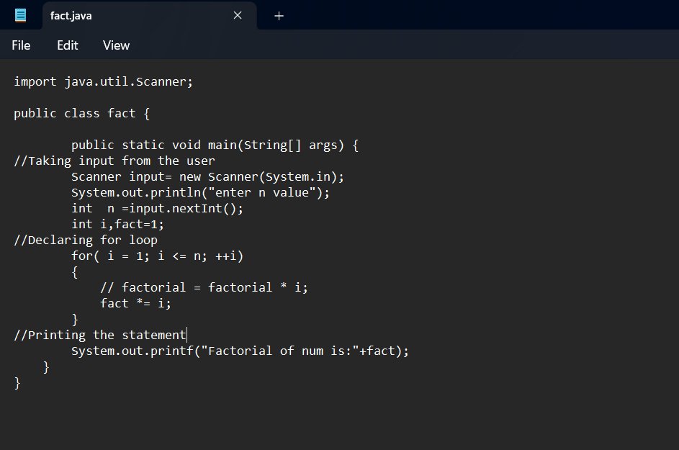
Step 2:Open in command prompt and run it.
Step 3: enter the commands as javac fact <<java fact the program is excuted successfully.

Output:
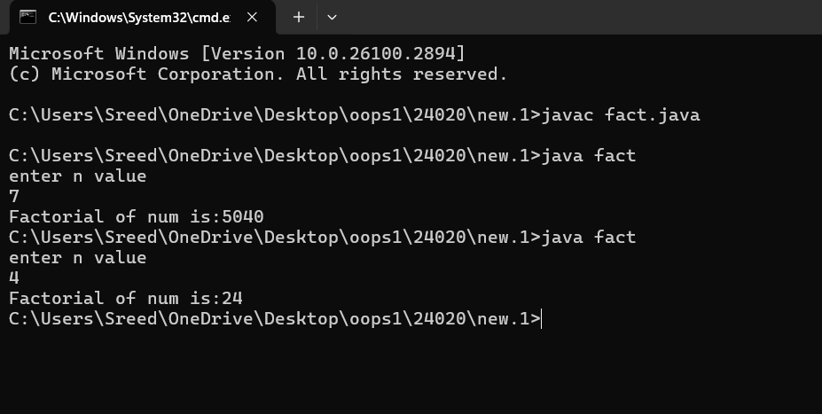
Step 4:After runner the program system automatically creates a class of it.
ERRORS:
S.NO | ERROR MESSAGE | ERROR RECTIFICATION
 | Error: line-9 illegal start of expression | Rebuilt of the line -9
 | Error :iteration error | Correct iteration inserted
IMPORTANT POINTS:
- Java for loop is a control flow statement that allows code to be executed repeatedly based on a given condition.
- The for loop in java provides an efficient way to iterate over a range of values ,execute code multiple times,or traverse arrays and collections.

Week3:
Program 1:
Aim: To write a java program that defines a Car class with attributes, a constructor and methods to perform actions like starting, stopping and servicing a car
Class diagram:

Car
-Name: String
-Colour: String
-Brand: String
-Milage: String
+Car(name,colour,brand milage)
+Start(): void
+Stop():Void
+Service():Void

Step 1: :open notepad<<save the note pad in the path[desktop<<oops<<week 1<<car.java
Code:

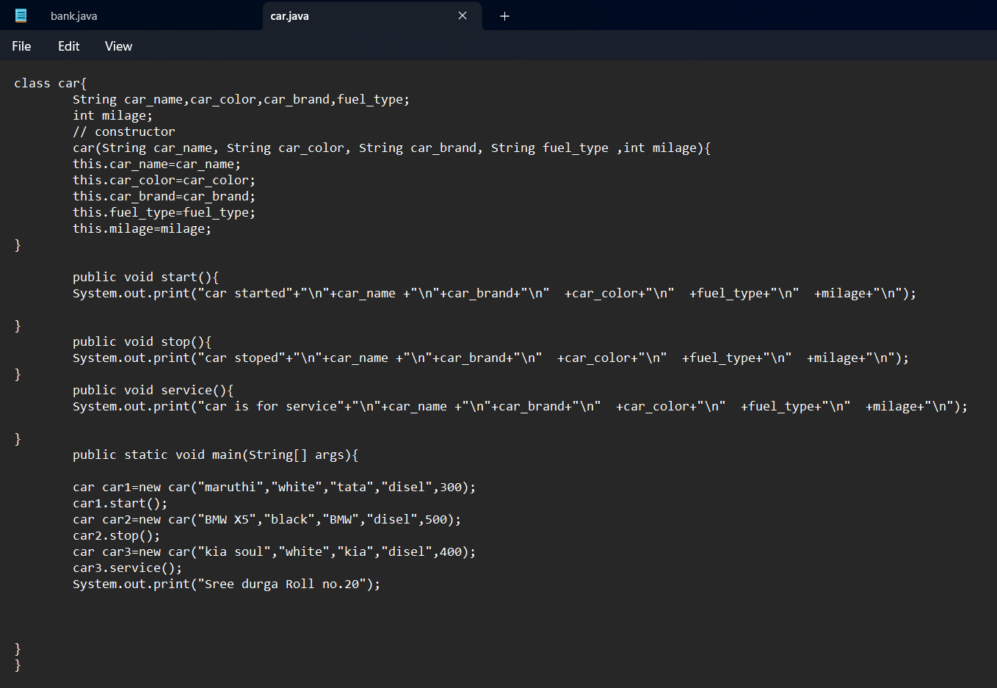
Step 2:Open in command prompt and run it.
Step 3: enter the commands as javac car <<java cars the program is excuted successfully.
Output:
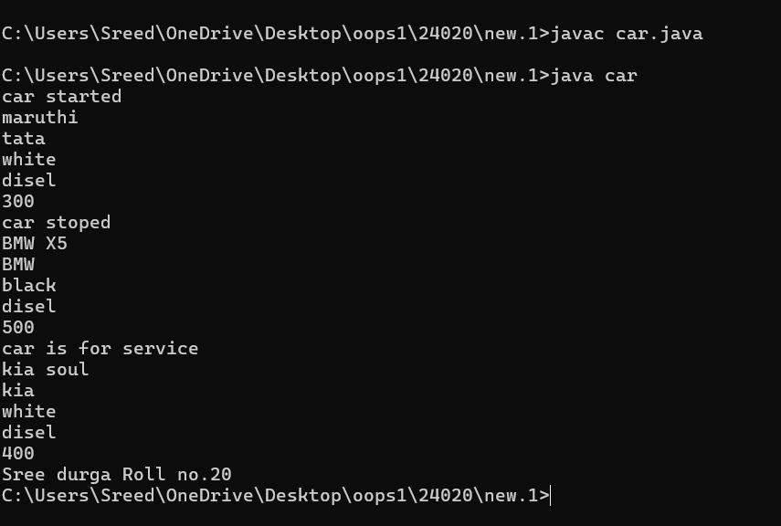
Step 4:After runner the program system automatically creates a class of it.
Errors:
S.NO | ERROR MESSAGE | ERROR RECTIFICATION
 | Error: ',', ')', or '[' expected | Inserted [
 | Error : ; expected in line 6 | Inserted ;
IMPORTANT POINTS:
1. Private Variables: Make the car's properties (like make, model, isRunning) private to keep them safe from direct changes.
2. Constructor: Use a constructor to set the car's details (like brand and model) when you create a new car object.

Program 2:
Aim: To write a java program to create a class named bank account with two methods deposit and withdraw.
Class diagram:
Bank Account
-balance: double
+BankAccount(intialbalance:double)
+deposit(amount:double):void
+withdraw(amount:double):void
+displaybalance():void

Step 1: :open notepad<<save the note pad in the path[desktop<<oops<<week 1<<bank.java
Code:
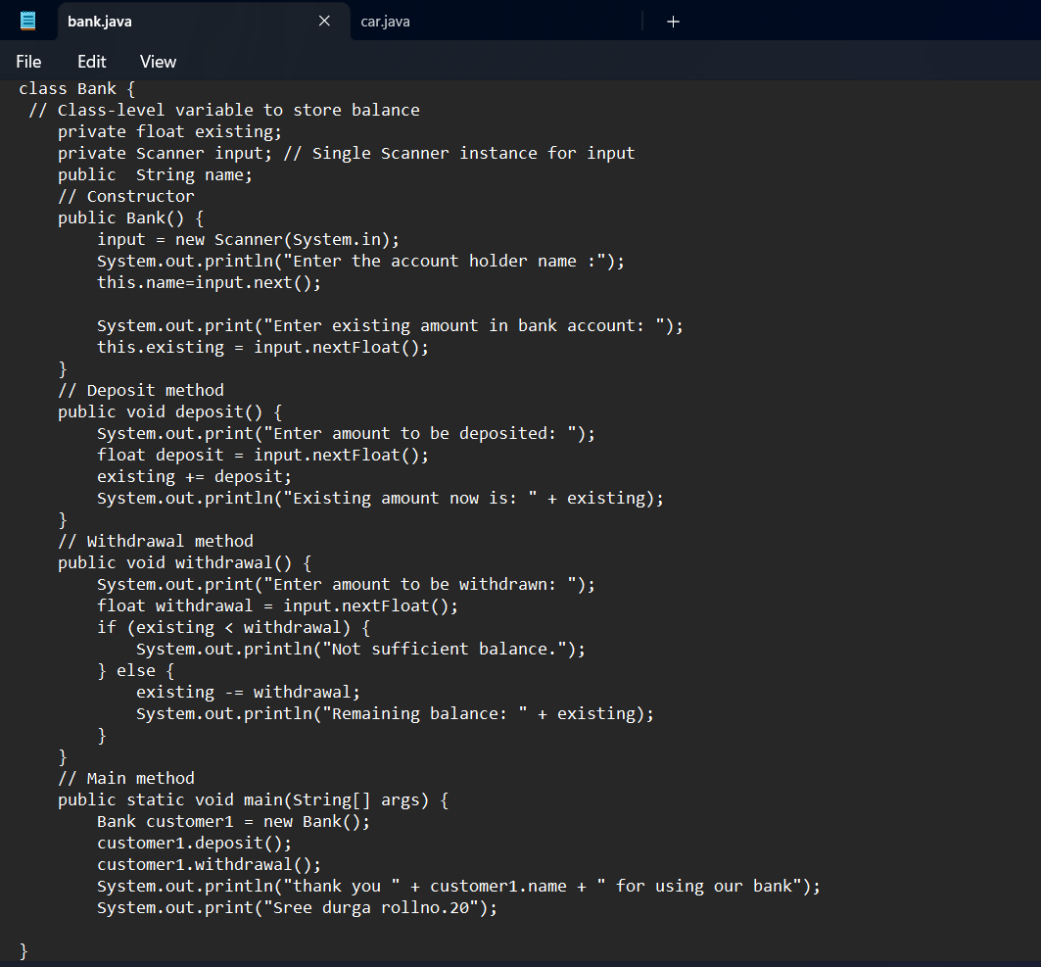

Step 2: copy the path then paste it in command prompt and run it.
Step 3: enter the commands as javac bank <<java bank the program is executed successfully.
Output:
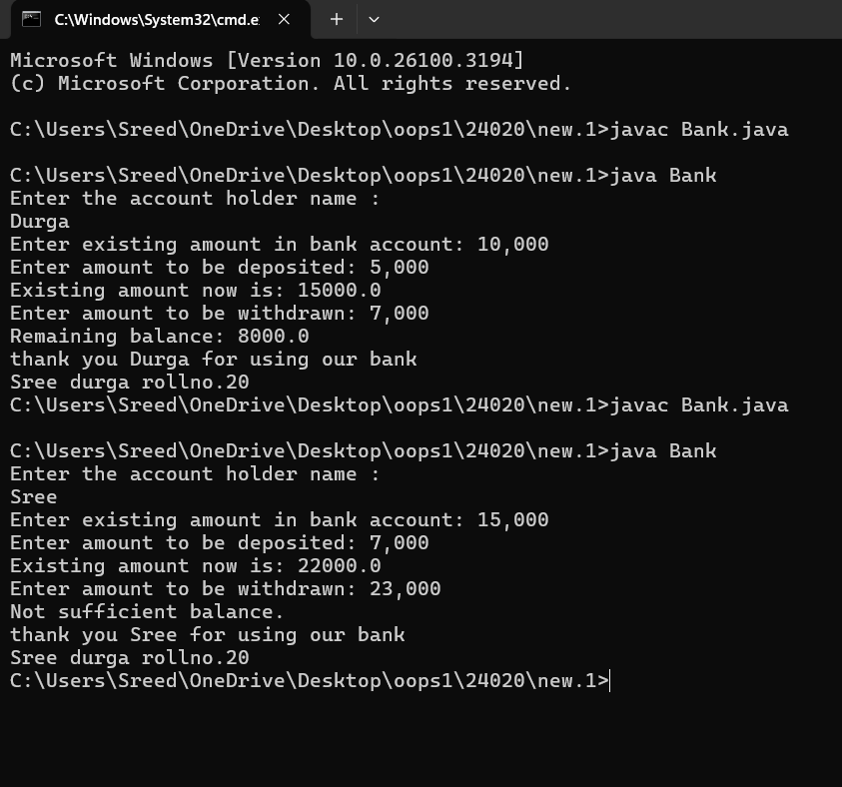
Step 4: After running the program system automatically creates a class of it.
Errors:
S.NO | ERROR MESSAGE | ERROR RECTIFICATION
 | Error: illegal start of expression in line 12. | Rebuilt in line 12
 | Error : Bank.java:37: error: cannot access bank | Replaced b with B.

Important points:
1)A method performs a task with a specific return type and optional parameters.
2) Methods can return a value or be void, and can take parameters as inputs.
Week 4:
Program1:
1)Aim: To write a java program with a class named book .The class should contain various attributes such as “title of book” ,” author ”,”year of publication” .It should also contain a constructor with parameters which intalizes “title of book ”,”author ”,”year of publication ”.Create a method which displays the details of the book it is “title of book ”,”author ”,”year of publication ”.Display the details of two books by creating two objects.
Class diagram:

Book
-title: String
-author: String
Yearofpublished: int
+Book(title,author,yearpublished)
+displaydetails():void

Step 1: :open notepad<<save the note pad in the path[desktop<<oops<<week 1<<book.java

Code:

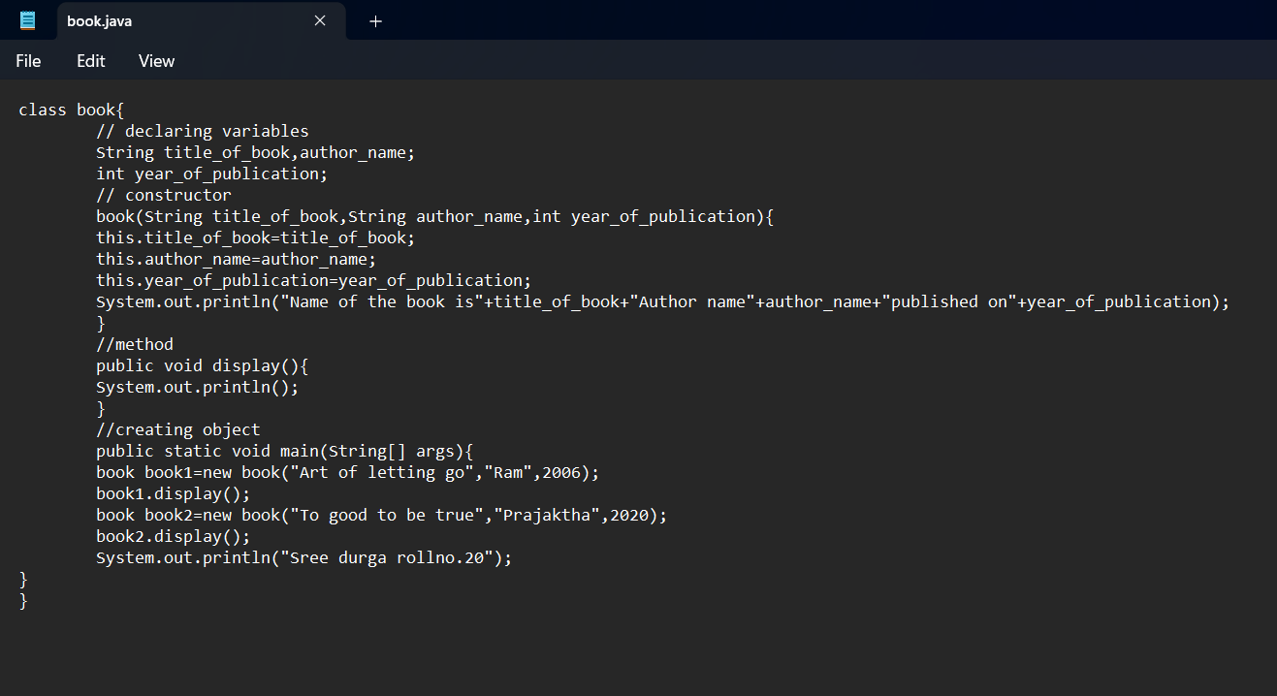
Step 2: copy the path then paste it in command prompt and run it.
Step 3: enter the commands as javac book.java<<java book the program is executed successfully.

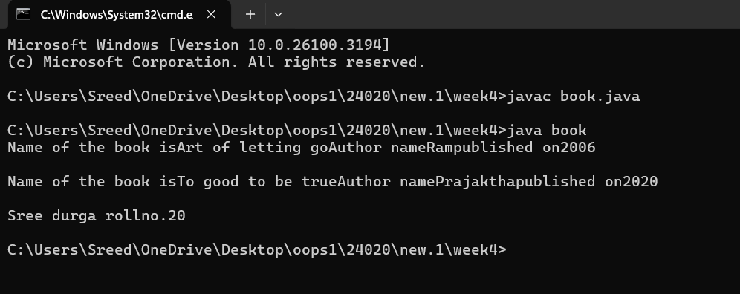
Step 4: After running the program system automatically creates a class of it.
Errors:
S.NO | ERROR MESSAGE | ERROR RECTIFICATION
 | Error: illegal start of expression in line 12. | Rebuilt in line 12
 | Error : Bank.java:37: error: cannot access bank | Replaced b with B.

Important points:
1)A method performs a task with a specific return type and optional parameters.
2) Methods can return a value or be void, and can take parameters as inputs.
3)Static methods belong to the class and can be called without creating an object.

Program 2:
Aim: To write a java program with class named “My class” with a static variable count of int type intalized to zero and a constant variable pi of type double intialized to 3.1415 as attributes of the class. Now define a constructor for my class .That incriments the count variable each time an object is created. Finally print the final values of count and pi variables.
Classdiagram:

Myclass
-static count:int
Final pi:double=3.1415
+Myclass():void
+display():void

Step 1: :open notepad<<save the note pad in the path[desktop<<oops<<week 1<<My_class.java
Code:

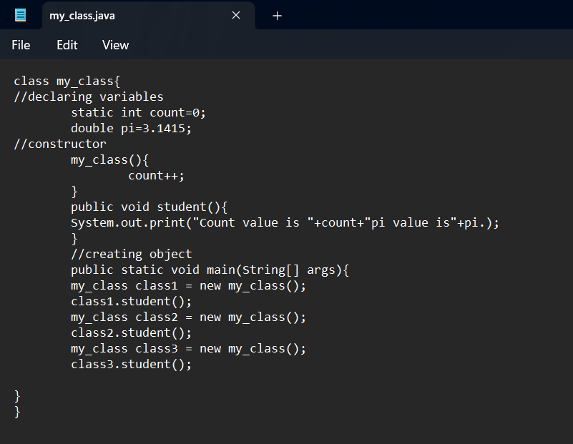
Step 2: copy the path then paste it in command prompt and run it.
Step 3: enter the commands as javac my_class.java<<java my_class the program is executed successfully.

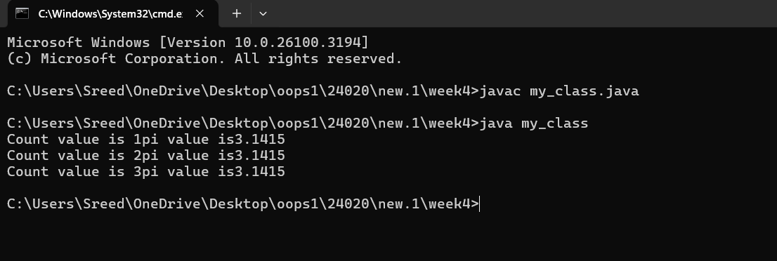
Step 4: After running the program system automatically creates a class of it.
Errors:
S.NO | ERROR MESSAGE | ERROR RECTIFICATION
 | Error: <identifier> expected  my_class class = new my_class(); | Replaced class with class2
 | Error : illegal start of expression  public void student(){ | Included }

Important points:
1) Static variables are shared across all instances, while final variables are constants whose values cannot be changed.
2)Constructors are used to initialize objects, and they can modify static variables like count to track object creation.
3)Static methods can access static variables directly, but instance methods require an object to access instance variables.
WEEK-5:
Program-1:
Aim :Write a java program to create a calculator using multilevel inheritance
Class diagram:
+-------------------+
| Calculator |
+-------------------+
| - a: int |
| - b: int |
+-------------------+
| + add(a: int, b: int): int |
| + subtraction(a: int, b: int): int |
| + multiplication(a: int, b: int): int |
| + modulo(a: int, b: int): int |
+-------------------+
^
| (Inheritance)
|
+-----------------------+
| AdvancedCalculator |
+-----------------------+
| + power(a: int, b: int): int |
| + square(a: int): int |
| + cube(a: int): int |
+-----------------------+
^
|
|
+-------------------------+
| CalculatorDemo |
+-------------------------+
| + main(args: String[]): void |
+-------------------------+

Step 1: :open notepad<<save the note pad in the path[desktop<<oops<<week 1<<Calculatordemo.java
Code:
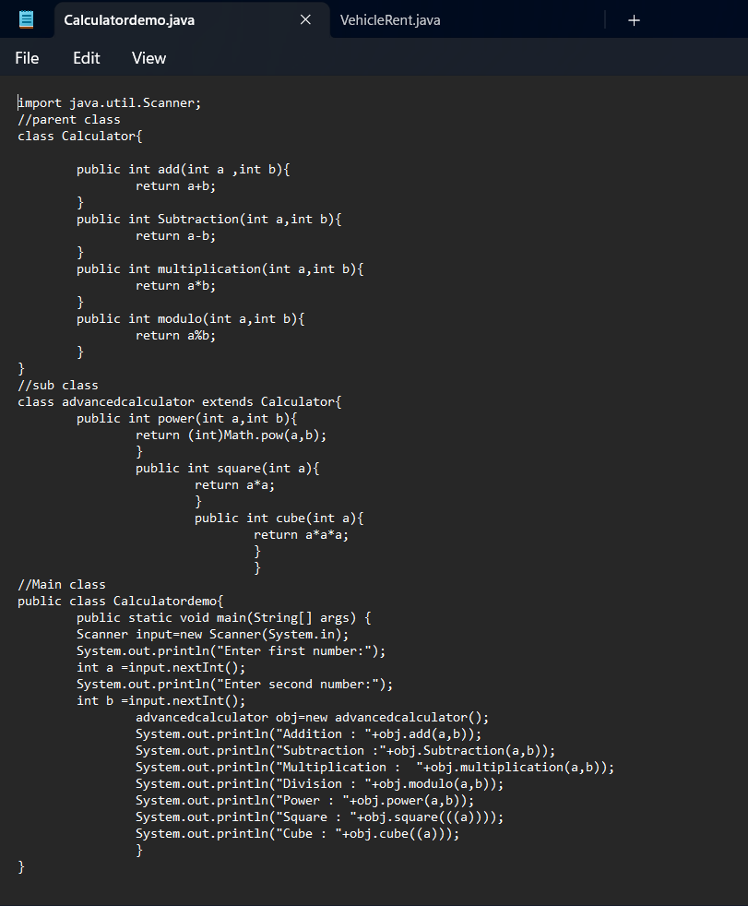
Step 2: copy the path then paste it in command prompt and run it.
Step 3: enter the commands as javac Calculatordemo.java<<java Calculatordemo the program is executed successfully.

Output:
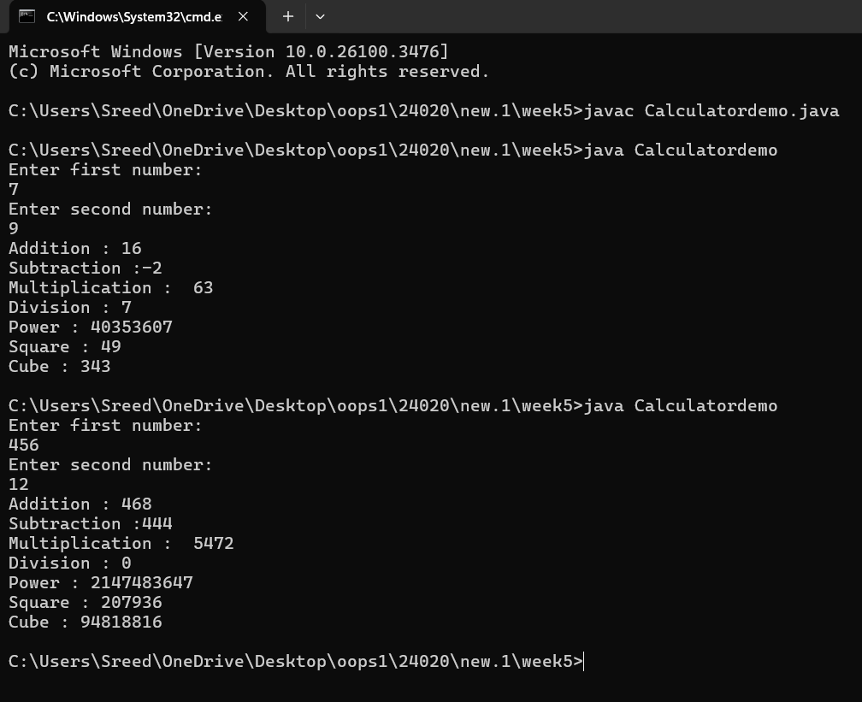

Step 4: After running the program system automatically creates a class of it.
Errors:
S.NO | ERROR MESSAGE | ERROR RECTIFICATION
 | Error: Expected Symbol “;” in line 40 | Inserted ;
 | Error : Incoorect expression “extend” | Replaced with extend
Important points:
1)Ensure each method in the Calculator and AdvancedCalculator classes has the correct signature. For example, methods should take two integers (or other types depending on the operation) as parameters.
2) The AdvancedCalculator class correctly inherits from the Calculator class, which is a good use of inheritance. This allows you to reuse common functionality like addition, subtraction, etc., while adding specific functionality like power, square, and cube.
Program 2:
Aim: Write a java program for vehicle renter company to store details about each vehicle such as brand and speed.
Class diagram:
| Vehicle |
| - brand: String |
| - speed: int |
| + displayDetails(): void |
▲
│
----------------------------------------------------------------------------------------------------------
| | |
+------------+ +------------+ +------------+
| Car | | Bike | | Truck |
+------------+ +------------+ +------------+
| - numOfDoors: int |
- hasGears: boolean |
| - capacityInTons: double |
| - seatingCapacity: int |
+------------+ +------------+ +------------+
| + displayDetails(): void |
+ displayDetails(): void |
+ displayDetails(): void |
+------------+ +------------+ +-----------+

Step 1: :open notepad<<save the note pad in the path[desktop<<oops<<week 1<<VehicleRental.java

Code:
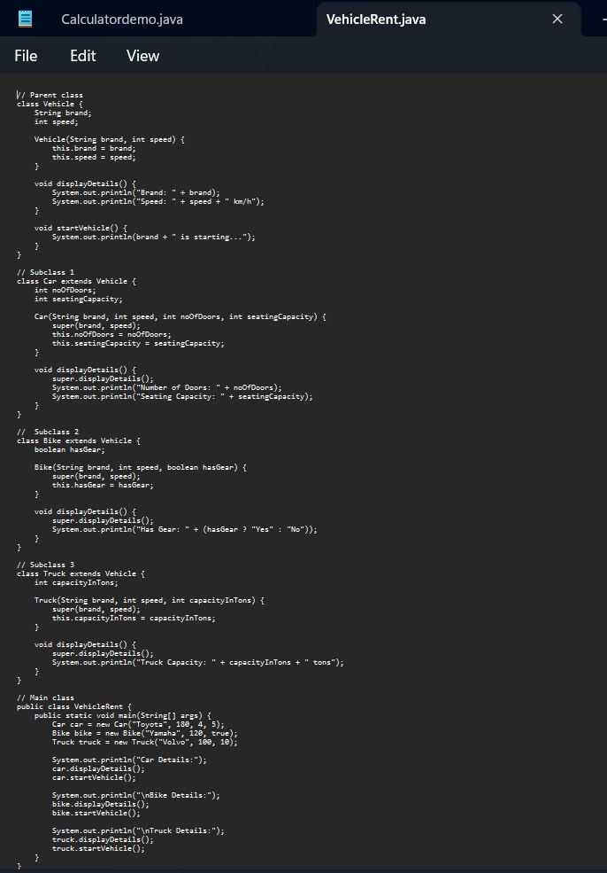
Step 2: copy the path then paste it in command prompt and run it.
Step 3: enter the commands as javac VehicleRental.java<<java VehicleRental the program is executed successfully.
Output:
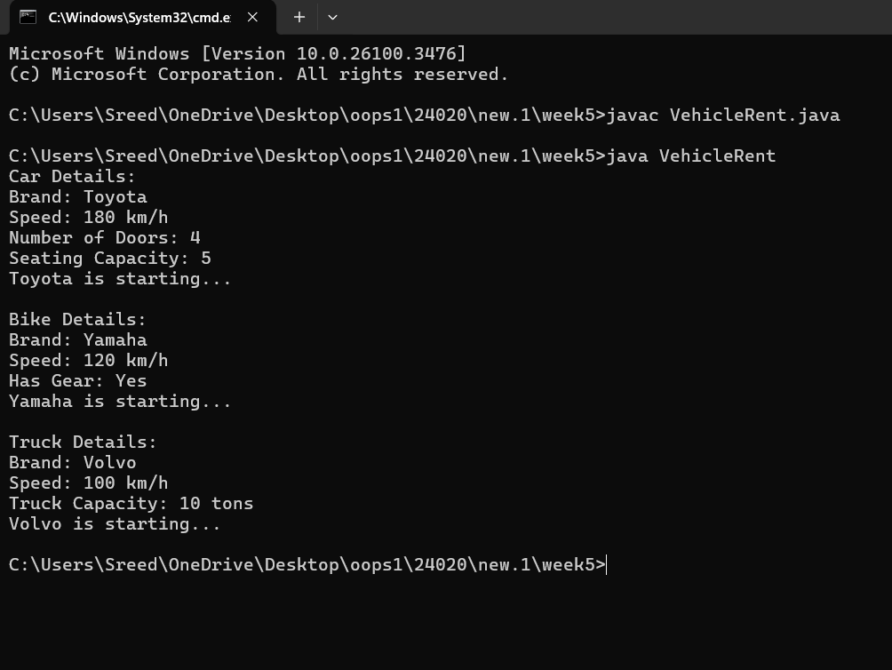

Step 4: After running the program system automatically creates a class of it.
Errors:
S.NO | ERROR MESSAGE | ERROR RECTIFICATION
 | Error: Incorrect method call | Inserted ()
 | Error : Cannot found file name | Replaced Vehiclerental with VechicleRental

Important points:
1) If you have different types of vehicles (e.g., Car, Bike, Truck), you can create subclasses that extend the Vehicle class. This allows you to reuse code and add specific features to each vehicle type.
2)You create objects of the Vehicle class or its subclasses to store details about specific vehicles. For example, you might create a Car object with a brand and speed.

