Prepositions

Exercise 1

Listen to the audio and answer the following questions.

1. Where did the traveller want to go?

1. What did the taxi driver think of doing to earn more money?

1. Write down directions to office from your house. Remember to mention every turn that you take.

Exercise 2

Fill in the blanks with the appropriate prepositions.

1. Temperance and employment are conducive _to____ health.
2. Dogs have antipathy _towards___ cats.
3. He promised not to do anything-repugnant _of_ the wishes of his parents.
4. He is not the man to allow anyone to encroach __upon__ his rights.
5. Some of the members of the Assembly complained __about___ increased military expenditure.
6. Even the enemies admit that he is endowed _with__ rare talents.
7. Our path is beset _of__ difficulties.
8. He has been very much indulgent ____ his children.
9. This discussion is hardly relevant __for__ the subject.
10. He is not likely to do anything detrimental __to___ our interests.
11. His benefactions must rebound __on___ his credit.
12. He is capable as a leader, but intolerant __as___ opposition.
13. Boys over sixteen are debarred __of___ competing.
14. Father Damien consecrated his life __for___ ameliorating the lot of lepers.
15. He is willing to make a concession __to___ the demands of his employees.
16. The authorship of the book is wrongly ascribed __to___ him.
17. Never do anything that is not compatible _____ public safety.
18. His father often connives _____ his follies.
19. The wild boar abounds ___in____ some parts of Europe.
20. The godown is infested ___with____ rats.

Exercise 3

Use the image below to answer the questions that follow.

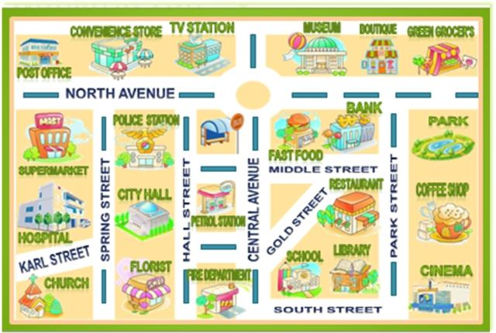

j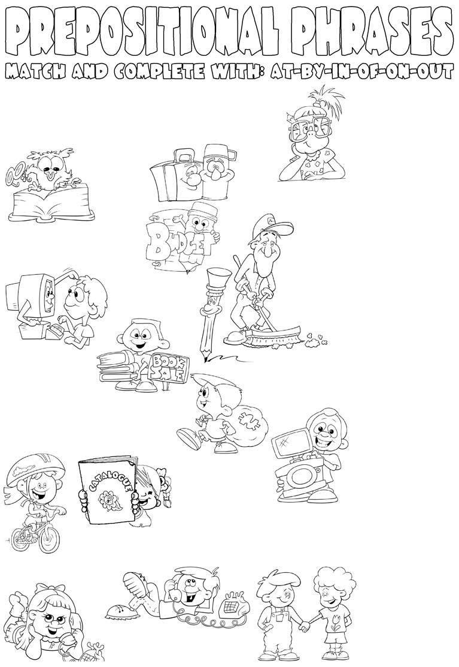

Please get this discussion _____ track. My time is limited.

______ the whole, I think my dinner party was a success.

Are you going ____ bike or ____ foot?

The question seemed easy _______ first sight, but when the students tried to answer it, they discovered how difficult it was.

Staying _____budget can be even harder.

A letter came today, totally ________ the blue, from a lawyer who said that an uncle I hadn't heard from in years had died and left me a million dollars.

Learn more about our ___ demand product and services from the new catalogue.

_____ terms of money,

I was better off in my previous job.

An outstanding camera _______

a reasonable price ______ the basis _____ good quality.

We put our wedding plans ____ hold until we finished school.

I left Jack _____ charge of the suitcases while I went to get the tickets.

If you're going to come, please let me know _____ advance.

My AVG is _______date! Remember to check for new updates regularly.

The new edition has already been ______ stock.

All bookings must be confirmed _____ writing.

1. being responsible for
2. running or walking using the feet
3. at any time   
   that you want or need something
4. too old and therefore not useful or correct any more
5. in written form rather that spoken
6. before   
   a particular time
7. regarding something
8. (not) available and ready for sale
9. within anticipated costs
10. seen for   
    the first time
11. fair considering quality
12. considering everything
13. waiting; temporarily halted
14. unexpectedly
15. on schedule; progressing as planned