Couse:devops Name:T.Sreenivasulu

Assignment:5 email.srinuthippanaboina@gmai.com

TOPIC:VPC

VPC(virtual private cloud)

Create vpc

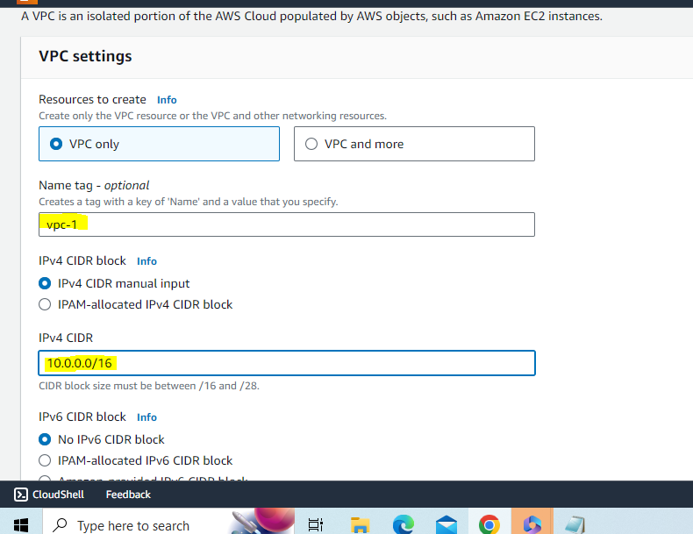

Create 2 subnets(s1-public ,s2-private)

Attach your vpc what you created in subnets

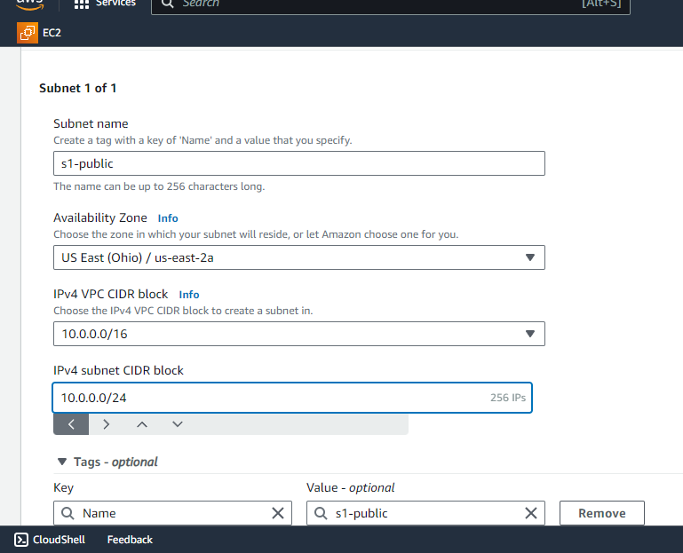

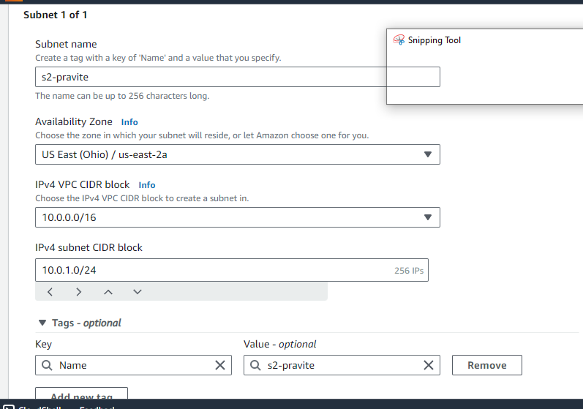

Create two route tables(route1,route2)

Attach vpc what you created in route tables

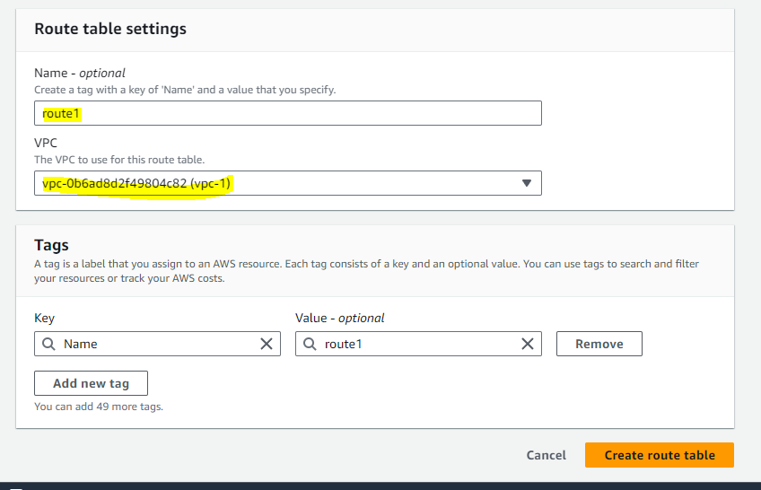

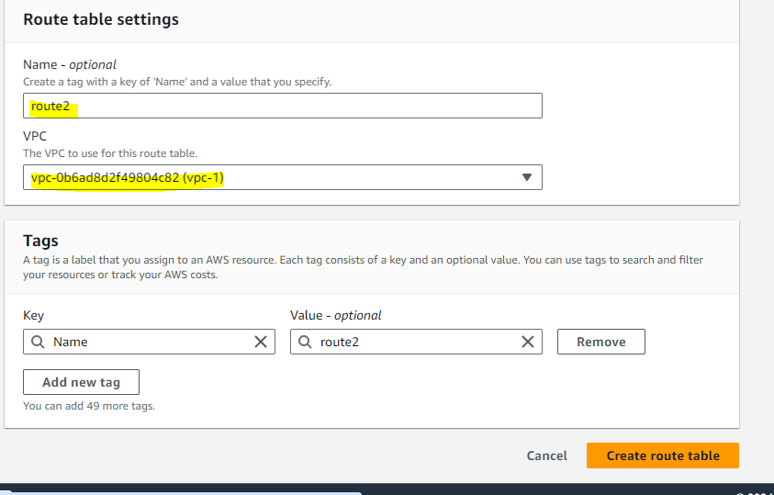

Create one internet gateway

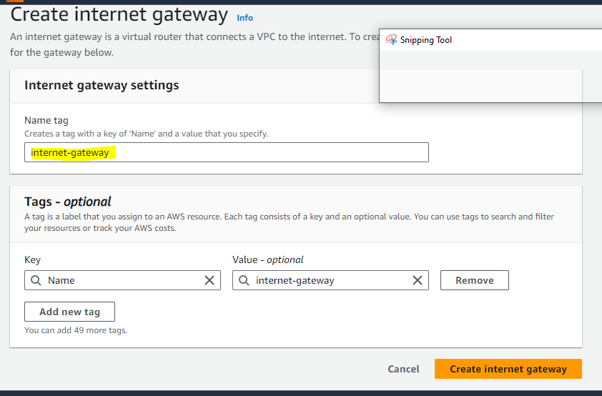

Create NAT gateway

In creating

1.NAT gateway we have to connect to s1-public(subnet1)

2.also allocate elastic IP

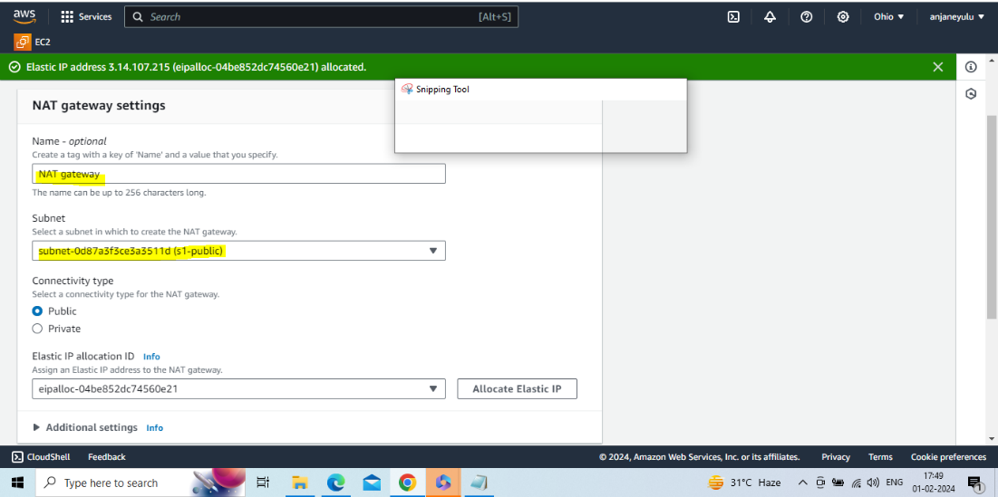ed

Attach internet gateway to vpc(what you created vpc)

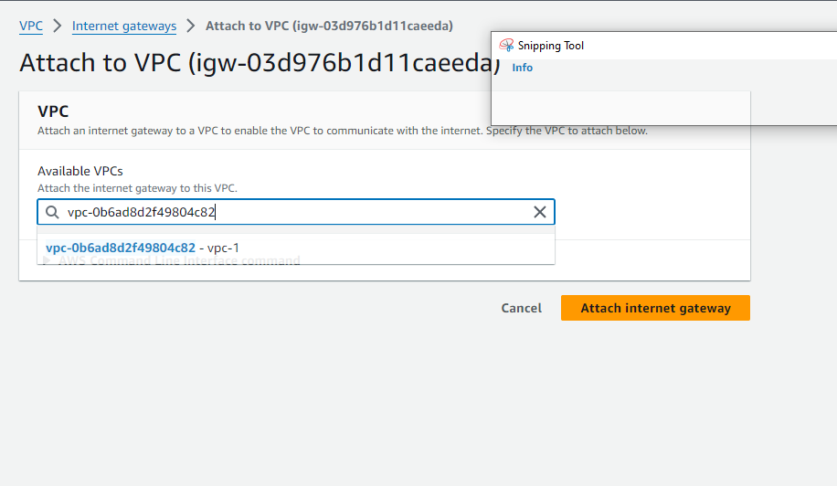

Attach internet gateway to route1

Route1-->actions-->edit rutes-->add route -->target : internet gateway ,select what you created internet gateway --> save changes

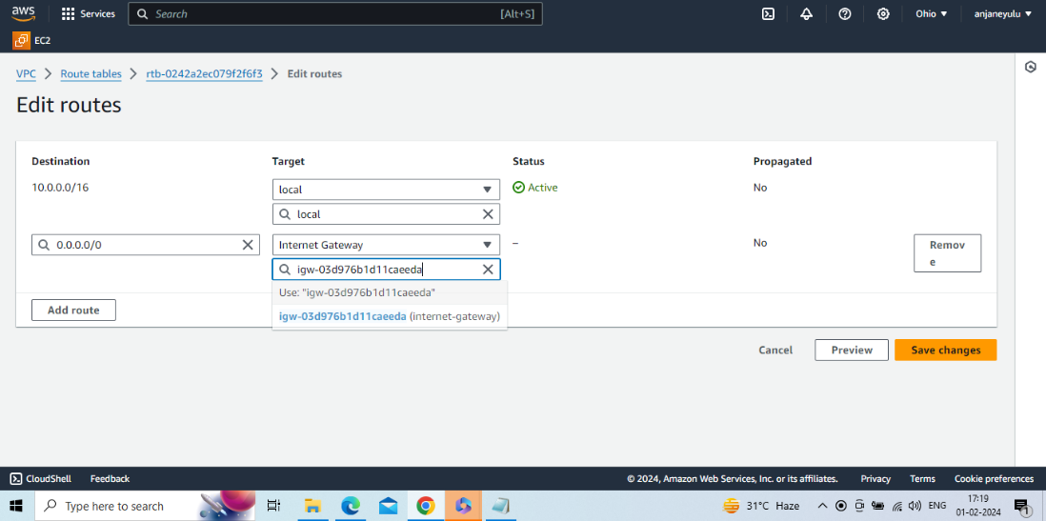

Attach route2 with s1-public(subnet1)

Route1-->actions-->edit subnet associations-->select s1-public-->save associations

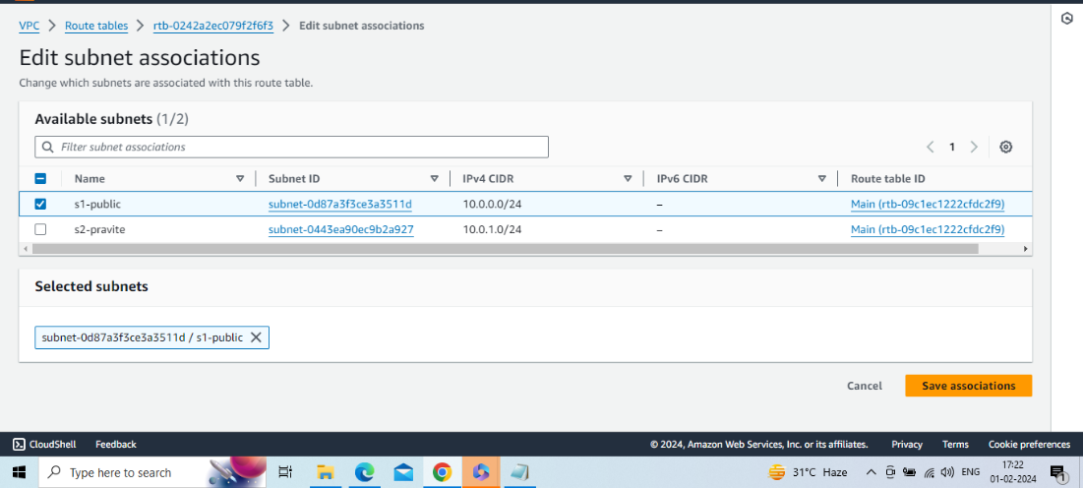

Attach NAT gateway with route2(s2-private)

Route2-->actions-->edit routes-->add route-->target : NAT gateway ,select what you created NAT gateway--> save changes

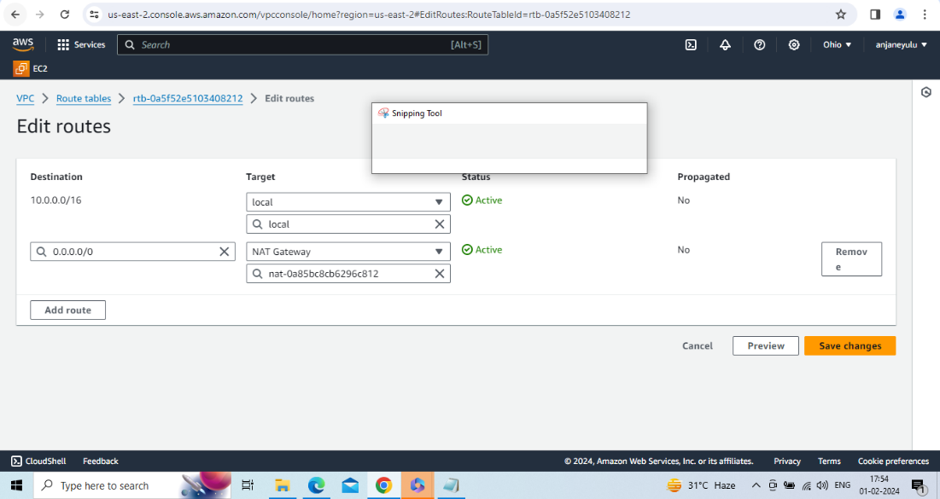

Attach route2 with s2-private(subnet2)

Route2-->actions-->edit subnet associations-->select s2-private-->save associations

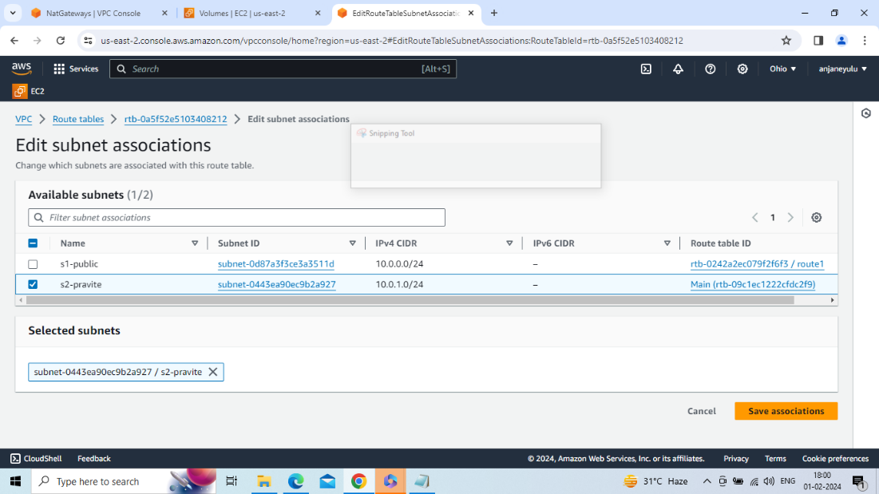

Create and launch two instances

1.ec2-public 2.ec2-private

1.ec2-public

In network settings select what you created vpc and s1-public subnet and then launch instance

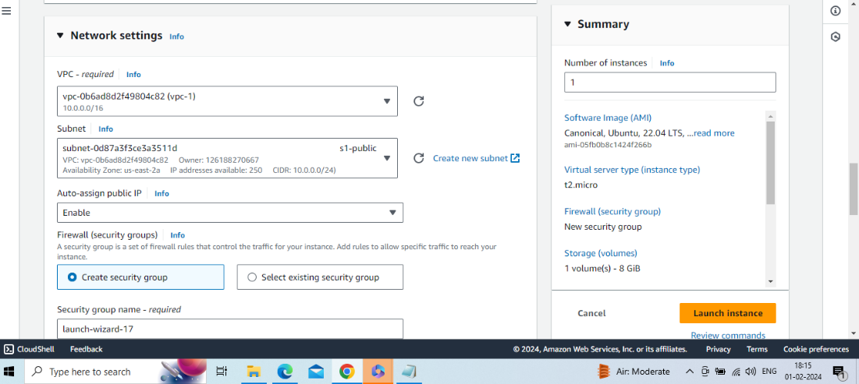

Connect to ubuntu server with ec2-public instance

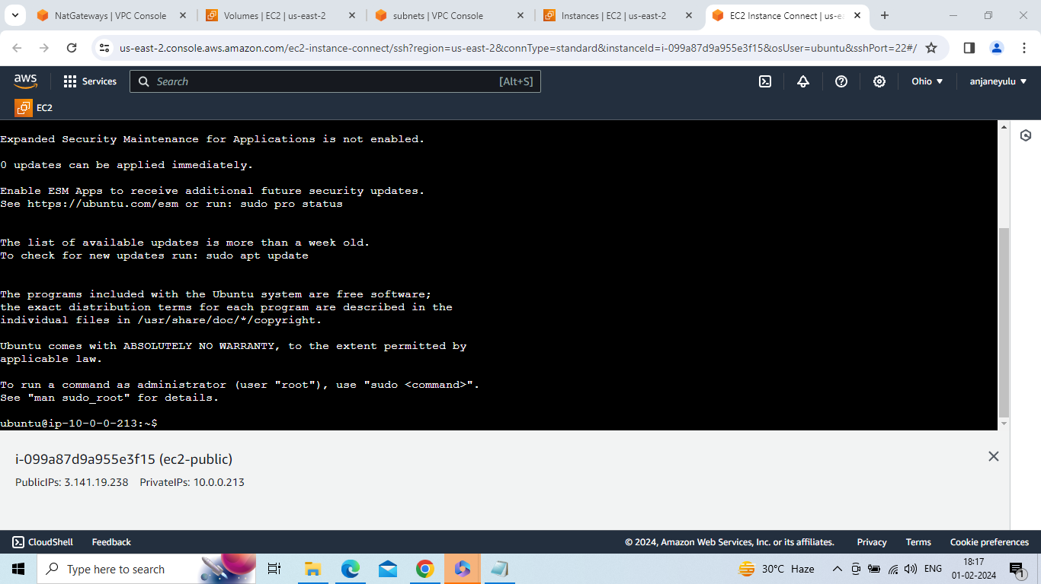

1.ec2-pravite

In network settings select what you created vpc and s2-private subnet and then launch instance

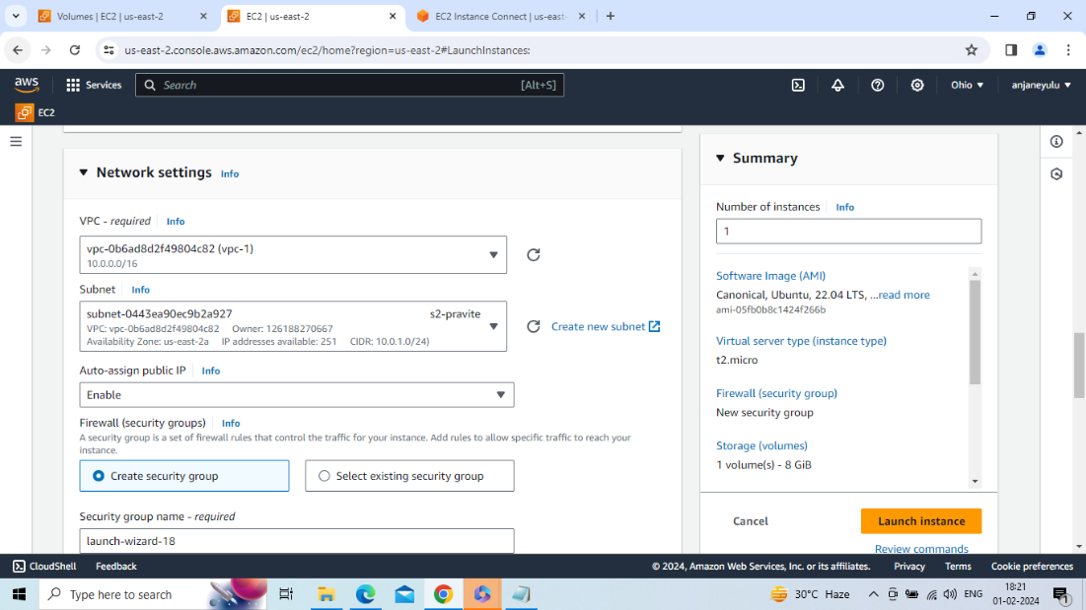

Connect to ubuntu server with ec2-private instance(but it is not connected to ubuntu server because it is private and there is no connection of internet gateway

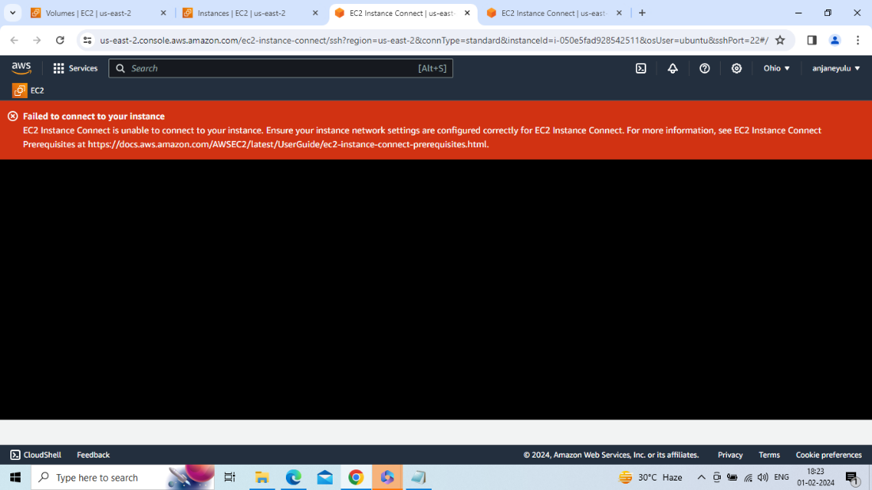

We see how to connect with ec2-private instance

Only One way available to connect ec2-private instance -->create one file(devi.pem) in ec2-public instance and copy and paste data from devi.pem file --> give all permissions to devi.pem file(chmod 400 "devi.pem")-->ssh –i “devi.pem” [ubuntu@10.0.1.252 (private](mailto:ubuntu@10.0.1.252(private) ip of ec2-private instance)-->then automatically connect to ec2-private instance

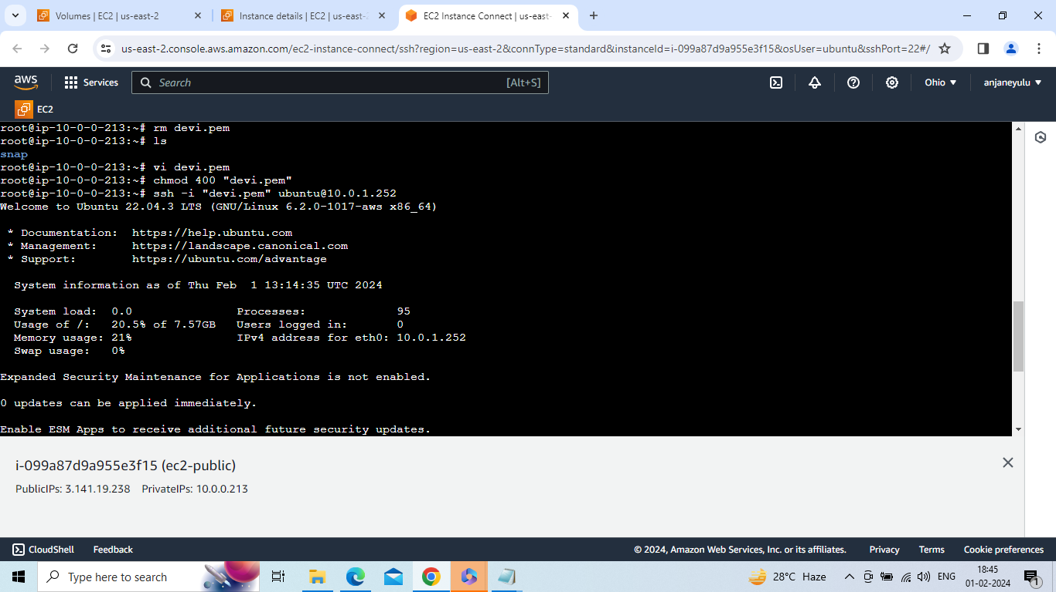

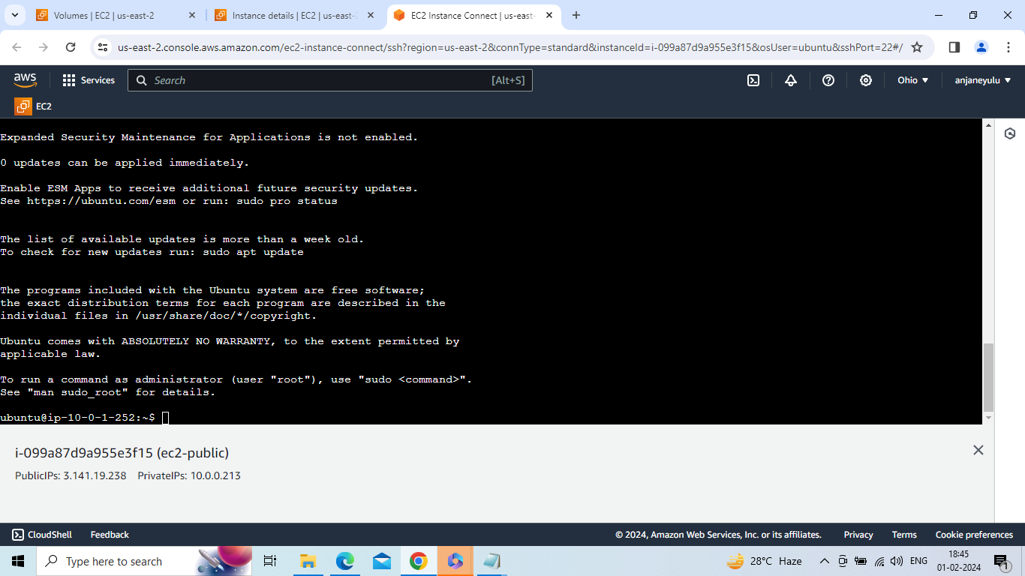

Check ping facebook.com is working or not in ec2-private instance

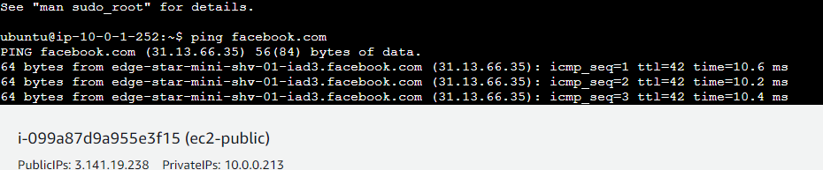

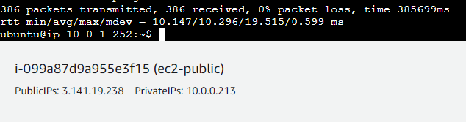

Check git clone working or not in ec2-private instance

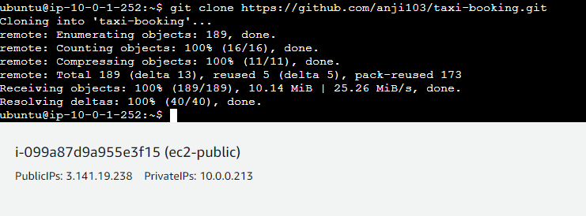

Check linux commands is working or not in ec2-private instance

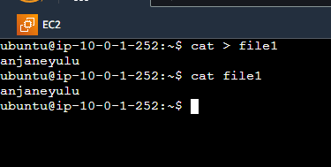

Check ping facebook.com is working or not in ec2-public instance

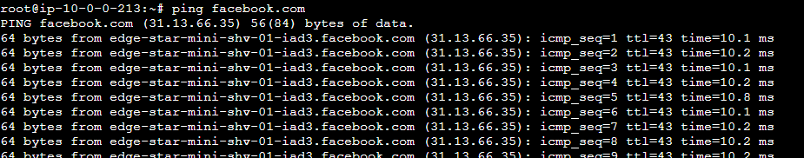

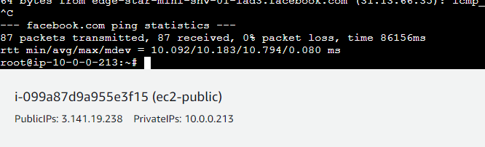

Check git clone working or not in ec2-public instance

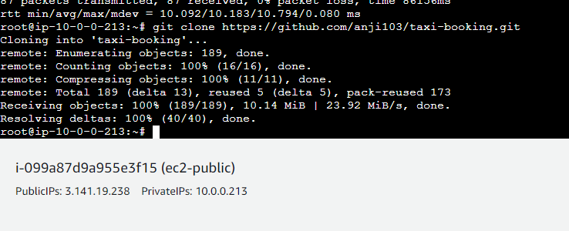

Check linux commands is working or not in ec2-public instance

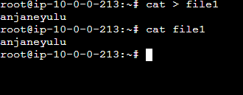

Note :

1.VPC(what you created) is used to create your own private IP

2.ec2-public instance is working like a normal ubuntu server because we attach internet gateway to VPC (what you created).In ec2-public instance all coommands are working like linux,git,maven,jenkins,docker,ansible,kubernetes,terraform

3.ec2-private instance is working like anormal ubuntu server because we attch NAT gateway to route2(route table 2) and route table is connected with VPC(what you created).

In ec2-private instance all coommands are working like linux,git,maven,jenkins,docker,ansible,kubernetes,terraform