Topic: k8s-cicd name:t.sreenivasulu

Course:devops email:sreenivasulut2000@gmail.com

Batch:116

1.launch ec2 instance

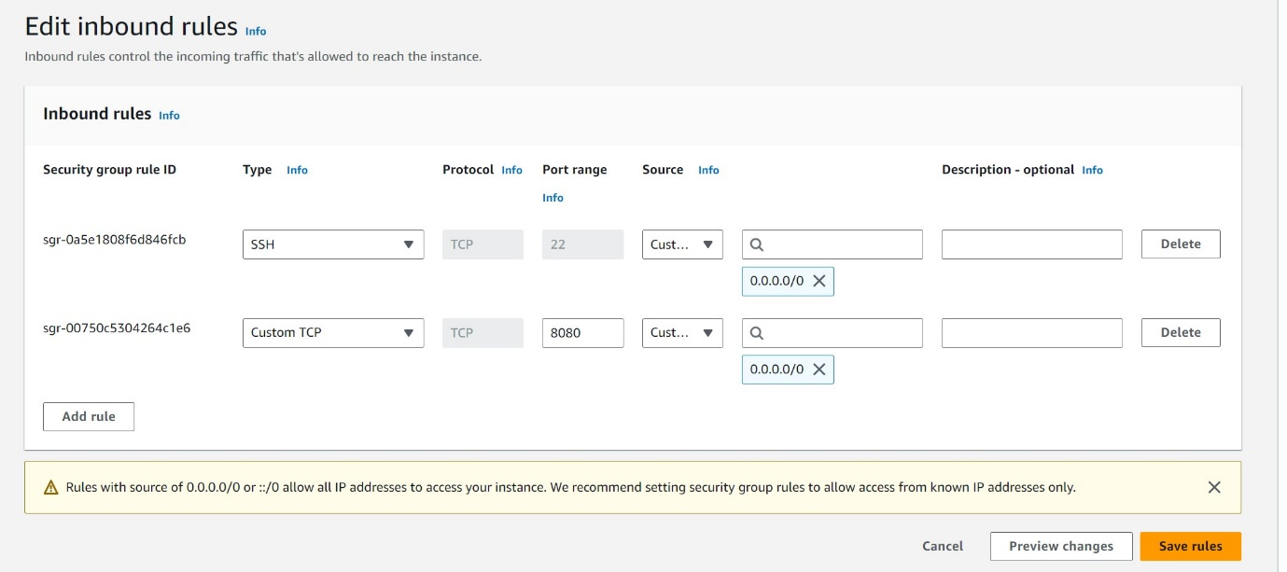

2.create IAM role , [AdministratorAccess](https://us-east-1.console.aws.amazon.com/iam/home?region=ap-south-1#/policies/details/arn%3Aaws%3Aiam%3A%3Aaws%3Apolicy%2FAdministratorAccess)

3.after ec2 instance modify IAM role 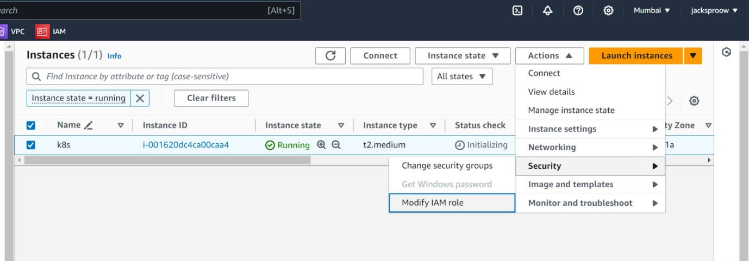

4.ec2 instance coonect after bellow commands use

apt update -y && apt install awscli -y && apt install default-jdk -y && apt install maven -y

5. ## Install EKS CTL tool

## Install EKS CTL tool

curl --silent --location "https://github.com/weaveworks/eksctl/releases/latest/download/eksctl_$(uname -s)_amd64.tar.gz" | tar xz -C /tmp

sudo mv /tmp/eksctl /usr/local/bin

eksctl version

6. ## install kubectl for compatability version eg : mine is using 1.21.14

curl -LO https://dl.k8s.io/release/v1.21.14/bin/linux/amd64/kubectl

sudo install -o root -g root -m 0755 kubectl /usr/local/bin/kubectl

kubectl version –client

7. ## Create an EKS cluster with empty node group

eksctl create cluster --name=jacksproow --region=ap-south-1 --version 1.24 --zones=ap-south-1a,ap-south-1b --without-nodegroup

8. ## Create Node Group with additional Add-Ons in Public Subnets

eksctl create nodegroup --cluster=jacksproow \

--region=ap-south-1 \

--name=jacksproow-ng-public1 \

--node-type=t3.small \

--nodes=2 \

--nodes-min=2 \

--nodes-max=4 \

--node-volume-size=8 \

--ssh-access \

--ssh-public-key=key \

--managed \

--asg-access \

--external-dns-access \

--full-ecr-access \

--appmesh-access \

--alb-ingress-access

9.jenkins download:

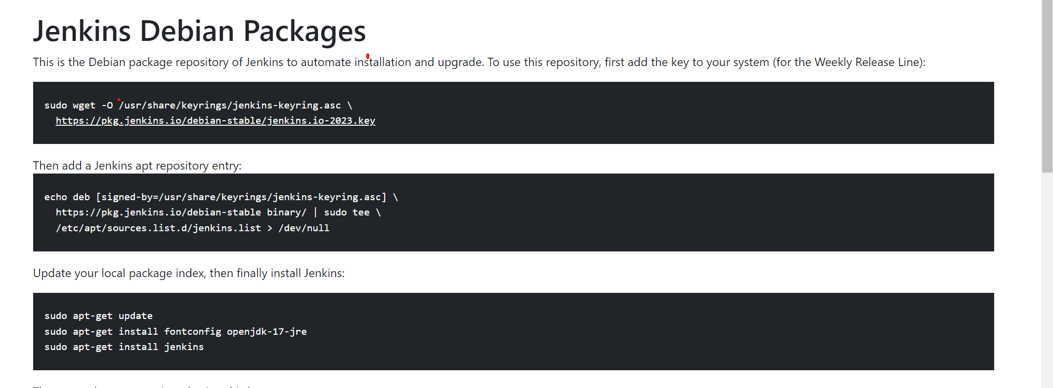

10.public ip -port number (past dashboard)

13.200.252.130:8080

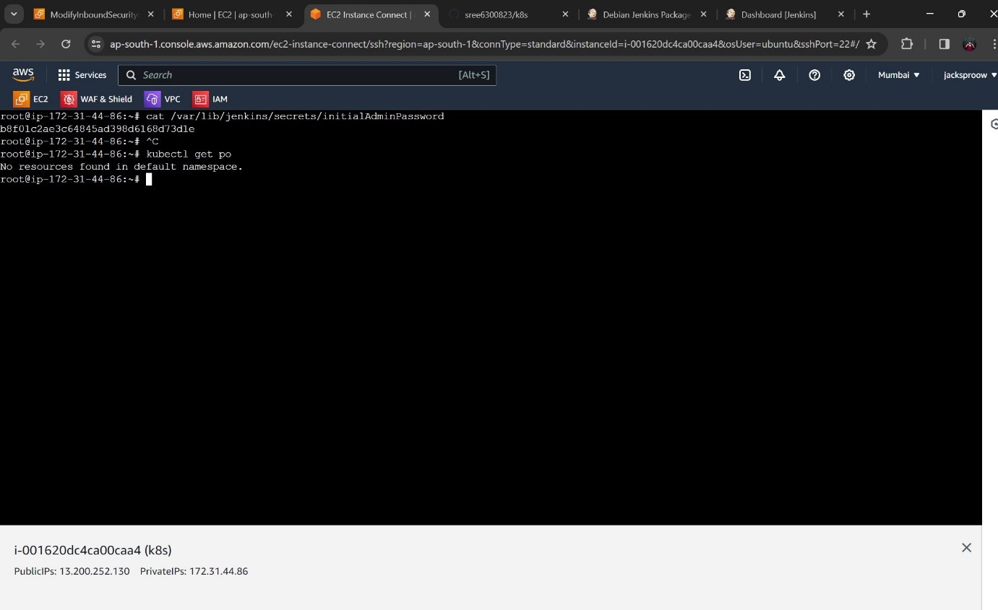

11.after Jenkins dashboard

Click on manage jenkins -🡪install plugins --🡪 [Kubernetes CLI](https://plugins.jenkins.io/kubernetes-cli)

* Create 1 job pipeline

pipeline {

agent any

stages {

stage('k8s') {

steps {

sh 'aws eks update-kubeconfig --region ap-south-1 --name jacksproow'

}

}

stage('clone') {

steps {

git branch: 'main', credentialsId: 'admin', url: 'https://github.com/sree6300823/k8s.git'

sh 'kubectl get pods'

sh 'kubectl apply -f pod.yml'

sh 'kubectl apply -f deployment.yml'

sh 'kubectl apply -f replicaset.yml'

sh 'kubectl apply -f pod_cip.yml'

sh 'kubectl apply -f pod_np.yml'

sh 'kubectl apply -f pod_lb.yml'

}

}

}

}

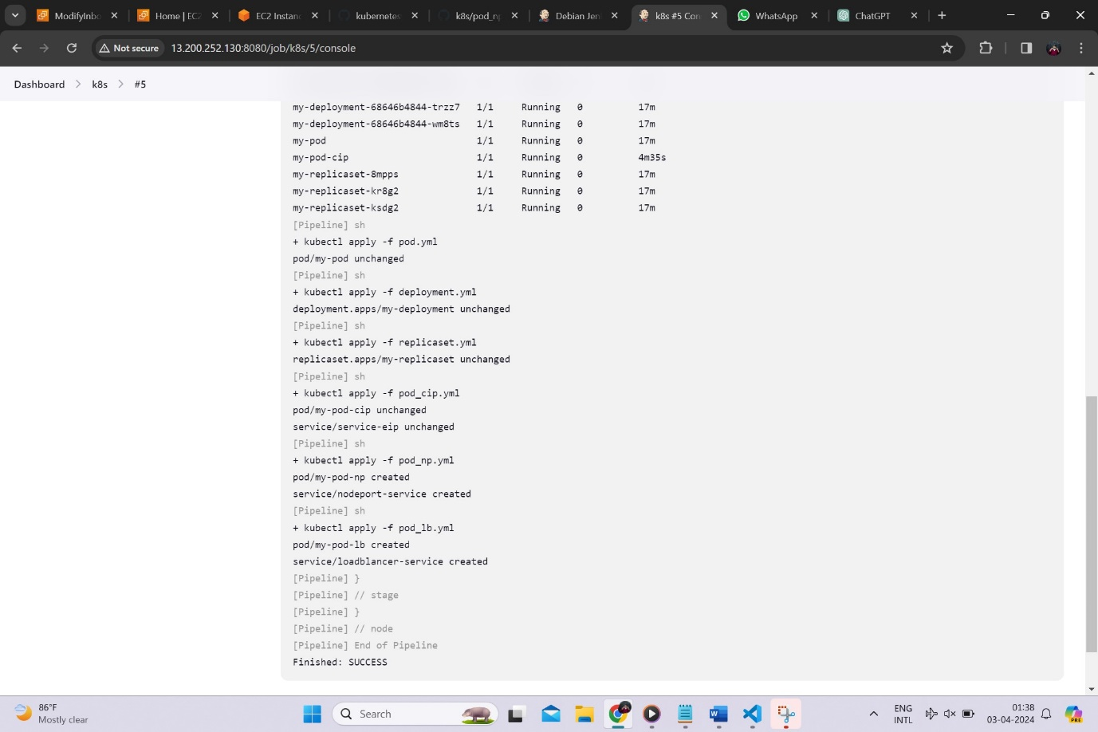

Success

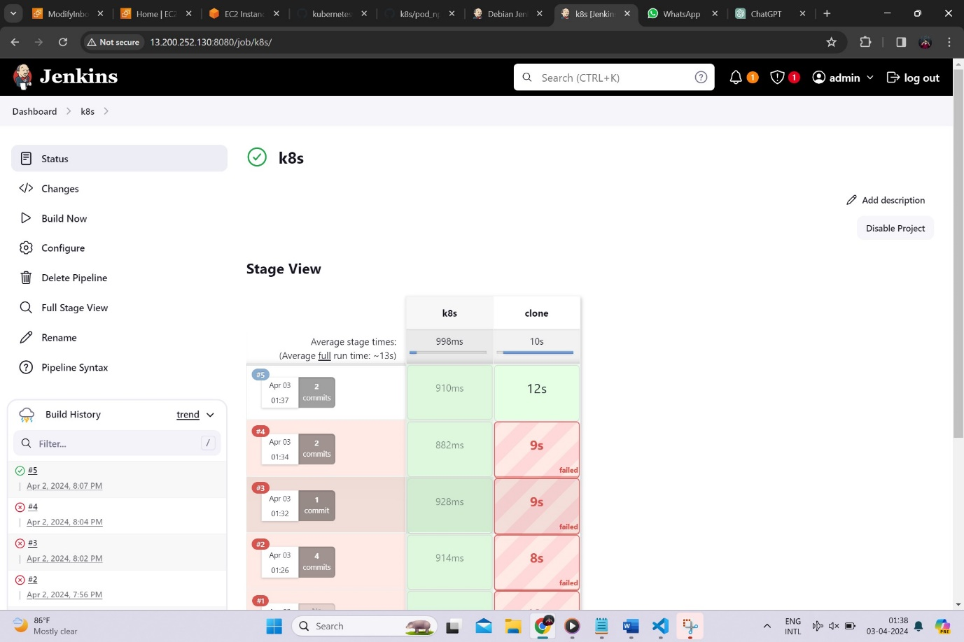

Finally ,kubernetes ingress ci-cd

