**Name: Sreelekshmi Anilkumar**

**Roll No:42**

**Batch:MCA-B**

**Date:14-11-2022**

**DATA SCIENCE LAB**

**Experiment No.: 5**

**Aim**

 Implement KNN Algorithm using python

**Procedure**

from sklearn.cluster import KMeans

import pandas as pd

from sklearn.preprocessing

  import MinMaxScaler

from matplotlib import pyplot as plt

%matplotlib inline

df = pd.read_csv("income.csv")

df.head()

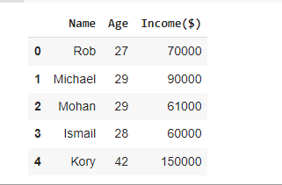

scaler = MinMaxScaler()

scaler.fit(df[['Income($)']])

df['Income($)'] = scaler.transform(df[['Income($)']])

scaler.fit(df[['Age']])

df['Age'] = scaler.transform(df[['Age']])

plt.scatter(df.Age,df['Income($)'])

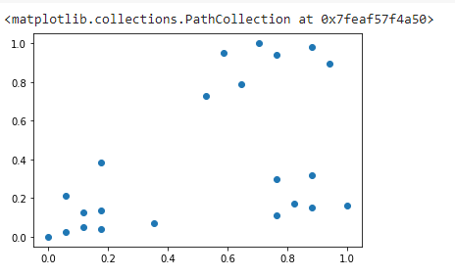

km = KMeans(n_clusters=3)

y_predicted = km.fit_predict(df[['Age','Income($)']])

y_predicted



df['cluster']=y_predicted

df.head()

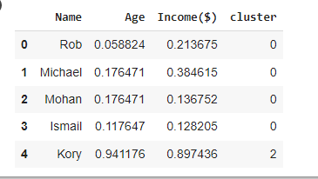

km.cluster_centers_

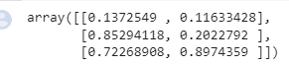

df1 = df[df.cluster==0]

df2 = df[df.cluster==1]

df3 = df[df.cluster==2]

plt.scatter(df1.Age,df1['Income($)'],color='green')

plt.scatter(df2.Age,df2['Income($)'],color='red')

plt.scatter(df3.Age,df3['Income($)'],color='black')

plt.scatter(km.cluster_centers_[:,0],km.cluster_centers_[:,1],color='purple',marker='*',label='centroid')

plt.legend()

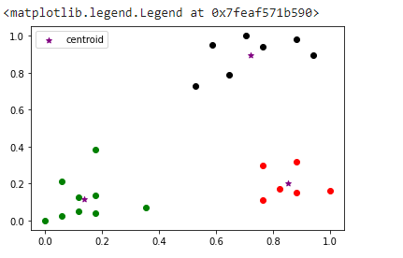

**Output**

Expected 0, Got 0.